From Walls to Bridges: A Journey of Resilience and Connection

By

Derrick R. Burns

© 2024 Derrick R. Burns, All rights reserved

**Family Celebration, Washington, DC  
November, 2022**

# Dedication

*To my birth parents, whose courage gave me life.*

*To Howard and Willa Burns, whose love gave me foundation.*

*To Gina, whose devotion places my needs above her own, every single day.*

*Thank you for choosing me.*

*Derrick R. Burns  
December 29, 2024*

# 

# Chronological Guide

## Early Life (1964-1982)

**1964** - Born to Marcia Rosenberg (Jewish) and William Burton Golden (Black) in Detroit; adopted by Howard and Willa Burns

**1970-1976** - Elementary years at Atkinson Elementary; early experiences with difference and belonging

**1976-1981** - University of Detroit High School; discovery of academic excellence and leadership

**1981** - Graduation; receives Bell Labs Engineering Scholarship to Princeton

## Princeton Years (1982-1986)

**1982-1984** - Struggles with theoretical computer science; finds community in Society of Black Engineers

**1984-1986** - Pivots to systems; summers at Bell Labs

**1986** - Graduates Princeton; heads to Stanford for PhD

## Graduate School & Early Career (1986-1990)

**1986-1988** - Stanford PhD program; struggles with pure theory

**1988** - Meets Gina Gregory in New York City

**1989** - Switches to systems focus; summer at Silicon Graphics

**1990** - Marries Gina; joins SGI full-time; daughter Maya born

## Silicon Valley Rise (1990-1997)

**1990-1995** - SGI success; builds Time Warner interactive TV system; son Jamil born (1992)

**1995-1997** - Begins search for birth parents; Mom's initial encouragement

**1997** - Discovers birth father died in 1971; first contact with birth mother Marcia

## Professional Peaks & Valleys (1998-2004)

**1998-2001** - NetApp struggles; learns hard lessons about corporate culture

**2001-2003** - Trovix startup; patent disputes and equity battles

**2004** - Google opportunity declined; joins Orbital Data

## Family Transitions (2000-2013)

**2000** - Dad's death; intensified relationship with Marcia

**2005-2010** - Mom's cancer diagnosis and final years

**2010** - Mom's death; Marcia's attendance at funeral creates family tension

**2013** - Marcia's death; final reconciliation

## Personal Growth (2010-2023)

**2010-2020** - Deepening friendships; Jala's transition and health struggles

**2020-2022** - COVID challenges; family healing

**2022** - Jala's death; renewed connections with childhood friends

## Health Crisis & Renewal (2023-2024)

**November 2023** - Cancer diagnosis; throat cancer treatment begins

**2024** - Recovery; weight loss; renewed perspective on life and relationships

**2024-Present** - Return to basketball; strengthened family bonds; memoir completion

## Key Relationships Timeline

* **Howard & Willa Burns** (adoptive parents): 1964-2000 (Howard), 1964-2010 (Willa)
* **Dave/Jala** (adopted brother): 1970-2022
* **Gina Gregory** (wife): 1988-present
* **Marcia Rosenberg** (birth mother): 1997-2013
* **Maya & Jamil** (children): 1990 & 1992-present
* **Silicon Valley mentors/colleagues**: 1989-present

# Preface

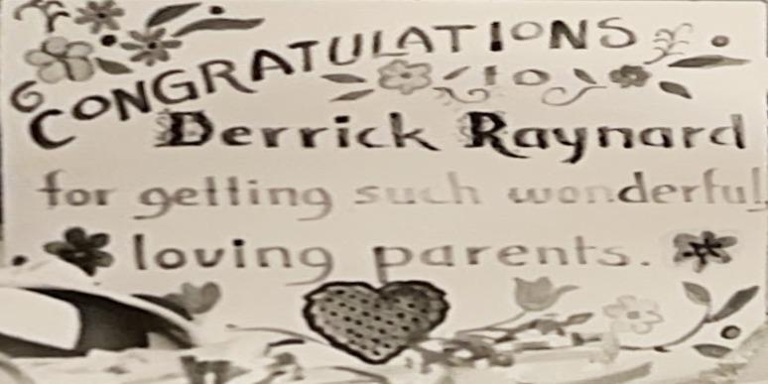

The sign hung in our basement: “Congratulations Derrick Raynard Burns for getting such wonderful, loving parents!” Even at four, the word "congratulations" bothered me. You got congratulated for achievements—first steps, potty training. But getting parents? That felt backward.

Every time I read those words, a knot tightened in my chest. Congratulations wasn't for anything I'd done, but for what had happened to me, like winning a cosmic lottery I hadn't entered. Even at four, I understood something important: if getting good parents was worth congratulating, then keeping them must require something from me.

"You are Momma's baby!" she'd say, pulling me close. The words should have comforted me, but something in her voice made me understand she was convincing herself as much as me. Her declaration felt like a door closing on questions I wasn't allowed to ask.

Instead of comfort, her words only deepened the mystery. If I was truly hers, why did The Sign exist at all?

Sometimes, alone in our basement, tears welled up and fell onto the cold vinyl tile beneath my bare feet. I carried a sadness I couldn't understand: mine, my birth mother's, or my adoptive mother's aching for the child she couldn't have.

The sign watched over my basement world—my trains, my toys, my hiding spots during games of hide-and-seek. But it never stopped feeling like a bright, beautiful warning: be grateful for a story you're forbidden to know.

At four years old, I was already learning that some questions were safer left unasked. But questions, I would discover, have their own stubborn life.

# They wait.

# Act I: Formation

# 

## Chapter 1: Two Worlds Converging

Years later, I would piece together the story of how I came to be—two separate lives converging at Crittenton Hospital in April 1964, creating the mystery that would define my childhood.

My birth mother had lived for months in the maternity home's quiet corridors, where strict rules shielded dozens of young women from the world's judgment. Twenty-two years old, almost finished with her degree, her own divorce not yet final. A Jewish woman pregnant by a Black law student—a scandal that would shake both their communities. In 1964 Detroit, such racial and religious boundaries weren't merely social; they were fiercely maintained lines between worlds. Her parents had arranged her stay, determined to shield their eldest daughter from scrutiny.

Across town, my future mother Willa Burns graded papers at her dining room table, trying to ignore the empty nursery down the hall. Each month brought the same disappointment, the same quiet grief. Her heart lifted briefly during visits to her sister, where children's laughter rang through the house—both a joy and a sharp reminder of what she longed for. Her husband Howard watched helplessly, carrying his own private pain from a son he couldn't reach, couldn't hold, couldn't father.

As spring arrived, my birth mother's time at Crittenton was ending. Through long nights, she had felt me kicking strong and insistent against her ribs, an innocent rebellion against the boundaries already shaping my future.

The phone call came on an April morning. A baby boy, the adoption supervisor told my parents. Mixed race. Beautiful. Healthy. Available immediately. Mom's hand trembled on the receiver, her quiet voice betraying her deepest fear.

"Howard, a mixed child—what if people don't believe I'm his mother?"

Dad met her eyes with quiet resolve. "Willa, you don't select a child like a pair of shoes."

In the hospital, my birth mother held me once, memorizing my face, my scent, the warmth of my small body. Perfect fingers, dark curls, skin lighter than my father's. She named me Michael, though she knew the name wouldn't last. Then she left Crittenton Hospital alone, carrying an ache she would hold for thirty-three years.

For five weeks, I lived between worlds—neither with my birth mother nor my adoptive parents, in temporary care while papers were processed. Even in those earliest days, I existed in the spaces between categories, between families, between identities that adults would spend years trying to make fit.

When Mom and Dad finally brought me home, a colleague of my Mom hung a sign that would witness decades of life unfolding:

"Congratulations to Derrick Raynard for getting such wonderful, loving parents!"

I remember staring up at those bright letters in our basement, puzzled by their meaning.

"Mom, what did I do to get congratulated?" I asked one day.

She smiled, wrapping me in a warm hug, explaining again about being "chosen" and "special"—words that somehow left me more confused. If they chose me, where had I been before? Who hadn't chosen me?

The space between "chosen" and "belonging" would become the defining geography of my childhood, where love and uncertainty coexisted, where gratitude and confusion lived side by side.

Four lives had intersected at Crittenton Hospital—a birth mother, a baby, and a married couple, each forever changed. But the true intersection, where identity meets truth and vulnerability meets courage, would take much longer to find.

That journey was just beginning.

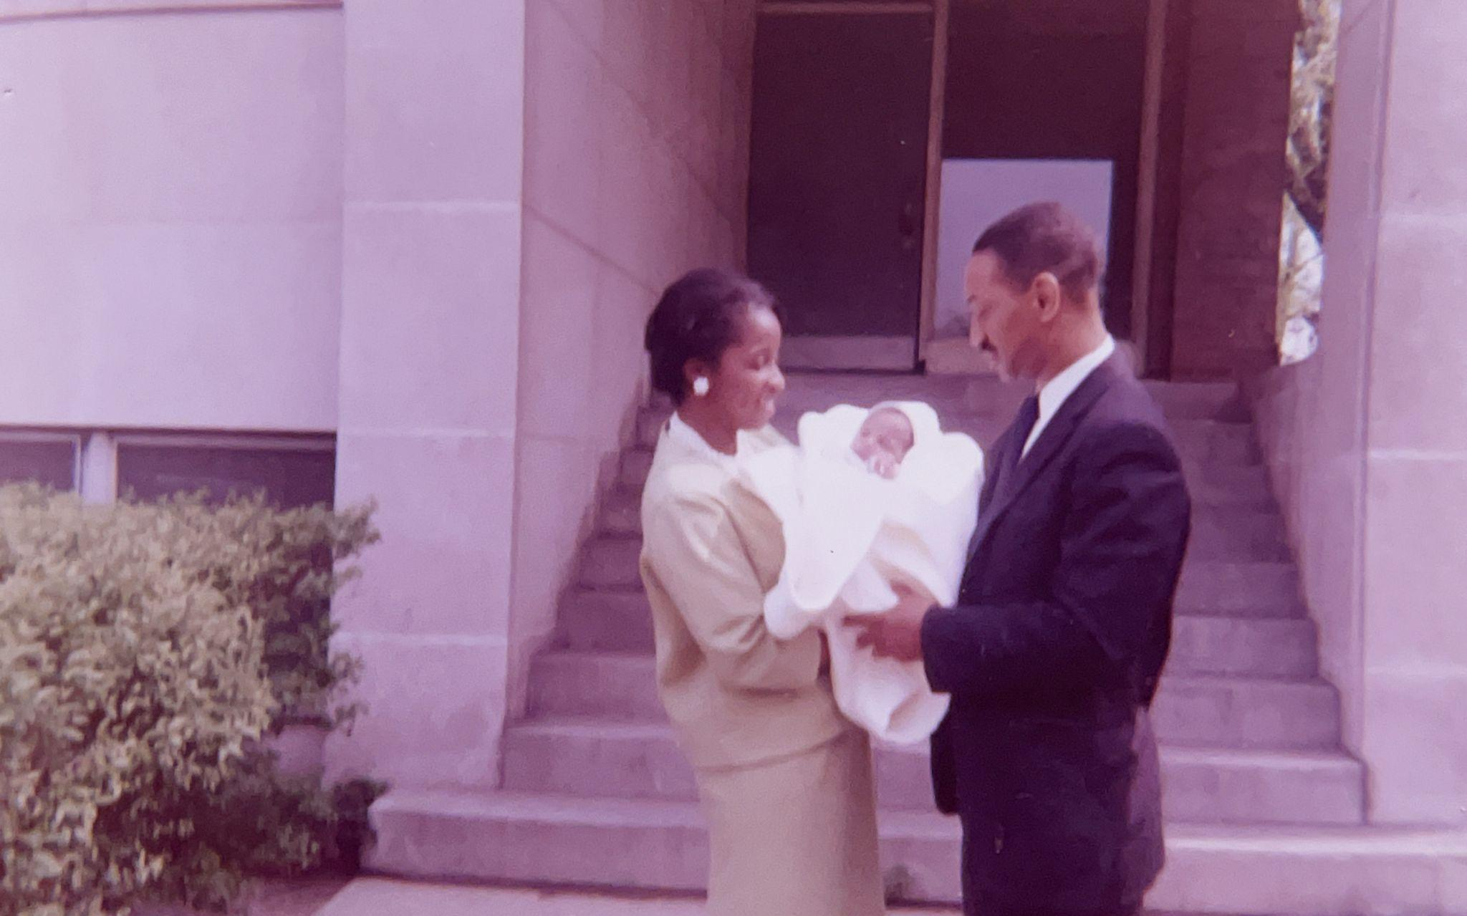

**Willa Burns, Howard Burns, and Baby Derrick  
May 12, 1964**

## Chapter 2: The Perfect Shot

### Preparation

"Derrick, go downstairs and get your graduation gown from the ironing board," Mom called from the kitchen.

I ran down to the basement and saw Daddy had his camera bag opened on the ping-pong table, checking his equipment.

"Hi Daddy!"

"Hey Bolo!"

"Howard, it is time to go!" Mom shouted from upstairs.

We both rushed up to the kitchen.

The white graduation gown was just a bit too long, pooling around my feet like a miniature wedding dress. I didn't understand why I was wearing this long dress or why I had to wear a cap. What did it mean to "graduate"?

"Stand still, Derrick," Mom said, kneeling to pin up the hem with quick, efficient movements. "I need to fix this before the ceremony."

As we drove over, Mom instructed: "Derrick, you need to act right. Smile! Walk straight. Don't talk unless spoken to by an adult. Understand?" "Yes ma'am." I dutifully responded.

Soon we were back in that familiar basement. Vernon Chapel AME Church occupied a corner on Norfolk, just a few blocks away on the other side of Ryan Road, the kind of place where Rev. Brockington could walk to work from his house five doors down from ours, where everyone knew which families sat in which pews. Mom had chosen it not for God, but for convenience. But we went to Metropolitan Church on Sundays, so I did not know these people.

Every day for a whole year, I came to this basement and lay down on the blue cots that smelled like pee. I would close my eyes and wait, listening for Mom's footsteps on the stairs. The other kids played together, but they never asked me to play. I wanted to go home where I could read my books and show Momma how smart I was.

Here, we just recited along with the teacher, "A is for Apple" while staring at the big red apple on the wall. I already knew all my letters and could read. The drills bored me.

Today the basement was crowded with parents, and it smelled different—like the perfume Mom wore to church mixed with coffee. Something was finally happening, though I didn't yet understand I was about to give my first real performance.

### Graduation

My church shoes squeaked on the vinyl tile as our teacher moved us around like dolls. "Stand here. Move there. Shortest to tallest." She spaced us out with her hands, measuring the gaps between us. I stood where she put me, trying not to move. The basement was hot and smelled like Pine-Sol mixed with that musty smell. My house never smelled like that.

Looking at the other children lined up beside me, I noticed something I'd seen before but never really thought about: the other kids looked more like Mom and Daddy than I did—their eyes were brown like Mom's, hair curly like Daddy's.

I could see Daddy in the back, with his camera in hand.

Mom sat with the other parents, and I could see her watching me. When the pianist played "Pomp and Circumstance" on the old upright piano, I remembered to smile big, just like I did every time Daddy raised his camera. I wanted to make sure Mom could see I was being good.

As the teacher called our names, an assistant passed out our diplomas.

"Hold this up in front of you," she whispered.

As we stood up waiting for our names to be called, I realized I needed to pee. Mom would be angry if I asked to pee now.

When my name was called, "Derrick Raynard Burns," I walked across the small stage to get my diploma, making sure to stand up straight like Mom always told me. I could see Daddy walking down the center aisle to get closer to the stage.

Daddy was ready, positioned perfectly at the front. I could see him in my peripheral vision, camera raised, waiting for the exact moment. As the teacher placed the diploma in my hands, the light of his flash blinded me for a second. Not now Derrick. Smile. Smile.

From the front row, Mom's smile was bigger than I'd ever seen it. That made me happy. Daddy's face was mostly hidden behind the camera.

"Congratulations, Derrick!"

"He's reading already," one mother said, shaking her head in amazement. "Willa, you're doing such a wonderful job with him!"

Mom beamed.

"Can I have another cookie, Mom?" I asked.

"Just one more," she allowed, then called across the room. "Howard! One more picture. Get Derrick holding his diploma by himself."

I straightened my cap and held up my certificate. I knew this was important.

### Back Home

"Mom, can we look at my baby book?" I asked, after dinner.

"Yes, dear. Howard…" she said, commanding Daddy to get the book.

Daddy sat up on the bed, holding the big orange baby book in his lap. I climbed up between Mom and Daddy and leaned on Daddy's right arm. I liked looking at the pictures. The best ones from Daddy's camera always ended up here.

I pointed to the photograph of Mom and Daddy standing with a woman in a dark dress outside a big brick building.

"That's me?" I asked.

"Yes, sweetie, and Mrs. Ricks. That's her with Momma's baby!" Mom said proudly.

Each time I see this picture, I stare at her. Who is she? Why is she holding me? She does not come to visit like Mom and Daddy's other friends. And, they always call her "Mrs. Ricks," no first names.

"She helped us to find you," Mom explained.

That night, after Mom tucked me into my twin bed, I pulled the covers back and got on my hands and knees and rocked back and forth. I rocked and I rocked, until exhausted, I buried my head in the pillow and fell asleep.

### The Report

6-26-64:

[The] Worker called at 18414 Shields in the mid A.M. at the Burns home. Both Mr. and Mrs. Burns, and baby Ricky, at home. Mr. Burns was enjoying a week’s vacation to get better acquainted with his son. Ricky was sleeping but soon awakened. He is indeed a happy, smiling baby. It was noted [that] his skin tone and features match Mr. Burn’s very well…

His nursery was spotless, airy, and most attractive with deep blue organdy tier curtains on the extensive window areas on two walls against the painted walls, which are white. Above his crib was hung a colorful plaque painted by the art teacher in the school Mrs. Burns has taught in, with the memo “Congratulations to Derrick Raynard Burns for getting such wonderful parents”. Mrs. Burns plans to have this framed. Ricky has sufficient current visual hunger to enjoy the bright colors in this plaque.

Mr. Burns reveals his pride and joy in his son, explaining he matches and fits so well in their way of life that even friends find it hard to believe he is not their biological child.

Mrs. Burns, in her quiet, refined manner seems to be basking in the compensations of her long-time planning for a child. With the evidence of baby furniture, equipment for baby’s comfort and needs everywhere about the home, one readily places this household as a child-centered family. Mrs. Burns proudly showed many colored pictures and snapshots, and gave [the] worker two [of them] for [the] office displayboard.

Mrs. Esther M. Ricks, AGSW  
Adoption Supervisor

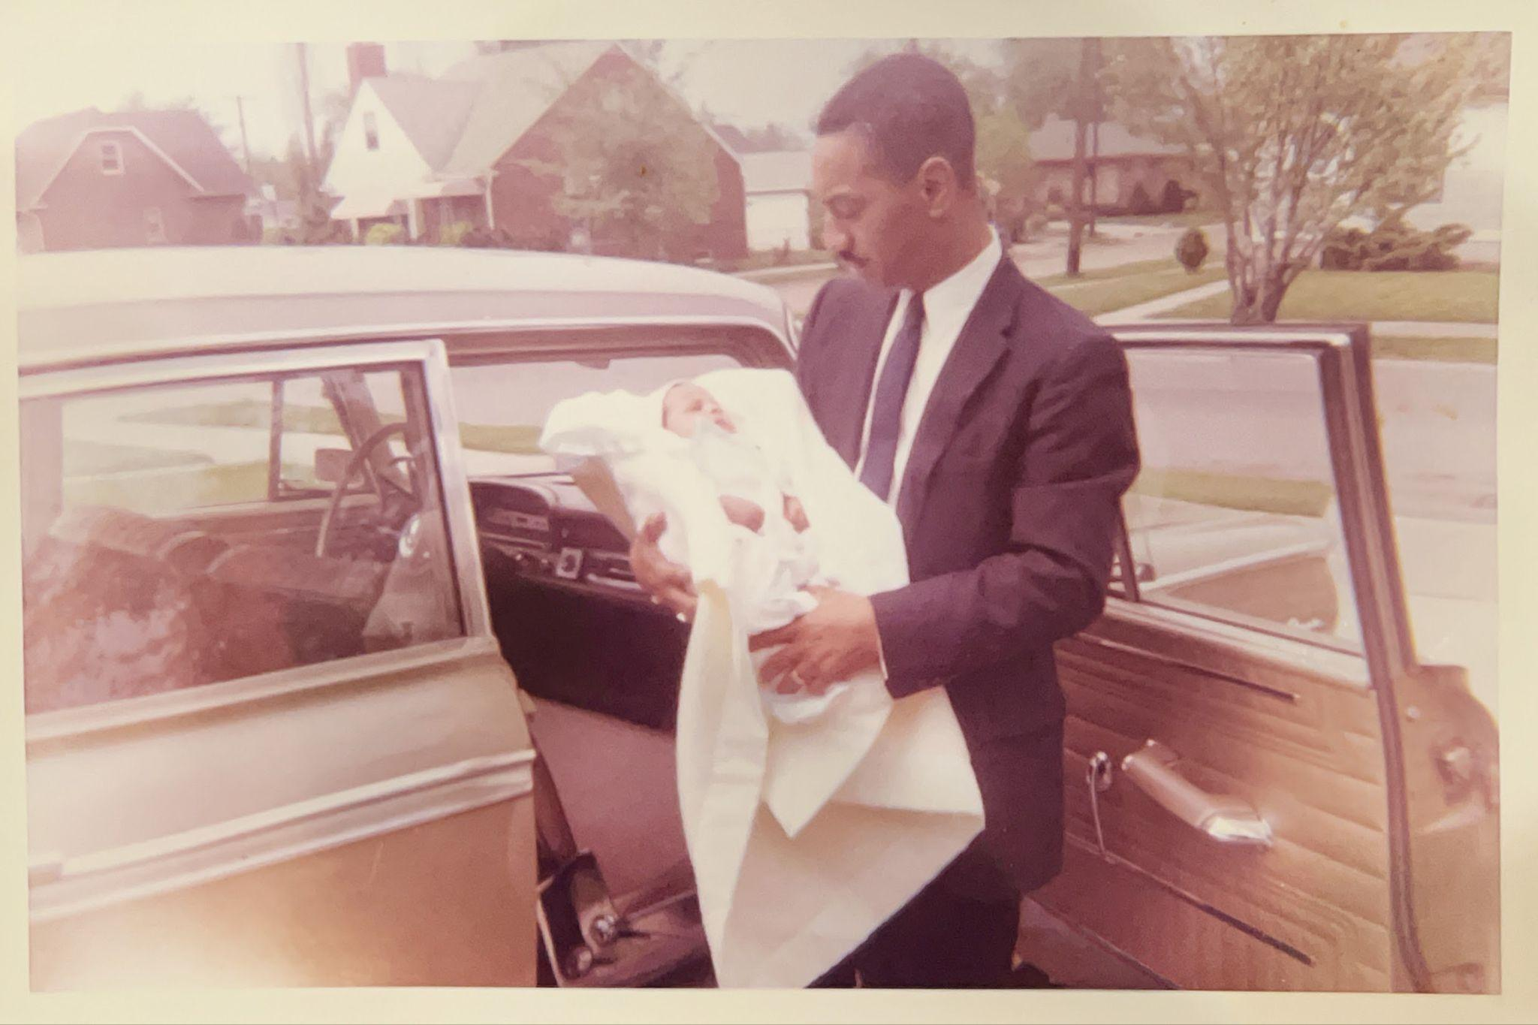

**Me and Dad, Arriving home at 18414 Shields for first time**  
May 12, 1964

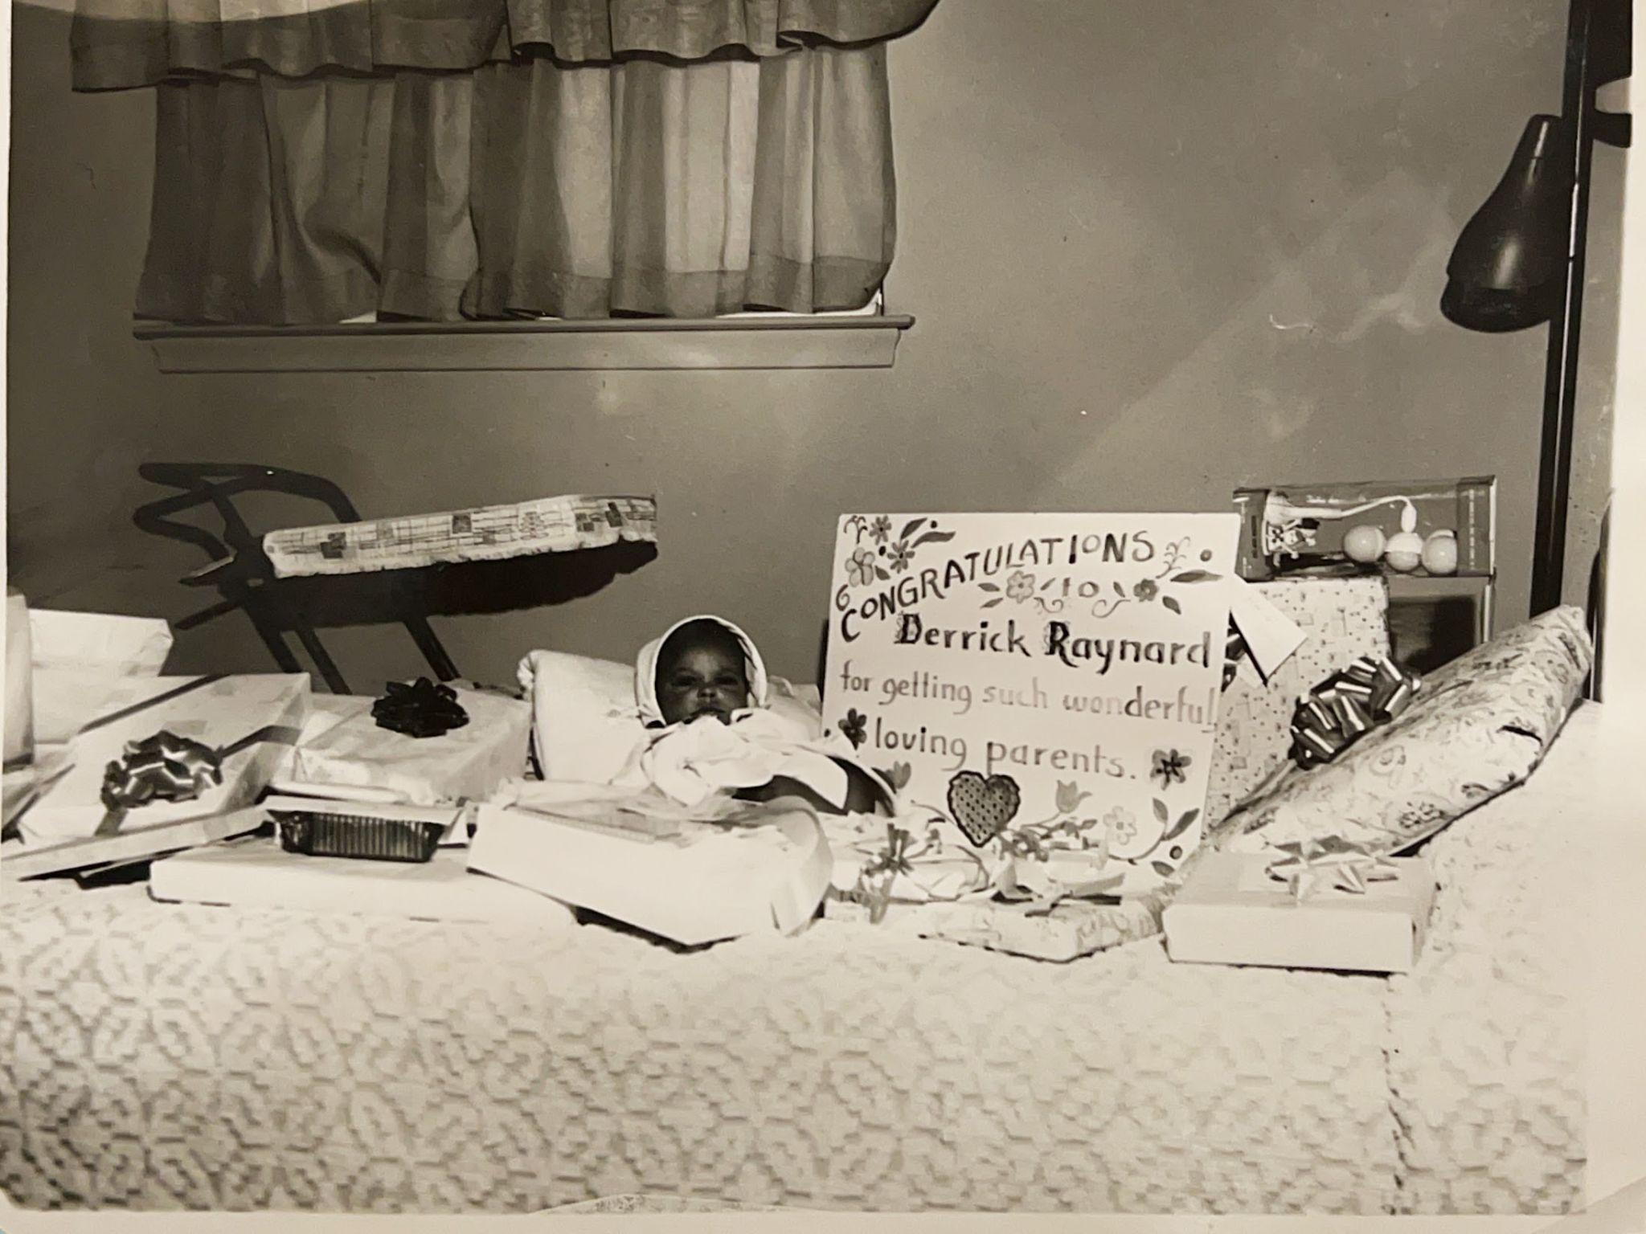

**Baby Derrick with The Sign  
May 12, 1964**

## Chapter 3: Lessons from Aunt Mae

With Nursery School over, Mom found other free respite from childcare duties in the form of her sister and surrogate mother, Classie Mae Walker, Aunt Mae to me. Aunt Mae was like the film negative of Mom: tall, buxom, and welcoming.

"You will get your education so you don't have to wash white people's clothes or take care of white people's babies," Aunt Mae had told Mom years before, as Mom repeated to me throughout my childhood.

But whereas Aunt Mae had been a mother to Mom, with all the attendant expectations and discipline of the head of household, she was more a grandmother to me. And when the weekends came, I loved to hear the magical words: "Derrick, get ready to go to Aunt Mae's house!"  
  
Mom's voice sent me flying upstairs, two steps at a time, yanking my overnight bag from under the bed. The zipper caught on my pajama sleeve as I stuffed everything in, but nothing could slow me down. Through the window, I spotted Mom's car already warming up, its exhaust making clouds in the evening air.

No Primary Church this Sunday. No standing straight and smiling at exactly the right moments. No getting in trouble for whispering to Mary like last week when Mom was our teacher and made me sit in the front row by myself, my face burning while everyone stared.

The familiar drive down Nevada Street to 18606 Mackay felt longer than usual. Before Mom could fully stop the car, I spotted Uncle John on the porch.

"Hey Boy!" he greeted me as I scrambled out of the car.

"Hi Uncle John!"

"Can we play checkers?" I asked.

"Boy, you don't know nothin' about no checkers," he said, smiling.

Before disappointment could run too deep, Aunt Mae came to the door.

"Shug!" Aunt Mae called.

Everyone had their favorite nickname for me. I suppose it was short for “sugar”, but all I know is that when I heard it, I felt good inside.

The screen door creaked its welcome as she pulled me close. She smelled like vanilla and fabric softener, and something in my chest loosened at the familiar scent—something I hadn't even realized was tight.

### Friday Night Rituals

"Shug, come help me fix your bed," Aunt Mae called from the small back bedroom.

I stood next to the mattress while she tucked the sheets, making the corners neat and tight. This simple invitation felt revolutionary. Mom would have shooed me away with an impatient "Go play, Derrick, you're in the way," but Aunt Mae wanted me close.

"Aunt Mae, can I stay up late?"

"We'll see how sleepy you get." She smoothed the quilt with her hands. "But first, you need to wash up."

Standing on the little wooden stool she kept just for me, I reached for the bar of Ivory soap. When I came out in my pajamas, she was sitting in her chair with her Bible open on her lap, the lamp casting a yellow circle around her. She patted the arm of the chair.

"Come sit with me while I read."

I climbed up next to her, fitting myself into the curve of her arm. Her voice was soft and steady as she read about shepherds and sheep, about still waters and green pastures. I didn't understand every word, but the sound of her voice created a different kind of safety—not the safety of rules followed correctly, but the safety of being wanted exactly as I was.

When my eyes grew heavy, she carried me to the little bedroom and tucked me in again, her hand cool on my forehead.

"Sweet dreams, Shug."

### Morning Without Rules

The smell of bacon drifted into my dreams before the sun came through the curtains. I padded to the kitchen in bare feet, finding Aunt Mae at the stove.

"Good morning Shug! Can you help me with these eggs?"

She handed me an egg. When pieces of shell fell into the bowl, her fingers moved quickly and gently to fish them out.

We ate at the built-in counter, the eggs still warm from the pan. She cut my toast into triangles without my asking.

"What do you want to do today, Shug?"

The question surprised me. Saturday mornings meant chores and errands, a schedule that moved around my wants, never with them.

"Can I play with Snuffy first?"

"Just watch where you step in that backyard," she warned with a knowing smile.

I bolted outside to find Snuffy, Aunt Mae's golden collie, sprawled in a sunny patch near the fence. At the sight of me, her tail started wagging like a furry metronome. We wove between the careful landscape of dog poop that dotted the grass, an obstacle course that made me giggle.

"Come here, girl!" I called, convinced I could ride her like the horses on TV westerns.

When I finally cornered her near the back steps and tried to climb on, Snuffy gave me a look that clearly said "Not happening, kid" and trotted away with dignified indifference, leaving me sprawled on the grass laughing.

"Derrick, come wash those hands!" Aunt Mae called from the kitchen door.

"Can we make ice cream now?"

"If you're willing to do the cranking."

"I am! I got stronger since last time!"

### Creating Something Together

Crack! The egg split perfectly against the rim of Aunt Mae's white bowl, the one with the tiny chip on the edge that she'd had "since before you were born, Shug."

She handed me her wooden spoon, worn smooth from years of stirring. The mixture fought against my spoon—sugar, eggs, and cream refusing to blend easily.

"Keep going, Shug. Got to get all those little sugar crystals dissolved."

Mom usually opened cans of peaches or scooped store-bought ice cream onto plates. But Aunt Mae carved out entire afternoons for us to make something together.

The wooden bucket sat ready on the back porch, ice and rock salt layered around the metal canister. She fitted the crank handle into place.

"Ready?"

The first few turns were easy. Then the mixture began to freeze, and the handle grew heavy. My shoulders burned, but I kept cranking because she was right there with me, her hands covering mine when I needed help.

When we finally lifted the lid, revealing perfect, creamy swirls inside, she handed me the first spoon.

The ice cream was cold and sweet and perfect. But more than that, it was something we had created together. This bore no resemblance to the store-bought varieties Mom served at home.

After lunch, Aunt Mae left for a couple of hours. With nothing to do, I joined Uncle John on the front porch. He sat there most days, waiting for company to drop by, with a glass of orange juice and ice. Aunt Mae had told me never to touch Uncle John's “juice”.

"Uncle John, can we play checkers?"

"No boy, you are not ready."

And as if on cue, one of Uncle John's friends walked up the walkway to the steps of the porch.

"Hey John, ready to get your butt whooped?"

"Sit down and stop that crazy talk," Uncle John retorted.

And I watched Uncle John play and win. He never lost.

### Sunday Belonging

The starch in my Sunday shirt crackled as I followed Aunt Mae up the worn stone steps of Corinthian Baptist Church. The heavy wooden doors groaned open, releasing waves of organ music and the sharp sweetness of ladies' perfume mixed with furniture polish.

In the choir loft, she stood straight and tall, her voice rising above the others, strong and sure: "Aaaah-mazing Graaaace..." I watched her face as she sang, eyes closed, completely lost in the music. The stained glass windows caught the morning sun, painting her face in blues and golds, transforming her into something almost ethereal.

After the service, Reverend Jordan found me in the fellowship hall. "You're getting so tall, Derrick!" He squeezed my shoulders. "Mrs. Walker talks about you all the time!"

"Aunt Mae, can I have a dime for some pop?"

"Let me see if I have a dime, Derrick." She dug through her large purse, finding the coin and pressing it into my palm.

I ran down the worn brown stone steps to the church basement with the same tile floor we had at home, heading for the soda vending machine. At the soda machine, I'd search for Fanta orange pop first. The glass bottles lay horizontally behind the glass. I always checked the coin return to see if someone had left change. If I couldn't find orange, I'd settle for red pop.

When I returned upstairs with my treasure, she was still surrounded by friends. She reached for me automatically, pulling me close to her side while she finished her conversation. Her arm stayed around my shoulders, claiming me.

Here, among these people who called me "Classie's nephew," I felt the same belonging I experienced at Metropolitan Church. But this was different somehow—less about performance, more about simply being present and accepted.

### The Shadow of Tomorrow

Later that evening, the phone's shrill ring cut through the quiet house.

"That's probably your mama, checking on you." Aunt Mae rose to answer. "Hello? Yes, Willa, he's been good as gold... No, no trouble at all... What time tomorrow? Alright then."

My stomach dropped at the word "tomorrow." I didn't want tomorrow to come. I wanted to play with Snuffy, watch TV, and eat ice cream!  
  
“Can I stay until dinner time?” I asked, bargaining for just a bit more time to play with Snuffy and be with Aunt Mae.  
  
“That’s up to your Momma.”

"Aunt Mae?"

"Yes, Shug?"

"Can I come back next weekend?"

"If your mama says it's alright, you're always welcome here."

She meant it. I could hear it in her voice, see it in the way she looked at me, like I was exactly who she'd been hoping to see, every single time.

But what if Mom said no? What if she discovered I preferred it here? The guilt crept in—was I betraying Mom and Daddy for wishing I could stay? Was I ungrateful, bad, for wanting this place where mistakes didn't matter?

When Mom picked me up after church, my overnight bag felt heavier than when I'd arrived. Aunt Mae had packed a Tupperware container of leftover ice cream.

"You be good for your mama now," she said, hugging me tight on the porch.

"I will. Bye, Aunt Mae!"

"Bye, Shug! See you soon."

As I walked down the straight concrete walkway to the sidewalk, I took one more look back. Snuffy was in the living room picture window. Aunt Mae on the concrete porch. I never felt more loved and more secure than I did in that small two bedroom home.

I got into Mom’s Pontiac, scanning the street. Mr. Clingman, Aunt Mae’s neighbor to the north, set the sprinkler head so that the water would reach both sides of the lawn.   
  
“Bye Bye Derrick”, Mrs. Clingman said from her porch.  
  
“How was your visit with Aunt Mae?” Mom inquired.  
  
“Great! We made ice cream!” I declared proudly.  
  
“Ah, is that what is in the container?”  
  
“I don’t know, but I hope so!”

In the car, I watched her house shrink in the rear window. Mom talked about our tasks for the week, but I wasn't listening. I was thinking about how Aunt Mae never scolded me. Why couldn’t Mom be more like Aunt Mae?

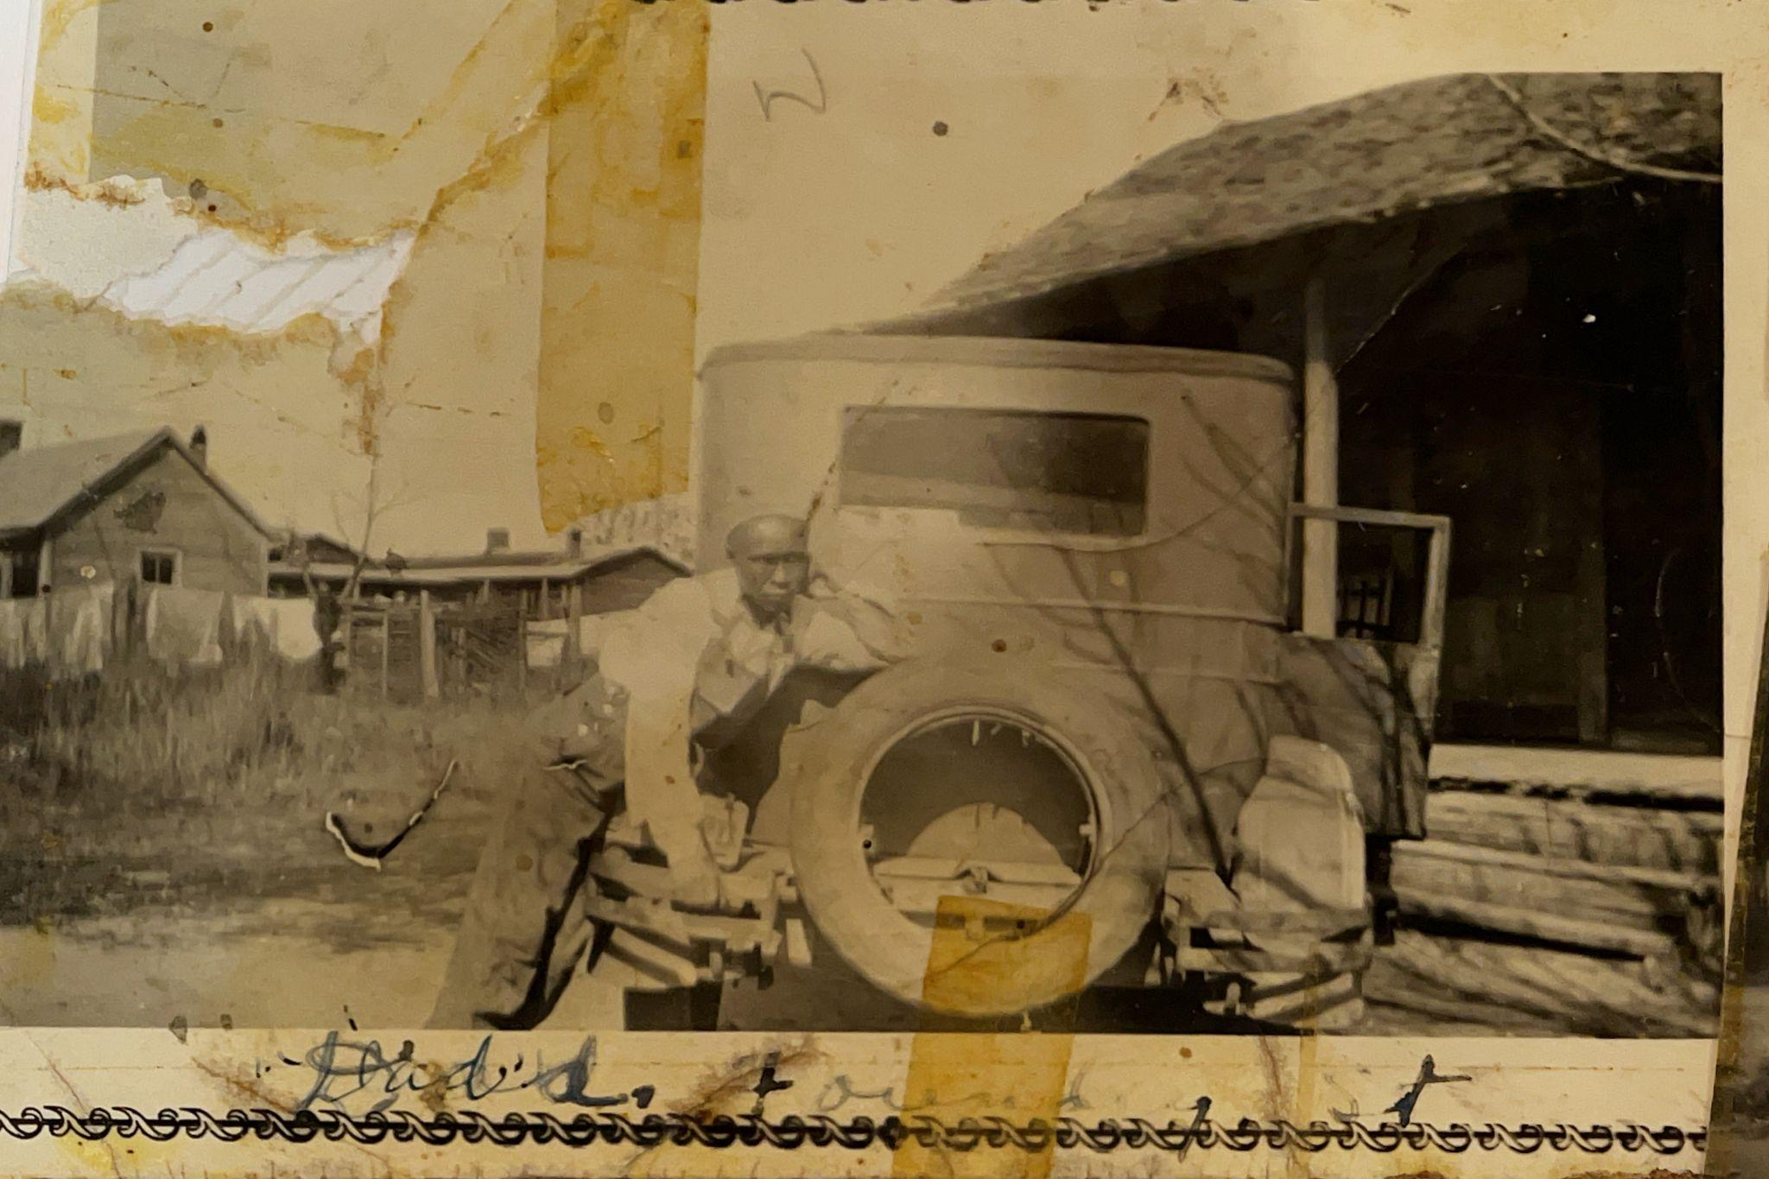  
**Willie Barnes, c. 1920**

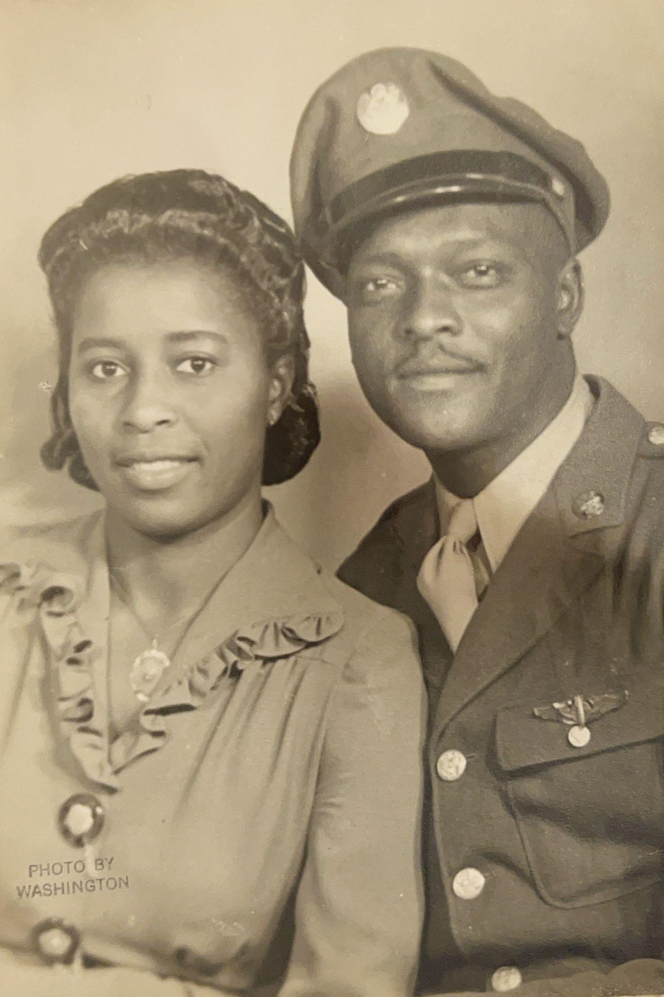

**Aunt Classie Mae Walker, Uncle John Walker, c. 1941**

## 

## Chapter 4: The Project Begins

Half-day kindergarten posed a problem for two working parents. Each morning at seven, Dad left in his sport coat and tie for TACOM, the Tank Automotive Command of the US Army in Warren, about six miles away. Mom followed shortly after, heading to McDowell Elementary School where she taught Special Education.

After Mom dropped me at Atkinson Elementary, I'd spend my mornings learning letters and numbers. At noon, Cille—our combination babysitter and housekeeper—would make the short walk to collect me, carefully navigating us past the Sojourner Truth projects and around Krainz Park. We always stayed on the park side, dodging broken glass and weeds that pushed through the cracked sidewalks.

"Cross your legs Indian-style," Mrs. Parker would say. "Look at the board. What letter is this?"

"B!" I'd call out, eager to please.

"Very good, Derrick!"

To Mom's delight, I earned gold stars regularly. When summer arrived, she had plans to ensure there would be many more.

### Summer School

When your mother is a teacher, you learn quickly that education never ends. Teaching other people's children paid the bills, but teaching her own child—that was her calling.

"Derrick, come to the kitchen table."

Mom only had one leadership style: directive. While other children spent the summer before first grade riding bikes and chasing fireflies, our kitchen table transformed into something that looked suspiciously like school.

She spread workbooks across the pad of the dining room table like a general planning battle strategy. I studied the neat stacks of books and papers. Through the window, children's voices mixed with the hum of lawn mowers and the distant melody of the ice cream truck—a world I was no longer part of.

The lessons followed the same pattern each day.

"Do these words first." Cat. Dog. Run. Jump. Words I already knew, but Mom demanded perfection.

“Finish the page”.

My pencil felt heavy as I carefully formed letters in the spaces she'd prepared, Mom monitoring every stroke.

But cursive proved the real battle. The letters had to connect perfectly, flowing together like Mom's pristine handwriting. My W's never matched hers.

"No, like this." She demonstrated on her own paper. "Do it again, to the end of the row."

By day's end, my hand cramped and my shoulders ached. But her smile when I succeeded made every moment worthwhile. When Mom was proud of me, the world felt right.

### Mrs. Blanding's Classroom

I entered Mrs. Blanding's first-grade classroom that September feeling like I possessed secret powers. While other children stared at their books with wide, uncertain eyes, I already knew most of the words.

"Who can read this sentence?" Mrs. Blanding asked, pointing to the chalkboard.

My hand shot up before anyone else's. I knew the answer. I always knew the answer.

When she distributed our math workbooks, I flipped through the pages. Page ten, twenty, thirty—I'd seen these problems before. Mom owned the same books.

"Mrs. Blanding, I already completed these," I announced, pointing to the first chapter. "Can I work on the harder problems?"

Mrs. Blanding looked surprised. "Derrick, we start at the beginning. Everyone learns the same way."

But I didn't want to repeat the elementary problems. At home, Mom had taught me addition that made my classmates stare in amazement. I could write in cursive while they still printed their letters. I finished assignments before Mrs. Blanding completed her instructions.

"Derrick, slow down," she'd say. "Check your work."

But I was too excited to slow down. I knew I was smart. Mom had told me so all summer long.

### Mrs. Blanding's Note

The note came home on a Tuesday. Was I in trouble?

I handed it to Mom when she returned from work, studying her face for clues. Her lips pressed into that thin line I'd learned to recognize—a warning sign whose meaning remained unclear.

Mom read the note twice, her finger tracing each line. When she finished, she folded it carefully and headed straight to her bedroom.

"Virginia, I just received a note..." I heard her say before she closed the door. Mrs. Donaldson was Mom's closest friend, her confidante and most trusted advisor.

I paced between the bathroom near Mom's bedroom and the den, trying to decode what I'd done wrong. Had I talked too much? Made too many mistakes? The muffled sound of her voice carried through the door, but I couldn't distinguish the words.

Later, Mom emerged to prepare dinner. She said nothing about the note.

The next morning, while Mom showered, I crept into her bedroom and found the note on her dresser. I couldn't read all the words, but I understood enough: Mrs. Blanding was complaining that I already knew everything. She wanted Mom to stop teaching me at home. The word 'mistakes' jumped out at me—Mrs. Blanding said I was making mistakes by rushing.

I folded the note exactly as Mom had left it, my heart pounding. No wonder Mom looked angry.

The next day, she came home late.

"Derrick, come here," she commanded.

I walked to her bedroom, my stomach tight with worry.

"Tomorrow you'll report to Principal Malinoff. You're no longer in Mrs. Blanding's class. You'll be in Mrs. Bridget's class."

"I don't understand. Did I do something wrong?"

"No. Mrs. Blanding isn't teaching you properly. Mrs. Bridget will do a better job."

### Walking to Second Grade

Principal Malinoff escorted me to Mrs. Bridget's classroom. When we entered, students' eyes moved between us like spectators at a tennis match.

"Stand here, Derrick," Principal Malinoff instructed, walking to Mrs. Bridget to whisper something in her ear.

"Class, this is Derrick Burns. He'll be joining us for the rest of the year," she announced. "Derrick, take that seat."

Every eye in the room focused on me. I scanned their faces and found Glenn Burch's familiar grin. Glenn lived around the block from me. Seeing his friendly face, my shoulders relaxed.

"Hey Derrick!" Glenn whispered as I claimed my seat. "How'd you get in here?"

"Quiet!" Mrs. Bridget commanded, her tone reminding me of how Mom controlled her classroom.

For the remaining months, school ceased to bore me. Mrs. Bridget spoke faster, expected more, moved through lessons as if she assumed we could keep pace. And I could. All those summer sessions with Mom had prepared me for exactly this.

When I brought home my first second-grade worksheet crowned with a gold star, Mom's face illuminated like Christmas morning.

"Excellent work," she said, pulling me into her embrace.

In her arms, I felt warm and significant. All the hard work, the repetitive lessons, the times I'd wanted to play outside instead of learning—everything had been worth this moment.

### Sunday Performance

Though pleased with my classroom instruction, Mom didn't reduce my home education. Her teaching extended far beyond school. As director of Metropolitan Baptist Church's "Primary Church"—the program for children too old for nursery but too young for the main sanctuary—she established curriculum and teaching schedules.

Some of the teachers of Primary Church were public school teachers like Mom, but most were just parents volunteering to help. Mrs. Davis played the out-of-tune upright piano while we sang “Jesus Loves the Little Children”—words I belted out enthusiastically, especially when Mary was in the classroom.

Mary was my cousin and best friend, though not really my cousin. We'd been play cousins so long I couldn't remember when it started. She lived on the West side with her little sister and father. I never knew what happened to their mother—I'd heard she was white. Uncle Bubba and Aunt Mildred, who lived behind us, were Mary's relatives too. Mom instructed me to address them as aunt and uncle, though they weren't really family either.

Mary's father often dropped the girls at Uncle Bubba's house, just as Mom brought me to Aunt Mae's. Those were magical days—Mary and I played hide-and-seek and talked endlessly. Which created problems, at least according to Mom.

"Derrick, stop that talking!" Mom commanded at Primary Church. Embarrassed and frustrated, I complied... temporarily.

"Derrick, what did I tell you about talking?" Her eyes blazed, her jaw tightened. This wasn't a question.

"Derrick, go sit over there."

In the car afterward, Mom announced my fate: "When we get home, fetch me a switch."

### The Price of Excellence

Even as I basked in the golden warmth of Mom's pride over my second-grade triumph, I was figuring out how our family really worked. I was learning to read a more complex language—the grammar of conditional love. Being smart illuminated Mom's face with joy, summoned her pride, caused her affection to pour over me like sunlight. But deviations—talking without permission, playing with food, hesitating before following her directives—cast shadows that felt like a Detroit winter.

The lesson crystallized with the clarity of revelation: smart meant loved. What felt like choice in those tender years would calcify into compulsion, defining the next four decades of my existence.

## Chapter 5: Developing the Picture

"Derrick, go downstairs and get me a can of pork and beans and a can of string beans from the pantry," Mom called from the kitchen.

I headed down the basement stairs, my hand sliding along the wooden banister. The familiar tick-tick-tick of Dad's darkroom timer drifted from behind the closed door next to our pantry. The air down here always smelled different - cooler, with hints of the chemicals Dad used for his pictures.

I retrieved the cans from the pantry, but found myself drawn to that photograph again—the large black and white picture hanging just outside the pantry door. Hundreds of men in uniform stood four deep in perfect military formation. Every time I passed it, I played the same game: find Dad. Second row, seventh from left. There he was, young and serious in his uniform, his face barely distinguishable among the sea of identical soldiers.

For years, that's all I saw—Dad's face among hundreds of others, proof that my quiet father had once been a soldier.

I stared at the photograph, tracing the familiar path to Dad's young face. His expression looked so different from the gentle man who helped me with homework upstairs—more guarded, more careful. As I got older, I'd started noticing other details beyond just finding him. Some men sat in chairs in the very front, looking important and serious, like they were in charge. I'd count them sometimes—maybe fifteen or twenty men in that front row, all sitting while everyone else stood.

"Dad?" I called softly toward the darkroom door.

"Hi Bolo, I'm developing pictures. Don't come in here - you'll ruin the pictures." And I stayed out, but I could imagine Dad dipping the pictures in the trays. He had let me in before. But once in, I could not leave. I knew the rules.

I could imagine Dad smiling, as he always did when he called me Bolo. I wonder what that name meant to him?

I could see a faint red glow from under the hollow wooden door. I had been in there before, the tiny room that sat just under the stairs to the kitchen. It was not much bigger than a closet really, with makeshift shelves holding developing paper and chemicals. One naked light bulb on a white ceramic fixture with a simple draw string illuminated the room most of the time. But not this time, light, Dad had told me before, would ruin the film. How could light ruin anything, I wondered, but I followed his instructions not to enter. Dad's shadow moved back and forth in the red light like he was performing some kind of magic ritual.

As I stared at the picture, I wondered what Dad felt at that moment. Was he happy? How did he feel being so far from home? Were these men his friends? Was his Mom afraid for him being in the Army?

Dad never explained. He never talked about the Army, about the segregation, about his time in France. He never talked about his past. For that matter, he did not talk about himself at all. What I knew about Dad, I learned from Mom.

I grabbed the cans and headed back upstairs, my mind full of questions about that photograph and the serious young man who would become my father.*consider adding a foreshadowing thought, somethnig like “It would be some years before I even understood the right questions to ask” or something like that….. You need to hint at the racial awakenig which your Mom is avoiding in the next section and which finally hits you at 10 (really it took that long?)*

### In the Kitchen

"Mom, why are there so many soldiers in that picture downstairs?"

Mom looked up from where she was seasoning the pork chops, her hands pausing mid-motion.

"That's your daddy's company from the war, baby. Company A, 1st Battalion, US Army, Fort McClellan, Alabama, January 1943." The date rolled off her tongue like she'd said it a hundred times.

I set the cans on the counter and climbed onto my usual stool, watching her work.

"What did Dad do in the Army?"

"Mostly he was a cook, but he also learned photography." Mom opened the can of pork and beans, the metal lid curling back with a soft pop. "He served in France during World War II."

"Why are some of the men wearing all white? And why are the white men sitting in front?"

Mom's stirring slowed. She glanced at me, then back at the skillet.

"Well, baby, back then the Army was... different. Black soldiers and white soldiers didn't serve together the same way."

I didn't understand, but something in her voice told me it was important.

"Tell me about Daddy in the war."

### Dad's Story

As Mom started the green beans, she told me about Dad coming home to Detroit in 1946. The city was changing, she said. All the factories that had made tanks and planes were making cars again. Dad came back to his family's house on Iroquois Street, near the airport.

"Mom, what did you do while Dad was in the Army?"

"I was eighteen when the war started, just finishing high school," Mom said, measuring out the green beans. "Aunt Mae made sure I went straight to college. I was studying to become a teacher while your daddy was overseas."

"Your daddy wanted to be a photographer." Mom drained the green beans into the colander. "He went to the Detroit School of Photography, then to Slade-Gragg Academy. The G.I. Bill paid for his schooling."

"What's the G.I. Bill?"

"A promise the government made to soldiers who came back from the war. It helped pay for school and houses, though..." She paused. "It didn't always work the same for everyone."

"Did Dad always take pictures?"

"Oh yes. He started his own business - Gad-A-Bout Photography. But taking pictures can't support a family, so your daddy got a job with the government, working with numbers at the IRS, then later at TACOM".

I thought about Dad in his darkroom, carefully developing pictures in the red light. Mom was not part of that. Neither was I. Photography was Dad’s safe place. With his camera he would be present and invisible, like … a ghost.

### Mom's Story

While the food simmered, I asked Mom about the pictures I'd seen of her as a little girl.

"Mom, were you always smart?"

She laughed, the sound light and musical.

"Classie insisted that Vivian and I get an education. I loved school from the very beginning. Made straight A's all through college."

"Why do you still go to school?"

Mom wiped her hands on her apron and turned to face me fully.

I'd watched Mom in her classroom after school sometimes, working with her student teachers from Wayne State. She'd click across the linoleum floor in her heels that lifted her 4'11" body to just over 5'0", watching them teach, taking notes in her precise handwriting. Some of those college students looked scared of her.

"Are you strict with the student teachers like you are with me in Primary Church?"

Mom smiled at that.

"If you're going to teach children, you need to know what you're doing."

### How They Met

"Mom, how did you and Dad meet?"

Her face softened as she stirred the pork and beans.

"Aunt Mae's neighbor, Mrs. Julia Clingman, introduced us. Mrs. Clingman and her husband Albert had moved away, and their house, just to the north of Aunt Mae's, stood vacant." Mom chuckled. "She was right."

"What was Dad like when you first met him?"

"Handsome. Always dressed so nice, always on time. Very polite." She glanced toward the basement stairs. "He was different from the other men I knew. Quieter. More thoughtful. I tried to imagine them young, meeting for the first time. Mom with her straight A's and Dad with his camera.

"Why did you marry him?"

Mom turned the heat down under the skillet and looked at me with that expression she got when she was thinking of exactly the right words.

"I loved your Daddy."

### Understanding

Later, after Dad came upstairs for dinner and we sat around the table, I watched them differently. Dad, methodical and gentle, preparing his usual green salad with iceberg lettuce, cucumber and tomato slices - content in his quiet rituals. Mom, animated as she directed:

"Howard, you can get the plates down." "Derrick, you can get the silverware and the napkins."

It was not until adulthood that I recognized the oddity of the phrase "you can," the request that was a command shrouded in an observation.

And as I walked through the dining room to the only full bathroom in the house, I looked at all the pictures in the frames. Mom. Dad. Aunt Mae. Me. Aunt Vivian. Sister and Paul. This was my family.

### The Awakening

It wasn't until I was ten that it finally hit me like cold water. I was making my usual trip past the photograph when I really looked at those men in the front row - the important-looking ones in chairs. Every single man in those front chairs was white. Every one. All the Black soldiers, including Dad, stood in the back rows. It wasn't random. It wasn't coincidence. It was the rule.

I stared at that photo with new eyes, seeing what had been invisible before. Dad's serious expression suddenly made sense - not just military discipline, but something heavier. The careful distance in his young eyes. The way he stood perfectly straight but somehow separate.

Looking at that photograph with this new understanding, I began to see something about the man who lived upstairs. Dad had learned early how to exist in spaces where he wasn't quite equal, where his service meant something different than the white soldiers' service. Where being excellent wasn't enough to earn a seat in the front row.

That photograph became a bridge between Dad's experience and mine - two generations learning to navigate spaces that included us but didn't quite accept us.

Standing there in our basement, staring at Dad's young face among those careful rows, I finally understood what I'd been searching for in all those childhood stares. Not just my father's history, but a map for my own journey. *Need a transitional thought here…At ten I didn’t fully grasp it, but i would learn that* We were both men learning to move through a world that demanded constant calculation, both building walls to protect ourselves while searching for places where we truly belonged.

The photograph would hang there for decades more, Dad's serious young face forever frozen among those segregated ranks. But now when I looked at it, I saw more than just a soldier. I saw a teacher, showing me how to stand straight and maintain your dignity, even when the world puts you in the back row.

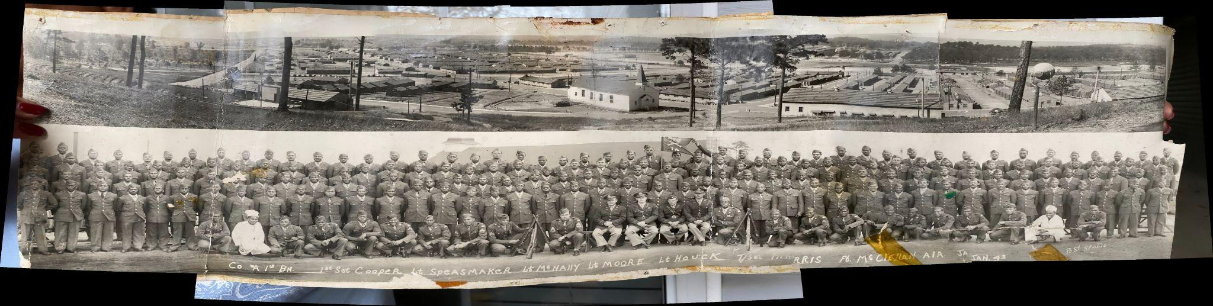  
  
**Company A, 1st Battalion, Ft. McClellan, Alabama, January 1943  
Howard L Burns (second row, seventh from left)**



**Dad’s Business Card, c 1965**

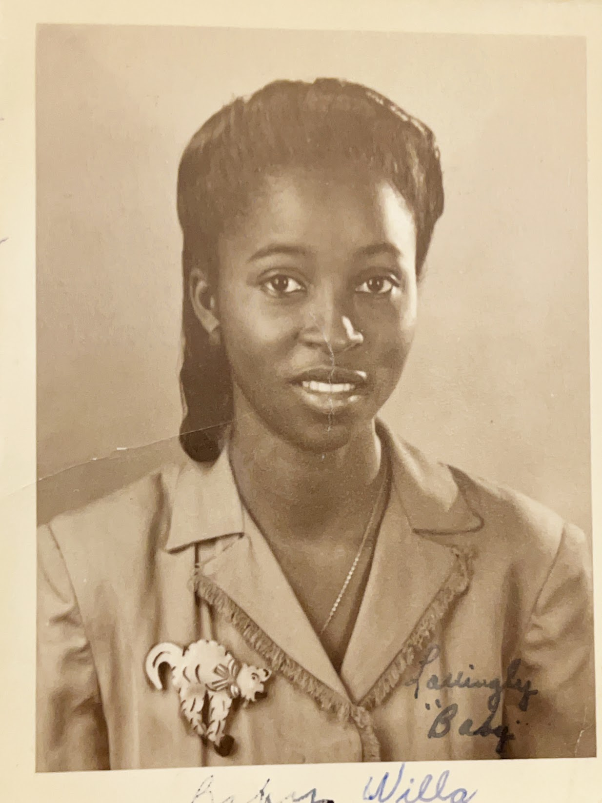

**“Baby Willa”, c. 1935**

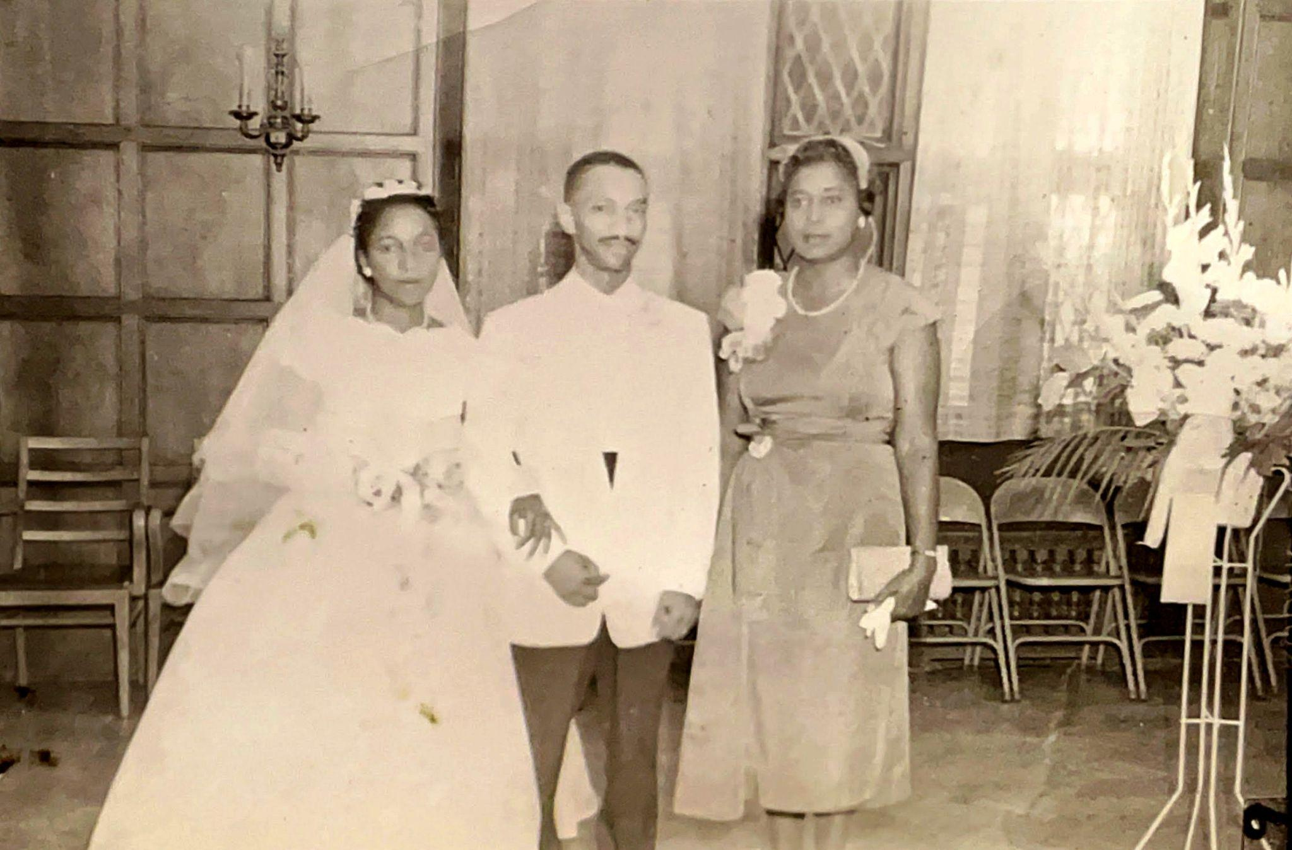

**Mom, Dad, and Aunt Mae at their wedding  
August 9, 1958**

## Chapter 6: Dave Arrives

### The Loneliest Desk

The wooden desk felt too big for me, like everything else in Mrs. Bridget's second-grade class. Multiplication tables marched across the blackboard in neat white rows. Seven times eight. My hand shot up before I could stop it, fingers stretching toward the ceiling tiles.

"Ooh, ooh!" The sound escaped my throat like a trapped bird.

Mrs. Bridget's chalk paused mid-stroke.

"Yes, Derrick?"

"Fifty-six!" The answer burst out, sweet relief flooding through me like when you finally scratch an itch.

"Very good." Her smile was warm, but behind me came the whispers, sharp as pins.

"Teacher's pet!" "Show-off!" "Think you're so smart..."

I slid lower in my seat, trying to fold myself smaller. The wood grain on my desk became fascinating - little rivers and valleys I could trace with my finger. But then Mrs. Bridget's chalk tapped against the board again: "12 x 9."

My arm betrayed me again, shooting up like it had a mind of its own. One hundred and eight screamed in my head, demanding to be let out.

Each correct answer I gave seemed to add another brick to an invisible wall growing between my desk and everyone else's. When the final bell rang, I waited until the scraping of chairs and shuffling of feet faded away. Better that way. No one to "accidentally" bump into me or whisper those names that followed me like shadows.

Outside, the afternoon sun hit me like a spotlight. Kids clustered in noisy groups on the front steps, planning after-school adventures or waiting for older siblings. Glenn caught my eye and waved, but he was already surrounded by his usual crowd, his big brother Dennis standing nearby. At least there was one familiar face from the neighborhood in my new class, even if we only shared quick waves.

I started the walk home, scuffing my shoes against the sidewalk. Each step taking me further from school made my shoulders feel lighter, but home wasn't the safe place it should have been. Instead, it was just a different kind of lonely - quieter, but somehow louder in its silence.

### After School Emptiness

"Who is it?" Cille asked as she pulled back the white lace curtain to see my face.

"It's me!"

"Your snack is on the table. And don't forget to take off those shoes - I just mopped that floor!" she said, heading downstairs to resume her ironing.

I carefully placed my shoes on the newspaper behind the door. A peanut butter and jelly sandwich waited on a paper towel, cut diagonally just the way I liked it. Next to it sat a glass of milk, beads of condensation rolling down the sides.

After I finished, I headed downstairs to watch Cille press sheets with precise, practiced movements. The iron hissed as she worked near Dad's bowling trophies while the small kitchen TV blared with Doctor Tom Horton dealing with another crisis at University Hospital.

"How was school?" she asked, not looking up from her ironing.

"Fine."

"Can we play gin rummy later?" I asked hopefully. Cille was the only grown-up who never seemed too busy to play cards, even if she did show no mercy when it came to winning.

"After my stories," she promised, warmth in her voice. "And after you do your homework. Mrs. Burns would have my hide if I let you play cards before your school work's done."

At 3:30, I'd head to the den for my shows - The Three Stooges, Little Rascals, Land of The Lost, Star Trek. The TV Guide was my constant companion, the schedule etched into my mind like a prayer. But when my favorite shows ended and the screen went dark, the silence would crash in like a wave, leaving me stranded in the emptiness of our house.

Dad's arrival at 4:30 PM was both comfort and fresh disappointment. I'd watch him settle into his chair after changing clothes, newspaper crackling as he unfolded it like a shield between us.

"Dad, want to play cards?" I'd ask, hope rising in my chest.

"Let me finish the paper first," he'd say, but the paper never seemed to end before dinnertime.

Mom was no better refuge.

"Mom, can we play a game?"

"I need to cook dinner, Derrick," came the tired reply.

So I'd retreat to my solitary games - Solitaire, a game whose very name mocked my loneliness, or jacks bouncing against empty floor, or Hot Wheels cars racing to nowhere.

### Breaking Point

One Saturday afternoon, the weight of solitude finally crushed through my defenses.

"I'm lonely!" The words burst from me like water through a broken dam. "I want a brother!"

Mom and Dad exchanged one of those long, heavy looks adults share when they're speaking without words. Their concern hung in the air like smoke, but neither seemed to know how to clear it.

I could see something shifting behind their eyes - Mom's teacher-brain already working on the problem, Dad's quiet consideration weighing options I couldn't imagine.

"We hear you, baby," Mom said softly, her hand finding my shoulder. "Let us think about this."

### The Mysterious David

"Derrick, I have arranged a playdate for you tomorrow," Mom announced one evening, her voice carrying an unusual note of anticipation.

"Who?" I asked.

"David," she responded, the name hanging in the air like a mystery.

"David Ragland?" I ventured, thinking of the boy Mom sometimes mentioned from her school.

"No, a different David. He will be here at 5 PM," she said in that same careful tone she used when telling us about important things.

Something in Mom's voice made me pause. Who was this David? The way she said "a different David" felt weighted with meaning she wasn't sharing.

### First Meeting

When David arrived, he was smaller than me, with curly black hair and brown eyes as big as quarters. Mom suggested we go into the basement to play. At first, he seemed to shrink under Mom's schoolteacher voice as she laid out the rules - no roughhousing, no yelling, clean up when you're finished.

But then something magical happened. As we started to play, his whole face transformed. His smile lit up like a lamp being switched on, and his laughter made our basement feel warmer somehow.

We built fortresses with my blocks, creating elaborate worlds with moats and bridges and secret passages. We raced Hot Wheels cars across the vinyl tile floor, thrilled each time they crashed into the wall. For the first time in what felt like years, the house didn't echo with emptiness anymore.

When it was time for David to leave, he looked back over his shoulder at me, like he didn't want the afternoon to end either.

"Can David come back?" I asked Mom after he left.

"Yes," she said, and something in her smile told me this had been more than just a playdate.

### Growing Connection

David's visits became more frequent, and somewhere along the way, he became "Dave." Each time he came over, the basement felt less like my lonely refuge and more like our special place. We'd spend hours down there, huddled on the basement floor around the train set Dad had built.

Sometimes when I asked Dave about where he lived before, his face would change - like when you accidentally step on something sharp and try not to show it hurts.

"Mrs. Williams was okay," he'd say, but the way he said "okay" didn't sound like okay at all. It sounded careful, like walking on ice.

I learned not to ask about her anymore. Even at seven, I could tell some doors were better left closed.

The Santa Fe engine puffed tiny clouds as it rounded the curve. Dave's eyes lit up as he reached for the transformer dial.

"Faster?" he asked.

"Yeah!" I nodded, both of us grinning as the train picked up speed.

We took turns adjusting the speed, laughing as the train zipped past the station and rumbled over the bridge. The smell of the "smoke" and the soft hum of the motor made it feel like we were running a real railroad, completely lost in the magic of our miniature world.

During one visit, we discovered my white upright toy piano - the Christmas gift from when I was five. We'd coax melodies from the keys, making up songs that only we understood, filling the basement with music and laughter.

But the best part was simply having someone to talk to, someone who listened to my ideas for games and added his own. Dave had this way of making everything more fun, more interesting, more alive.

### The Question

Then one day, after Dave had been visiting for weeks, Mom asked me the question that would change everything.

"Would you like Dave to stay here?"

"Yes!" The word burst from me before I could even think, like it had been waiting there all along.

That evening, Dave and I were in the basement, trying to teach my toy piano to play "Chopsticks," when Dad descended the stairs wearing that special smile that made his whole face soft.

He crouched down next to Dave, and in a gentle voice asked, "Would you like to live here with us?"

Dave's face bloomed with joy.

"Yes!" he shouted, and my heart soared with his answer.

The lonely boy who'd begged for a brother was disappearing, replaced by someone new: a big brother.

### Becoming Brothers

My bedroom transformed - now twin beds stood where one had been. At night, defying Mom's explicit instructions, we'd push those beds together, creating our own island in the darkness. We barely dared to whisper, knowing Mom's sharp ears could detect the smallest sound, but Dave's presence beside me was comfort enough.

The night didn't feel so big anymore.

Like a tour guide showing off my favorite city, I introduced Dave to my world - to Glenn and the neighborhood kids, to the secret spots where adventure lived. Dave had this magic about him; his kind face and ready laugh drew people in. While I could ace any test the teachers threw at me, Dave could make friends as easily as breathing.

Walking to school together, the path didn't seem as treacherous anymore. Glenn had his big brother Dennis for protection. Now I was a big brother too, and that title came with a responsibility that felt both heavy and wonderful on my shoulders.

"Come on, Dave," I'd say, reaching for his hand as we crossed the street. "I'll show you the best way to get to the playground."

At home, our afternoon routines shifted too. Instead of solitary games and empty silence, there was constant chatter, shared adventures, someone to build pillow forts with during commercials.

"Derrick! Dave! Dinner!" Mom would call, and we'd thunder up the basement stairs together, bringing our laughter with us into the kitchen.

### Sunday Mornings, Doubled

Sunday breakfast became an even grander affair with Dave at the table. He'd watch in amazement as Mom piled pancakes high, his eyes widening at the abundance of food, the easy warmth of our family routines.

At church, I'd sit a little straighter knowing Dave was beside me. When Mrs. Johnson asked about my "little brother," the words felt natural, true, important.

"This is Dave," I'd say proudly, my hand on his shoulder. "He's my brother."

The congregation embraced him immediately, the way they'd embraced me years before. He was part of our family now, which meant he was part of their extended family too.

### The Gift of Brotherhood

Those first months with Dave felt like waking up from a long sleep. The house was full of life now - two boys racing cars, building towers, arguing over TV shows, sharing secrets in the darkness after bedtime.

Mom and Dad watched us with something like wonder, seeing how we'd transformed each other. I was no longer the isolated smart kid eating alone at the kitchen table. Dave was no longer wherever he'd been before he came to us.

We were brothers.

That first night with Dave in the twin bed beside mine, I lay awake listening to his breathing, steady, trusting, unaware that he'd just saved me from a loneliness I hadn't known how to name. The empty spaces in our house that had echoed with my solitary footsteps now hummed with shared whispers, muffled laughter, the simple presence of someone who belonged to me the way I belonged to him.

Not by blood, but by choice, by love, by the simple miracle of two lonely people finding each other and deciding to build something together.

For now, that was enough. More than enough.

It was everything

## Chapter 7: Two Different Boys

I could feel her breath as she looked over my shoulder. Mom had walked up behind us as we copied the letters onto huge green paper with sets of three parallel lines, the middle one dotted.

"No, Dave. Loop the lower case 'l'. Do it again. Write five more on the next lines!"

Two years after Dave came to live with us, Mom was beginning to understand something that would reshape our entire family dynamic: Dave was not going to be another Derrick.

At first, she'd approached him with the same strategies that had worked so well with me - structured learning, high expectations, academic focus. But where I had flourished under pressure, Dave seemed to wilt. Where I craved her approval through achievement, Dave sought acceptance through connection.

### The Contrast

Having Dave as a permanent fixture in my life was different from our playdates. Within weeks, the differences between us became impossible to ignore.

I excelled at schoolwork the way plants thrive on sunlight. Homework was a puzzle to solve, tests were competitions to win, and Mom's academic expectations felt like challenges I was born to meet.

Dave's talents lay in the mysterious art of making friends. He could walk into a room full of strangers and leave with three new best friends. Where I saw potential rejection, he saw potential adventure. Where I calculated risks, he simply jumped in.

Mom noticed everything.

As we grew older, she assigned us household chores: making our beds, dusting the furniture, sweeping the floor, and washing the dishes.

"Derrick! These dishes are greasy!" Mom's words would pierce the kitchen air. "How can you clean with dirty, cold dishwater? Empty it and start again!"

I'd scrub harder, determined to get it right.

But it was Dave's inattention and struggles with her tutoring that really set her off. My good grades would bring a smile to her face, like sunshine breaking through clouds.

"Dave, focus!" she'd say, her teacher-voice sharp with disappointment when he stared out the window during our kitchen table sessions.

While she never explicitly compared us, we both could hear the unspoken question hanging in the air: "Why can't you be like Derrick?"

Those moments made my stomach twist into knots. I wanted to speak up, to tell her how Dave could make anyone laugh, how he could turn strangers into friends with just a smile. But the words stayed locked behind my teeth, held there by fear of losing her approval myself.

### Dad's Separate World

Every Tuesday and Wednesday evening, Dad would come home from work, change clothes, and head out for his bowling league. It was a regular routine - he'd always tell us exactly when he'd be back, and he was always true to his word. But lately, I'd noticed Mom's lips pressing into that thin line I'd learned to recognize as trouble whenever Dad gathered his bowling shoes and headed for the door.

One evening, after Dave and I had dragged our feet getting to the dinner table despite Mom's repeated calls, her patience finally snapped.

"Derrick! Dave! Get your coats," she said, her voice carrying an edge that made both Dave and me look up from our homework.

"Where are we going?" I asked.

"Just get in the car," she said, clearly upset. Did we do something wrong?

The bowling alley hit us like a wall of sound and smoke. Pins crashed, voices boomed, and somewhere a jukebox competed with it all. My eyes stung as Mom's fingers drummed against her purse strap, her lips pressed into that familiar thin line. Dave pressed closer to me, overwhelmed by the chaos of noise and cigarette smoke.

Through the haze, I spotted Dad in lanes 7 and 8, surrounded by his bowling buddies, laughing in a way I rarely saw at home. His shoulders were relaxed, his smile easy and genuine. This was a different version of my father - looser, freer, unguarded.

When Mom grabbed his elbow, that smile vanished like smoke in the air.

"Howard, we need to go," Mom said, her words slicing through the noise.

"Willa, what are you doing here?" Dad's response was quiet, but there was something underneath it I'd never heard before - embarrassment mixed with irritation.

"It's a school night. The boys have homework."

Dave and I stood there, feeling the eyes of Dad's friends on us, understanding without being told that we were the reason this confrontation was happening. Dave's hand found mine, both of us sensing we'd stumbled into adult territory where we didn't belong.

The ride home was silent, but tension crackled between my parents like electricity before a storm. Dave stared out his window while I studied the back of Mom's head, trying to read her mood in the set of her shoulders.

When we got inside, Dad's voice carried an authority I'd never heard before.

"Willa, if you don't want kids around smoking, drinking, and cursing, don't bring them to the bowling alley."

No shouting, no argument - just facts laid bare like the pins at the end of a lane. It was my first real glimpse of how different my parents could be, and how Mom's control extended even into Dad's separate spaces.

### Different Standards

In the weeks that followed, the household dynamics shifted subtly. Mom's expectations for me remained sky-high, but with Dave, she seemed to oscillate between patience and frustration.

"Dave, how many times do I have to tell you to put your dirty clothes down the chute?" she'd say, her voice carrying that teacher-tone that made both of us freeze.

"Sorry, Mom," Dave would reply, genuinely apologetic but somehow destined to forget again the next day.

Meanwhile, if I left so much as a sock on the floor, Mom's disappointment was swift and sharp.

"Derrick, you know better than this."

I did know better. That was the problem. With knowledge came responsibility, and with responsibility came the weight of constant expectations. *Say more about this*

### Summer Activities

Maybe it was this constant measuring of our different abilities against her unchanging standards that drove Mom to structure our summer so completely. As if enough organized activities could somehow even us out, make us both easier to manage. Whatever her reasoning, Mom filled our days with scheduled events - Vacation Bible School, swimming lessons, Boy Scouts, educational field trips to the zoo and Michigan State Fair.

At the YMCA on Woodward Avenue, we learned proper swimming strokes: freestyle, backstroke, and breaststroke. The pungent smell of chlorine turned our eyes red and made our noses burn, but Dave took to the water like he'd been born for it.

I struggled with the rat races across the short side of the pool - dive in, swim across, climb out, wait for the whistle, repeat until your lungs felt ready to burst. While I calculated each stroke and worried about technique, Dave simply enjoyed the water, laughing even when he came in last.

"Good job, boys!" the instructor would call, but I could see Dave's natural athleticism emerging while I remained awkwardly cerebral about everything, even swimming.

### The Threat

By the time I turned twelve, something had shifted in our house. *Can you describe the shift? The buildup of tension? How old was your Mom Im wondering was this menopause or some underlying thing with your Dad? We need some guidance from adult Derrick….* The final straw came on a Tuesday evening when I was on the phone with a friend from school, discussing a project we were working on together.

"Derrick! Get off that phone right now!" Mom's words erupted across the room. "You've been talking for twenty minutes!"

"But Mom, we're working on—"

"I don't care what you're working on. Hang up. Now."

I mumbled an apology to my friend and hung up, my face burning with embarrassment. But what really got to me was what happened next. Dave had forgotten to take out the trash again, and Mom's reaction was explosive.

"Dave! How many times do I have to tell you? You're so irresponsible! When are you going to start paying attention?"

Watching Dave's shoulders slump, seeing him shrink under her words while she'd just humiliated me in front of my friend for trying to do schoolwork - something clicked inside me. I was tired of her yelling, tired of her telling me to get off the phone, tired of her judging Dave! Enough was enough. I may not be able to shut her up, but I could shut me up.

So I stopped talking to her.

Not completely - I wasn't stupid enough to ignore direct questions or refuse to answer when spoken to. But I gave her nothing more than she demanded. One-word answers. Shrugs. The minimum required to avoid outright defiance while making my displeasure crystal clear.

"How was school, Derrick?" "Fine." "Did you finish your homework?" "Yes." "Do you want to tell me about your day?" "No."

It was a cold war, and I was determined to win it. I wanted to hurt her the way she hurt Dave with her constant criticism. I wanted her to feel what it was like to be shut out, controlled, dismissed.

After weeks of this treatment, Mom's frustration reached a breaking point. One afternoon, she loaded Dave and me into the car without explanation.

"Where are we going?" I asked, breaking my usual silence.

"You'll see," she said, her voice tight with anger.

We drove through unfamiliar neighborhoods until she pulled up in front of a large home.

We walked inside, and I was struck by the huge circular staircase that led to the second floor. A man came out to introduce himself - he knew we were coming, which meant Mom had planned this.

"What do you do here?" Mom asked, as if she didn't already know. "What is this place?"

"This is a group home for children who have gotten into trouble at home," he explained, his voice matter-of-fact as he looked at Dave and me. "Children whose parents need help managing their behavior."

"This is where children go when they can't behave at home," Mom said, her voice cold and matter-of-fact. "If you two don't start acting right, this is where you'll end up."

Dave's face went pale. I felt my stomach drop, but I refused to let her see my fear.

"Do you understand me?" she demanded.

We both nodded silently.

The drive home was quiet, but the threat hung between us like smoke. Dave's hand found mine in the back seat, both of us understanding that Mom had just shown us exactly how conditional our place in the family really was.

### Family Trips and Tensions

The group home threat hung over our house like a storm cloud that summer, changing the way Dave and I moved through our daily routines. We were more careful, more compliant, but also more distant from Mom. It was against this backdrop of uneasy peace that August brought our biggest adventure yet - a family road trip that would take us all the way to Los Angeles. Dad arrived home with his treasures: the AAA Triptik and TourBook, each page a window into our upcoming journey.

"Look, Dad! This hotel has a pool!" I'd exclaim, pointing excitedly to listings.

"How much does it cost?" he'd ask, teaching me to balance dreams with budgets.

Dad packed the car the night before so we could leave before dawn. Dave and I transformed the back seat into our traveling nest, pillows propped against doors as the engine's hum lulled us into drowsiness.

But Mom had planned a detour that would change everything: Boys Town.

### He Ain't Heavy

The bronze statue loomed before us under the Midwest sun, its surface almost glowing in the heat. One boy carried another on his back, frozen mid-step for eternity. I read the inscription carved in the stone base: "He ain't heavy, Mister... he's m' brother!"

A little kid nearby pulled at his mother's sleeve.

"Why's that boy carrying the other one?"

"Because that's what brothers do," his mother answered. "They help each other."

Dave's face was expressionless, almost like he was asleep except his eyes were wide open. The statue boys stared past us toward something we couldn't see, their faces serious like they knew something we didn't.

My pulse raced, pressure built in my chest, and a lump formed in my throat that made it impossible to speak.

Mom rested her hand on Dave's shoulder, but I saw the slight tension in his posture. Around us, other families snapped photos and chatted, but as Mom encouraged us to walk around and explore, Dave and I remained silent.

The tour guide's voice drifted across the courtyard, talking about Father Flanagan and how Boys Town started - a place for boys who had nowhere else to go. Boys who needed homes. Boys like... like Dave?

I couldn't meet Dave's eyes, afraid of what I might see there. Did he think this was why we'd stopped? Did he worry that Mom and Dad were reconsidering? That maybe two boys were too much trouble after all?

The questions I couldn't ask hung between us like the summer heat, thick and suffocating.

### The Quiet Drive

The drive away from Boys Town was subdued. Even the radio seemed muted, its songs blending with the endless cornfields outside our windows. In the back seat, Dave's hand found mine - a simple gesture that carried everything we couldn't say aloud.

We were different boys from different places, but we were real brothers now. Whatever Boys Town represented, whatever fears it had stirred up, we belonged to each other and to this family traveling west together.

Our westward journey ended in Denver. Dad, too tired to continue and unwilling to let Mom drive, declared Los Angeles a destination for another time.

That night in the motel, Dave's steady breathing next to me felt different somehow. The statue boys' faces kept appearing in my mind - one carrying the other, the weight shared between them.

I thought about Mom's struggles to parent two such different boys, about the way Dave and I had each found our own ways to earn love and approval. I thought about Dad's bowling alley and the spaces where he went to be himself, away from Mom's expectations and our needs.

But mostly I thought about Dave's hand in mine during that quiet drive, and how being brothers meant something deeper than either of us fully understood yet.

Dave and I were learning that families are complicated, that love comes in different forms, and that sometimes the people who care about you most are also the ones who struggle most to know what to do with you.

But we were learning it together, and that made all the difference.

### Finding My Way

Back home from our truncated trip, something had shifted inside me. The group home visit, the Boys Town statue, the weight of being the "difficult" one - it all pressed down like a stone in my chest. I went straight to my room, then slipped out the back door to the park. The familiar sounds of kids playing, the creak of swings, the thud of basketballs - it all felt safer than the quiet tension inside our house.

I hung from the jungle gym, stretching my body, breathing deeply to calm myself.

Then I got on the swings. I used to be afraid of swinging high, afraid that I would fall off. But not today. Today, I wanted to go higher than ever. As I kicked my feet out and back, I felt the old painted wooden seat creak against the metal hooks that attached it to the chains. The wood would not crack. The chains would not break. I would not fall. Not today. Not ever.

I didn't know it yet, but Walter's invitation to U of D High would become my escape route - not just from Mom's expectations, but from the version of myself that everyone at home thought they knew.

**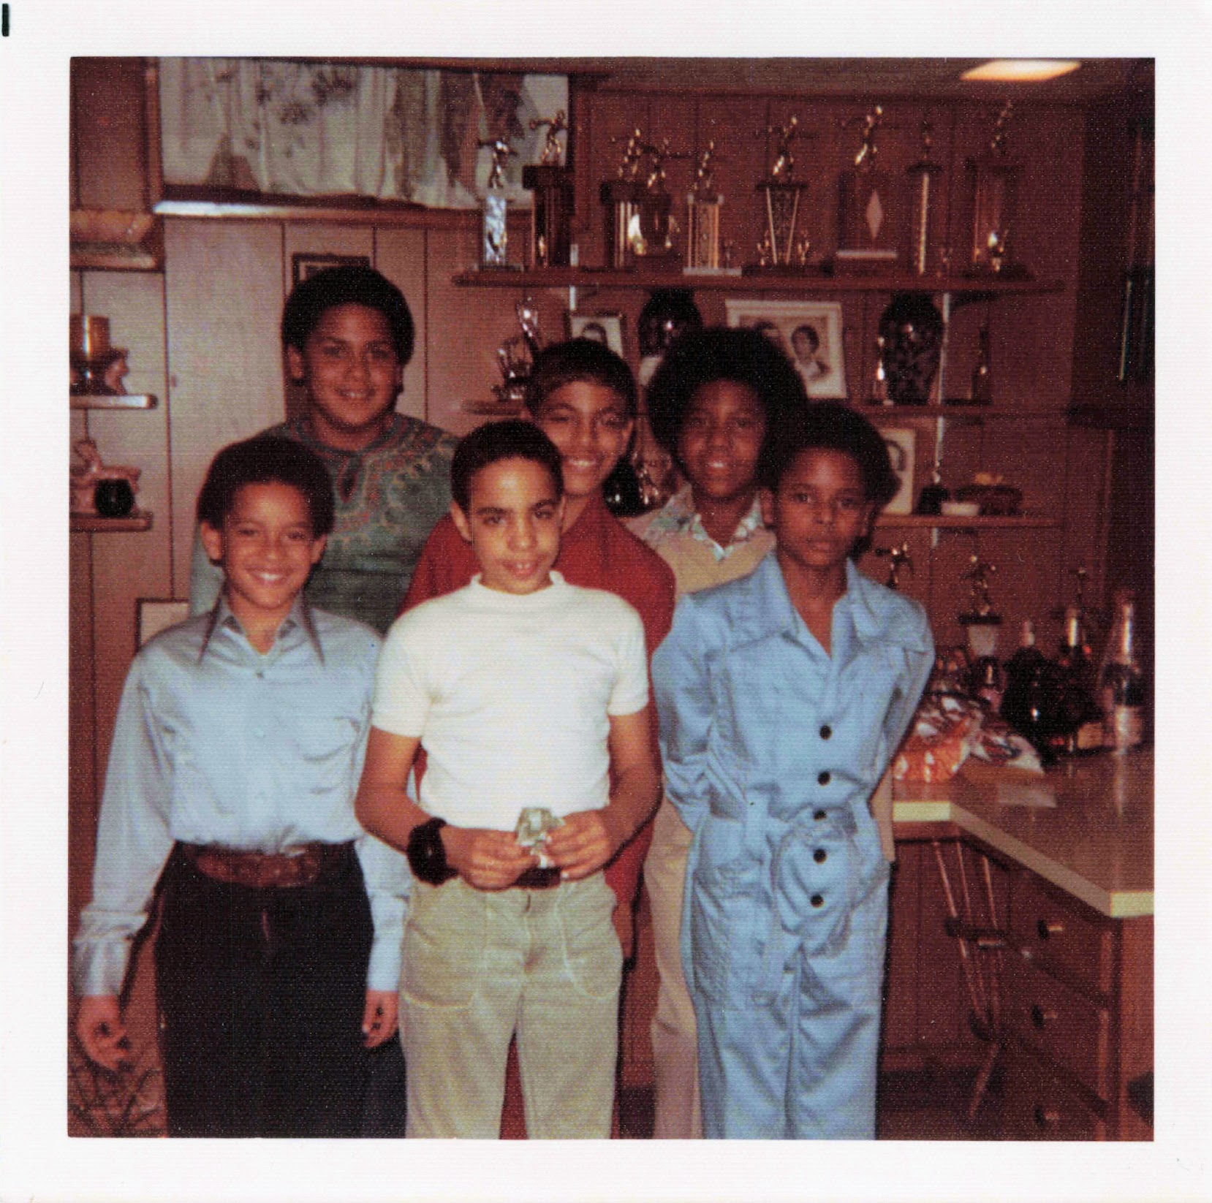  
Dave’s Birthday, November 1975  
Front Row: David Ragland (left), Dave Burns, unknown  
Back Row: Glenn Burch (left), Derrick Burns, unknown**

**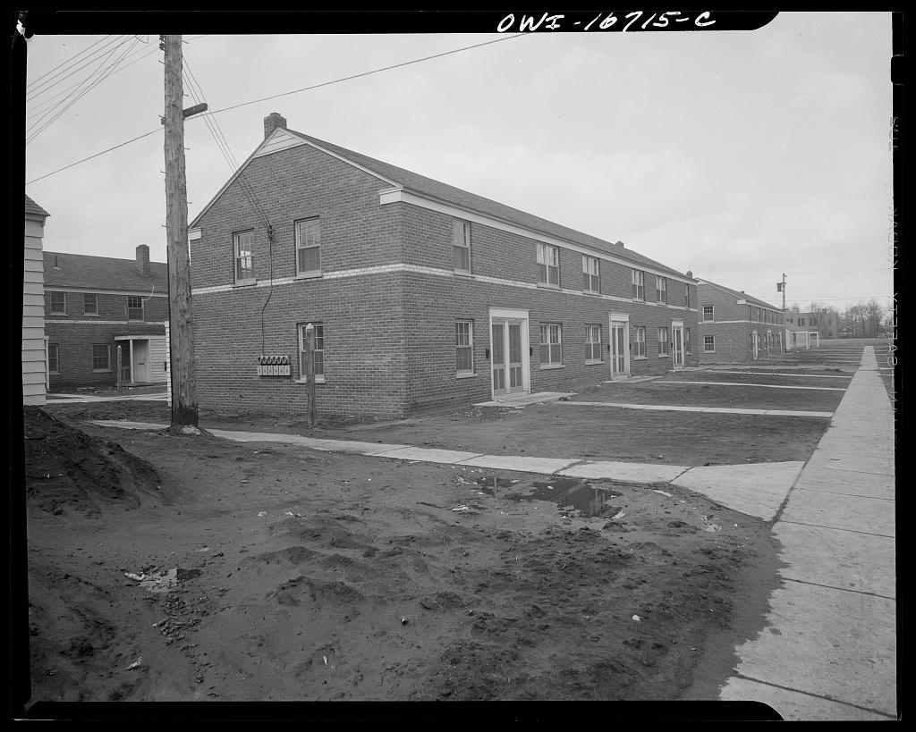  
Sojourner Truth Projects, 1942   
https://www.loc.gov/resource/fsa.8d13617/**

## Chapter 8: Finding My Voice

When the yellow bus turned east onto Seven Mile Road, we passed familiar landmarks that now felt different - Mac's Barber Shop where I got my haircut once a month, the Mount Elliott Post Office that Mom and Dad occasionally visited on weekends, Mound Road where Dad worked just a few miles north. Then we entered unfamiliar territory, crossing Sherwood Street past the familiar K-mart and turning left onto Rogge Street. Houses on Rogge looked similar to Mr. Harvell's house next door and Mrs. Dukes' house across the street, both two stories with large porches, older than ours, but with nice lawns like Mr. Allen's.

Law Middle School loomed ahead - three stories of red brick with wide concrete steps leading to heavy wooden doors with brass handles. As I stepped off the bus, that's when I saw them - white kids. Not just one or two, but dozens of them, streaming through those brass-handled doors. I recalled the talk about "the white boys coming" to Atkinson.

My footsteps echoed in the empty hallway, which smelled of floor wax and new textbooks. White kids clustered by their lockers, black kids found each other, and teachers watched carefully from doorways.

The white kids didn't really notice me. They were too busy with their own friend drama to care about me one way or another. At first, I thought they were ignoring me, but then I realized - for the first time in my life, I did not stand out. Nobody cared that my hair was straight, that my skin was light, or that I was adopted. I was anonymous, and that was just fine!

Miss Vigliotti looked like the pretty white women I saw on TV shows - the ones who played doctors' wives or teachers in those after-school specials. She had this really nice smile and always made me feel smart when I got the right answer. When she wrote 'Excellent work!' on my paper, I kept that assignment in my folder long after we'd moved on to new chapters. Sometimes I'd raise my hand even when I wasn't completely sure of the answer, just to see her smile when she called my name. When she announced that she would be taking a leave for a year, I felt like someone had punched me in the stomach. Math wasn't as fun after she left.

Then came the fine arts class in the auditorium. That year, girls suddenly seemed different. When the teacher paired us up for square dancing, my heart nearly stopped. Kim stood across from me, her strawberry blonde hair catching the light, blue eyes darting away when I looked at her. Her hands felt cool and dry against mine as we learned to dance. Every time we had to do-si-do or promenade, our hands would touch and my heart would beat really fast.

"Bow to your partner!" the teacher called over the scratchy country music. I counted under my breath, trying not to step on her feet, trying not to notice how she smelled like flowers, trying to ignore how my heart raced every time we touched.

After class, I gathered my courage in the hallway. Lockers slammed around us as kids rushed to their next class.

"Hey Kim..."

"Yeah?" She shifted her weight between feet.

"Can I have your number?"

"No!"

Her answer came quiet but firm, eyes fixed on the floor. I watched Kim hurry away down the hall, my stomach tight.

I kept replaying that "No" in my head during classes, wondering what it was about me she'd rejected so quickly. The worst part wasn't even the rejection - it was seeing her every day, pretending nothing had happened, while my stomach did flip-flops whenever she walked by. That "No" followed me to every class, making me question what else about me people might reject.

Then came Doctor James Allen Jones, my first black male teacher. Like my Dad, he always wore a sports coat and slacks to work. He was bald with a neat beard and mustache, and wore dark rectangular glasses. Doctor Jones commanded the classroom like Doctor Morton commanded the pulpit. Confident, certain of his role, adroit in his navigation of territory that he most certainly controlled: Shakespeare for one, the Bible for the other, each offering insights into human behavior, human morals, and human foibles.

Watching Doctor Jones move across that classroom, I realized I was witnessing something I'd seen before but never quite understood, the way certain Black men could own any space they entered, not by diminishing themselves but by fully inhabiting their authority. Doctor Morton had taught me that excellence could be spiritual; Doctor Jones was showing me it could be intellectual.

Maps covered the classroom walls - not just the usual pull-down kind, but detailed maps showing mountains, rivers, and cities from around the world. But Doctor Jones really came alive when he announced tryouts for the school play, performing lines from Macbeth:

*To-morrow, and to-morrow, and to-morrow, Creeps in this petty pace from day to day, To the last syllable of recorded time; And all our yesterdays have lighted fools The way to dusty death. Out, out, brief candle!*

His voice filled the classroom, making Shakespeare's words sound like music. Watching him command that room, I wanted his confidence, his swagger. I wanted to own my space the way he owned his.

When he announced tryouts for the school play, I signed up right away. I wasn't nervous about performing - I'd been an altar boy at church and had lead roles in several church youth performances, including a Tom Thumb wedding. The auditorium smelled like dust and old velvet curtains, with rows of empty seats stretching back into darkness. A single spotlight lit the stage where Doctor Jones stood, his voice echoing off the walls as he explained the audition process.

That's how I met Eugene. Eugene strode onto stage like he owned it. His deep voice filled the space as Shakespeare's words flowed naturally from him. I watched in awe. He was in seventh grade, a year ahead of me, and the only other black kid trying out.

We were the only two black people in the play, the only two black boys. Theater forces interaction in much the same way that square dancing in class does. The engagement is structured, choreographed. But there is room for interpretation, for expression. I was in awe of Eugene's presence. He spoke with such conviction.

After rehearsal one day, Eugene caught up with me. He didn't take my bus to school, so I asked him where he lived.

"Albany, just one street west of Mound Road," he said.

"Want to come over?" he asked.

"Yes," I answered excitedly.

Mom let me ride my 1970 Campus Green Schwinn Sting-Ray the one mile east on Stockton to his house, my longest trip ever. I rode quickly past the Sojourner Truth projects, past the park where Bernie had taught me to play chess, past Atkinson Elementary School where I had been teased and bullied. Anxiety turned into excitement as I reached the streets beyond Atkinson and turned right onto Albany to Eugene's house.

He introduced me to his mom and sister.

"You play chess?"

"Yeah, I'm pretty good," I said, thinking about my games with Bernie at the park, but quickly regretting my boast as I remembered losing the 10 and under division of the City of Detroit Chess Tournament the year before.

"Want to play?"

What had started as survival at Law, learning to speak up in integrated classrooms, was evolving into something I'd never expected: the desire to be heard, to lead, to create the very spaces where voices like mine could thrive. Doctor Jones had shown me that commanding attention wasn't about fitting in, it was about refusing to diminish yourself.

That weekend, funk music played softly in Eugene's family room while sunlight filtered through curtains. I had ridden my green bike the one mile east to his house on Albany Street. It was a small room, but comfortable. Through the doorway to the kitchen, I could see family photos attached with magnets on the refrigerator, and the smell of dinner cooking made my stomach growl. The chess pieces felt smooth and heavy as we set up the board on the table between us.

I thought I was good at chess until I played Eugene. Ten moves later, he knocked over my king with his queen.

"Checkmate!"

"One more game?"

"Want another ass whoopin'?" he laughed.

"Bring it" I said, bluffing a confidence that I did not have.

After my second loss, Eugene needled me "I thought you said you were good!"

"I have to go home. You won't be so lucky next time" I offered.

As I rode my bike home, I thought about the chess matches and I realized that I was smiling. Usually, I hated losing, but Eugene was different. He was smart like me but didn't try to hide it. He was cool too - the other kids respected him. And now he was my friend!

Eugene got the main part in the play - Caius Martius in "Coriolanus." I got the part of First Citizen. That meant I was just one of the people in the crowd, but I was determined to be the best crowd person ever.

Then one late afternoon, as the clock ticked toward dismissal and chalk dust floated in the air, Doctor Jones paused dramatically. "I will be taking a select group of students to perform Coriolanus in England this summer. Here is a flyer. Take it to your parents if you are interested. Rehearsals start next week."

The classroom erupted in excited whispers. England! I couldn't believe it. That was a place in books and movies, not somewhere real people like me actually went. When I asked my parents about it, I was sure they'd say no. It cost $700, and Mom had already said no when David Ragland invited me to go skiing with him for $100. But they surprised me and said yes!

But first, I needed a passport. David Knott's mom provided us with passport applications. David had a big part in the play. Mrs. Knott would join the trip as a chaperone. I would go alone.

We met at the Mount Elliott Post Office on Saturday with passport photo, completed application, birth certificate, and fee in hand. When I slid my birth certificate across the counter, the clerk frowned.

"This copy is dated over a year after your birth," he said loudly, like he wanted everyone to hear.

My face got hot. I leaned in close to whisper "I was adopted."

Everyone in line could hear, and they all started looking at me. I wanted to disappear. I stared at the date on my birth certificate, the numbers swimming before my eyes. Everyone else in line probably had normal birth certificates, ones that matched their birthdays exactly. My stomach churned as I wondered how many other papers in our house told different stories about who I was. Standing there, I realized how many everyday moments could suddenly become explanations about who I was and why my story was different.

The clerk said that he could not accept that document, and suggested that I return with my parents, but I could barely hear him over the rushing sound in my ears.

When I got home, I told Mom what happened. She just said calmly that she'd take care of it, but I could tell this was going to lead to conversations I wasn't sure I wanted to have.

Two weeks later, Mom handed me my new passport with a quiet smile that said she'd handled everything, just like she always did. The crisp blue booklet felt heavier than it should have, each page a promise of places I'd only seen in Doctor Jones's classroom maps.

"Thank you, Mom," I said, running my thumb across the gold embossed eagle on the cover.

Mom laid out my suitcase on the bed and proceeded to pack for me.

"Derrick, grab a belt and 4 pairs of pants from the closet," she ordered.

"After you brush your teeth tonight, place your toothbrush in this container and put it in this toiletry bag."

The plane engine hummed as we took off into the evening sky. Through my small oval window, I watched Detroit's lights spread out below - the Ambassador Bridge glowing like a string of pearls, Windsor fading into darkness until clouds swallowed everything. My stomach felt weird during takeoff, and I squeezed my eyes shut until we were in the air. This wasn't like the short trips I'd taken with Mom and Dad - I was crossing an ocean, and I was on my own.

I woke up to a gray Scottish dawn in Glasgow. Everything sounded different - even the airport announcements were in strange accents. The air smelled different too, like coal fires and something else I couldn't name. When the immigration officer stamped my passport, it felt real for the first time - I was actually in another country.

Everything here was backwards. Cars drove on the wrong side of the road. The British pound didn't weigh a pound, but was worth almost 2 US dollars. Even breakfast was weird - beans on toast? The train to the Lake District clicked and clacked along the tracks, while green hills rolled past the rain-streaked windows. Stone walls crisscrossed the fields like a giant's game of tic-tac-toe, and sheep dotted the hillsides like tiny cotton balls.

Our bed-and-breakfast was this old three-story house with creaky stairs and tiny rooms. But it had something amazing - a TV game called Pong! You could actually move the lines on the screen with these knobs and play tennis! I'd never seen anything like it. I played only once, saving my money for souvenirs to take back.

Mom had asked me to bring her something special. I didn't know what Wedgwood was, but Mrs. Knott said that she would take me to get some. "How about this one?" she pointed to a plate with an image of Benjamin Franklin in raised relief on it. "It's for America's two-hundredth birthday," the sales clerk explained. I counted my money carefully and bought two plates. The lady wrapped them up in so much paper, I was sure they wouldn't break.

Our first performance came too quickly, an open-air performance in the park, a warm-up to the "real" performance in a local children's hospital. With a smaller travel troupe than we had back home, I was assigned additional small roles. Now I was Citizens One, Two, and Three.

As we set up in the hospital cafeteria, I surveyed the room. The English kids came in, some in wheelchairs, some on crutches, and some pulling IV stands. For the first time, I was nervous. I didn't want to disappoint these kids. They weren't our parents who had to applaud. They were sick and needed something from us.

But then I heard my first line come out strong and clear, just like we'd practiced. No one coughed or shuffled or whispered. When I finished my last line, a nurse in the front row smiled and nodded, like I'd done something special. When we took our final bow, the applause thundered. Stoic but back erect, Doctor Jones thanked the crowd for their kind approval.

For the first time in my life, I felt like I'd given something meaningful to people who really needed it. This wasn't about grades or approval or fitting in - this was about using what I could do to make sick children forget their pain for an hour. The feeling was intoxicating.

But as the performance ended and we mingled with the audience, I spotted Eugene across the dining room, laughing with some kids from the play. When I waved, he just nodded and turned away. My chest felt tight. What happened to our chess games, our talks? The dining room suddenly felt too hot, too crowded.

Back home, Eugene and I would have been playing chess right about now, arguing about moves and laughing. But something had shifted during the trip. Maybe it was watching him command the stage as Coriolanus, or the way the other kids looked up to him. Maybe I reminded him of a version of himself he was trying to leave behind. Either way, he acted like those games never happened.

As the room closed in on me, I headed outside. The English evening was cool and damp, nothing like Detroit summers. As I walked away, Eugene held court.I felt small and left out, like the kid who always finished his work first but had no one to share it with.

When we arrived back at the bed-and-breakfast, I ran down the garden path, stone walls on either side and flower beds buzzing with bees, when suddenly - sharp, hot pain! Before I could stop myself, tears welled up. I ran to Mrs. Knott, pointing to the site of the sting, thankful that all the other kids were off playing elsewhere. I was eleven years old - too old to be seen crying over a stupid bee sting!

But it wasn't really about the bee sting. It was about Eugene, about feeling alone even when surrounded by people, about not knowing how to keep the friendships I thought I'd made. Was Eugene really my friend?

The flight home felt different than the trip over. I stared out the window as England disappeared below the clouds, then hours of ocean, then finally the familiar lights of Detroit spreading out like a circuit board. Everything looked smaller than I remembered.

When we got back to Detroit, I grabbed my suitcase out of the trunk.

"Got it Bolo?" Dad asked.

"Yes, I have it," as I tried hard to hide the strain in carrying the suitcase to the door and down the stairs straight to the washing machine. The paint on the side door seemed dirty and worn. The landing where I had pivoted to sit on the two stairs as I removed my shoes before entering the kitchen seemed smaller.

I stepped into my old bedroom and was instantly swept back by the wallpaper, an enchanting patchwork of antique ships, steam trains, and hot air balloons drifting among compass roses on a faded cream backdrop, like a boyhood atlas come to life, still charting the dreams I once had.

"Are you hungry, Derrick? Dinner will be ready soon."

"Yes, please."

"Oh, I want you to talk to Walter Booker on Sunday at Church. I talked to Pat. She says that Walter loves U of D High School on Seven Mile Road. The Jesuit Academy starts at seventh grade. You need to take a test to get in." Mom said, knowing that challenging me would pique my interest.

The rejection from Kim during the school year had hurt enough. Now Eugene, who I thought was different, who I thought was my friend, couldn't even be bothered to really look at me anymore. The thought of going back to Law in September made my stomach tight.

But Mom's words sparked something. A chance to leave Law behind? To escape all those memories of crying in empty hallways, of Kim's quick "No," of Eugene turning away like our friendship had never mattered? I wanted that more than anything.

"Tell me about it," I said, trying not to sound too eager.

During those months at Law and that transformative trip to England, I had learned something crucial: my voice mattered not because it sounded like everyone else's, but because it was uniquely mine. Doctor Jones had shown me that excellence could be intellectual and commanding. The sick children in that English hospital had shown me that what I could offer had real value. Even Eugene's rejection had taught me something important about friendship and loyalty.

I did not know anything about U of D. The name sounded impressive, "University of Detroit High School". I liked it. And it was on the other side of town. I would not know anyone there, except Walter, and perhaps that was a good thing!

The wallpaper in my bedroom still showed ships and trains and hot air balloons, but now they looked less like dreams and more like destinations. I was ready to see where they might take me.

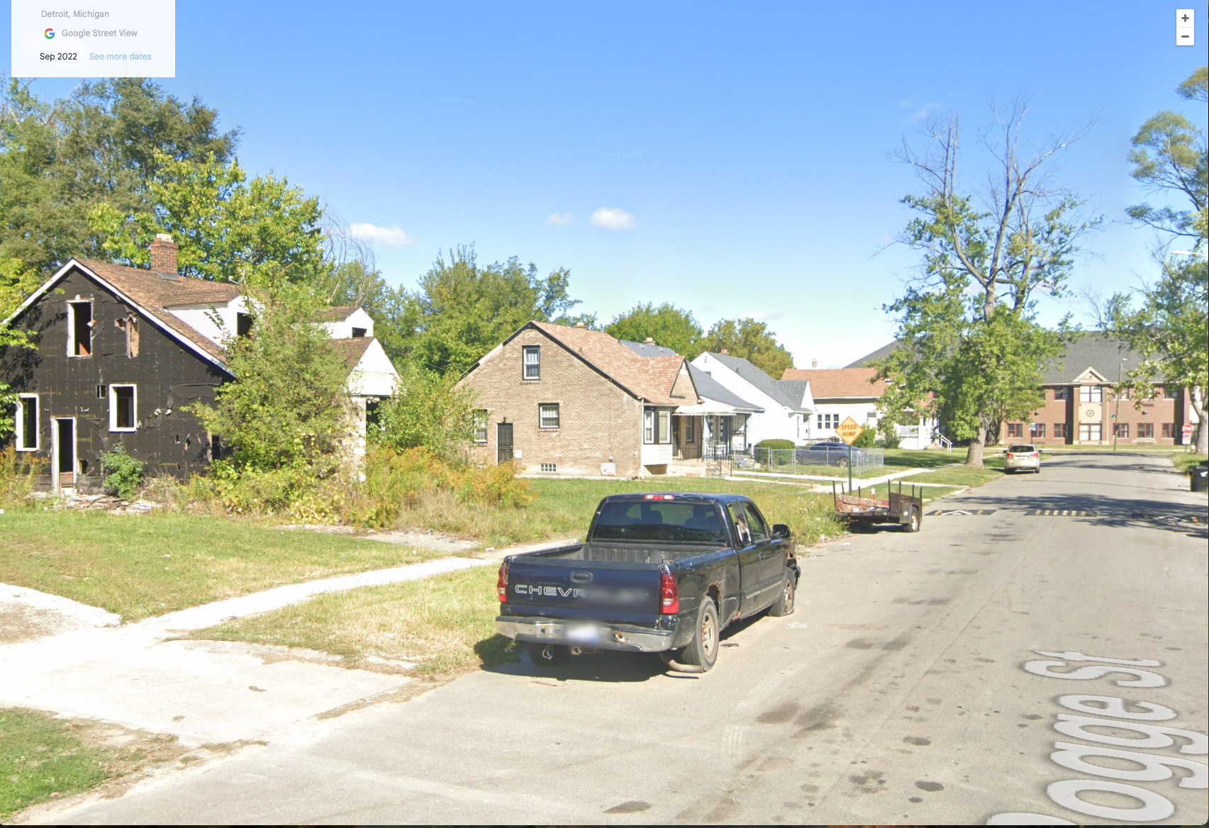

**Law Middle School (now Marion Law Academy) at the end of Rogge Street, c 2022**

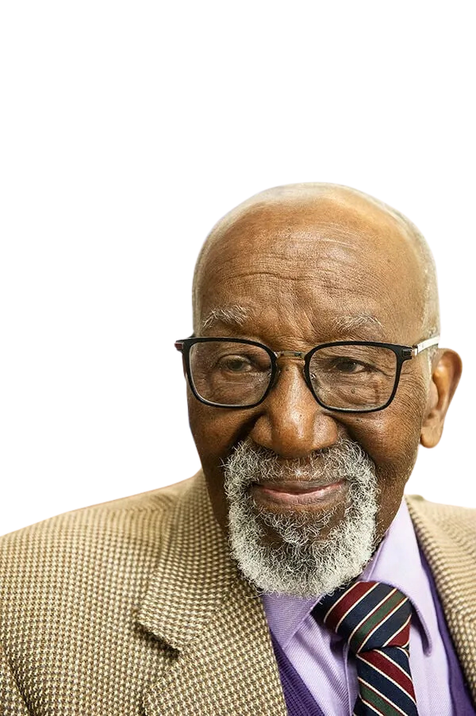

**Doctor James Allen Jones, c. Feb 2020**

# 

## Chapter 9: The Power of Belonging

I felt a mix of nerves and excitement about my first day at the University of Detroit High School Jesuit Academy, U of D High, or just The High, as people called it.

Mom dropped me off on her way to work at McDowell Elementary, just a mile past U of D. It took her exactly 25 minutes to get me to school. The first bell rang at 8:20 AM, and we had ten minutes to put our coats in our lockers and find our first-period class.

As I walked into the building, the first thing I noticed was an office to the right. A sign read, Dean of Students. I peeked in, curious.

"Hello! What's your name?" asked the woman behind the counter.

Her smile made me feel a little less nervous.

"I'm Derrick Burns," I said, trying to sound confident. "A new 7th grader."

"Welcome, Derrick! I'm Mrs. Voss. Do you have your class schedule?"

"Yes, ma'am," I replied, handing over the neatly folded paper. It listed my classes: Reading, Math 7, English 7, Art, Gym, Social Studies, and Theology 7.

"Alright. Do you know where your first class is?"

"No, ma'am," I admitted.

"Go up the stairs past the library. At the top, turn left."

Walter was the one who told me about U of D. His mom and mine are friends from church. Walter's an altar boy like me, but he's a year older. He told me that U of D was great, most of the kids are smart, and no one bothers him. That stuck with me. I didn't really know any Catholics, though.

Mom calls it the "Jez-u-white Academy," which always makes me want to laugh, but I never do!

Most of the kids I knew were Baptist, like me. Gerri, short for Geraldine, is five years older than me and used to babysit me when I was younger. She lives two doors down, and her family is Pentecostal. Her dad, Elder Ellerbee, is the pastor of their storefront church, some people call them the "Holy Rollers."

The U of D High Jesuit Academy is really just a fancy name for seventh and eighth grade. I'm in homeroom 7A with Jimmy Latham, Jimmy Wardell, and Ron Levi and about 20 other guys. Over half the guys are black.

I recognized Karl, Jerome, and Alan from the YMCA swimming class that Mom enrolled me in this summer. Alan lives on Pennington just a few blocks away from U of D. Most live nearby, but some of the white kids take school buses in from the suburbs. A lot of the kids went to 6th grade together at Gesu. Apparently, Gesu is also the name of their church. I didn't know that some churches run schools.

When I walked into theology class, I remembered the church ceremony we had to attend at the start of the year, called Mass. Everyone said together:

"In the name of the Father, and of the Son…"

Afterward they made weird hand motions. I just stood there, confused. I recognized the Holy Trinity, but the hand signs were totally new to me. We didn't do anything like that at Metropolitan.

"Who's heard of Buddhism or Hinduism?" our teacher asked. A few kids raised their hands.

"We'll be studying those, along with Animism, Zoroastrianism, Islam, Paganism, Taoism, and Christianity," he said.

I wondered what those other religions were like.

Our theology teacher is a Jesuit priest or brother, I'm not sure what the difference is. They all wear the same black shirt with a little white collar that looks like a flat tie but not really. The Jesuits live in a building attached to the school by a long breezeway. Weird. I wondered if their families lived there too, but someone explained they couldn't marry or have kids. That seemed so strange to me. Doctor Morton, my pastor, is married and has two grown daughters. Why couldn't priests marry?

After theology, I went to math class. I was glad for something familiar but still excited to learn new stuff. Math homework was usually easy, and I used to finish it on the bus home. But now, we were doing math I didn't already understand.

Our teacher, Mr. Zybrad (pronounced "zee-bard"), isn't a priest and isn't married either. I'm not sure what to make of him yet, but when he smiles, his eyes nearly close, like a cat. He's the coolest teacher, always cracking jokes while teaching at the same time.

"Mr. Burns!" he called out, tossing a piece of chalk at me.

But before he could ask me a question, he noticed some kids whispering.

"What's so interesting?" he asked.

"Paul bet on the Cowboys and won't pay up," someone said.

This weekend was the Super Bowl, and for some reason, everyone was betting. I'm not a big sports fan, but I wanted to fit in, so I made a bunch of bets. I thought I was being smart, I bet on the Steelers with some guys and on the Cowboys with others, figuring I wouldn't lose any money no matter who won. Genius, right?

Well, the Steelers won. I paid off the kids I lost to, but when I tried to collect from the kids who owed me, they refused to pay! It was a disaster.

Luckily, Mr. Zybrad came to the rescue. He knew a lot of kids had made bets and that some weren't paying up. He made everyone settle their debts right there in the classroom. I got my money back, but the other kids looked at me like I was from another planet. No one could understand why I'd bet both ways!

### Getting Cut

As spring came, Mom noticed my body odor after P.E. "Wear deodorant or take the bus," she said. I forgot the next day, so I started taking the bus. Detroit winters made those bus rides miserable - waiting in the cold for transfers, the plastic seats like ice through my pants. But at least Harry, an upperclassman from U of D, was usually on the back of the bus where it was warmer.

Around the same time, I decided to try out for baseball and track. I played every weekend in the park and thought I could throw and hit a baseball pretty well. But at tryouts, I was shocked to discover that most of the other kids had already been on teams - Little League, Catholic Youth Organization, all kinds of organized sports I'd never heard of. They knew things about the games that I didn't even know I was supposed to know.

When the lists went up, my name wasn't on either one. I'd been cut from both teams. Walking home that day, I felt embarrassed and confused. How was I supposed to know about all those other teams? Nobody had ever told me.

Jimmy defended me when I told him about the betting disaster. "That was actually smart, D," he said, though his grin suggested he found something amusing about the whole situation. "You just didn't count on people being dishonest."

I started spending more time with Jimmy. He mostly spared me from being the target of his teasing, and he always made me laugh. When we had to part at the end of the day, I always felt a bit sad, like I was leaving behind something important.

### Finding My Place

By lunch, our group had settled into a routine. Our lunch room featured long tables and bench seating that unfolded from the walls. Mom sent me a bag lunch, so I just needed to purchase my small carton of chocolate milk and on those days that I could sneak a few coins from Mom's purse, I'd buy an apple turnover from the vending machine for dessert.

When it was too cold to go outside, we'd head to the Commons - a big room across from the cafeteria that used to be the gym. The room has an overhead oval-shaped running track, and on the main floor are square tables with steel chairs.

Jimmy was always making people laugh. Some kids teased him about his front teeth sticking out, but if he cared, he hid it. There was something familiar about Jimmy's laugh, something that made me feel at home even though I'd just met him. Maybe it was the way he could turn any situation into a joke, or how he seemed to understand exactly when to pull back from teasing me.

Jimmy and I would scan the large room for an empty table. I spotted Walter, Harry, and a bunch of other black kids there too, from all six grades. Everyone seemed to get along, but I couldn't help noticing that, just like at Law Middle School, the white kids mostly stuck together, separate from the black kids.

We usually joined James Wardell, who we all called "Wardell." Jimmy would make jokes about my clothes. He reminded me of the funny guys from my neighborhood. When I tried to be funny like them, no one laughed. Wardell seemed to know better. He never made fun of anyone.

Wardell knew a number of our classmates from Chrysler Elementary in Lafayette Park, east of downtown, including some of the white kids, but the majority came from Gesu Elementary. Walter was the only kid I knew.

### A World of My Own

While Jimmy found his element making people laugh and I was learning to navigate the social dynamics of U of D, I discovered something else that captured my imagination completely: computers.

It started with BYTE Magazine. Mom had been supporting my reading habit since elementary school, and by seventh grade, my magazine subscriptions had evolved from Highlights to more sophisticated reads like Psychology Today and Chess Life. But nothing fascinated me quite like those glossy photos of the new Radio Shack TRS-80 computer. The machine looked like our small black and white TV, but with a thick detached keyboard.

"Dad, can we get a TRS-80?"

"A what?" He'd look up briefly from his newspaper, his face carrying that patient expression I knew so well.

"A computer, Dad. Look at this." I'd hold out the magazine, trying to make him see what I saw - not just a machine, but a future.

"What are you going to use that for?"

"I don't know. Write programs!" The words came out eager but vague. I couldn't articulate why this mattered so much, why this machine felt like a key to something important.

"For my birthday Dad? Please????" I pleaded.

"We'll see," he offered in the same voice that he used when I asked to play board games when he was reading the paper.

But I happily heard in my mind a definitive "Yes." So when my birthday came and went, no TRS-80 appeared. I sulked, not understanding then that the $600-$1000 cost of my dream machine represented several weeks of Dad's take-home pay from TACOM.

The computer remained an impossible dream, but the magazines kept coming. Each issue of BYTE was like a window into another world - one where people spoke in languages of BASIC and FORTRAN, where problems could be solved with elegant lines of code.

My real introduction to computing happened in a tiny room across from the cafeteria at U of D. The space itself was unremarkable, maybe five by five feet, with institutional beige walls and the lingering funk that only teenage boys can create. But to me, it was an amusement park.

At its heart sat a TTY-33 Teletype terminal, connected via a modem to a computer at the University of Detroit on McNichols. The machine's mechanical chattering filled the room like music, each keystroke a percussion note, each linefeed a drumroll.

After school and during lunch, while other kids headed off to sports, clubs, or hung out in the Commons, I'd slip into that room and wait for my turn to play the Star Trek game, written in 1971.

"Scan the battlefield!" "Fire a torpedo!" "Enter warp speed!"

I'd shout at whoever was playing, caught up in the action, until it was finally my turn to take the captain's chair. But it wasn't just about playing, it was about understanding.

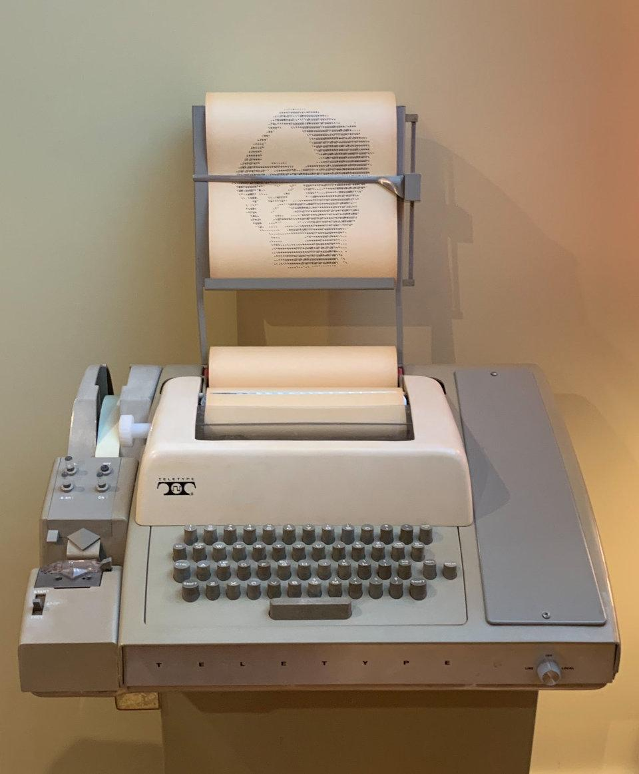  
**TTY-33 Terminal**

I'd carefully print sections of the program onto endless rolls of yellow paper, the text crawling out at a glacial 110 baud, half the speed of an average human reader. Each printout was a treasure, a manuscript of mysteries.

Later, at home, I'd unroll one across the den floor, scanning the lines of code like an archaeologist deciphering an ancient script:

10 REM STAR TREK - MIKE MAYFIELD, CENTERLINE ENGINEERING  
20 FOR I=1 TO 8:FOR J=1 TO 8:K[I,J]=0:NEXT J:NEXT I  
30 DIM G[8,8],C[9,2],K[8,8],N[3],Z[8,8]

Who was this Mike Mayfield? And how did he make a computer, this cold, mechanical thing, create entire universes?

The variables danced before my eyes, G for galaxy, K for Klingons, Z for starbases. Line by line, I traced the code, piecing together how it shaped the gameplay. When I finally got my hands on the slow terminal again, I'd experiment, tweaking a few lines just to see what would happen. Like a painter adding a brushstroke, I leaned back, admiring the changes I had set in motion.

When I played the game, I was an armed starship commander seeking out my Klingon prey. As I navigated the unknown universe of the game, I felt a freedom that I had never experienced before. In that computer room, alone with the mechanical sounds and glowing screen, I was safe. I didn't have to contend with anyone else's emotions. I had no one to impress or disappoint. The random events in the game were so much easier to navigate than the apparently random swings of friendship and social dynamics. With no one to judge me, and nothing to fear, I could be at peace. I could be me.

While other kids threw their attention to sports, art, and social hierarchies, I threw mine into the pursuit of knowledge in this incredibly new world of computing. I didn't mind the solitary nature. In fact, I relished it! The computer didn't care about my need to prove myself. It responded only to logic, to precision, to getting things right. Maybe that's why I loved it so much. I knew and understood all the rules.

Mr. Christopher Buryta, our math teacher, noticed my constant presence in the computer room. When he told me about the Mathematics Club at Lawrence Institute of Technology, Dad agreed to drive me to their monthly Saturday morning meetings. The club featured lectures and programming competitions, including a monthly battleship game where we had to write programs to play like humans.

Just as he drove me to countless other activities, Dad would drive me to the data entry room with keypunch machines. He supplied me with stacks of blank cream-colored cards and coding paper that he got from work. I wonder who he petitioned for these things. The cards would stack up, each one representing a line of code. One mistake meant starting over - no quick backspace key, no easy fixes.

Dad waited patiently during these competitions, probably reading his newspaper or dozing in the car. He never complained about the long hours, never asked why this mattered so much.

"How'd it go?" "Did you win?"

And he would listen patiently as I relayed the scoring of each round.

"Ready to head home?"

"Yes. Thanks Dad," I hope that I said it each time!

Dad couldn't help me with the actual programming - this was as foreign to him as his world of darkroom chemicals was to me. But like those long hours we spent in cars, we both understood the comfort of focused solitude. He could provide the space for me to chase whatever this dream was, just as he'd provided the space for me to find my voice.

I never did beat the same two Asian-American students who always seemed to win. But in that cold computer room, punching cards and chasing victories, I was learning lessons that went beyond programming syntax: about persistence, about the difference between winning and succeeding, and about finding a place where I could be completely myself.

### Summers Change

After getting cut from both baseball and basketball teams, I threw myself into reading. At least with books, no one could cut you from the team. And unlike sports, reading came naturally to me. Walter had warned me that we'd be reading a lot more at U of D, and he wasn't kidding! I hadn't read this many books before, but I was starting to enjoy it. My favorite so far was George Orwell's Animal Farm.

Mr. Bankston gave us a summer reading list, and I was excited. We could earn credit for reading any book on the list, or even other books, as long as we passed a test on the content in September.

The last day of seventh grade felt like it would never end. Still, my mind was already on summer: swimming at the Y, playing in the park, and wondering where we'd go on vacation.

Gerri challenged me to read Jaws, and I finished it in just a few days. I had committed to read Great Expectations for school credit, thinking of all the points I would earn for such a thick book. We got one point for each page, but I got bored halfway through and never finished it.

That summer, like always, I spent Sundays at church. By this time, I was almost too old for Primary Church. Sometimes, I'd sit with Mom in the main sanctuary. The moment Pastor Morton said, "Amen," I'd already be looking at Mom, ready to bolt.

"Mom, can I go now?"

"Yes, Derrick," she'd say, waving me off.

The basement always smelled like coffee and whatever Deacon Modest was cooking. Through the kitchen pass-through, I'd see him in his giant white chef's hat, sweat dripping down his face.

"Hello, Mr. Modest! What are you making?"

"Hey, Derrick! Tonight, we're having meatloaf, cornbread, collard greens, candied yams, and black-eyed peas."

I'd gulp down as much red punch as I could while walking around with my biggest Sunday smile, being polite to all the church ladies just like Mom taught me.

"Mom, can I go to the library?"

"Yes, but be back in 30 minutes," she replied.

I climbed the three flights of stairs to the Youth Library, a small room with eight free-standing metal paperback racks. Ever since the books were donated, I'd spent every Sunday exploring the shelves. I'd already read The Hobbit and found the entire Narnia series.

Doctor Morton's office was on the way back. "Derrick! Come in, come in," he said warmly. When I showed him the Narnia books, he smiled like he was letting me in on a special secret. "Add those to your personal collection. Take them. I'm sure you'll make great use of them."

When I got home, the books felt like a treasure. For the first time, I felt like I was building something that was just mine.

On the last day of school, Jimmy caught up with me after the final bell.

"What are you doing this summer, D?"

"We usually go on vacation in August, and I'll probably do swim lessons again," I said.

"We should hang out! Come by my house in Oak Park."

"Where's Oak Park?" I asked. I didn't know much about the Detroit suburbs, except for Warren, where Dad worked.

"Near the zoo!" Jimmy laughed. "Come on over!"

"I'll ask my dad to bring me."

### The Discovery

Jimmy's mom looked old like my mom and his dad had died. Except for David Ragland, I didn't know of any other kids without two parents at home.

"My parents are old too. Actually, I was adopted," I said.

Jimmy stopped what he was doing and looked directly at me.

"Really?! So was I!"

I couldn't believe it. In all my years, I'd never met another adopted kid my age.

"No way! Have you always known?" I asked.

"Uh huh."

"What about your sister?"

"She was adopted, too."

And then Jimmy fell silent, something I had rarely seen at school. Jimmy told me that his mom is a social worker. I shared that my mom is a teacher.

"Levi is adopted too," he offered.

"What?!" I couldn't believe Ron Levi too? Three of us?

"What do you know about your adoption?" I asked.

"Not much, except that I was born at Crittenton Hospital. Levi too," he answered.

Now it was my turn to be silent.

"What is your birthdate?"

And then I did the math in my head. Jimmy and I had been in the same hospital at the same time!

For the first time in my life, I wasn't the only one. Dave was my brother and adopted too, but he'd come to our family when he was four - he remembered his life before. Jimmy was different. He was my age, smart like me, and adopted at birth from the same hospital. He'd always known he was adopted, just like me. There was someone else exactly like me! Someone who understood what it meant to be chosen by your family instead of just born into it. Someone who wondered about the same things I couldn't even put into words.

I saved the news for when I got home.

"Jimmy was adopted and was born at Crittenton too," I announced!

"Really?!" Mom said.

She had talked to Mrs. Latham before my visit to make sure that it was ok for me to come. I don't know if they talked about adoption, but Mom didn't seem very surprised.

"Yes, and he says that another classmate was too!" I said.

"A lot of unwed mothers went to Crittenton to deliver their baby before giving the baby up for adoption," she told me.

Crittenton Hospital stood as a landmark on East Grand Boulevard, its brick walls holding countless secrets. I wondered how many other stories like mine, Jimmy's, and Levi's started there.

"Can we go by there again?"

Dad had driven us by there before. It was along the same route that we would take downtown to the Auto Show at Cobo Hall or the fireworks on the river. Mom would always point the building out.

"I think the hospital is closed, but we can drive by," Dad said.

On the drive to Crittenton, I thought about what Jimmy had told me. Three boys from the same small school, all born in the same hospital, all adopted. As we pulled up to the building, I stared at those brick walls differently now.

This was where our stories had started - not because of who our birth parents were, but because we'd all been babies who needed families to choose us.

I thought about how much I liked to be around Jimmy. He mostly spared me from being the target of his teasing. He always made me laugh. And I always felt a bit sad when we parted.

And as I took in the news, it hit me. U of D had already started to feel like home, but now it was different. In Jimmy, I'd found more than just a friend or classmate - I'd found a brother. We shared more than just a birth hospital or adoption stories; we shared an understanding that went deeper than blood.

Sometimes family finds you in the most unexpected places.

### Brother Jimmy

Jimmy was now Brother Jimmy.

I couldn't wait to tell Dave about Jimmy. Having one brother had changed my life; now I had two.

That summer, everything changed. What I'd been looking for without knowing it had been right there at U of D all along - not just a school, but a brother. Dave had shown me what having a brother meant, but Jimmy showed me that sometimes the family you're meant to have finds you. As I looked at the old hospital building, I realized that some beginnings take years to understand.

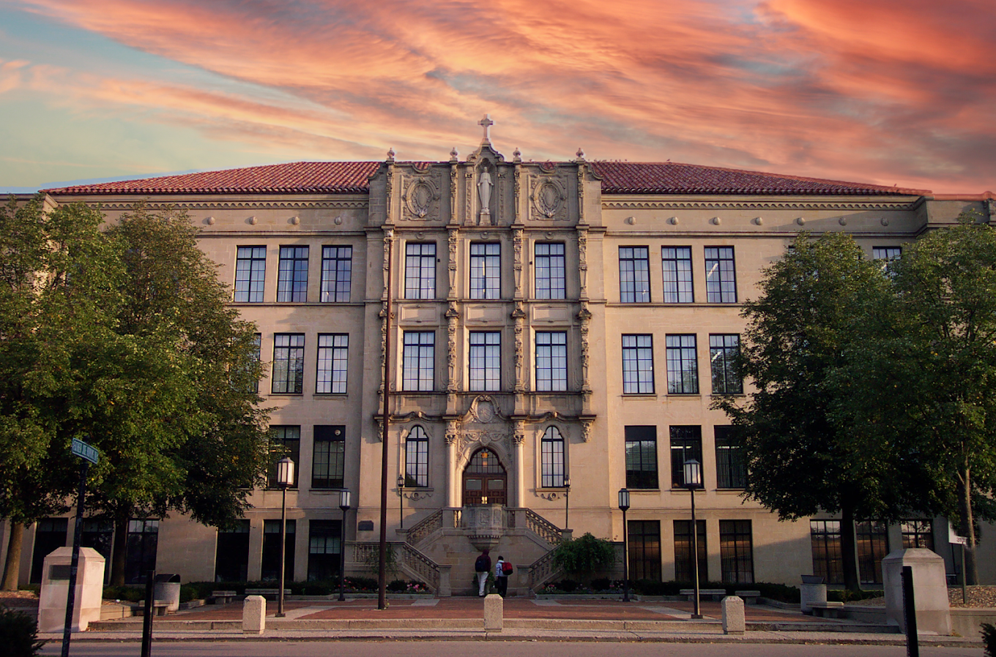  
**University of Detroit Jesuit High School main building, c. 2022**

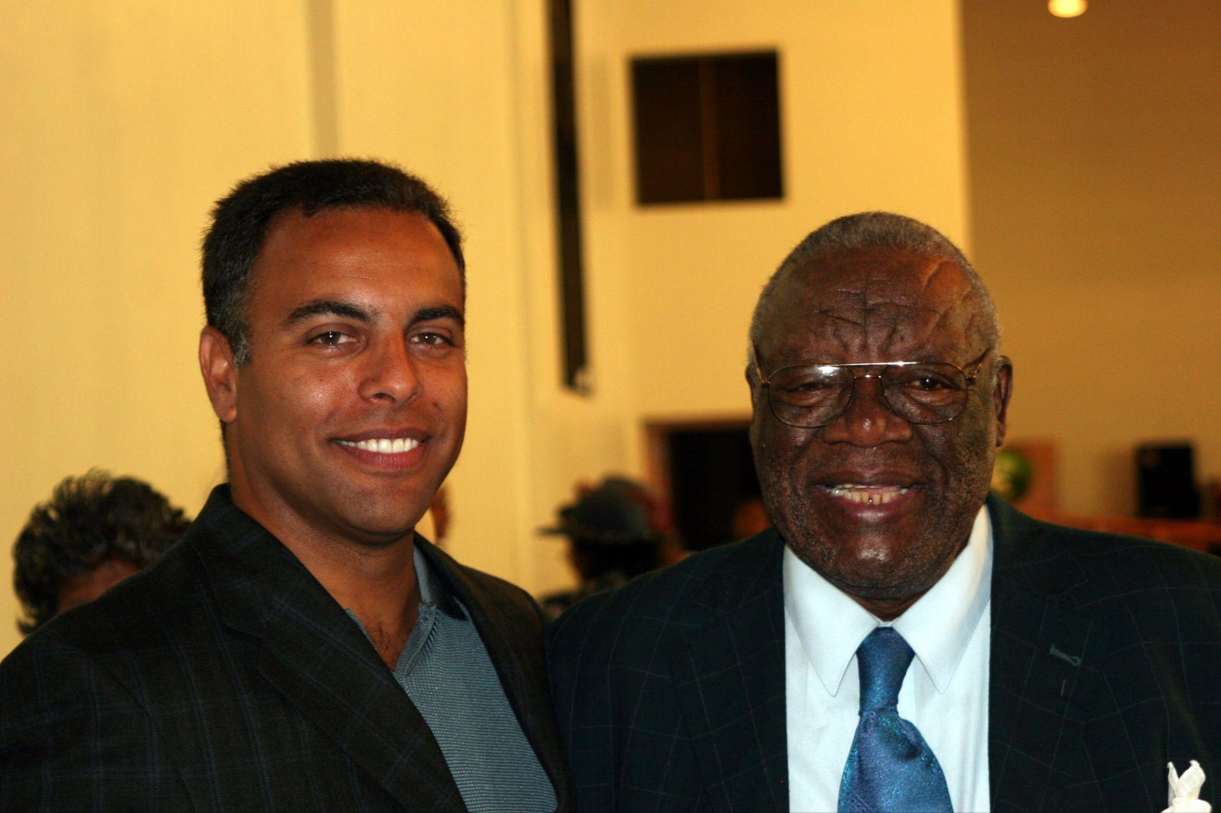

**Derrick and Doctor Charles E. Morton, c. 1995**

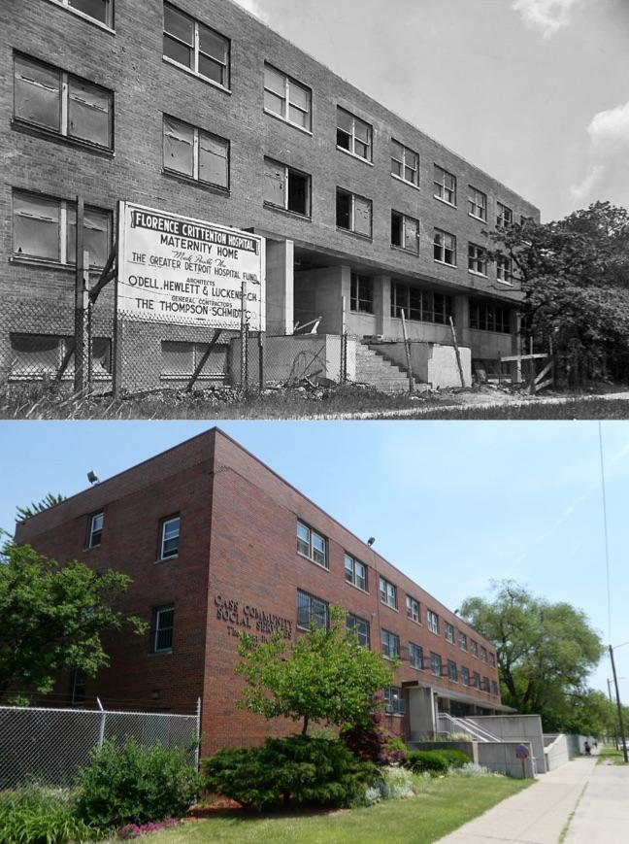

**Crittenton Maternity Home on Woodrow Wilson , c 1970  
Now is Cass Community Social Services.**

## 

## Chapter 10: Performing Identity

### A Winter's Bluff

*What year are we in?*Snow crunched under my boots as Bill and I crossed the Northwest Rec Center parking lot. The bass from inside thumped against the cold air, Kool & the Gang competing with the wind. We were far from my northeast side neighborhood - the rec center sat on the west side of Detroit, but word was the party would be worth the drive.

"Look who's in that Land Rover," Bill muttered, nodding toward the idling vehicle.

Through the open passenger window, I spotted Leslie - Leslie who was halfway through her junior year at Princeton, where I was finishing my first semester. I'd seen her at plenty of parties before, but those were always word-of-mouth affairs in private homes, church basements, or rented halls. Northwest Rec was just a public recreation center, open to anyone who showed up. Two young men stood by the passenger door, leaning into the conversation.

"Derrick. Bill." Leslie's voice was quiet, controlled.

"These are our boyfriends."

One of the men stepped back from the window.

"Uh huh. I see what's happening," he muttered, cursing under his breath.

His friend followed his lead, both of them backing away into the darkness.

We made small talk about the holidays, about Princeton, about Yale - all of us performing normalcy while the muffled sounds of "Celebration" leaked from the rec center's walls. Finally, I made our exit:

"Well, if you're not coming in, we'll catch you later."

But halfway to Mom's lime green 1978 Bonneville Brougham, I caught movement in my peripheral vision. The two men had returned with reinforcements - five or six more figures emerging from the shadows of the parking lot. The math changed instantly. No way to reach the car in time.

I unzipped my leather jacket with deliberate precision, making a show of reaching into my vest pocket. The gesture needed to look natural. They couldn't know I was bluffing.

It worked. They scattered into the darkness as quickly as they'd appeared. Bill and I made it to the car, drove away with the windows down despite the cold, letting the winter air blast through. My pulse pounded so hard it hurt my neck.

We didn't speak during the drive home. The cold air whipping through the windows helped clear my head, but questions kept spinning: Why were Leslie and Lynn really there? What would have happened if those guys hadn't bought my bluff? What if they'd called it?

Back home, I lay in bed staring at my ceiling, too wired to sleep. The adrenaline had faded, leaving me exhausted but restless. I'd pulled it off - played the role those guys needed to see to leave me alone. But man, pretending to be tough was draining. One wrong move, one slip in the performance, and disaster!

The whole scene felt surreal now. Leslie and Lynn, Ivy League students home for break, mixed up with guys at Northwest Rec. Me, three months into Princeton, still having to navigate Detroit's unwritten rules. All of us wore different masks depending on where we were, who we were with, what was needed to stay safe.

The Northwest Rec scene could have played out differently. But by that winter night in '81, I'd had years of practice reading situations, knowing which version of myself to present. It hadn't always been so smooth.

### Learning the Roles

This wasn't always so smooth. Learning to read situations and present the right version of myself took practice, and high school was where I perfected the skill.

About ninety new students entered U of D's freshman class. Many came from the suburbs on school buses, bringing their own unwritten rules and expectations.

The school sorted some kids into an honors program, including Tim Devine and William Doss, Wardell's grade school friend from Lafayette Park. I wanted to be with them and the other smart kids, but Mom said I should stay where I was since I'd already skipped a grade.

I made friends with several of the new white kids. Tom Doyle seemed really smart. Tim Devine seemed very nice, with older brothers already at The High. His mom led the Mother's Club. I heard Jerry Cahalan's dad was a Wayne County Prosecutor.

Then I met a couple of guys who had noses and hair like mine. They were Chaldean. The other kids called them A-Rabs, and soon I was hearing that too. I'd seen adults who looked like them at the grocery store on Conant and 7 Mile Road.

We didn't have much choice with history. It was required, and I hated it almost as much as social studies in 7th and 8th grade. I found memorizing dates boring, so I waited until the day before the exam to commit them to short term memory. Two days later, those memories were gone! Why does it matter that the Civil War was fought between 1862 and 1865?

By contrast, I loved my English classes. In the academy we'd focused on grammar and rules, but now we did a lot more reading and writing. With writing, I could argue my point without interruption. No heckling. No shouting.

I was learning to read the different groups and their unspoken rules. The suburban kids seemed to understand things about social positioning that the city kids took for granted. There were expectations about dress, about language, about family background that I was just beginning to notice. Each group had its own way of establishing who belonged and who didn't.

The success of seventh and eighth grade had proven that I could handle the academics. I could win debates, I could analyze problems that stumped other kids. That intellectual confidence felt solid, unshakeable. When someone challenged me on facts or logic, I never backed down because I trusted my mind. I had no problem admitting when I was wrong intellectually, that was just data, just learning. Intellectual battles felt safe because I knew my weapons worked.

When conversations turned to parties or hero worship of athletes and bullies, I felt disgusted more than threatened. The faux toughness was the same gang-like behavior I'd seen in second grade, teasing, bullying, cliquishness. It was all abhorrent to me. Some boys seemed to only feel confident when they expressed dominance, and I resented that whole dynamic. But with girls, it was different, I felt completely comfortable, safe even. More than safe. From my experiences with Mary and my sister-cousins, I'd learned how to be vulnerable with girls, how to just be myself. Around them, I felt like I was floating in salt water on a warm sunny day, relaxed, soothed, completely at ease.

It was with those dominance-seeking boys that I retreated to higher ground. "What you think doesn't matter because I am intellectually superior," became my silent mantra. I'd steer conversations back to academics, politics, anything where I could regain control. My real intellectual gifts became shields against the vulnerability of genuine social connection.

Jimmy showed me a different way. His weapon was humor, sharp, biting critiques of others and himself that could cut through any tension. But unlike my intellectual retreat, Jimmy stayed in the social arena. He wanted people to laugh, wanted to secure the floor, and when he couldn't get the audience's attention, he just stayed quiet. No antagonism, no retreat to some claim of superiority. He didn't seem afraid of what people thought, as long as they were willing to let him entertain them.

I told myself I didn't need other boys' approval, mainly because I was afraid of rejection. The only friends I made were those who weren't playing the mainstream approval game, the gentle, soft-spoken boys who had found their own quiet strength, the closeted gay boys who had their own reasons for staying outside the system, and Jimmy, whose boisterous authenticity cut through all the performance. These boys had discovered ways to be themselves without seeking external validation, and I admired that courage even as I hid behind my intellectual armor.

I could win any debate, but I was learning that being right wasn't the same as being connected. And every space still required a different version of myself, it was just that my default version was becoming the smartest guy in the room, whether that's what the situation called for or not.

When Jimmy was struggling with Mr. Baugh's English class, I went over to his house to help him write an essay.

"Come on in D, let's go in the basement," Jimmy said, as I entered his house on Renfrew.

"Ok, let me see what you have written," I said.

As I read the essay, I could see a few differences between his approach and mine.

"D, just tell me what to do," Jimmy surrendered.

So we spent the next two hours rewriting. I told Jimmy there must be a logic to the argument. Each sentence is like a step along a path. When we finished, the essay was as good as any that I would write.

When Jimmy received a "D", he was crushed and I was mystified. That essay would have gotten me an "A". I know it.

Jimmy's mom went to the school to meet with the principal. I don't know what she said, but Mr. Baugh was gone after the next semester.

The incident taught me something important about the unwritten rules of academic performance. I understood what teachers wanted to see, how to structure arguments, how to present ideas in ways that earned grades. Jimmy was just as smart as me, but he hadn't learned to read the system the same way. It wasn't about intelligence, it was about knowing the performance they expected.

### Social Performances

Jimmy told me about a party Saturday night at Plymouth Church. A party at a church? I'd been to plenty of roller skating parties sponsored by Corinthian, but those were family events for all ages. This was different.

"Everybody is going to be there, D," Jimmy said.

I wore my best clothes, polyester brown pants, yellow v-neck polyester sweater, and brown dress shoes. But walking into that church basement stopped me cold. This wasn't just some basic room with folding chairs and punch. There were decorations everywhere, a DJ spinning records through massive speakers, light bouncing off a disco ball. The setup was as sophisticated as anything I'd seen.

What struck me most were the girls. I met girls from Mercy, our sister high school in Farmington Hills, some from Cass Tech, and a few from Renaissance. One of them told me she was going to be in the Cotillion. Jimmy explained that it was a Debutante Ball, whatever that was. These weren't the working-class girls I'd grown up around, daughters of teachers, postal workers, factory workers. These girls talked differently, carried themselves differently, expected different things.

But I felt comfortable. With girls, I always felt comfortable. From Mary and my sister-cousins, I'd learned how to be vulnerable, how to just be myself. Around girls, I felt like I was floating in salt water on a warm sunny day, relaxed, soothed, completely at ease.

That's why what happened with Tiffany shocked me so much.

I'd given her my number at one of those Plymouth Church parties. When Dad dropped me off at the movie theater, I found her and her friends in the ticket line. In the darkness of the theater, we kissed, paying no attention to the movie or her friends. Everything felt natural, easy, like it always did with girls.

Her friend offered to drive me home after. I directed them east, across town, far from their familiar west side neighborhoods. As we pulled up to my house, I leaned back in for one last kiss.

"No!"

The violence in her voice shocked me. Her friends turned around from the front seat to witness my humiliation. I closed the car door, my mind spinning to understand how the same kiss could be welcome in the theater but threatening in my driveway.

Inside my house, I couldn't make sense of it. What was different? The same girl, the same me, the same kiss. But something about the context, my neighborhood, my house, something I couldn't name, had changed everything. I never heard from her again.

That's when I started paying attention to questions I'd never been asked before. Where did I live? What did my parents do? Which church did we attend? I was very confident I could perform well in these conversations, I had the right answers, the right way of presenting myself. But perhaps I was unaware of the role I was auditioning for.

I wasn't interested in their world for its own sake, the Cotillion Clubs and Jack and Jill organizations that I'd eventually learn about held no appeal for me. But if that's where the girls were, if that's what I had to navigate to connect with them, then I'd learn the rules. My comfort with girls was real, but apparently it wasn't enough. Context mattered in ways I was just beginning to understand.

The rejection stung, but it also taught me something crucial: the same person could get different reactions in different settings. If I wanted to succeed with girls across these different worlds, I'd have to learn to read the room, not just trust my natural ease. My floating-in-salt-water comfort had limits I'd never known existed.

### Finding Authentic Leadership

What made me decide to do cheerleading despite potential ridicule? In a word: Jimmy!

If Jimmy was willing to lead, I was willing to follow. Something about his presence let me translate my intellectual confidence into social confidence. No, I wasn't playing basketball for the school, I'd been cut from the teams in 7th grade. Jimmy had been cut later too. But if Jimmy had the audacity to stand up and cheer after being cut, I could too. I would shake off whatever shame I might have carried and boldly claim space in front of the crowd with him. I would shout!

At an all-boys school, there wasn't anyone else to do it anyway. We were the only guys willing to get the crowd going, and we owned it completely.

"Who are we?!" we yelled before the basketball games. "U of D!!" the crowd responded. "Who are we?" we yelled louder! "U of D!" the crowd screamed.

Every Friday night game, we'd get the whole gym going crazy. I'd leave hoarse from screaming our chants: "We are, [stomp] [stomp]" "U of D [stomp] [stomp]!"

This was my house! In that gym, leading those cheers, I wasn't performing, I was claiming my space, claiming a voice, and challenging anyone to attempt to ridicule me. I was fearless. While cheerleading obviously was a performance, it didn't feel like one. It felt like the most authentic thing I'd ever done. I wasn't retreating to intellectual superiority or calculating what role to play. Jimmy had shown me how to step forward instead of step back, how to claim space instead of defending it.

The cheerleading wasn't about athletics, it was about claiming space, about refusing to apologize for who we were. Some people talked trash, but we didn't care. We were providing something the school needed, and we were good at it. For the first time, I felt what real leadership was like, not the intellectual dominance I used as armor with other boys, not the careful class performances I was learning for dating, but genuine confidence that didn't require putting anyone down or hiding anything about myself.

That confidence got tested in a different way when rumors circulated that I was in trouble with some guys from school. The trouble had started a few weeks earlier when, bored one Saturday afternoon, I'd driven to visit one of the girls I'd met at YMCA residential camp. When we arrived, I parked the car and rang the bell.

"Hi Derrick! Come on in!" she said.

As we sat in the living room, I realized her parents weren't home. Then came the big surprise - her boyfriend, a popular athlete from my high school, walked out. Wardell got visibly nervous, but I decided to show that I wasn't. She was my friend long before she was his girlfriend, and she gave me no hint that my presence wasn't welcome. We stayed for an hour.

The next week at school, rumors circulated that I was in trouble. I was warned not to come to the basketball game. I went anyway, but slipped out early before the crowd dispersed.

The walk home that night was long and cold. I stuck to the side streets, jumping at shadows, my heart racing every time a car approached. By the time I made it home, my fingers were numb from the winter air, but something else had crystallized inside me: anger. Pure, clarifying anger.

No. I wouldn't be chased away like this. After all, I had already found my place at The High, even if it wasn't where anyone expected.

"Nothing will happen, Glenn," I told him before the next game. "These guys think they are tough, but they are all talk."

So the next game, we arrived early. Glenn's large 6'5" frame and his hair cornrowed made him look pretty imposing. As the crowd filed into the seats in the bleachers of the school gym, something strange happened. By game time, all the bleachers were full, except for all the seats within five feet of where Glenn and I sat.

The message was clear, and so was my response. I wasn't running, wasn't retreating to intellectual superiority, wasn't trying to perform my way out of a threat. I was claiming my space and daring anyone to challenge it.

"Hey D. Hey Glenn," Jimmy approached, breaking the ice like nothing was wrong.

"Hey Jimmy," Glenn responded in his slow, easy drawl.

Jimmy's willingness to approach us despite the obvious tension showed me something about authentic friendship. He wasn't calculating the social cost or worrying about what others might think. He just came over because we were his friends.

This was what authentic assertiveness looked like, and I was learning it from Jimmy, not the quiet, gentle boys I'd been drawn to, not the intellectual equals I could debate with, but from the boisterous friend who had the courage to be himself completely, even after being told he wasn't good enough for the teams. Whether leading cheers or facing down threats, Jimmy showed me how to step forward instead of stepping back, how to claim space instead of defending it.

### Questions Emerge

By second semester senior year, these performances had become second nature. Maybe that's why Father Radloff's Ethics and Morality class hit differently. Instead of just making us read books, he got us thinking about real stuff. His handouts broke down heavy Catholic teaching so it made sense. Like with the Final Option Theory, he explained that the choices you make every day become habits. So if you're always choosing to do bad stuff, that's probably what you'll choose at the end too.

That idea stuck with me, but not because I was getting exhausted. I was starting to gain confidence. When I invited Glenn to join me at the game, it was partially out of real fear, but more about pushing back, claiming my space as a young man who was determined not to be afraid. This wasn't about switching between versions of myself anymore, it was about choosing who I wanted to become.

I loved the debates in Father Radloff's class. When he asked, "Is abortion moral?" I didn't speak up to win the argument. I spoke up to find a moral path that felt authentic to me. These weren't just philosophical questions, they hit at the heart of my own existence, my own beginning. My birth mother had made a choice. My parents had made a choice. Now I was making choices about who to be.

Father Radloff's teachings actually mirrored my Christian teachings at Metropolitan. The difference was, Father Radloff asked me what I thought, opening the door for exploration. At Metropolitan, we learned what to believe. Here, I was learning how to think through what I believed and why.

I had learned to navigate different worlds, intellectual battles with boys who sought dominance, class-conscious spaces to connect with girls, authentic leadership in front of crowds. But Father Radloff's questions made me realize I wasn't just switching between roles anymore. I was integrating them, choosing which parts of each context brought out something real in me.

The choices I was making every day were becoming habits, just like Father Radloff said. But instead of losing myself in all the different performances, I was starting to find myself through them. Each situation was teaching me something about who I wanted to be, not just who I needed to be to survive.

And as importantly, I had several deep and emotionally fulfilling relationships with boys and girls that created spaces where I could explore safely. These weren't the class-conscious dating performances or the intellectual armor battles. These were genuine connections where I could be vulnerable, ask questions, and discover parts of myself I hadn't known existed. In these relationships, I wasn't performing at all, I was just being, and learning what that felt like.

### The Cost and the Promise

As senior year wound down, I took stock of what I'd learned. I could navigate intellectual battles with dominance-seeking boys, slip smoothly between different class contexts when dating, and claim space fearlessly when leading crowds. I'd become sophisticated at reading rooms and presenting whichever version of myself each situation required.

But more importantly, I'd discovered something deeper. Through Father Radloff's questions about daily choices becoming habits, I wasn't just switching between performances anymore, I was choosing who I wanted to become. Each context taught me something about authentic strength, whether it was Jimmy's social fearlessness, the gentle boys' quiet confidence, or my own emerging ability to stand up without putting others down.

The deep, emotionally fulfilling relationships I'd built with both boys and girls had shown me what it felt like to explore safely, to be vulnerable without armor, to discover parts of myself I hadn't known existed. In those connections, I wasn't performing at all, I was just being, and learning what that felt like.

Standing in the lunch line at The High one day near graduation, I overheard two classmates talking. These weren't just any classmates, they were white kids whose parents had made the supposedly progressive choice to send them from the suburbs into Detroit for an education alongside black students.

"I heard you got into Princeton," one blurted, his voice carrying a challenge that stripped away years of polite coexistence.

The other, our valedictorian, stood silently beside him, his silence its own form of complicity.

"You don't deserve it. You're going to fail," the first one charged.

I walked away, their words following me like shadows. But my steps were firm. I knew where I was going.

I'd spent four years learning to navigate different worlds, becoming skilled at giving people what they wanted to see. But I'd also learned what authentic confidence felt like, not the intellectual armor I'd used for protection, not the class performances I'd mastered for dating success, but the real thing. The fearless space-claiming of cheerleading, the moral exploration of Father Radloff's classroom, the safe vulnerability of genuine relationships.

Princeton represented something I'd been moving toward without fully understanding it, a place where I wouldn't have to choose which version of myself to be. Where intellectual confidence could exist without armor, where authentic exploration was encouraged, where I could build on the genuine connections I'd already learned to make.

The skills I'd developed would serve me well, I knew how to read different contexts, how to adapt when necessary, how to claim space when challenged. But more than that, I'd learned the difference between performing and being, between surviving and thriving, between armor and authentic strength.

I was ready for whatever came next.

## Chapter 11: Finding My Voice

"You should join the debate team."

Dad's suggestion came during one of our quiet drives home from Lawrence Tech. The words hung in the car like smoke, carrying more weight than their simple syllables suggested. I'd watched him for years, choosing careful silence when Mom's sharp words filled our house. His suggestion felt like both a gift and a confession - perhaps seeing in me the voice he wished he'd claimed for himself.

But debate wasn't my path. Instead, I found my voice in an unexpected place: the Model United Nations Club and Team, which had won two consecutive national championships. I wanted to be on a national stage. Bring it!

### Competition and Growth

My passion for computing had grown beyond just playing games in the school's computer room. When Dad told me about programming competitions at the Lawrence Institute of Technology Mathematics Club, I was eager to test my skills against other students.

The competitions were held monthly on Saturdays in a big conical auditorium. We had to write programs to play battleship - not against humans, but programs that could think like humans. Just as he drove me to countless other activities, Dad would drive me to the data entry room with keypunch machines.

He supplied me with stacks of blank cream-colored cards and coding paper that he got from work. I wonder who he petitioned for these things. One mistake meant starting over - no quick backspace key, no easy fixes.

Dad waited patiently during these competitions, probably reading his newspaper or dozing in the car. He never complained about the long hours, never asked why this mattered so much.

"How'd it go?" "Did you win?"

And he would listen patiently as I relayed the scoring of each round.

"Ready to head home?"

"Yes. Thanks Dad," I hope that I said each time!

I never did beat the same two Asian-American students who always seemed to win. But in that cold computer room, punching cards and chasing victories, I was learning lessons that went beyond programming syntax: about persistence, about the difference between winning and succeeding, and about building confidence through technical mastery.

These competitions taught me systematic thinking and confidence under pressure - skills that would serve me well when I discovered my next challenge.

### Finding My Voice

David and Eric, two juniors whose quiet demeanors masked deep intellects and fierce competitive spirit, were looking for a third person to round out their Model UN team. A senior would be acceptable. They offered me a chance to join them in an upcoming regional competition, just a few hours drive from Detroit. Of course, Dad drove me.

Our school entered several teams into the event. Like our name suggests, we modeled the operations of the UN, each team a "delegation" to a conference where each side creates rhetoric to sway the judges in their favor on an issue.

With our lack of seniority, we got Yemen. But during lunch breaks in the Commons, while other delegations coasted on their countries' reputations, we dove deep into Yemen's politics and positions: Yemen's strategic position on the Arabian Peninsula, the impact of Saudi influence, and our stance on Palestinian rights.

We worked through lunch periods, huddled over reference materials from the library, building our case point by point. The other delegates might have had the prestigious countries, but we would know our role better than anyone knew theirs. The systematic approach I'd learned from programming - breaking down complex problems into logical steps - served me well in preparing our arguments.

The competition itself was held out of town. The room buzzed with energy - dozens of teams in their best suits, playing at international diplomacy. We stood out immediately - the only black delegation in the room. But when I approached the podium for my first speech, something shifted. Like the predictable logic of computer code, our careful preparation gave me control. Each word was planned, each argument structured. In this moment, I didn't have to navigate uncertain social waters - I just had to execute our strategy, and my years of practice speaking in front of people made the lectern feel like my throne.

"Distinguished delegates, the Republic of Yemen rises to address the critical issue of regional stability..."

When they announced the awards, I barely registered my name at first. I had won a Major Speaker Award and our delegation had won a Delegation Award! Our small delegation from Yemen had done more than participate - we had excelled. I read the certificate again and again, stopping at my name like I had stopped while reading The Sign. This wasn't just about public speaking anymore. We had transformed ourselves from outsiders into leaders, making our voices resonate in rooms that weren't designed for us.

Later that evening, Dad picked me up from the competition. I placed the certificate carefully on my lap.

"How'd it go?" he asked, his usual question.

"We won the Best Minor Delegation Award as a team and I won a Major Speaker award," I said proudly, but somewhat irritated that we did not have a chance to compete for the Best Major Delegation Award.

He nodded, a slight smile playing at the corners of his mouth. We drove home in our comfortable silence, but something had changed. I had found my voice - not in the way he'd suggested, but in a way that felt authentically mine. In that moment, I realized I had become what he'd hoped for - someone who could stand up and speak truth to power, who could command attention in any room.

### Growing Independence

Junior year brought my first real taste of independence. I did not expect it to be fried! Mom's teacher salary and Dad's TACOM pay kept us solidly middle class, but there wasn't much extra for spending money. After weeks of pounding the pavement, I landed a job cooking at Kentucky Fried Chicken on Van Dyke and Seven Mile.

My romantic notions of earning my own money quickly vanished when I faced the reality of fast food work. To prevent pockets of chicken blood from bursting into unsuspecting customers' mouths, I had to pop frozen thigh bones out of their sockets. The process of breading the chicken, dunking it in seasoned flour and an egg-based batter, left me coated in a fine layer of flour dust and chicken blood.

My co-workers were mostly teenagers like me. Debbie, one of the cashiers, was almost 21. During breaks, the smokers would gather outside, regardless of the temperature. These weren't the "bad kids" Mom had warned me about - they were just regular teenagers, testing limits in their own ways.

At first, Debbie and I got along great. She'd laugh at my jokes, share stories about her weekend parties, treat me like I belonged in her world, until the day her view of me changed:

"You are not black!" The horror in her voice was almost comical.

"Yes, in fact, I am," I replied, letting my smile carry all the irony of the moment.

Her face crumpled as she realized I'd heard every racist rant she'd shared, every casual slur she'd thrown around, thinking I was "safe."

The next few shifts were deliciously awkward. A year ago, I might have retreated into silence, found safety in invisibility. But now, like at the Model UN podium, I owned my presence. I let her confront her assumptions while I continued being exactly who I was - her discomfort was no longer my problem to solve.

At fifteen and a half, I got my driving permit from Pershing High. The freedom of movement this promised felt intoxicating. On nights when I couldn't borrow a car, I'd bike to work, even in the depths of Detroit winter. But even that discomfort felt like independence.

I started putting gas in my parents' cars whenever I borrowed them. The first time I did this, Mom's surprise was worth every penny:

"Derrick, did you put gas in the car?"

"Yes, Mom."

"Well... thank you."

It was a small gesture, but it shifted something in our relationship. I wasn't just their child anymore - I was becoming someone who could contribute, who could think beyond my own needs.

When I got Glenn and Jimmy hired at KFC too, it felt like we were all growing up together. Neither stayed as long as my year-and-a-half stint, but for a while, we shared more than just school and neighborhood - we shared the pride and exhaustion of earning our own money.

### Personal Loss and Growth

The call came during dinner. Mom's fork clattered against her plate as she listened, her face draining of color. Cancer. The word hung in our kitchen like a physical presence. Two months, they said. Just two months.

I was deep in my teenage self-absorption - work schedules, school assignments, girls, college applications - when Aunt Mae's diagnosis shattered our world. The woman who had taught me about unconditional love through ice cream and hymns was slipping away, and Mom wouldn't let me see her.

"No, Derrick. I don't want you to remember her like this."

But I already had memories I couldn't shake. The last time I'd visited her house, before we knew she was sick, she'd seemed smaller somehow. Her movements were slower, her legendary hugs a bit weaker. But her "Shug!" still carried all the warmth it always had.

The day she died, Mom didn't come out of her room. Through the door, I could hear her crying - not the sharp, angry sobs that sometimes came after fighting with me, but a deep, wounded sound I'd never heard before. Dad moved through the house like a ghost, bringing her tea she wouldn't drink, speaking in whispers when he had to speak at all.

After the funeral, our house felt like it was underwater - everything moved slower, sounds were muffled, colors seemed dimmer. Mom went through the motions of daily life like an actress who'd forgotten why she'd taken the role. Her voice, usually sharp with purpose, became flat and distant. Even her corrections of my behavior seemed hollow.

But even in her grief, even through the fog of depression that would take nearly a decade to lift, Mom never lost sight of her mission for me. If anything, her determination to see me succeed grew stronger, as if my achievement could somehow fill the void Aunt Mae's death had left. College wasn't just an option - it was an imperative.

The unspoken part hung in the air: You're going to live the life Aunt Mae wanted for all of us.

### The College Journey

While Mom retreated into her grief after Aunt Mae's death, I was learning to step forward. Each competition, each speech, each small victory pulled me further from my own safe harbors of solitude. Maybe that's why she pushed so hard for college - she saw me finding the strength she'd temporarily lost.

College wasn't just the next step - it was a lifeline, a way to move forward when everything around me felt frozen in loss. But in my neighborhood, college was the exception, not the rule. The stark reality played out in the lives of boys who lived within a block of my home.

Terrence *who lived next door? Down the street?*  had mugged me at 13, grabbing me as I walked from Uncle Bubba's house and demanding my wallet with a mere $2 inside. John Eric *tell us something about him…*had found his fortune in dealing drugs, his new car a bright advertisement for choices I couldn't afford to make. These weren't cautionary tales from the evening news - these were my neighbors, boys who'd played on the same streets I did.

I approached the college application process with the same systematic determination that had fueled my success in programming competitions and Model UN. My parents didn't need to push me; the idea of staying in Detroit never crossed my mind. My credentials were strong, awards in public speaking, technical competition experience, involvement in extracurricular activities, solid SAT scores, and glowing recommendations. The programming competitions and Model UN victories had given me confidence that I could compete at any level.

Father Polakiwski, his precise diction hinting at his own elite education, urged us toward the University of Michigan at Ann Arbor. Mr. Gulock and Doctor Morton pointed me toward MIT's engineering program. Then came the conversation that would change everything - a casual exchange with our future valedictorian about Princeton University. "It's the best school in the country," he said simply, and something in me rose to that challenge.

Getting into college was one thing, and I felt pretty confident. But financing college was quite another concern. Mom had been setting aside $25, $50, and $100 US Savings bonds from her paycheck since I was four. The small fortune she had accumulated was impressive, but hardly enough to fund even the first year of tuition at these private schools. I needed to do my part!

So night after night, I sat at Dad's old typewriter, the same one he'd used for Mom's master's thesis. Its green keys and case were familiar friends by now. I applied to every scholarship that I discovered in the large reference books that I studied at the main branch of the Detroit Public Library and those in the College Guidance office at U of D. Each application had to be perfect - no errors, no corrections.

The college acceptances came in waves: MIT and Michigan in December 1980, Princeton in April 1981. After the first wave, I sent off fresh scholarship inquiries, emboldened by my success:

*To whom it may concern: I, Derrick R. Burns, am a minority student in my senior year at University of Detroit High School. In the fall of 1981, I will be entering a program of study encompassing electrical engineering and computer science at either the Massachusetts Institute of Technology, the University of Michigan, or Princeton University; I have been accepted into the former two schools…*

Then the moment that changed everything arrived in a Western Union Mailgram:

*Bell Telephone Laboratories 600 Mountain Avenue Murray Hill, NJ 07974 Congratulations, You have been selected as a finalist for the Bell Laboratories Engineering Scholarship Program. Please call me collect at (201) 582-4587 on April 10, 1981 so that we may discuss your application and scholarship. Louis Cain, Jr. Bell Tel Labs Murray Hill, NJ 13:57 EST*

Four days later, another telegram arrived:

*Congratulations, You have been selected as an award recipient for the Bell Laboratories Engineering Scholarship Program. Please call me collect at (201) 582-4587 by April 15, 1981 8:30 AM - 5:00 PM so that I may learn if you will accept the scholarship.*

Standing on our front porch, clutching that piece of paper, I yelled for Mom. When she read it, her face transformed - the first real smile I'd seen since Aunt Mae's death. She danced in circles, her joy breaking through months of grief. This wasn't just a scholarship; it was everything: full tuition, room and board, a monthly stipend, and guaranteed summer employment at Bell Labs - with no post-graduation obligation.

### Making Choices

Dad drove me to the April hosting events at MIT and Princeton, the same quiet presence he'd been during all those programming competitions and Model UN events. The MIT visit shook my confidence. In a narrow dorm room thick with marijuana smoke, my friend Mark, a High graduate and MIT freshman, shared his latest triumph - scoring in the mid-20s on a physics exam.

"But that's failing," I said, confused.

"No, man, you don't get it," Mark grinned through the haze. "It was above the mean!"

The idea of celebrating what I'd always considered failure made me deeply uncomfortable. Was this what MIT would be like?

Princeton felt different. Leslie, who'd graduated two years earlier from Mercy, our sister school, painted a picture of possibility. Her enthusiasm was infectious, her success tangible. But even as I leaned toward Princeton, reality delivered one final lesson about the world I was leaving.

Standing in the lunch line at The High, I overheard two classmates talking. These weren't just any classmates - they were white kids whose parents had made the supposedly progressive choice to send them from the suburbs into Detroit for an education alongside black students.

"I heard you got into Princeton," one blurted, his voice carrying a challenge that stripped away years of polite coexistence.

The other, our valedictorian, stood silently beside him, his silence its own form of complicity.

"You don't deserve it. You're going to fail," the first one charged.

I walked away, their words following me like shadows. But my steps were firm. A year ago, those words might have shaken me, might have sent me retreating to intellectual defenses or questioning my worth. Now they felt like echoes from a world I was already leaving behind. I knew where I was going, and I knew I belonged there.

Years later, when I learned that Eric had become a powerhouse corporate attorney at an elite firm after Yale, it made perfect sense. Those Model UN competitions had taught us more than just public speaking. We'd learned to navigate spaces where we were the only ones who looked like us, to turn being underestimated into an advantage, to make our voices heard even when others would prefer we stayed quiet.

I'd spent years learning to find my voice through different forms of mastery - technical skills that taught me systematic thinking, public speaking that gave me confidence, work experience that showed me independence. All of it had led to this moment: standing on the threshold between the world I knew and the world I was about to enter.

I was ready for whatever came next.

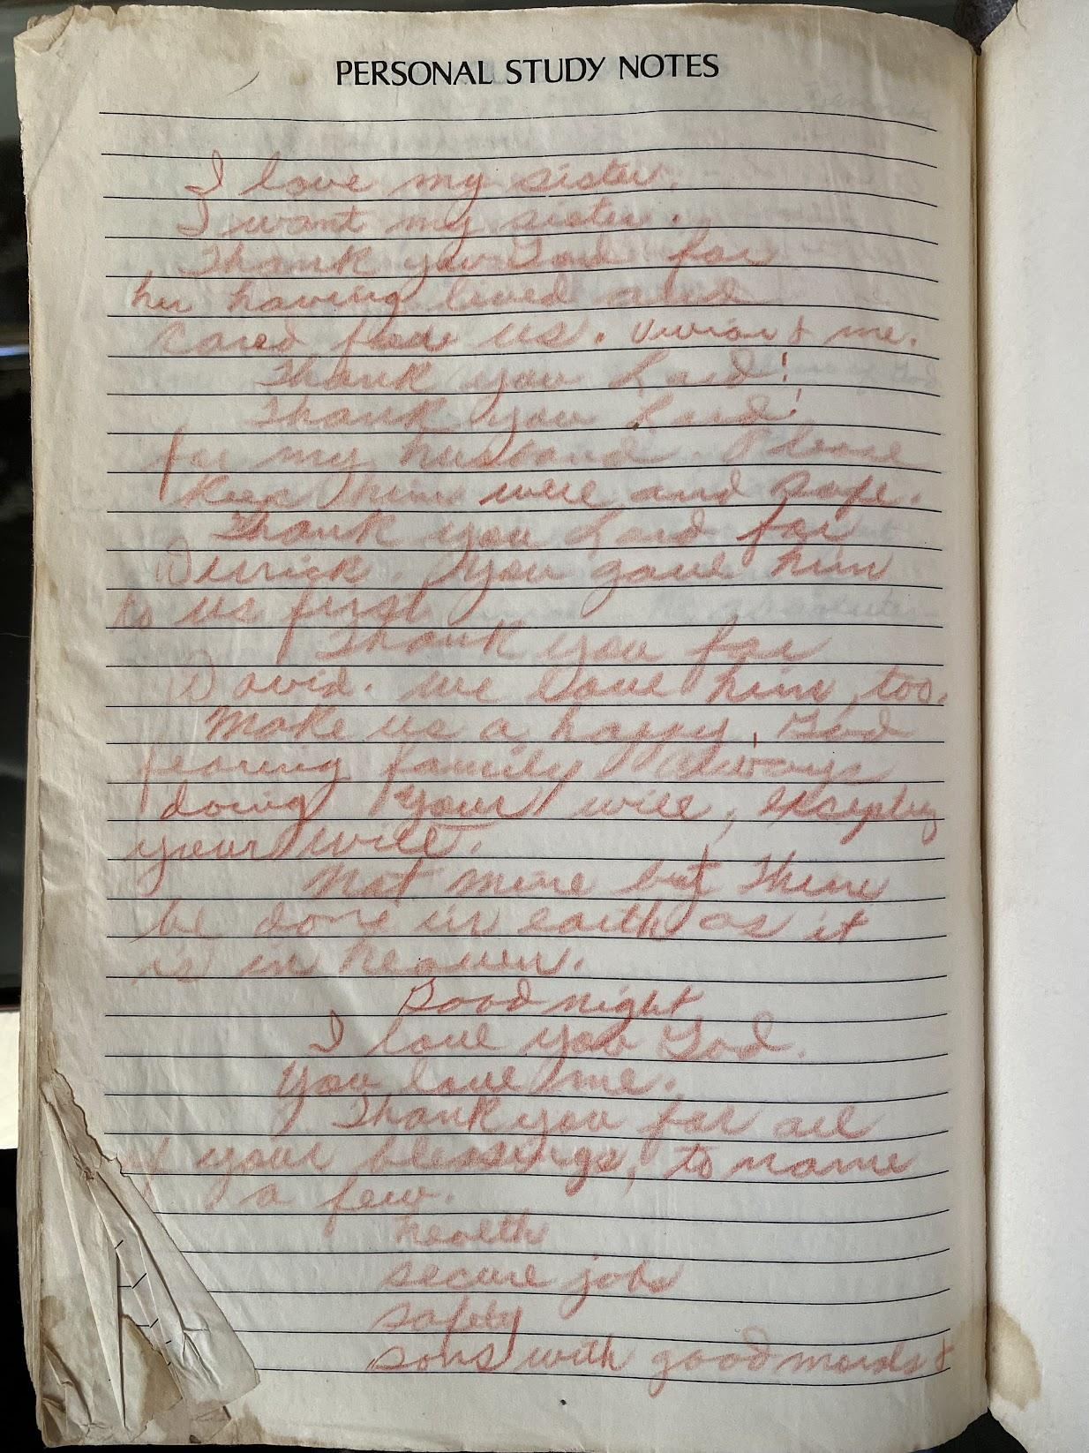

**Handwritten by Mom in her Bible c. 1980**

*I love my sister  
 I want my sister.  
 Thank you Lord for  
 her having lived and  
 cared for us,* ***Vivian and me.***

*Thank you Lord!  
 Thank you Lord!*

*for my husband. Please  
 keep him well and safe.*

*Thank you Lord for  
 Derrick – you gave him  
 to us first.*

*Thank you for  
 David. We love him too.*

*Make us a happy, God-  
 fearing family, always  
 doing Your will, obeying  
 Your will.*

*Not mine but Thine  
 be done in earth as it  
 is in heaven.*

*Good night.  
 I love you, God.  
 You love me.*

*Thank you for all  
 Your blessings; to name  
 a few:  
 • health  
 • secure job  
 • safety  
 • sons with good morals*

## Chapter 12: Finding My Place at Princeton

Dad adjusts his camera one more time, framing the shot with the precision he brings to everything. Behind us, Princeton's Gothic towers rise against a perfect June sky, ivy cascading down weathered stone walls that have witnessed countless graduations. Mom stands to my right in her cream dress with its burst of geometric patterns: blues, purples, bright splashes of color she chose especially for this day. She clutches my graduation program like a treasure, her smile radiant with four years of worry finally released. Dad, distinguished in his light gray suit, stands with the quiet dignity that carried our family through decades of struggle. Between them, I wear the black gown and orange hood that mark me as Princeton Class of 1986.

The camera clicks, capturing what none of us could have imagined when Dad first drove me through these gates. Five years that nearly broke me, that saw me living in basements and confronting prophets, resigning from leadership and learning to stand my ground. But here we are: vindication in three smiles, achievement measured not just in a diploma but in the distance traveled from doubt to this moment.

But to understand how we got here, we need to go back to September 1981, when Dad first drove me to Princeton.

### First Impressions

That first morning, Nassau Street finally appeared, dividing two distinct realms: on one side, a quaint town devoid of familiar fast-food joints and chain stores; on the other, Princeton University itself, a fortress of Gothic architecture, wrought iron fences, and climbing ivy. Despite my love of fantasy novels, this place felt pulled from a chapter of history I'd never read. The weathered stone buildings loomed with a gravitas that made my campus visit last April feel like a distant dream.

My late arrival to 211 Dodge Osborn Hall in Wilson College meant a bottom bunk in a cramped quad, not the single or double rooms that the first five of my eight suitemates had secured. Nine of us shared one common area and one bathroom. The windows' ancient manual latches rattled in their casings, refusing to seal completely, a preview of the drafty nights ahead. Late arrival. Bottom bunk. Another lesson in Princeton's unwritten rules.

### Meeting Jamal

The door opened to a cramped common room where suitcases and half-emptied boxes created an obstacle course of other people's lives.

"Hello?" I called out, my voice echoing against bare walls.

"Who's there?" A response came from the common area.

My eyes caught on a white cane with a red stripe propped against a desk. Waiting.

"I'm Derrick, one of the new roommates."

"Jamal," he said, standing and extending his hand in my general direction. "Welcome to the suite."

I stepped forward to shake his hand.

"You're from Michigan too, right?" I said, having been informed by the Princeton housing office to expect and welcome Jamal.

"Ann Arbor. My Dad is a professor of African Studies there. Have you heard of the PBS series *The Africans*? He created it."

"Yes! That is so cool."

### Finding My Voice Through NSBE

While I navigated my academic and social footing (remedial English despite AP successes, sidewalks where I'd yield to groups of white students), a sign promising free pizza led me to the Society of Black Engineers welcome meeting. What I found there changed everything.

Tonya Chisholm, class of 1982 and President of the Princeton chapter of the National Society of Black Engineers (NSBE), stood before us with quiet confidence. Her message wasn't about belonging—it was about redefining belonging. "We don't just want to finish the race together. We want to cross the finish line first."

Our freshman year metronome was the weekly physics quiz, and we learned that intellect was *not* enough. Stamina and perseverance were required to place first.

That March, my first NSBE Conference in Detroit inspired me. The moment those thousand black engineering students rose to their feet, the applause thundering off the walls, I felt the ground beneath my assumptions crack open. From across the nation, row upon row of young men and women—future chemical engineers, computer scientists, mechanical engineers—were running along with us cheering, no yelling, "Nez-be. Nez-be! NEZ-BE!"

From my seat, I could see James Raby, who would become a friend and colleague for the next 40 years, a hint of a smile on his six-foot-four muscular frame. Next to me, a fellow Princeton student leaned over, shouting above the noise, "This is what *they* don't want to believe exists!"

But I was not concerned about *them* at this moment. As Andrew Solomon described in *Far From The Tree*, we were not different here. We were no exception. We were not the "minority" that I had claimed in my scholarship applications. We were a community, one thousand strong.

Walking back to my hotel that night, I made a decision. I wasn't going to just participate in NSBE. I was going to lead it.

By the end of sophomore year, I was elected chapter president. I didn't just embrace Tonya's message of excellence—I weaponized it. When I proposed increasing the company sponsorship fee for our second annual job fair from the prior year's $150 to $500, even our NSBE leadership worried companies would stop coming.

"Which bike is better," I asked them, "the $150 bike or the $500 bike?"

Silence. Then Kevin Dowdell, our outgoing president, started smiling. "You're absolutely right. We are Princeton."

The gamble paid off. The increased fees meant we could send every NSBE member to the national conference. We weren't asking for help anymore. We were creating our own economy of excellence.

### Learning to See the Invisible

Two blocks from campus, between the engineering building and the eating clubs stood the Third World Center. Director Czerny Brasuell ruled it, a chain-smoking woman who reminded me of my mother's boldness in a younger package. She taught me to see what had been invisible: the subtle normalization of whiteness that permeated everything. A room with white kids was "normal." A room with black kids was "a room with black kids," different, implicitly less than.

The way I unconsciously stepped aside on sidewalks. The invisible black service workers in the eating clubs. Even my own compulsion to prove myself, *to leave no doubt*, all of it connected to patterns Czerny helped me recognize. Though she would later leave Princeton in disgust over the administration's handling of a paper she co-authored on the challenges black students faced on campus, her lessons stayed with me.

Czerny opened my eyes to these systems. Jamal gave me the courage to act.

"MAZRUI!" became my call entering our suite.

"BURNSIE!" Jamal would respond, his face lighting up with that infectious grin.

We were united. Young black men from Michigan, used to being underestimated, absolutely refusing to bow to anyone intellectually. Before exams, we'd pump each other up: "Bust it out! Write the answer key!"

### The Prophet

Jamal's mind was never sharper than the night we confronted the self-proclaimed prophet. By junior year, this charismatic figure had attracted a following from our class. Several of my friends had already abandoned their studies to follow him. One evening, I convinced Jamal to join me for dinner with this man and his disciples at the Princeton Inn, a former hotel converted to a dorm and owned by the university that housed many black upperclassmen.

The prophet was seated at the head of the long banquet table when we pushed through the double doors, our dining hall plates in hand. His followers filled in around the scratched wood surface, a table that had endured decades of student meetings and makeshift banquets. Jamal and I claimed spots near the far end.

The prophet's voice, practiced and rhythmic like a Baptist preacher's, filled the space. His pale features and flowing hair seemed crafted to match paintings of white Jesus hanging in churches across America, while most of his disciples (my friends) were black, their trays of cafeteria food forgotten as they leaned forward to catch every word.

The prophet's monologue flowed over us while we picked at our dining hall chicken. His words wove promises of divine insight with hints of secret knowledge, each phrase landing like honey on eager ears. I glanced at Charles Vandross, a fellow engineering student and distant cousin of singer Luther Vandross, now sitting transfixed, nodding along. Next to me, Jamal sat perfectly still, eyes closed, head tilted slightly, absorbing every word.

When the prophet paused for breath, Jamal's voice cut through the reverent silence. "Could you please explain your prophecies more specifically?" The question sounded innocent enough, but I recognized the setup—the same tone he used before demolishing someone's faulty logic in our late-night debates.

"I see the future as it unfolds before me," the prophet replied, his hands spreading wide. "The signs are clear to those who—"

"What signs, exactly?" Jamal interrupted. "What specific events have you predicted?"

The prophet's rhythm faltered. First crack in the armor.

"My followers understand—"

"So no specific predictions then?" Jamal pressed. "Just general feelings anyone might have?"

Around the table, heads began to turn. The spell of the prophet's words started cracking under Jamal's precise questioning. I watched Charles's expression shift from reverence to uncertainty and perhaps to hostility as Jamal's logic began to pierce through the prophet's vague responses.

The prophet tried to regain control, his voice rising with wounded authority. "Those who truly seek truth will understand..."

"But you haven't provided any truth to understand," Jamal said, his voice calm but relentless. "You've offered feelings, impressions, vague promises. Where's the substance?"

One by one, around that scratched wooden table, I watched my friends struggle with the revelation. The emperor had no clothes. But while Jamal's surgical questioning had stripped away every pretense, logic rarely overcomes faith.

Walking back to our dorm, adrenaline still coursed through my veins. "That was incredible. Mazrui, you are the man!"

But we stopped by the Wawa Market for me to get a 16 oz. box of soft Entenmann's Chocolate Chip Cookies, which we devoured before we got back to our room less than ten minutes later.

"Burn-zie. Do you think I was too hard on him?"

"You tore his ass up," I said, avoiding the question and feeling just a small bit of shame for instigating the confrontation.

### The Microsoft Choice

"Interview Signups: Microsoft, Jan 1983" the sheet read. My eyes opened wide. The company I devoured articles about in *BYTE* magazine was coming to Princeton.

I'd been following Microsoft's story obsessively since they'd licensed MS-DOS to IBM. For the generation preceding me, IBM defined computing excellence. With this deal, Microsoft was positioning itself to become the universal language of personal computing. Bill Gates hadn't just purchased DOS; he'd orchestrated what would prove to be one of the shrewdest deals in technology history. By providing MS-DOS to IBM while retaining the rights to sell to other manufacturers, he'd positioned Microsoft perfectly for the coming PC revolution.

This was the future being built in real time. And Microsoft was at the center of it all.

As a sophomore, I didn't qualify for these senior-level interviews for full-time positions, but my NSBE leadership had made me bold. If I could convince companies to pay $500 for our job fair, surely I could convince one recruiter to give me an interview.

"I will forward your request to the recruiter, Derrick," Director of Career Services Minnie Reed said when I presented my case.

The call came back within forty-eight hours. Steve Ballmer would see me.

Steve Ballmer's intense gaze fixed on me across the small table. "Here's your problem," he said. "You have a black and white picture that contains either an orange or a banana, exactly one, fully visible. Design an algorithm to identify which fruit it is."

As I explained how aspect ratios could distinguish between round and elongated shapes, I saw his skepticism turn to interest. "That's... actually a novel approach," he said. "It would work."

"One more thing. I see that you are a sophomore. This is for a full-time job. What are you thinking?"

"To be honest, I am bored in school. I want to build things."

The offer letter arrived: full-time employment starting immediately at $27,000 base salary, 15% bonus, stock options. But what made my hands shake was the possibility of joining the PC revolution at its ground zero. To paraphrase from the musical *Hamilton*, I wanted to be in the room when it happens, where the future was built.

I needed to hear Mom's voice. She listened patiently as I explained the opportunity. When I finished, there was a rare, thoughtful pause.

"Derrick, you need to finish your degree. No one can ever take a Princeton degree from you."

Could I walk away? God I wanted to! What's the value of a degree if not to *open doors*? The door was open, for Christ's sake!

I declined the offer.

Was I afraid of giving up a full scholarship and an Ivy degree? Did I need to prove the high school "friends" who told me I would fail Princeton wrong? Did I just feel compelled to finish what I started? Did I fear being naked, without cover in a place very far away? Perhaps all of those are true. Or, perhaps, what I really was afraid of was walking away from my *NSBE* *community*!

### The Fall

I started junior year as President of the Princeton chapter of NSBE and in the spring I was elected Treasurer of the National organization. Aside from the annual job fair, our local chapter offered peer support that had no equivalent from the University. We were vested in each others’ success, a far cry from the feeling that I and many of my black friends felt of abandonment and isolation. We organized parties on campus, often sporting over a dozen boxes of large Vesuvio’s pizza to any and all attendees, free of charge thanks to the full coffers from our job fair. After two years of the tutelage from master DeeJays Gary Jenkins and Charles Anderson of Sonic Sounds, my classmates Sheila Dooley, Joanne XXX, and Kristie Lancaster of Trice-as-Nice treated our parties to the rhythms of hip-hip and R&B songs of Kool & the Gang, Patti LaBelle, Ashford & Simpson, Cameo, Michael Jackson, Donna Summer, Rick James, Parliament Funkadelic, and my favorite, Prince.

My classes were more engaging, classes in my major, upper level economics classes with text book authors, senior advisors to the President, and even a Nobel laureate.

I sought software project oriented courses, seeking each time to refine my software talents to the maximum extent possible in the limits of a ten week semester course. I poured myself into each project, setting my bar far higher than any professor expected or fellow student would attempt, leading my project partner Michael Kandall, a snarky Jewish buddy from Connecticut, to say “Oh no, Burns. You are doing it again.” When he failed Japanese because of my demands, I did not feel guilty or remorseful. I took it as a sign of success that I had captured his attention. Little did I know I had discovered the secret to silicon valley startup culture!

Had I finally found my rhythm at Princeton?

A restlessness ate at my certainty. Instead of fueling my soul, the thrill of external validation from NSBE waned as the year progressed. Runs to Wawa Market concluded with me consuming an entire boxes of Entenmann chocolate chip cookies before I even returned to my dorm room, with another in hand for “later”. My campus girlfriend, if late night rendezvouses count as such, escaped her reality with weed and, I suspected, cocaine. If my mother had not scared me off drugs and alcohol, our relationship would not have imploded from my constant condescending comments about drug use.

Then I remembered.   
  
“The Annual NSBE National Conference is coming up in March. We need to decide how many people we can send and how to decide who gets to go.” I said, announcing the agenda for our chapter board meeting.

I needed the kick of adrenaline that the conference would bring. I needed the team to rally behind me. I needed to feel the energy and excitement of 1000+ strong.

“I propose that we send every member who wants to go to the conference. Not everyone will want to go, but I suspect that of those who do, we can afford to send them all.”  
  
“What happens if we get too many? I think we should prioritize members based on their tenure and loyalty,” said our Vice-President.  
  
“Well, if we get too many, I think we should prioritize freshman. I think the earlier they experience NSBE, the better they will be able to handle Princeton.” Was I talking about them, or me?

"I disagree. Travel rights to the conference must be earned. We should only send the members who are deserving—those who've put in time to NSBE, who've earned it."

What was going on? We had the money. Hell, I had raised it.

As I scanned the room, I could see that I did not have consensus, and perhaps not even a majority. Was this a revolt? Where was the loyalty to me?!

### The Conference

March could not come soon enough, and when I got there I ingested the elixir that I needed. “Nez-be! Nez-be”.   
  
I marvelled at the leaders. As a student run organization, all the leaders were close to my age, but I was in awe in their presence. The speeches they gave roused the crowd. One could not resist the draw, feel the camaraderie, and scream at the top of one’s lungs, “NEZ-BE”!

I befriended the current treasurer, Louis Hureston, a fellow mid-westerner from Chicago who was also a Bell Labs scholar. Smooth, calculating, and focused, Louis had a plan on how to harness the financial resources of the fast growing organization to expand its influence within the United States and abroad to increase the number of culturally responsible Black engineers who excel academically, succeed professionally, and positively impact the community. I asked Louis to support my candidacy to succeed him as national treasurer, and he readily agreed. With his support, I won.

But when I returned from the conference, Princeton was still there, unchanged. I slumped as the adrenaline high fell like my blood sugar did one hour after eating all those cookies.

The words fell out of my mouth before my brain could stop them: "Fine. I resign." The silence that followed felt like falling into an abyss. Around the table, faces I'd considered family suddenly looked like strangers deciding whether I was worth retrieving. The rift had torn a hole in the fabric of my social network and my confidence as a leader. I had felt this before. Junior achievement in high school. Yes, that was it. I was a President without a team. I just wanted the pain to go away.

Each night, as the sugar rush wore off, I wallowed in a grief that I could not name. I had walked away from my most cherished identity. Who was I without the title, without the platform, without the community that had become my identity? In the mirror, I still saw the same face, but the person behind it felt like a stranger—someone who'd confused leadership with belonging, achievement with acceptance. And why didn't any of my friends ask me to stay?

For the first time since arriving at Princeton, I felt truly alone.

### Summer Time

I recalled my chance to escape to Microsoft, a route closed to me now.   
  
Following an uneventful summer with James Raby at the Richardson Apartments of Rutgers University in Piscataway, New Jersey with Bell Labs housed hundreds of summer interns, I grew impatient. James had found employment at a new startup. MaxThink occupied a few rooms in a nondescript Bay Area office park - a world away from Bell Labs' fortress-like Murray Hill campus. The entire engineering staff could fit in an elevator, but what we lacked in size, we made up for in possibility.

With several weeks to go before my senior year began, I decided to head out to California with James. James's recommendation opened the door, and the owner's offer seemed generous at first - $30,000 was serious money for a college student in 1983. But I'd been reading about Silicon Valley startups. I knew the real wealth came from equity, from owning a piece of the dream. When I pushed for stock options, the owner's response revealed the gulf between old and new thinking: a 20% salary bump and - I nearly laughed in his face - a pension plan. A pension plan? In a startup? It was like offering a savings bond to someone looking for venture capital.

MaxThink was no Microsoft, and without equity, the opportunity felt hollow so I returned to Princeton to start my senior year, disappointed but wiser. MaxThink might have been a dead end, but Silicon Valley had shown me its promise. The question wasn't if I would return, but when and how.

### Senior Year

The train lurched out of Newark Airport, each mile carrying me closer to an uncertain future. Through grimy windows streaked with late summer rain, New Jersey's industrial heart throbbed past - smoke-belching refineries and rust-belt warehouses suddenly surrendering to a pastoral revolution of fertile farmland, neat rows of vegetables stretching toward the horizon. At Princeton Junction, I shouldered my bags and boarded what we affectionately called the "Dingy" - a worn shuttle that had ferried generations of ambitious dreams to campus. Today, its familiar rhythm felt like a funeral dirge.

The station emerged across from Wawa, and my eyes were drawn involuntarily to Princeton Inn College, where the body of a classmate freshman year in his dorm room had left an invisible scar on our collective consciousness. His absence was a constant reminder: our presence here was precarious, our grip on these ivied walls tenuous.

I walked across campus with the heavy suitcase and received my key to the second story attic bedroom in the Third World Center (TWC) from Ms. Sara Miller. This room was mine to inhabit in exchange for caretaking duties. With no food plan and scant cooking skills, I joined the TWC food cooperative, organized by fellow engineer Mike Barney, '82, our center's emotional anchor. Mike had weathered Princeton's storms and stayed to help others find their way. For fifteen dollars a week, he didn't just manage our food co-op - he cultivated our community.

The TWC's heart beat strongest at lunchtime, when our food co-op transformed the space into a family kitchen. Michelle - "Meech" to us - would glide in, her smile lighting up the room as much as mine lit up at seeing her. Her presence reminded us of her brother Craig, last year's basketball captain, whose leadership had made Princeton a little more our own. While Miche and Caroline worked their magic in the kitchen, I happily tackled the dishes, each of us playing our part in this daily ritual of belonging. In those moments, elbow-deep in soapy water, listening to laughter and conversation float from the dining room, I understood: this wasn't just a meal program. This was how we created family, how we carved out space to be ourselves in Princeton's shadow.

The food co-op routine - Michelle's bright smile, Caroline's cooking, my dish-washing duties - provided structure, but Czerny was gone, choosing to leave after refusing to let Princeton sanitize her honest portrayal of Black student life in a report they'd commissioned. Her departure, along with her young son Jonathan who we all adopted as our younger brother, created an emotional vacuum that I filled with sadness.

While junior year filled my need to build, senior year was to fulfill the computer science requirements, with classes that carried no more of my interest than freshman year remedial English. My comeuppance came when midterm exams demonstrated that skipping class would not work very well anymore: the lessons that I needed to learn were not in a textbook and classmates grew weary of me borrowing and copying their notes!  
  
Three forces converged that fall: the fracture with NSBE, Czerny's departure, my growing impatience with theory divorced from practice. Like tributaries feeding a river, they pulled me toward one inevitable destination. California. James. The promise of building something that mattered.

James welcomed me into his apartment, but when I arrived, James had soured on MaxThink, perhaps concluding as I did that work without ownership was insufficient. We wanted to build something of our own. James suggested that we rebuild MaxThink.

Then I discovered it—books by Yourdon and Dijkstra that merged with everything that Professor Greg Nelson had taught me about provably correct code. Instead of just building a perfect piston, what if I could build a perfect car? This wasn't just another project. This was my destiny, my redemption, my answer to every rejection I'd ever faced. The perfect system. The perfect code. The perfect life.

My thoughts exploded, each insight spawning three more. Sleep became an inconvenience. I abstracted the details away, leaving a simplicity that belies the complexity of the real world, a problem that would plague me for decades. After failing at NSBE leadership, after struggling to focus academically, I needed this to be the answer. I needed to prove I belonged somewhere, that I could build something that mattered.

Days and nights blurred. I made frantic calls to anyone who would listen—NSBE contacts, Princeton grads, job fair connections. I thought I could sell ice to an Eskimo. I didn't hear "no." I heard "great, keep me informed" and interpreted it as eventual "yes." I was running up James's phone bill, talking all night, trying to make my vision so public I couldn't back down.

"You need to stop. Take a break," James said. He wasn't angry. He was steady, matter-of-fact. It sounded like a breakup between lovers.

When I ignored him, James made his decision: "Derrick, I think you need to leave."

The words shattered my dream into a million shards. I knew James valued our friendship. My community had two members, me and James.

Embarrassed and ashamed, I left the next day.

Now, I was alone.

### The Basement

With no other options, I crawled back to Princeton in February, still in possession of the keys to the doors of the Third World Center, my home at the time I left. A closet in the basement transformed from storage space to shelter. The basement closet smelled of industrial cleaning solution and old concrete. At night I closed the door, stacked cardboard boxes in rows, pulled out my blanket, and went to sleep. The cardboard beneath me grew damp from my body heat, corners digging into my shoulder blades. Each time I shifted, the boxes made a scratching sound that seemed to announce my presence to anyone who might be listening above. The concrete floor beneath the cardboard never warmed—it pulled heat from my body all night, leaving me perpetually cold.

In the early morning, I could hear the familiar sounds above. Resident caretakers left for class. Sara Miller arrived to support the director of the center. Midday, members of my former food co-op arrived to make cold-cut sandwiches between classes and returned later six nights a week to prepare and eat dinner together. These familiar sounds were from a life that no longer belonged to me.

I started timing the sounds above—Sara's arrival at 8:17, the co-op lunch prep at 11:45. I was mapping a world I could no longer enter, creating systems to understand my own exile. Even in homelessness, I was abstracting.

I made my presence known during the day, but hid my sleeping arrangement. The bathroom became a challenge of timing and stealth. Showers required military precision—in before dawn, out before the earliest risers arrived. But once dressed, I was free to roam the building and campus. I was still a student, right?

Several weeks later, the jig was up. Center Secretary Sara Miller approached me with the gentleness she'd always shown.

"Derrick, it has come to our attention that you are sleeping in the basement. Is that true?"

"Yes."

"Professor Martin cannot allow that. You will need to find another place to live. Do you need help?"

Damn. Martin is the new director of the Third World Center, replacing Czerny who had left in frustration. The irony.

"No ma'am, I have some money. I will find a place. Thank you." I could see the pain in her eyes. Perhaps she saw me as a struggling son; her motherly instincts wanted to protect me.

### Standing Up

I found a room for $210 a month in Kingston, New Jersey—small, with shag red and purple carpet, but it was mine. As I unloaded my belongings from my Bonneville, I felt something unexpected: excitement. I had $700 in the bank. I could figure this out!

"Derrick, get a job. Burger King, wherever!" Mom counseled. Recalling my eighteen-month minimum wage cooking job at Kentucky Fried Chicken during high school, I said: "I hear you Mom. I will get a job, but it won't be fast food. Been there, done that. No thanks."

Consulting work came through a newspaper ad: "Looking for software consultants, Bell Communications Research (Bellcore)." A spinoff of AT&T Bell Labs, I presumed I knew Bellcore culture, certainly enough to get hired. Mr. Charles Ugwu, the consulting company owner, agreed to present my candidacy. A month later, my first paycheck made a nice increase in my bank account, but I wondered just how much Mr. Ugwu was getting from my labor.

When a sympathetic secretary quietly showed me an invoice revealing my middleman was billing $360 daily for my labor while paying me less than half, I felt that familiar burn of injustice. But this time was different.

The drive to his Newark apartment gave me time to think. Thirty-eight miles of New Jersey highways to plan exactly what I'd say, how I'd stand, what I'd do if he said no. It took me 6 gear changes to park the car, and though there were only ten steps to the front door, each step seemed 18 inches high. I remembered every lesson about power I'd learned in the 'hood.

When I rang his doorbell, I breathed slowly to calm my pounding heart. Not from fear. From clarity.

"Come in, Derrick, what can I do for you?" Mr. Charles Ugwu said warmly, though this was our first meeting. Nigerian-American was my guess from his name and rich dark skin. Probably in his 50s. I scanned the room: tidy, unremarkable, the home of a man who I presumed had built his business on the backs of younger talent. On people like me.

"Let me get to the point," I announced. "I want more money."

"You are making plenty of money. What are you doing with all that money?" he asked, trying to deflect.

I ignored his question. "I know that you are making more per hour off my services than I am. That is not fair."

"It is none of your business how much I make!"

"It is my business how much I make, and I demand an increase of 25%."

"No, I will just give them your two weeks' notice!" he pronounced. A bluff. We both knew it.

This was the moment when I could accept being diminished, or I could stand up for what I was worth. I thought of yielding on Princeton sidewalks, of being dismissed by professors, of Pam's casual rejection of my leadership. All those moments when I'd absorbed the blow and kept moving. All those moments when I'd built barriers instead of standing my ground. I'd spent years abstracting away my own worth, reducing myself to whatever others expected.

Not this time.

"No, you will give them nothing! I will stop work immediately, but only after I tell them how you treated me. I am well regarded there. They know me, not you. I will guarantee that you **never** get another penny from Bellcore."

I turned and walked out. My legs quivered, but I refused to show fear. When I reached the last step, dusk was settling around me. My pulse hammered against my ribs. I had only a couple thousand dollars to my name, and the possibility of losing this income terrified me. But something deeper was happening. I was learning the difference between building walls and standing firm.

"Alright, you can have your money!" he shouted from the steps.

I kept walking, refusing even the courtesy of turning around. But inside, a fundamental shift had occurred. For the first time in my life, I'd stood up for my worth without compromise, without performance, without pretense.

### Return and Proving Ground

I returned to Princeton in September, having earned over $30,000. I just needed to maintain my focus for nine months. But just after midterms came the body blow.

"Derrick, I just got back a report on your performance. You are failing your Industrial Organization class. If you fail you will be expelled," said the dean.

"The midterm was a fluke. I froze for some reason, but this material is easy for an engineer," I said, channeling as much confidence as my arrogance could muster. "But in any case, why would I be expelled for failing a single class, not even in my major?"

"You are on academic probation as a result of you voluntarily withdrawing mid-semester last fall."

"Uhhh, I thought I was on a leave of absence."

"No," the dean said firmly.

From that moment on, I sat front and center of that class and every other class. And for the record, particularly for you high school classmates who said I could not do it: I aced that final and graduated *cum laude*!

Sometimes the best response to doubt is not argument, but achievement.



**Jamal Mazrui, c. 2010**

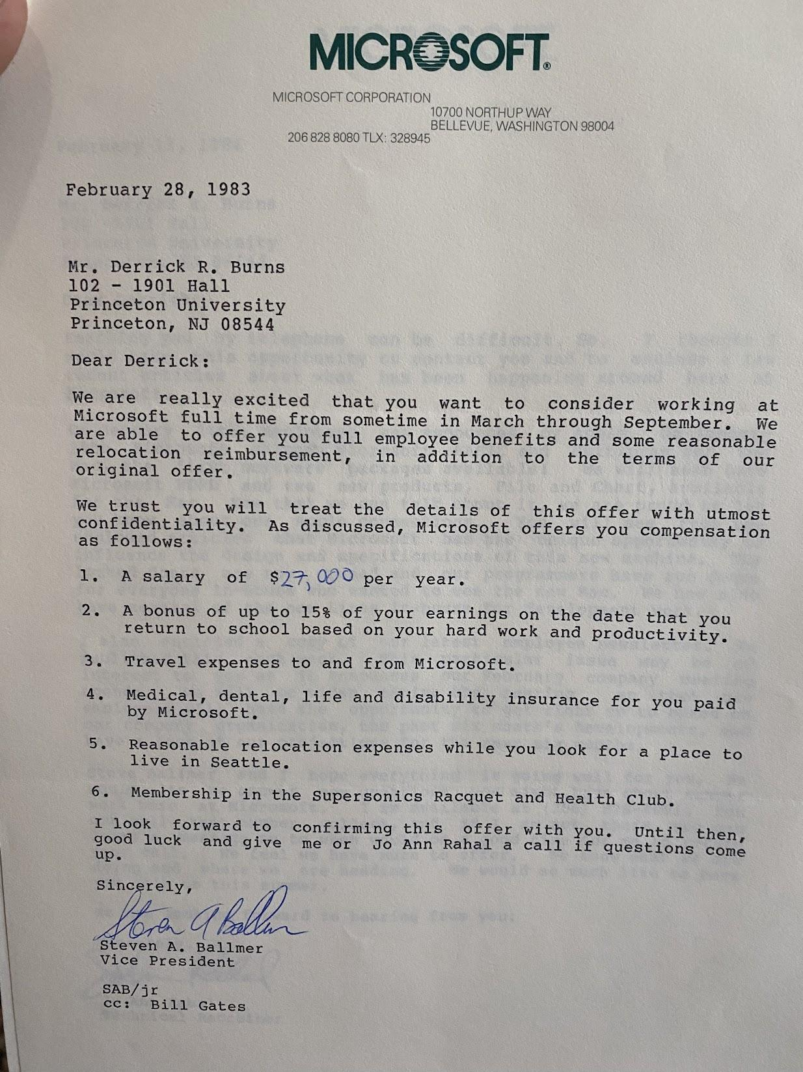

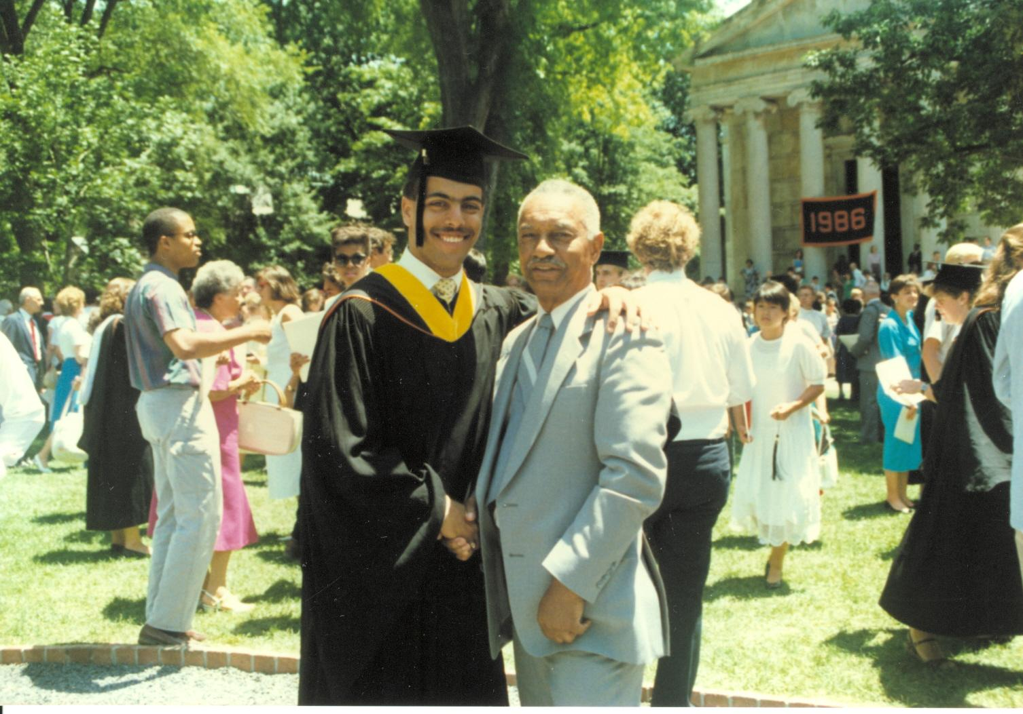  
**Derrick and Dad, June 1986**

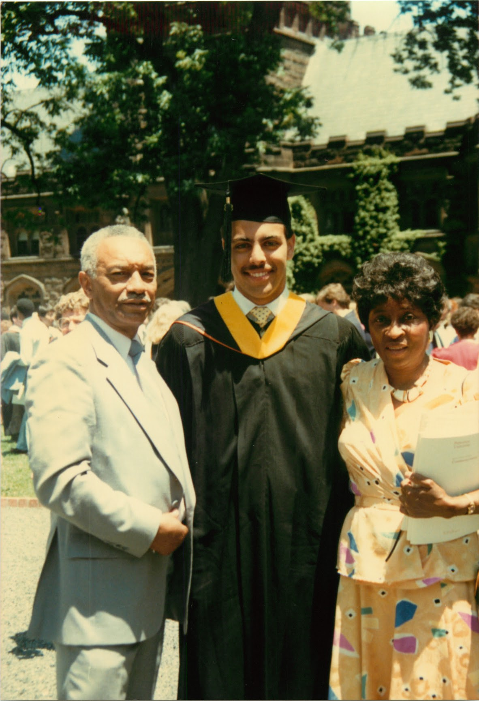  
**Dad, Derrick and Mom, June 1986**

## Chapter 16: Understanding My Path

### Arrival at Stanford (Fall 1986)

The drive from Detroit to Stanford in August 1986 was more than a road trip, it felt like stepping out of one life and into another. My father rode beside me in Mom’s old '78 Bonneville as we watched the streets of my childhood recede in the rearview mirror. Those neighborhoods weren’t just familiar, they carried a sense of identity, of community, that I was leaving behind without knowing what might replace it.

I arrived at Stanford with a fire in my chest: I was going to earn a PhD in two years, just like Professor Robert Tarjan had done under the guidance of Donald Knuth. To me, that wasn’t just an impressive academic feat, it was a map. Tarjan’s work in graph algorithms was already foundational, and Knuth’s influence on the analysis of algorithms was unmatched. Their ideas had shaped the field I loved. I wasn’t just pursuing a degree, I wanted to contribute to that kind of legacy.

But Stanford had its own rhythm, and I soon realized the typical dissertation takes seven years to complete. The department was world-class, yet I often felt adrift. At Princeton, I’d had a strong and supportive Black community; at Stanford, I struggled to find connection.

Weekends gave me some relief. My friend James introduced me to his circle from Cal, University of California at Berkeley, and that group became my lifeline. We played pickup basketball, gathered for poker nights, and hit up Silks nightclub in Emeryville. These were small escapes, but they mattered.

Our game nights, held in modest apartments, were a kind of ritual, filled with laughter, takeout, and endless conversations about where our lives were heading. We played Guts, a high-stakes card game that demanded nerve and intuition. Every hand pulled me back to Detroit, where reading people quickly had been second nature.

Still, beneath the camaraderie, a deeper kind of loneliness crept in. I was learning that academic challenges were only part of the journey. I was also rebuilding a sense of belonging, one piece at a time.

It wasn’t until later that year that I heard Tarjan had won the 1986 Turing Award for his work on graph algorithms. The Turing Award was the highest recognition in our field, and knowing I had studied under someone of that caliber made the goal feel real, even if distant.It felt like a signpost, confirmation that the path I admired truly led to the summit. Theoretical Foundations (Winter 1986)

Four months after arriving at Stanford, I found myself in an intimate research seminar led by none other than Donald Knuth, who had been Tarjan’s mentor and who had won the Turing himself back in 1974. Being in his classroom felt both inspiring and daunting. Seated at a long table with some of the most brilliant theoretical computer science students of my generation, my dreams of Silicon Valley briefly faded, replaced by a more immediate concern: keeping up.

This wasn’t the collaborative, affirming environment I’d read about in *Ebony* profiles of Black tech pioneers. This was theory at its purest and most unforgiving. My practical instincts, the same ones that had served me so well at Princeton, suddenly felt insufficient. At the head of the table, Knuth sat quietly, eyes sharp, while an open research problem hovered in the room like both a challenge and a test.

The seminar space was stark. No computers, no distractions, just a long wooden table and our notepads. It reflected the essence of Knuth’s philosophy: clarity through precision, solutions forged from first principles. Breakthroughs were meant to happen here with pencil and paper, and when they did, they were typeset in TeX, the elegant system Knuth had designed himself to express mathematical thought with perfect fidelity.

The problems he posed weren’t from textbooks. They were raw, complex, and often unsolved. The first time I read through one of his assignments, I could barely understand what was being asked. Concepts like Stirling numbers were completely new to me. My year of graduate-level study under Robert Tarjan had given me confidence with graph algorithms, but this level of abstract mathematical analysis was unfamiliar territory.

What surprised me even more was that I wasn’t alone in feeling lost. As we went around the table, it became clear that others were just as bewildered. This wasn’t a room full of students breezing through elite math, it was a room full of smart, capable people learning to navigate the unknown together.

That first problem set the tone for the rest of the seminar. We weren’t expected to memorize or apply known results. We were asked to explore the unknown, to test ideas, and to learn from each other. We tackled each problem over two weeks, inching forward together. My contributions to the first two assignments were small. I mostly watched, tried not to fall behind.

Then came the third problem, graph algorithms. At last, familiar ground. I dove in with renewed energy. That night, under the steady glow of my desk lamp, I filled pages with diagrams, reductions, and half-finished proofs. By dawn, I was exhausted but exhilarated. I had something real.

Walking across campus to Terman Engineering, I ran into Tomas Feder, my Argentinian classmate. Excited, I shared my approach. As I explained, I saw a flicker of understanding in his eyes, not awe, but recognition. In seconds, he extended my ideas, skipping over entire steps to arrive at a more elegant, far-reaching solution, solving not just the problem I had focused on, but others I hadn’t yet seen.

His ease left me stunned. Back in Detroit, I’d taught myself programming and calculus. At Princeton, I’d held my own. But here, watching Tomas work was like watching a grandmaster play chess while I was still figuring out how the pieces moved. His brilliance was effortless, almost casual, and it shattered the tidy narrative I’d been carrying, the one that traced a steady arc from inner-city striver to Ivy League success.

Still, I hadn’t failed. These were open problems, and the real measure wasn’t whether we solved them but how we thought about them, and how we worked together. When grades came in, I received an A+.

Despite that success, I remained unsure of my place in the world of pure theory. I had shown I could contribute, especially on familiar ground. But my encounter with Tomas had revealed something deeper: the difference between competence and genius. As winter gave way to spring, I continued my coursework, quietly wondering whether theoretical computer science was truly where I belonged. With summer approaching, I started searching for opportunities that might point me toward a clearer path.

### Silicon Graphics Opportunity (Summer 1987)

After my intense introduction to theoretical computer science, the summer of 1987 arrived like a blast of fresh air, reconnecting me to the world I'd first glimpsed in those inspiring Ebony profiles. At Silicon Graphics (SGI), I found what theoretical computer science couldn't offer, a place where practical innovation mattered more than academic pedigree. Doctor Marc Hannah, a fellow BLESP scholar and co-founder of SGI, represented everything I'd aspired to become: a Black pioneer turning theoretical insights into real-world impact.

Stepping into SGI's bustling offices, I discovered a culture that celebrated creativity and collaboration over abstract theory. The energy was infectious, 600 employees jammed into spaces built for far fewer, generating an atmosphere of constant, enthusiastic innovation. The company seamlessly blended work and play: basketball courts outside, foosball tables in the break rooms, Friday beer busts, and lavish annual parties featuring top music headliners. Everything at SGI was structured to keep talented minds engaged and collaborative rather than isolated and competitive.

My officemate Vince quickly evolved from colleague to mentor, expanding my world beyond mere technical pursuits. Through him, I discovered excellence wasn't confined to algorithms and coding, it encompassed fine dining, impeccable attire, disciplined workouts, and meticulously brewed espresso. Vince's guidance helped me see professional growth as holistic, blending cultural sophistication with technical skill. Our late-night coding sessions often turned into expansive discussions, bridging worlds from East to West, engineering to culture, and refining my Detroit-born sensibilities.

Our team focused on fundamental challenges in computer graphics, transforming complex mathematical surfaces into beautifully rendered visuals. Collaborating with Vince, Doctor Rosemary Chang, Doctor Tom Davis, and Henry Moreton, I quickly found my niche.

My project addressed the "trimmed patch problem" in computer-aided geometric design. Complex curved surfaces in 3D models are represented mathematically as patches, but accurately rendering these surfaces when trimmed, for instance, to create car windows or holes in mechanical components, is notoriously difficult. The algorithms I developed offered a novel method for accurately and efficiently rendering these trimmed surfaces. Seeing our approach flawlessly render the famous Utah teapot, complete with intricate cutouts, was a transformative moment, validating months of dedicated effort. It crystallized a vital lesson: genuine innovation arises from combining practical skills with theoretical insights. This wasn't mere academic exploration, our automotive industry clients depended on this technology to visualize their designs, transforming my theoretical algorithms into vital industry tools. Eventually, this work became the cornerstone of my dissertation.

Rosemary, thirteen years my senior, taught me the fundamental mathematics behind creating sophisticated graphics algorithms. Henry, already seasoned from his tenure at Schlumberger and his graduate studies at Cal, shared invaluable practical insights. Under their mentorship by day and through intensive study by night, I discovered how my programming skills, merged with their profound theoretical understanding, could solve previously intractable problems.

Despite flourishing at SGI, the allure of academia persisted. The theoretical computer science community embodied a form of excellence I wasn't ready to relinquish entirely.

When our SIGGRAPH paper was rejected, I initially felt the familiar sting of academic disappointment, but this rejection was different. At SGI, setbacks were part of the creative journey, not judgments of worth. My colleagues' supportive reactions illuminated what academia had lacked: a culture valuing contribution over immediate perfection, iterative improvement over flawless initial attempts.

Doctor James "Jim" Winget personified this practical excellence. Like Tomas Feder at Stanford, Jim possessed immense intellectual depth, yet his brilliance extended beyond theory, demonstrating how profound theoretical knowledge could address real-world problems. Jim's mentorship offered a compelling model of success, one where understanding and application coexisted seamlessly.

Yet, the academic aspirations of matching intellectual feats with giants like Robert Tarjan lingered. Memories of how Mike and I had once outperformed Princeton's brightest, independently rediscovering solutions known only to Professor Tarjan, continued to fuel my scholarly ambitions.

As summer concluded, I returned to Stanford invigorated yet internally conflicted, torn between the collaborative, practical world of industry and the rigorous, theoretical demands of academia.

### The Theory Qualifying Exam Crisis (Fall 1987 - Spring 1988)

Returning from the energizing summer at SGI, I quickly faced another crucial test, the theory qualifying exam. As winter quarter approached, the qualifying exam dominated every conversation in the graduate student offices on the fourth floor of Margaret Jacks Hall. Stories from previous years, whispered rumors about its difficulty, only amplified our collective anxiety. This exam wasn't merely a test of knowledge, it determined who belonged in Stanford's theoretical computer science program and who didn't.

To prepare, Alex methodically filled notebooks with practice proofs, while David thrived in his new academic direction. Unlike them, and reminiscent of my electrical engineering courses at Princeton, I had little genuine interest in this level of mathematical detail. I aspired to the elegant intellectual world inhabited by Professor Tarjan, where proofs reflected brilliant insights into structure rather than tedious derivations. Yet, much like an overweight person promising to diet "tomorrow," I continuously procrastinated, always vowing to start studying seriously the next day.

The qualifying exam was a grueling, week-long ordeal, a take-home test allowing unrestricted access to textbooks and papers. Similar to my economics final at Princeton, this moment tested more than just my knowledge; it assessed my fundamental sense of belonging. Unlike Princeton, where I'd confidently claimed space in the classroom, Stanford found me shrinking into the background.

The take-home format intensified my struggle. For seven agonizing days, I sat surrounded by stacks of reference materials, confronted by problems that mocked my inability to grasp their elegance. The open-book freedom emphasized my deeper issue, it wasn't about memorization or access, but a profound mathematical intuition I feared I lacked. Mathematics, like professional athletics, demanded consistent practice and dedicated training. I had invested in neither, and my shortcomings became painfully evident.

Each evening left me staring at unsolved problems, blank pages mirroring my growing panic. My old Detroit instinct surfaced, never show weakness. Yet Stanford was not Detroit or Princeton, and my usual defenses failed miserably.

When Professor Knuth eventually published the exam solutions, they were concise, masterful proofs composed by students, primarily by Tomas Feder. His solutions, crafted effortlessly during the same week of my struggle, displayed clarity and sophistication I found unattainable.

The exam results delivered a crushing blow: I had failed. Alex, despite months of insisting he wasn't ready, passed with quiet competence. The truth I'd tried to avoid shattered my carefully built defenses, passion for elegant algorithms wasn't sufficient. Theory required mathematical maturity, something I'd forfeited by abandoning advanced math at Princeton to prioritize practical programming. That seemingly reasonable decision now haunted me.

My academic disappointment bled into every facet of my life. Calls home dwindled as I dreaded explaining my failure to parents accustomed to my success. Pride and shame trapped me in isolation. The fourth floor of Margaret Jacks Hall transformed into a gauntlet of anxiety. Its dingy graduate student offices, worn carpets, and oppressive fluorescent lights seemed suffocating. Navigating these halls meant carefully timing my visits, yet sudden encounters were inevitable. Colleagues quickly averted their gazes, sharing my discomfort. My failure hung silently in the stale air between us.

Each day deepened my isolation, making the already dreary fourth floor darker and more confining. The maze-like corridors, previously a shared academic home, became oppressive and intimidating, each turn threatening another awkward interaction. My failure had seeped into the physical space itself, embedded in each scuffed carpet tile and flickering fluorescent bulb.

While academic theory had left me isolated and inadequate, I began contemplating whether another path might better align with my strengths and aspirations.

### FOCS Conference Epiphany (Fall 1988)

The personal toll of my academic struggle had become undeniable. One Sunday morning, as I shaved, I barely recognized the exhausted, drawn face staring back at me. My mother's gentle inquiry during our weekly call, "Are you doing okay?", held a quiet concern that I couldn't simply brush off. Something had to change, not just for my academic future, but for my overall well-being.

Despite failing my theory qualifying exam, I wasn't ready to entirely abandon my theoretical ambitions. At SGI, my meticulously maintained collection of recent Foundations of Computer Science (FOCS) and Symposium on the Theory of Computing (STOC) proceedings remained my pride and joy. These publications symbolized my aspiration: to write papers that earned me a respected place within these prestigious conferences. When Bellcore funded my trip to FOCS in Chicago, I packed the latest proceedings like a talisman, reminiscent of the way I'd prepared books for my first day at Detroit's most prestigious high school years earlier.

Upon arrival in Chicago, I registered eagerly and immediately acquired the new conference proceedings, full of anticipation. However, the reality of the conference quickly shattered my expectations of collegiality and acceptance. As I navigated through the halls, clutching the latest proceedings like a protective shield, I again encountered the invisible barriers that had long marked my academic journey. Attendees clustered in tight-knit groups, exchanging insider references and jokes. My attempts at conversation were met with polite yet distant silence. Once again, I found myself an outsider looking in.

Yet, this rejection felt distinctly different. During breaks, while sitting alone and pretending to study the proceedings, I experienced a moment of profound clarity. Although familiar pain lingered, I suddenly understood something essential, I had convinced myself that I wanted to become a theoretician without fully comprehending the cultural realities of academia. Observing the conference closely, it became clear to me: if this was what academic success meant, it wasn't for me.

This realization was unexpectedly liberating. The problem wasn't a lack of capability; rather, I'd been measuring myself against standards that didn't align with my true strengths or values. Walking back to my hotel that evening, I felt lighter, freed from the weight of expectations that didn't reflect who I genuinely was or wished to become.

Chicago’s streets seemed brighter, the evening air fresher. For months, I'd carried the heavy burden of perceived failure. Now, I recognized that what I'd failed at wasn't necessarily what I was meant to succeed in. While theoretical computer science had undeniable value, my true talent lay in bridging theory and practical application, as I'd experienced at Silicon Graphics. This wasn't giving up; it was discovering my authentic direction.

### Pivot to Systems (Winter 1988 - Summer 1989)

Armed with newfound clarity from the FOCS Conference, I began exploring systems with a determination previously reserved for theoretical computer science. After my epiphany at the FOCS Conference, I found myself at Stanford's engineering library at 11 PM, surrounded by stacks of systems papers. The building was nearly deserted, save for a handful of dedicated graduate students hunched quietly over their desks. My lamp cast a focused circle of light onto Dennis Ritchie and Ken Thompson's original Unix papers as I scribbled notes in the margins.

I traced the evolution of operating systems, from MIT's CTSS through Multics to Unix, observing how each generation refined the lessons of its predecessors. The elegant simplicity of Unix's "everything is a file" philosophy transported me back to my first summer at Bell Labs in Naperville, where I had marveled at the powerful combinations achievable through a few simple commands. I vividly recalled learning to chain grep, sort, and awk through careful study of examples in Unix's manual pages, transforming data effortlessly, tasks that would have taken me days manually.

"It's the same elegance," I murmured to myself, realizing for the first time how deeply Unix’s principles had unconsciously shaped my programming style. Initially, I'd appreciated Unix purely for its practicality; now, I began to see and admire its underlying architectural beauty.

In stark contrast to my earlier procrastination with theoretical concepts, I approached systems with genuine enthusiasm and eagerness. I compiled a detailed reading list and methodically immersed myself, often staying up late into the night, unable to consume the papers quickly enough. Each paper built logically upon the last, shaping a coherent mental model of how large-scale computing systems functioned. Thompson's "The UNIX Time-Sharing System," Lampson's "Hints for Computer System Design," the Berkeley Fast File System paper, I devoured them all passionately, driven by genuine curiosity rather than obligation.

The difference was transformative. Theory papers had frequently left me feeling bewildered and discouraged, whereas these systems papers resonated deeply with my practical experiences. Discussions about operating system architectures brought back memories of the layered design in Xinu, reminding me vividly of the challenges of running it on real hardware. Process scheduling discussions triggered recollections of writing assembly language for the 68000 processor. Trade-offs in programming language design evoked memories of the compilers I'd built during my time at Princeton. These weren't mere abstract theories; they were concrete solutions to challenges I'd personally encountered.

I studied alone, without study groups or practice sessions. I didn't know anyone else preparing for the systems exam simultaneously, yet unlike my isolated struggle with the theory exam, I felt no fear or loneliness. This was my comfort zone, where each concept connected naturally to hands-on knowledge I already possessed. Reading about virtual memory management wasn't an abstract endeavor; it recalled tangible experiences dealing with actual memory constraints on real machines. File system optimizations were not theoretical puzzles but practical responses to real performance bottlenecks.

On the day of the exam, I entered the room with a newfound confidence absent during my theory exam. When I read the first question about file system design trade-offs, it wasn't an intimidating abstraction, it felt like engaging in a meaningful conversation about real engineering decisions I understood intimately. Comparing Unix's i-node structure with alternative approaches, I found myself writing enthusiastically, driven by genuine excitement rather than academic obligation.

### Integrated Identity (Summer 1989)

Passing the systems exam provided a tangible sense of achievement and validation, yet it also highlighted a new set of challenges. Passing the systems exam on my first attempt felt less like a surprise and more like validation. The results arrived quietly in my department mailbox, a simple sheet with check marks indicating success across every section. Standing in the hallway of Margaret Jacks Hall, the same place where I had grappled with imposter syndrome just months earlier, I now held tangible proof that I belonged, at least in the systems world.

Yet, the path forward remained uncertain. My theory advisor had been denied tenure, and because I'd immersed myself so deeply in theoretical computer science, I had neglected to build relationships with any of the systems faculty. I'd been so focused on fitting into the theory community that I'd overlooked connections with professors whose interests aligned more closely with my own strengths.

But what initially seemed an obstacle quickly became a catalyst. Through my work at SGI, I'd cultivated a professional network and discovered a colleague who was also an assistant professor at Stanford. As I weighed my options, a simple yet powerful possibility took shape: could my practical work at SGI become the foundation of my systems dissertation?

I approached him with this idea clearly outlined: my algorithms were fully implemented, already used by real customers, and with my full fellowship, I required no financial support. He readily agreed to become my advisor.

Could it really be that simple? The irony wasn't lost on me. After years of struggling to conform to academic expectations within theoretical computer science, my path forward emerged not through academic channels, but industry connections. The same practical work I'd initially pursued as an escape from academic pressures was now the key to academic advancement, on terms that highlighted my strengths rather than my shortcomings.

Reflecting on my journey, I saw that moving from theory to systems mirrored my broader transition from Detroit to Silicon Valley. Each shift demanded adaptation; each new phase required growth. Most importantly, each challenge had clarified where my particular talents could make the greatest impact.

I thought back to the Black pioneers I'd admired in Ebony magazine, Marc Hannah, Roy Clay, Ken Coleman. They had carved out their own paths, often outside traditional academic frameworks. True success, I realized, wasn't about meeting someone else's definition of excellence, but about finding a path where my authentic self could thrive.

As the summer of 1989 approached, clarity about my professional identity finally emerged. I wasn't destined to be another Robert Tarjan; my path was uniquely mine, integrating theoretical insights with practical innovation. This realization brought not disappointment but relief. I stopped striving to be something I wasn't and embraced who I truly was: someone capable of bridging theory and practice, making theory practical and practice principled.

Standing on Stanford's Quad, a profound sense of peace settled over me. The campus that once represented a theoretical ideal was now just one milestone in my evolving journey toward meaningful contribution. The failure I'd once feared had ultimately catalyzed a more genuine, lasting success.

What I didn't yet know was that this newfound professional clarity would soon be mirrored by equally transformative developments in my personal life. But that story was still to come.

## 

# Act II: Searching

## 

## Chapter 17: Encountering Love

While I had finally found clarity about my professional identity, my personal life remained adrift. The questions of belonging that had followed me from Detroit to Princeton now echoed through Stanford's halls. I had learned to navigate between worlds professionally, theory and practice, academia and industry, but meaningful human connection seemed perpetually out of reach. Each phone call to my Princeton girlfriend grew more distant as we silently acknowledged we were evolving along different paths.

Getting a PhD in two years was a bold ambition, and sixteen months into my Stanford journey, reality had set in, I was nowhere close. Weekends brought some relief, largely thanks to James, who introduced me to his circle of Cal friends. Casual poker games and outings to Silks nightclub in Emeryville provided welcome distractions. Yet despite this camaraderie, a profound loneliness lingered; I craved emotional connection.

When BellCore offered a summer placement back East, I eagerly accepted, not just for professional growth, but for a chance to reconnect with my Princeton network. This included a former girlfriend from Fort Lauderdale who'd moved to New York after graduation. Her suggestion to meet one April night in midtown Manhattan in 1988 felt like an opportunity for closure, or perhaps something more.

By 10:30 PM, my second Long Island Iced Tea was gone. She wasn't coming. The bartender's sympathetic glance, that universal look reserved for the stood-up, said everything as I signaled for another drink. April 1st. The calendar mocked me as I sat nursing wounded pride in a bar full of strangers.

Three drinks in two hours was too much, so I cancelled my request, paid my check, and headed out. Embarrassed and frustrated, I donned my prized light gray distressed leather bomber jacket, flipped up its stand-up collar, and headed to the Village Gate in Greenwich Village to join Patrick and other Princeton friends.

### The Meeting

"Point out the finest woman here," I challenged Keith, my pride still bruised from earlier rejection.

Keith scanned deliberately before nodding toward the bar.

"Her, the one in the black leather mini, talking to Vietta."

I followed his gaze and recognized Vietta Johnson from Princeton, now a Harvard-trained orthopedist. Beside her stood a striking woman with commanding posture, long brown hair shimmering under the club lights.

"You know my cousin Vietta?" Keith asked.

"Oh yes," I confirmed, ready to make a bee line over to meet her gorgeous friend.

Drawing on years of sister-cousin coaching, I crossed the dance floor. I fought to maintain eye contact and not glance down at that leather mini again. Her eyes locked onto mine with a slight, warm, welcoming smile. Up close, she was even more captivating, her intelligent eyes immediately sizing me up.

"Gina," Vietta introduced, "this is Derrick, a Princeton classmate. Derrick, meet Gina, a fellow resident at St. Vincent's."

"Resident?" I extended my hand. Her grip was firm, confident.

"Medical resident," she smiled slightly. "Third-year internal medicine."

As Vietta introduced us, something shifted in the atmosphere, an instant recognition that transcended the club's superficial environment. When Gina's eyes met mine, I felt simultaneously exposed and welcomed, as if she could see past my carefully constructed personas to something more authentic beneath. The sensation was both terrifying and exhilarating, like stepping onto solid ground after months at sea.

We talked as we danced, voices competing with music, her sophisticated perfume lingering in my senses. Hours dissolved into minutes.

As closing time approached, I asked the question I had forced myself to hold back until it was welcome.

"What is your phone number?" I asked with the confidence of a male lion.

She raised an eyebrow playfully.

"Want to write it down?"

"No need. I got it."

My bravado masked frantic mental repetition, 212-515-0472, 212-515-0472.

Her skeptical expression told me she didn't expect I'd remember. Neither of us knew this chance encounter, sparked by a stood-up date, would reshape our lives.

### The Chase

Six weeks after our first meeting, I clutched my BellCore summer offer letter with mixed emotions. It was now early June 1988, and my $770 weekly salary hinged on passing qualifying exams I hadn't yet taken. But Doctor Chung had made an exception, giving me just enough breathing room for what mattered most: pursuing Gina.

Our first date almost ended before it began. I paced anxiously in Saint Vincent's Hospital lobby, shoes squeaking against polished floors, checking my watch repeatedly. Forty-five minutes late. The emergency room guard's glances grew from polite to sympathetic. Just as I prepared to leave, Gina strode in, smiling and joyful.

"I just got your page," she said happily. "Have you been waiting long?"

"I have been here for 45 minutes," I blurted, barely hiding my feeling of contempt.

"Let's go to a local spot," she led.

As I followed her out of the hospital, the unfamiliar neighborhood streets compounded my lingering anxiety.

After fifty steps, Gina broke the awkward silence.

"So, what exactly do you do at Stanford? Computer engineering?"

"Computer science," I corrected, defensively adding,

"I think for a living."

She raised an eyebrow and turned toward Manhattan's passing lights, unimpressed.

Great start, Derrick, I chided myself.

Yet, something softened between us as we walked after dinner, the city lights illuminating our conversation.

"Are you familiar with New York? I grew up near City College," she said, gesturing north.

"I live with my father in our co-op near 141st Street."

"Harlem?"

"Yes, Harlem," she said firmly. "Before gentrification became trendy, before Columbia swallowed everything around it."

"And you went to...?"

"Fieldston, then Yale, then Howard for medical school." She listed her credentials matter-of-factly.

Her connection to Howard resonated powerfully, highlighting my Stanford isolation, echoing my yearning for community. Her world felt both larger and more grounded than mine, intimidating yet irresistible.

My Princeton network stretched across the East Coast like an invisible safety net. These weren't just casual acquaintances but links in a carefully cultivated chain of black excellence, graduates who had emerged from the pressure cooker of elite education with their identities intact. When Vietta introduced me to Gina, she wasn't just connecting two individuals but potentially extending this precious network.

### Testing Waters

On our second date at Melvin's apartment in Morristown, New Jersey, I prepared an ambitious chicken Alfredo while we watched a rented VHS.

As Gina shared the realities of her thirty-hour hospital shifts and life-or-death decisions, my own professional challenges at Stanford acquired new perspective. My theoretical computer science struggles suddenly seemed contained in a protected bubble, far removed from the raw human suffering Gina encountered daily. Yet I recognized a surprising parallel: we were both fundamentally problem-solvers, though in vastly different domains.

Despite the gravity of our conversation, or perhaps because of it, I decided it was time for a strategic move. Heart racing with anticipation, I suddenly sprinted upstairs, returning moments later in a carefully selected tank top and matching shorts, not so subtly highlighting months of hard-earned muscle. Throwing in a casual flex, I basked briefly in my moment, though her reaction was harder to read than I'd hoped.

At 1 AM, when Gina announced she was ready to head home, another assumption shattered. The fifty-mile drive to Manhattan, followed by the lonely fifty-mile return to New Jersey, gave me ample time to reflect.

On our third date, Gina's pager went off twice during dinner. She excused herself each time, returning with the weary resignation I would come to recognize as part of her professional armor.

"It's one of my patients," she said softly after the second interruption.

"Thirty-two-year-old with PCP pneumonia. Fourth hospitalization this year."

Gina's casual mention of "PCP pneumonia" told me everything about the medical world she inhabited in 1988. Her 32-year-old patient was almost certainly dying of AIDS, a disease that medicine was still struggling to comprehend. When she returned to the table, the weariness in her eyes spoke of medicine's limitations in the face of this epidemic. While I wrote code in comfortable labs, Gina worked on the frontlines of a crisis that disproportionately affected marginalized communities.

Gina possessed a centered calm that both attracted and perplexed me. While I had spent my life shape-shifting to fit different environments, she moved through the world with a consistent core identity. Watching her switch effortlessly between technical medical terminology and compassionate inquiries about family members, I recognized this wasn't compartmentalization as I'd practiced it, this was integration, a wholeness I was still learning to achieve.

### A Moment in History

Two weeks later, Gina and I were curled up together on her living room couch, eyes fixed on the TV screen. Jesse Jackson had captured an astounding 29.7% of the Democratic nomination vote, a seismic shift in American political possibilities. His Rainbow Coalition had built bridges across racial and economic divides, challenging conventional wisdom about what kind of leadership Americans would accept.

For black professionals like Gina and me, watching from her living room in 1988, Jackson's campaign wasn't just politics, it was personal validation. Here was a man who refused to code-switch or dilute his blackness to appeal to white voters. In a nation still grappling with the legacies of Reagan-era policies that had devastated many black communities, Jackson's prominence offered a powerful counter-narrative about black leadership and possibility.

I glanced at Gina, recognizing my own complicated emotions mirrored in her eyes. Here we were, two black professionals navigating elite spaces, witnessing something extraordinary unfold. The scale of what Jackson had achieved, taking his rightful place on the national stage, unapologetically black, resonated strongly with our own journeys through predominantly white institutions where we constantly negotiated our identities.

### The Caribbean Test

Over our first weeks together, I'd noticed something wonderfully authentic in Gina's friendships: genuine warmth, deep trust, and the kind of meaningful connections I'd always valued.

When she called that Friday, casually mentioning, "My brother Hugh is organizing a sailing trip in the Caribbean to celebrate the end of my residency," I listened carefully for what wasn't being said.

"I don't know if there's room," she added lightly, "but if there is… would you like to come?"

This wasn't just a vacation invitation, it was an offer to step into the inner circle of her life, to meet the people who knew her longest and loved her most. For someone who had spent a lifetime trying to prove I belonged, this invitation represented something precious and precarious.

The hesitation in her voice wasn't about physical space, it was about inviting me deeper into her world, into friendships built on honesty and permanence. This wasn't a casual offer; it was a quiet test, an invitation into her future.

When I shared my dilemma with Mom, that I'd already committed to Miche's brother's wedding, her response was swift: "Weddings are a dime a dozen. Go sailing in the Caribbean!"

Mom's immediate counsel revealed something essential about her character that I was only beginning to fully appreciate. Beneath her strict rules and high expectations had always run a pragmatic understanding of human connection. She recognized that genuine bonds of love and friendship were ultimately more precious than any achievement.

She was right. Weddings were common enough, but a chance like this, an invitation into Gina's carefully nurtured circle, felt rare and significant.

### Testing Waters (Literally)

I stood on the deck of the sailboat, watching the turquoise waves lap gently against the hull. The sleek Sou'wester 51 CC was our home for the week. Hugh, Gina's older brother and a successful attorney, and his wife, RuthAnne, had quickly put me at ease with their humor, reminiscent of the playful teasing between my mother and Uncle Bubba.

Hugh embodied a different kind of male excellence than I'd encountered in academia or Silicon Valley. His confidence wasn't wrapped in credentials or technical jargon but in an easy authenticity and clear sense of purpose. In him, I glimpsed what brotherhood could look like when untangled from the complexities of adoption and difference that had shaped my relationship with Dave.

Still, beneath my laughter, I felt the pressure of approval, eager to impress, yet wary of stumbling. My heart quickened when Hugh casually mentioned swimming to shore. From the deck, that beach appeared close enough, maybe 200 yards, tops. Confident after seeing Hugh's swimming skills earlier, I decided to slip quietly into the water, leaving Jay's recommended life vest behind.

The initial swim felt manageable, but upon reaching shore and turning back, the boat suddenly looked shockingly distant. I scanned the water for Hugh, only then realizing he hadn't followed. He had probably joked about swimming to shore and gone below deck with everyone else.

The return swim turned treacherous. Each stroke became increasingly difficult as fatigue set in. By the time I hauled myself up onto the deck, my arms and shoulders were burning intensely, and my breathing ragged. Our party below remained completely oblivious to my absence.

As I struggled through that return swim, I confronted a metaphor for my larger life journey. I had always been swimming between worlds, between my biological heritage and my adoptive family, between Detroit's streets and elite academic institutions, between theory and practice. The difference now was that Gina and her circle represented a potential shore, a place where I might finally stop swimming and simply belong.

Later that evening, when I casually mentioned my adventure to Hugh, his expression shifted from surprise to what seemed like newfound respect. "Man, that's a serious swim," he said, clapping my shoulder. "Next time, tell someone before you go." His concern, wrapped in casual brotherhood, felt like acceptance.

### Leap of Faith

Back in New York, reality quickly overshadowed our Caribbean afterglow. One evening, as Gina entered the front door of her co-op apartment building on Convent Avenue, a thief snatched the gold chain from her neck. The incident unsettled her far beyond the loss of jewelry. For a woman who'd confidently navigated New York streets all her life, this violation fractured something fundamental in her relationship with the city.

"When are you coming to California?" I asked over the phone, only half-joking.

Gina and I had casually discussed her moving to California, but I'd never taken it seriously. New Yorkers don't leave New York, especially not Harlem-raised, Yale-educated doctors whose East Coast roots stretch back generations.

Yet after the mugging, subtle shifts became noticeable. She didn't break down or blame the city outright; that wasn't her style. In the following weeks, our conversations about the future changed. She stopped automatically dismissing California, instead asking thoughtful questions about neighborhoods, hospitals, and lifestyle. I could sense the careful calculation happening behind her eyes, the measured assessment of a physician reevaluating her prognosis.

Then one Tuesday night, she called and said simply, "I'm looking at positions in Northern California."

No dramatic announcement, no emotional declaration, just a quiet certainty. Gina never wavered once her mind was set. As I struggled to find words, I wondered: Had the mugging truly changed her, or had I underestimated how deeply she valued our relationship all along?

When Gina announced she was looking at positions in Northern California, I felt a dizzying mixture of elation and terror. Her words represented a profound act of faith, not just in our relationship, but in me. This brilliant woman with deep East Coast roots was willing to uproot her life based on a connection we'd built over just months. Was I worthy of such faith?

Meanwhile, Stanford beckoned me back with its own urgency, qualifying exams, research deadlines, the relentless march toward my PhD. Our discussions began circling an impossible question: How do you merge two lives on opposite coasts?

My academic pivot from theory to systems found unexpected echoes in my evolving relationship with Gina. Just as I'd discovered that my true contribution lay not in pure theory but in bridging theoretical concepts with practical implementation, I was learning that real intimacy required bridging the gap between idealized romance and practical partnership. Both transitions demanded authenticity over performance, substance over appearance.

The answer emerged unexpectedly. When Gina mentioned practicing medicine in California, the Palo Alto Medical Clinic initially seemed perfect, until suddenly, inexplicably, the offer was rescinded. But Gina, driven by the same resolve that had carried her through medical residency, secured a position at Kaiser Permanente in San Francisco instead. With the decision now firm and the employment path clear, we transformed a bi-coastal dating relationship into a budding new future together.

**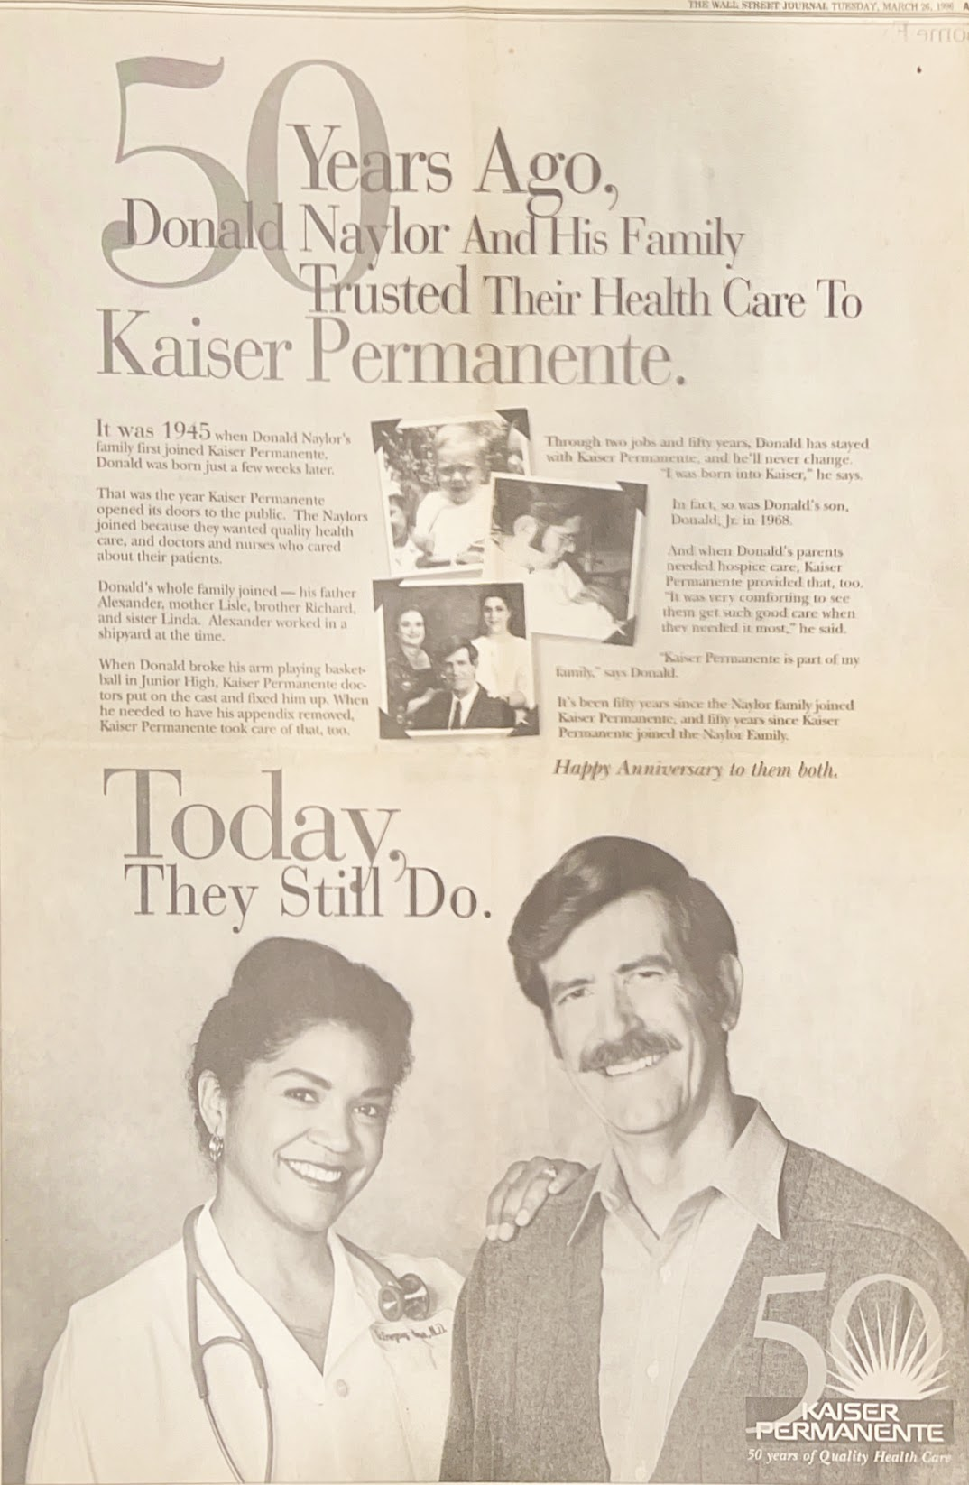  
Gina in a national Kaiser Permanente ad  
March 26, 1996**

## Chapter 18: Becoming Real

### Opening Scene (1995)

The digital clock on the nightstand glowed 6:17 AM when I first heard Maya's excited whisper to Jamil in the hallway. Their footsteps padded past our bedroom door, hushed but vibrating with barely contained energy.

"Mama, is Santa here?" Maya's stage whisper carried through the door.

"Shh, let's wait for Dad," Gina murmured back.

I pulled the comforter over my head, creating a cave of darkness. The weight pressed against my chest, not just fabric, but the accumulation of a thousand small failures. What terrified me most wasn't failing at the performance, but the possibility that there was nothing authentic beneath it.

Gina's side of the bed dipped as she sat beside me. "Derrick, it's almost seven. The kids have been up since six."

Her voice was carefully neutral, devoid of the frustration I knew she must feel. I grunted in response, still hidden.

"They're waiting," she added softly.

When Maya's voice finally called from downstairs, "Daddddd?! Santa came!", the plaintive note pierced through my fog. I pictured them cross-legged by the tree we'd decorated together, their eyes scanning the presents. They weren't waiting for Santa. They were waiting, for me.

With mechanical movements, I swung my legs over the side of the bed.

### The Professional Self (1988-1990)

At SGI, I'd found a professional identity that clicked into place naturally. I was valued for my mind, my problem-solving abilities, and my collaborative spirit. I belonged without explanation.

The elevator doors opened at building 6, and I stepped into a scene that still felt surreal. Engineers in t-shirts and shorts sprawled across bean bag chairs, arguing passionately about RISC vs CISC architecture. A unicycle leaned against a whiteboard covered in equations.

"Burns!" Rick called from across the lobby.

"We need you for the football team. Defensive line."

Later that day, hunched over a keyboard with Vince, we attacked a memory allocation bug. My fingers flew across the keys, finding that sweet spot where mathematics met real-world problems. Unlike my struggles with theoretical CS courses, this felt natural.

"Got it," I announced as the code finally ran clean.

Walking back to my desk, I passed offices with revolutionary graphics machines. Each one held Marc's innovation inside. A smile formed on my face. The emerging 3D graphics powerhouse was founded by a Black man from the midwest! Someone had already been here, had already excelled.

That Friday, during our pickup basketball game, I blocked Kirk's shot with more force than necessary, sending the ball sailing into the bleachers.

"Damn, Derrick!" Kirk laughed, jogging after the ball.

"Save some for the other team." James tossed me the ball.

"Pick and roll."

For once, I didn't need to borrow moves or channel someone else's confidence. I just played, fully, authentically me.

### Unexpected Fatherhood (1990)

Sunday morning sunlight filtered through our kitchen blinds. Gina pushed her untouched toast away and sipped water instead of coffee.

"You okay?" I asked, glancing up from the newspaper.

"Not really."

When she emerged, her face was pale, holding a white plastic stick with a small window in its center.

"I'm pregnant."

The kitchen clock ticked. Five, six, seven seconds of silence.

"Say something," she whispered.

My mouth went dry.

"You're sure?"

Inside, I screamed: "A baby! I am a grad student. I am not ready!"

"That's wonderful," I exclaimed!

My hand reached for hers, squeezing with an actor's precision.

### Learning to Be Real (1990-1992)

When they placed Maya in my arms, time suspended. A full head of hair crowned her tiny face, eyes finding mine with an intensity that felt like recognition. Her tiny fingers wrapped around my index finger with the gravity of a question I wasn't yet ready to answer.

For the first time, I saw a face like mine. As an adopted child with no biological mirrors in my family, this connection hit me with unexpected force. Growing up as a "mixed" child had been like being an extraterrestrial visitor, dropped into humanity without a clear lineage. Questions of "What are you?" had always haunted me, not from a place of racial identity, but from a deeper alienation of seeming to lack visible roots.

Now, looking at Maya, I finally had an answer to the lifelong question "What are you?", I am her father. Her features echoed mine, a biological connection that anchored me to Earth in a way I'd never before experienced.

But parenthood offered no clear parameters like my work at SGI. Maya's demands interrupted the mental focus that made me successful professionally. While debugging code required uninterrupted thought, parenting demanded constant context-switching and emotional presence I hadn't yet learned to provide.

At nine months, Maya was walking. Jamil arrived in 1992, earning his nickname "Mr. Smiley" with an infectious laugh that could transform my darkest moods. Where Maya demanded attention, Jamil absorbed the world around him, simultaneously curious and cautious.

Gina's challenges became clearer to me. One evening, after a particularly grueling shift, she dropped her hospital bag and leaned against the kitchen counter. "Doctor Coleman asked if I was 'planning to stay committed' after having the kids," she said, her voice flat. "As if motherhood was some kind of professional weakness."

She was juggling a demanding medical career while raising our kids, navigating a world where someone like her, Black, female, working mother, wasn't who her colleagues pictured when they thought "doctor."

I saw her exhaustion, her quiet defiance. I admired her strength but didn't know how to truly support her.

### Moments of Truth

That June 1995 evening, I knelt on the floor reassembling the kids' bunk bed. Maya watched critically.

"Dad, you are doing it wrong," she said matter-of-factly.

For a moment, I felt that familiar defensiveness rise. But something in her expectant face stopped me.

"You know what? You're right," I admitted. "Let's fix it together."

Her smile contained no judgment, only delight at collaboration. We spent the next hour rebuilding, Maya handing me exactly the right screws without being asked. When we finished, the bed stood perfectly.

"We did good, Dad," she declared, patting my hand.

In that moment, we weren't performing roles, but simply working together, seeing and responding to each other's needs without pretense. The relief of that authentic connection felt like coming up for air after swimming underwater too long.

### Looking Forward

Sitting there on Christmas morning, I felt like I was watching someone else's life through glass. I had everything I was supposed to want, yet something was missing.

Maya's handprint, painted in SGI's blue and green, hung on the wall, a "World's Best Dad" plaque that felt more like a challenge than a celebration. At work, I wrote clean code that made machines sing; at home, I struggled to decode my own children's needs.

My search for identity, as an adopted son, as a father, was really one journey. Who am I beneath the performances and expectations? Perhaps in seeking answers, I might finally learn to be present, to be real.

The man who hid under the covers that morning was still learning how to emerge. The hardest role I'd ever have to play, I was beginning to understand, wasn't a role at all, it was simply being myself.

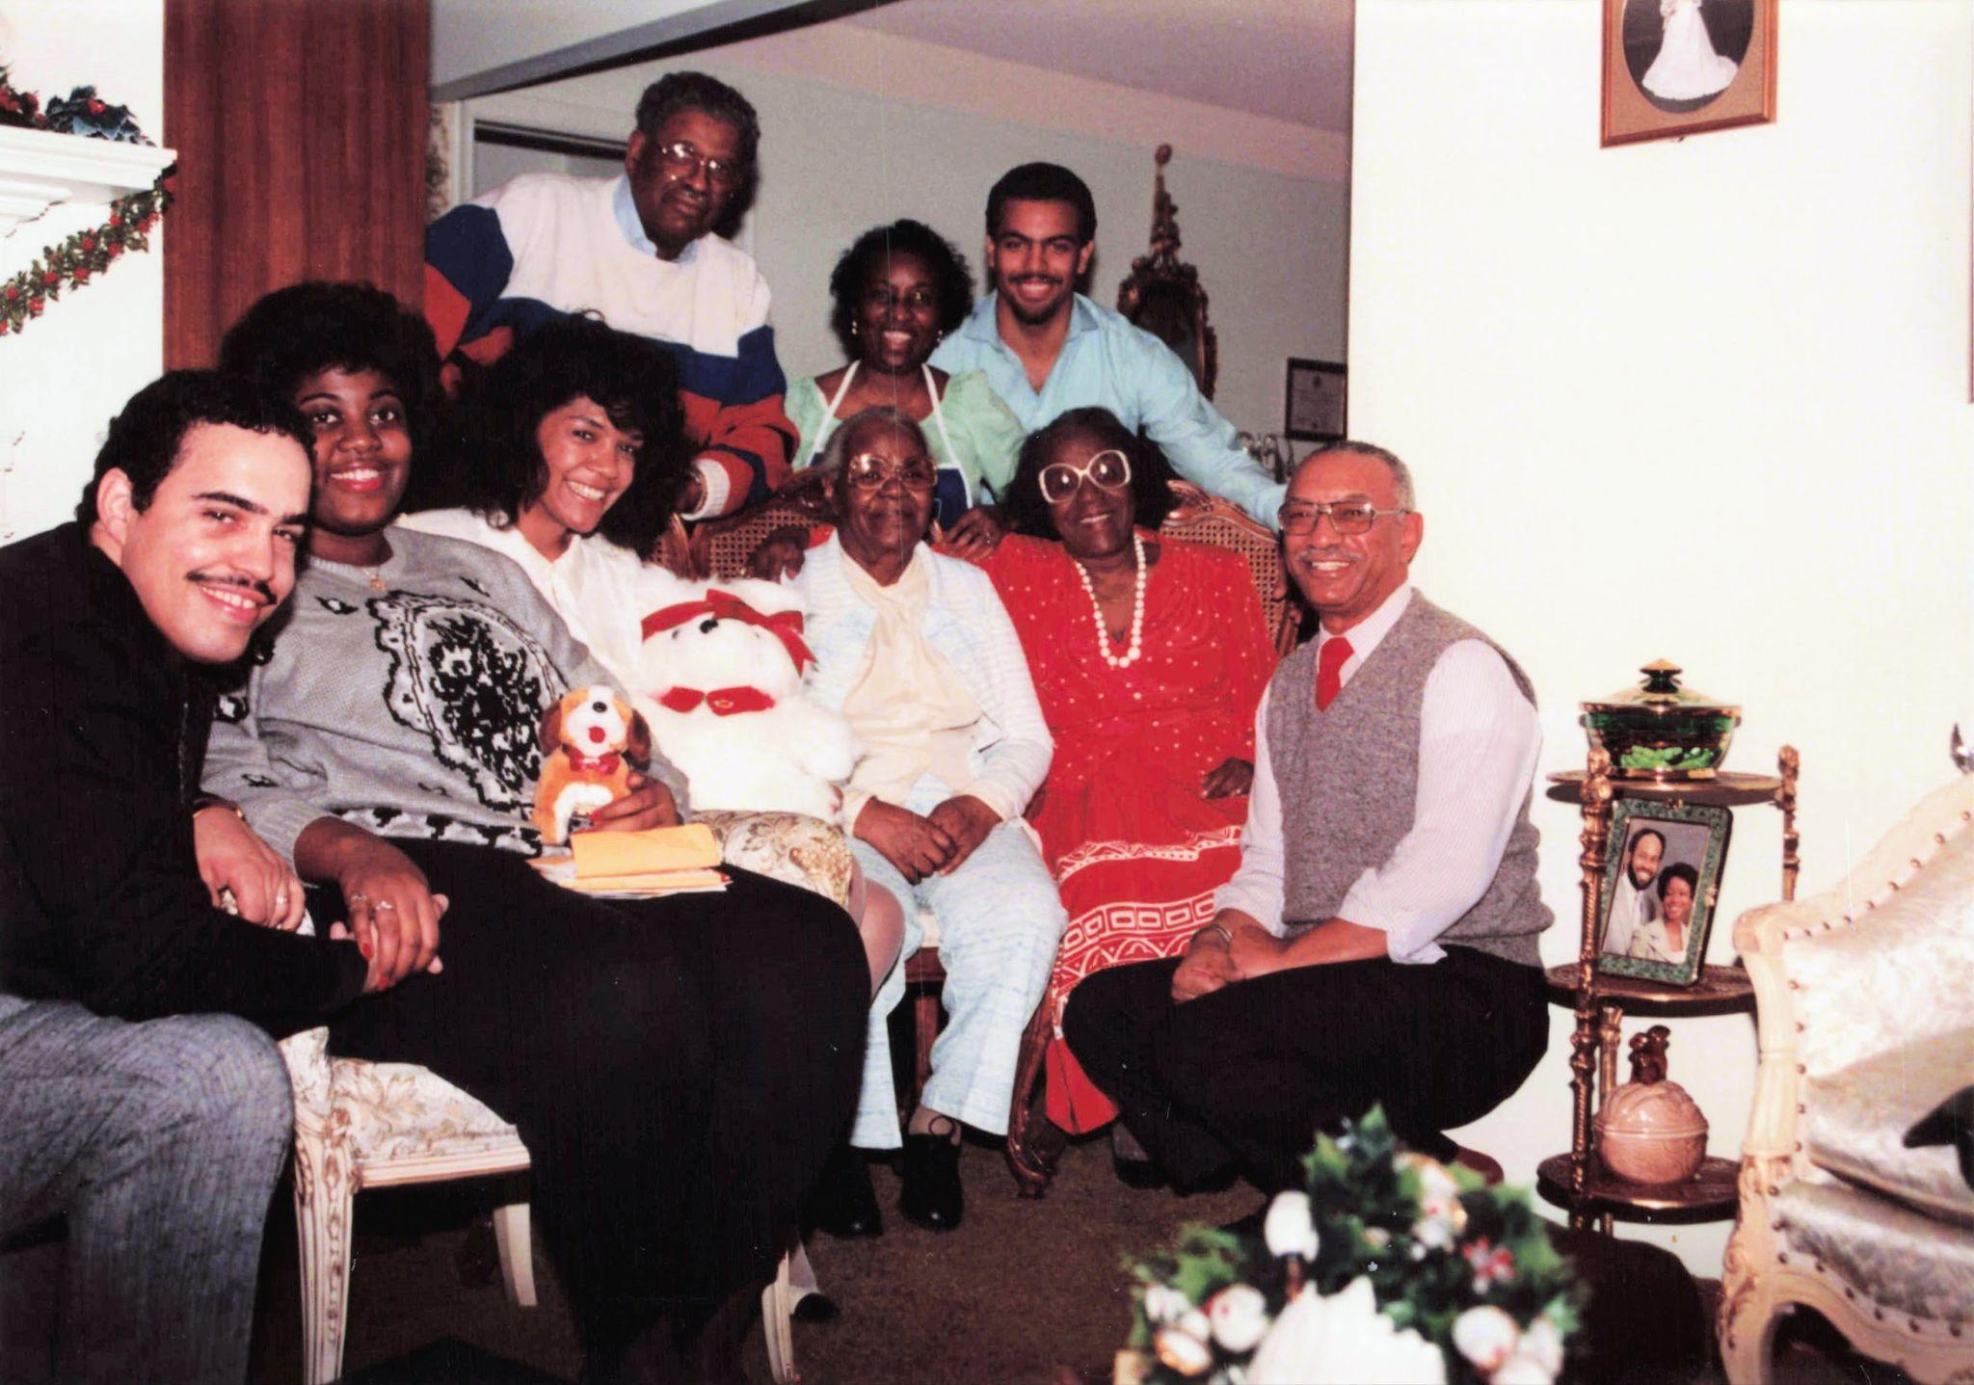

***Standing/Back*: Henry Rogers (Uncle Bubba), Willa Burns (Mom), Derrick Burns (me)  
*Front*: Dave Burns, Renee Burns (Dave’s wife), Gina, Lucille Pryor (Cille), Mildred Rogers (Aunt Mildred), Howard Burns (Dad)**  
**c. Dec 25, 1990**

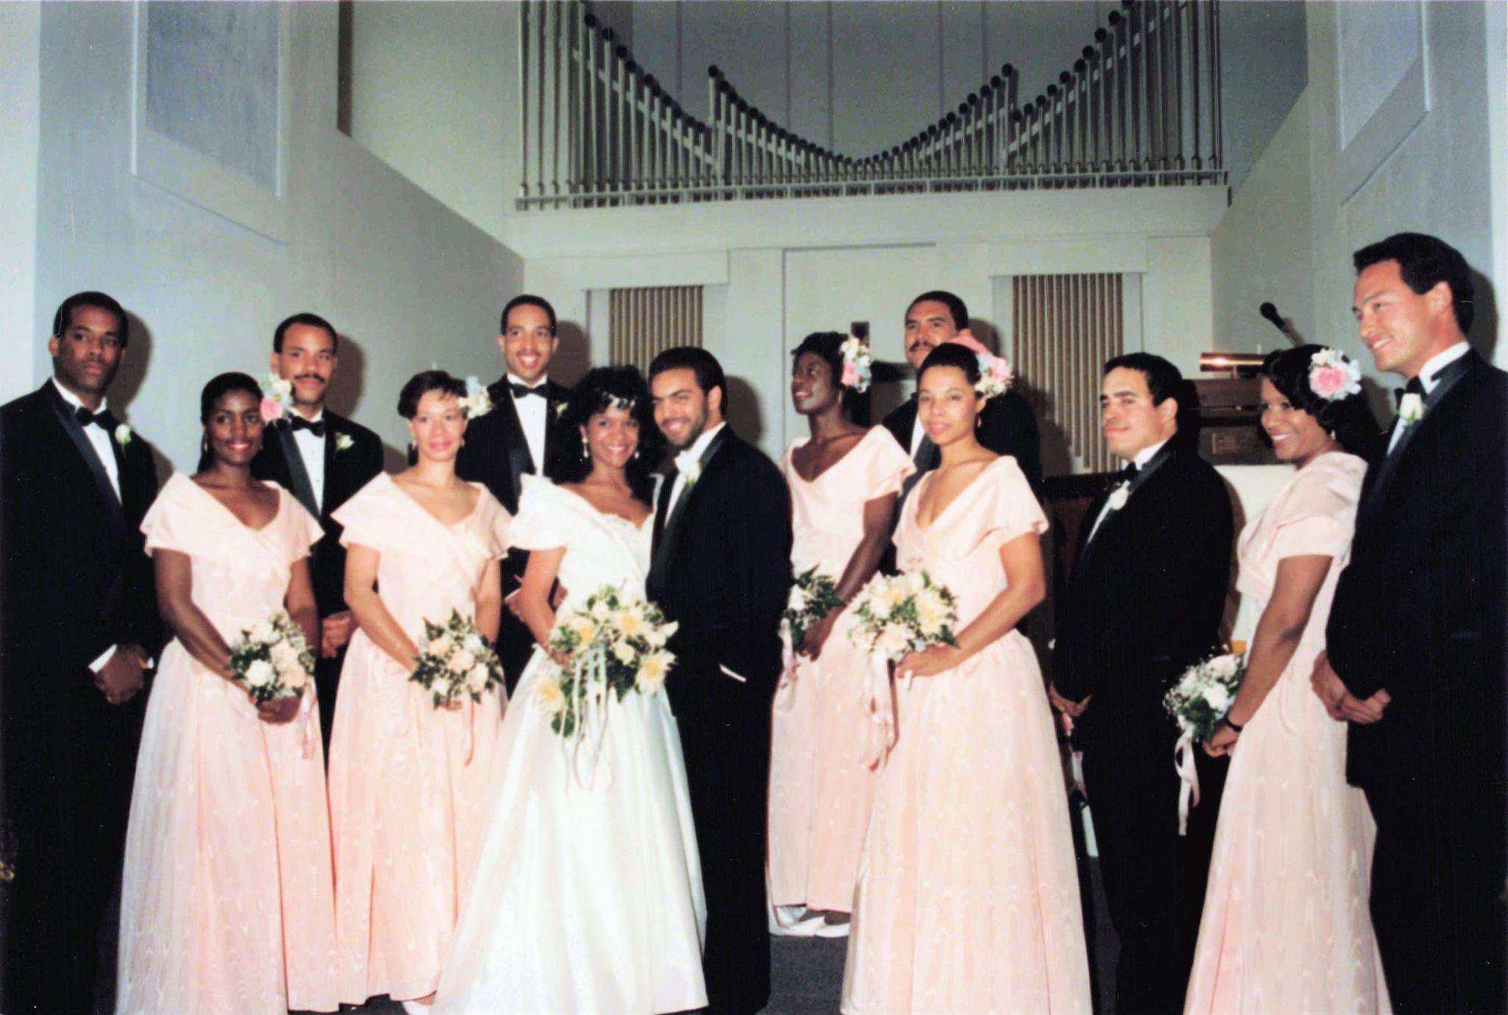  
***Groomsmen*: Patrick Lawrence, James Raby, James Latham, Hugh Gregory, David Burns (Jala), Vince Nakayama  
*Bridesmaids*: Brenda Carr, Cheryl Grills, Dayna Matthew, June Cross, Wendy Snypes**  
April 28, 1990

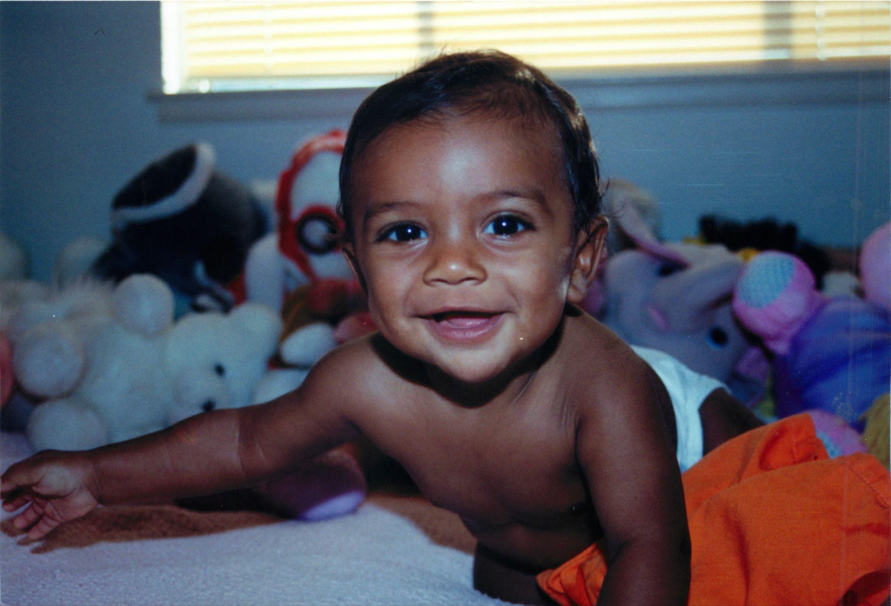  
**“Mr. Smiley”, Baby Jamil Burns**  
**c. May, 1993**

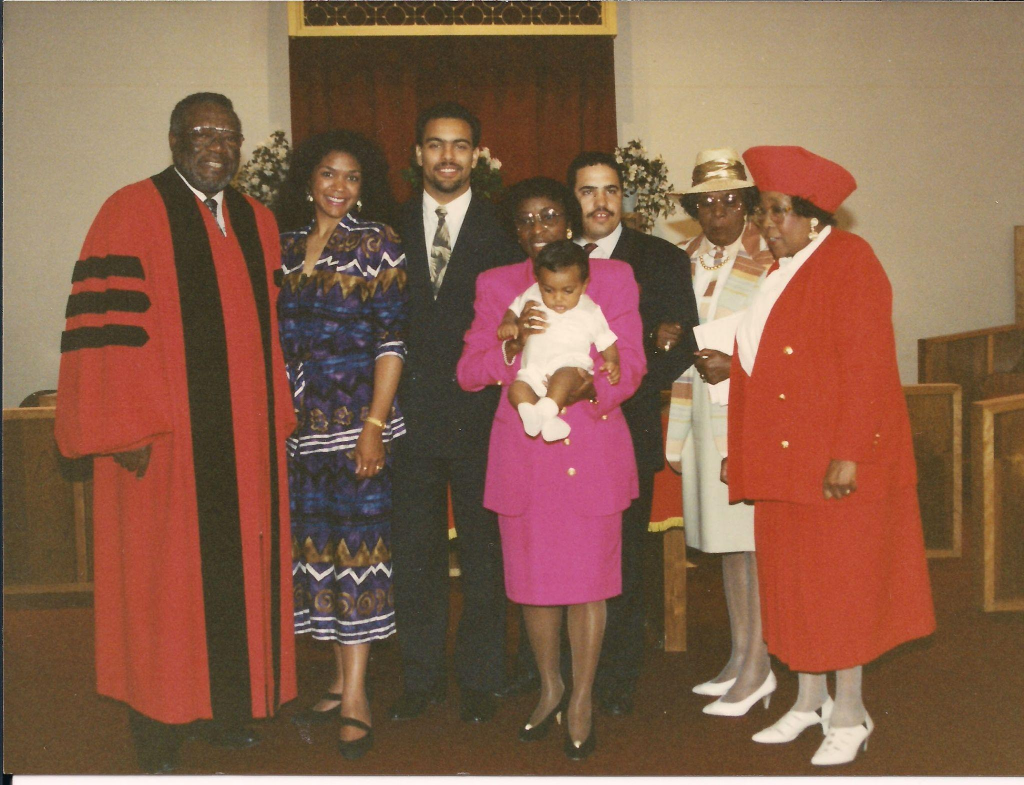

**Rev. Doctor Charles Morton, Doctor Gina Gregory Burns, Derrick Burns, Mrs. Willa Burns, David Burns (Jala McKenzie Burns), Mrs. Mildred Rogers, and Mrs. Virginia Donaldson, c. May 1993**

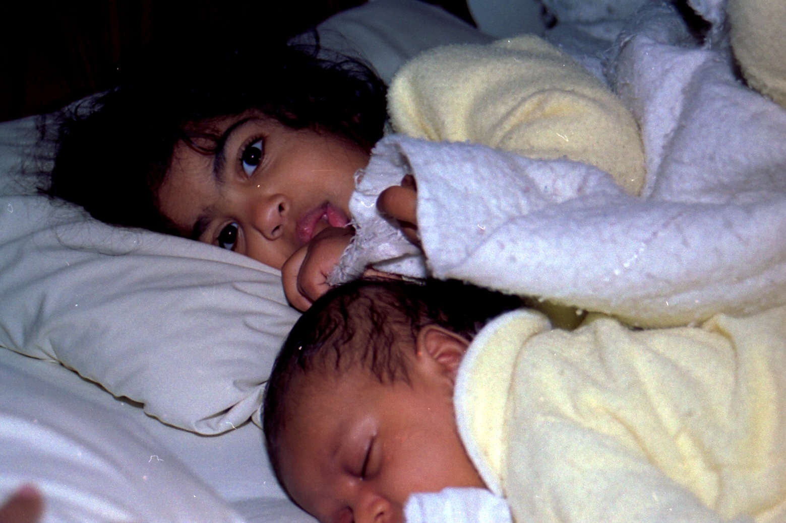

**Baby Maya looking out for Baby Jamil  
c. January 1993**

## Chapter 19: What Blood Remembers

### Unearthing the First Fragments

"That's ME!"

The words nearly escaped my lips as I stared at Marcia Rosenberg's face in the 1958 Mumford High yearbook. After thirty-three years, I finally saw someone who shared my blood. But this moment was only the culmination of a journey that had begun years earlier, with a simple question.

When Mom forwarded me the March 22, 1990 letter from the Detroit Probate Court detailing an interview with my birth mother at Florence Crittenton Hospital, my throat tightened as I unfolded the pages. The report revealed two startling truths: I was born to a Jewish woman and a black man in 1964 Detroit, a product of two distinct cultural traditions that had somehow found each other across racial boundaries rarely crossed in that era.

I read and reread this description of my birth father:

*She said he was born in 1938 of Negro parentage in Michigan and reared in the Episcopalian faith. He is described as a 6' 2" tall young man, slim, and very good looking, and altogether very personable. He is said to have friends and, as noted above, his achievements are outstanding. He presently feels very rejected by his mother. He is the only boy in the family. He has an older sister.*

*After completing high school he enrolled at a prestigious white university out-of-state and graduated with a Bachelor of Arts cum laude. He subsequently completed his law degree at another prestigious university. He is presently in private practice.*

As a Princeton graduate who grew up in Michigan, I correctly translated "prestigious white university out-of-state" to mean an Ivy League university. But I missed a crucial clue in the next line. "Another prestigious university" did not mean another Ivy League school. The writer had specifically mentioned "out-of-state" for the undergraduate degree but omitted it when describing the law school, a detail that would prove decisive years later.

### The Legal Maze and the Cost of Searching

Between 1990 and 1997, I pursued this quest without the benefit of online databases, often leaving my wife and young children behind for law library research sessions in Redwood City or trips back to Detroit. On weekends, I shifted from writing complex code at work to combing through legal directories, two tasks requiring the same exacting focus. Guilt weighed on me as I recognized I was approaching this personal quest with the same analytical rigor I applied to coding, often at my family's expense.

Maya arrived on October 11, 1990, and Jamil followed on November 5, 1992. Even as my family expanded, questions about my own origins haunted me.

"Do what you need to do," Gina told me one evening, her silhouette framed in the doorway as I gathered my notes for another law library expedition. Her words registered, but little else. Blinded by obsession, I missed the quiet resignation and weariness crossing her face, a burden she carried silently. The pull of potential discovery eclipsed the impact of my absence.

"What will you do if you find him?" she asked once, looking up from a medical journal.

"I just need to know," I said, my voice catching slightly.

She studied my face for a moment, then nodded, understanding something I couldn't yet articulate.

"Then keep looking."

Her hand squeezed mine briefly before returning to her reading.

Looking back now, I finally see that Gina's support never wavered, though it surely came at a cost invisible to me then. The same woman who navigated the pressures of being a black female physician somehow carried our family's emotional weight as well, supporting my search with strength I didn't fully appreciate at the time. My obsession with finding my past left me unable to see the sacrifices happening right in front of me.

All my life, I'd navigated questions about my light skin, straight hair, and hazel eyes, only to discover that my heritage was more complex than I'd imagined. The discovery of my Jewish maternal lineage didn't alter my black identity, but it illuminated why I never quite fit the categories others imposed upon me.

I'd spent my life like a puzzle piece that didn't quite fit in any box, edges too rounded here, too sharp there, only to discover I belonged to a different puzzle altogether.

I came to understand later that there had been unconscious connections all along, at Princeton, most of my closest friends had been either black or Jewish, a pattern I'd never examined until learning about my birth mother. The irony wasn't lost on me that I'd grown up feeling disconnected from humanity, like "an alien," when I actually had connections to two groups who understood what it meant to be marginalized while striving to maintain their identity and dignity.

For a person who had grown up fielding constant questions about "what" I was, this report wasn't just data, it was affirmation. The ambiguity that had followed me through childhood playgrounds and college campuses wasn't a mistake; it was a deliberate combination of specific people with specific histories.

Later, my birth father's sister would ask, "Why didn't you search for your birth mother first?" The question haunted me because I had never even considered searching for my maternal side first. The choice to seek my paternal lineage had been instinctive, like a compass needle swinging north, responding to a magnetic pull beyond conscious thought or decision. Perhaps because I'd grown up in a black family, finding my black birth father felt like finding the biological connection to the cultural identity that felt like home.

### ALMA: A Path Through the Labyrinth

Discovering the Adoptees' Liberty Movement Association (ALMA) stirred the same excitement I'd felt years earlier when I found the Bell Labs scholarship. Founded in 1971 by fellow adoptee Florence Fisher, ALMA was one of the earliest and most vocal advocates for adoptees' rights in America.

What moved me wasn't the discovery of other adoptees, I had known many throughout my childhood. What struck me was finding a movement, a collective voice demanding change. Here were adults like me who had grown up loved and cherished, yet still felt entitled to know their origins.

As I reviewed ALMA's materials, I gained perspective on why finding my birth parents had been so difficult. My birth in 1964 had placed me at the center of multiple colliding social forces, during a moment when adoption practices were beginning to shift but hadn't yet transformed.

Michigan's adoption laws created what advocates called a "donut hole" period, affecting adoptees born between May 28, 1945, and September 12, 1980. While adoptees born before or after this period could access their original birth certificates unless a birth parent explicitly objected, those of us caught in this window faced a different reality. We needed each birth parent to have proactively filed a statement of consent with the Central Adoption Registry, or we'd need to pursue a court order, a bureaucratic mountain designed to be nearly impossible to climb.

ALMA's lobbying efforts revealed crucial changes to Michigan's adoption laws, particularly Section 710.27, which defined "recognizable information." The law created an absurd paradox: requests for records must not reveal personal details, yet were required to disclose all non-identifying data.

This revelation led to an important insight, the report I'd received in 1990 couldn't be the original document, as it was printed in a modern typeface. Someone had retyped it, raising the question: what hidden details might the original document contain that had been deemed too identifying to share?

### The Breakthrough After Years of Silence

By late 1995, the landscape had shifted. Maya had started kindergarten, her backpack almost too big for her small frame, while three-year-old Jamil constructed elaborate block cities in the living room. Their growing independence created space for me to reignite my search with renewed determination.

Throughout my search, the three thousand miles between California and Michigan created a particular rhythm to how I shared my progress with my parents. Dad, whose quiet strength had always been my north star, would often ask, "Any news about your search?" His question came as a genuine interest in this chapter of my life.

What I appreciated most was how Dad never made me feel that my search reflected poorly on him as a father. His questions weren't tinged with insecurity but with the same curious intelligence he brought to everything. These brief affirmations, coming across the phone line in his familiar baritone, carried surprising weight.

During my visits to Detroit, these long-distance exchanges would transform. Sitting in the living room where I'd grown up, I'd sometimes catch him watching me with an expression I couldn't quite define, not concern, exactly, but a quiet assessment. In those moments, I realized that Dad was witnessing my search not as a rejection of my upbringing, but as an extension of the independent thinking he and Mom had always encouraged.

Mom's approach was different. She rarely revealed vulnerability, and my intuition suggested that her brave suggestion to search stemmed more from a sense of parental duty than personal desire. Her pragmatism had always been her strength and her shield, and I found myself protecting her emotions just as she had always protected mine. Their unspoken support allowed me the freedom to search without the burden of their feelings, a final parenting gift I only recognized years later.

By September 1995, I had renewed my search with fresh determination. Over the next year, a frustrating dance with bureaucracy ensued. Letters and meetings with officials at the Probate Court led only to polite responses that my "social file" was lost. After exhausting standard avenues, I decided to pivot. Presuming my birth father practiced law in Michigan, I reached out to Mr. Edward J. Littlejohn, the historian of the Wolverine Bar Association, in November 1996.

Then on January 4, 1997, the unexpected happened. Ms. Evanski called with news that a copy of my social file had been recorded at the Family Independence Agency. She offered to request a copy and forward it to me.

The envelope arrived on January 23, 1997, thin, official, unassuming. I held it for several minutes before opening it, running my fingers along the sealed edge. This ordinary paper might contain the key to everything. Finally, with an unsteady breath, I tore it open and unfolded the pages, revealing a copy of the long-missing social file. Although all names were redacted, the names of schools were included:

*…had graduated from Harvard College in 1960 and the University of Michigan Law School in 1963.*

### The Discovery and the Void

A jolt of recognition ran through me. I immediately called Mr. Littlejohn to share the new findings. A month later, on February 24, 1997, he faxed me a list of seven names and their academic credentials. Among them, only one person matched all the criteria: William Burton Golden, whose educational background perfectly aligned with every hint from my social file. Here, finally, was the name I had been seeking.

For the next two days, I returned to the legal directories with renewed purpose, methodically scanning for William Burton Golden. To my growing frustration, I found no trace of him. The elation of discovery gave way to confusion, how could a Harvard graduate and University of Michigan Law School alumnus simply vanish from legal records?

Then a possibility I had never considered in all my years of investigation suddenly dawned on me, what if he was no longer alive?

With trembling fingers, I navigated to the Social Security Death Index on February 26, 1997. My heart already knew what my mind refused to accept. There it was, William Burton Golden had died on May 18, 1971, in San Rafael, CA. He had always been "Burton" to his family, not William, a detail that explained why he had eluded my searches for years.

My stomach clenched, lungs emptied, as I stared numbly at the date on the screen: May 18, 1971. I had been robbed of possibility before knowing it existed. The shock was visceral, like being punched by an invisible fist. I had been seven years old when he died, still collecting matchbox cars and playing in Aunt Mae's yard, completely unaware that death had already sealed a door I hadn't yet discovered existed.

What hit me hardest wasn't just that I would never meet him, but that I had been robbed of even the possibility without knowing it. Years of searching, only to find... absence. Permanent and irrevocable.

But ghosts leave traces. William Burton Golden had lived. He had family. He had a story. And somewhere in that story was the beginning of mine.

### Traces of Ghosts and First Contact

When I called Mr. Littlejohn back, my voice was steadier than I expected. The news of William's death had changed everything, and nothing. I still needed to know.

Two days later, on March 3, 1997, Mr. Littlejohn faxed me an autobiographical sketch written by James R. Golden, William's father. A cold ripple passed through me as I held the paper. Here was something tangible, words written by my grandfather about his son, my father. Then came another revelation: William's sister, Mrs. Phyllis Butler, was a practicing lawyer in Detroit. Mr. Littlejohn provided her work address and phone number.

The pieces of the puzzle were falling into place, and the truth that had eluded me for so long was finally within reach. I stared at Phyllis Butler's phone number for a long time. This woman, my aunt, might not even know I existed. She had lived her life in Detroit, practicing law, while I grew up just miles away.

Now that I knew the identity of my birth father, I was faced with an unexpected conundrum. What was it that I truly sought?

My quest had evolved into something much deeper. Despite the boundless love and support from my family, I felt a persistent sense of being an "other." I was Derrick, an individual in a world where everyone else seemed to belong to a collective. I had no photographs of people who looked like me, no stories of ancestors to share.

Searching for my birth parents was like archaeology of the self, carefully brushing away decades of dust to reveal fragments of a forgotten civilization that somehow produced me.

Determined to fill this void, I reached out to my Aunt Phyllis by phone on March 5, 1997. "Hello, my name is Derrick Burns. You don't know me, but I have some news to share with you. I am your late brother's son."

Phyllis was understandably shocked and confused. "Is this a prank? Are you mistaken? Why are you calling me?" she asked, her voice tinged with disbelief. Realizing this wasn't the right time or place, she gave me her home phone number so we could talk more privately later.

During our second call, Phyllis confessed she knew nothing about her brother having a child. She speculated that perhaps I was the son of his girlfriend Susan, a white woman she remembered from those days.

I explained how I had uncovered the identity of her brother. I told her about my loving upbringing, my happy family with my wife and two children, my Ivy League education, and anything else I could think of to reassure her. I wanted her to know I wasn't after anything from her.

But deep down, I knew that wasn't entirely true. I did want something from Phyllis, though I couldn't quite articulate what it was. It certainly wasn't money; our careers provided comfortably for our needs. It wasn't love either. I had "wonderful loving parents," without a hint of sarcasm.

During our third call, Phyllis's demeanor abruptly shifted to hostility, her voice edged with suspicion born from years of fiercely guarding her family's past. "Why are you looking for your father? Most people seek their mother!" she snapped.

Phyllis's hostility stung, but I sensed beneath it a deeper fear, an instinctive guarding of family legacy. Her comment about seeking my mother struck a chord. Why hadn't I thought to look for my birth mother first? It had seemed natural to seek out my birth father, someone I identified with as a well-educated, presumably successful black man.

Nevertheless, it seemed this path was a dead end. Phyllis made it clear she didn't trust me or my motives. But even as she tried to shut the door, I detected something in her voice, guarded, but not fully closed, that suggested she wasn't done thinking about me. Questions clearly nagged at her: "Who was this young man who had reached out?" "Could he actually be a son of her deceased brother?" The uncertainty lingered, and with it, a thin thread of possibility.

### First Connection

My black lucent Merlin phone lit up at 7PM, an unusual hour for an outside line call.

"Hello, may I please speak to Derrick," the caller asked.

"This is he." "This is Karen Butler. I believe that you spoke to my mother Phyllis Butler."

"Hello Karen!" I said excitedly.

After my interactions with Phyllis, I had thought my quest had ended.

Her voice carried a warmth that contrasted sharply with her mother's defensive tone during our calls. Where Phyllis had been guarded, Karen's words flowed with genuine curiosity.

I later learned that Karen's decision to call hadn't been simple. Phyllis had mentioned our conversations to her daughter almost as a warning, be careful of this stranger claiming to be Burton's son. But Karen, analytical and fair-minded like the attorneys in her family, approached the situation differently. 'I thought you deserved at least a conversation,' she would tell me years later. 'Whatever the truth was, shutting the door completely didn't seem right.'

We met at Fishbones, a restaurant in Greektown that Karen had suggested. I arrived twenty minutes early, claiming a corner table where I could watch the door. My palms were damp despite the air conditioning. What if we had nothing in common? What if the connection I sought wasn't there?

When Karen walked in, time dilated. She navigated between tables with confident grace, scanning faces until our eyes locked across the crowded room. Something clicked instantly, not quite recognition, but an uncanny familiarity, as if meeting someone I'd known in a forgotten dream. Her light skin and curly hair reminded me not of myself, but of the girls I had found attractive during my adolescence. The ironic realization that she was "my type" made me chuckle inwardly, a bullet dodged indeed!

Our conversation that evening flowed with surprising ease. We discovered shared interests that went beyond coincidence. The ease with which we fell into intellectual rapport felt both strange and natural, we were strangers with the unconscious rhythms of family.

What struck me even more was the discovery of our overlapping social worlds. As we talked about Mercy High School, where she had attended, I realized we knew many of the same people. For the first time, I felt a bond with people who thought like me. Here was tangible proof of my intellectual roots, a family of analytical minds spanning generations.

That evening with Karen transformed my understanding of what I had been seeking all along. Beyond medical histories and biographical details, I had yearned for this precise feeling, recognition of self in another, the experience of intellectual kinship that went beyond mere genetic connection. As we parted that night, I realized I had found something more valuable than facts: I had found living proof that my analytical mind hadn't emerged from nowhere but had roots in a lineage I was only beginning to discover.

Our relationship developed gradually over the following years. We settled into a rhythm that suited us both, occasional phone calls, holiday cards, and sporadically shared family news.

### Uncovering My Father's Life

Through Karen and later conversations with Phyllis, I learned that my father had married a concert pianist named Althea Robinson. They had twin daughters, Angela and Jennifer, born in 1969. I had two half-sisters, one living in New York City near her mother and stepfather, the other teaching at Phillips Andover Academy in Massachusetts.

In April 1997, during a sabbatical from my job at Silicon Graphics, I decided to reach out to Althea. I wrote her a letter, and she called me a few days later. Our conversation was warm and open. She seemed genuinely pleased to hear from me and said she had much to tell me about Burton and his family when we could meet in person. She mentioned that Burton had been "treated" at the time of his death, a hint at circumstances I would learn more about later.

I planned a trip to New York City during my sabbatical to meet Althea and hopefully my half-sisters, though Karen had told me they weren't ready to meet me yet. Before my trip, I had sent an email to Angela at PC Magazine where she worked, but received no response.

### The Other Half of My Story

Meanwhile, my thoughts began to turn toward finding my birth mother. I had her birth date (April 13, 1941) and those of her two siblings from the social file. I also knew that her mother was born in Detroit. From the interview copy I received in January, I was able to deduce the number of letters in her first and last names.

I posted these facts to an internet mailing list of adoptees. Most responses were well-wishes, but one stood out. Daryl Royal from Dearborn, Michigan, who had also been born at Crittenton Hospital, suggested I examine the Detroit Legal News for birth notices of my birth mother and her siblings. He explained that back issues could be found at the Detroit Public Library.

On April 21, I began a 10-week sabbatical from Silicon Graphics, originally planning to work on home repairs and my dissertation. Instead, I found myself drawn into two life-changing pursuits: interviewing with Virage for a much-needed career change, and finally, seriously searching for my birth mother.

With my days free from corporate demands, I could fully dedicate myself to the search. Gina supported me wholeheartedly but worried about what it might stir up emotionally.

"Just be prepared for anything," she cautioned one night, her eyes meeting mine over her cup of tea.

"People have complex reasons for the choices they make."

### Discovering My Mother's Face

The moment I landed in Detroit, I felt a strange mixture of homecoming and hunting. This city had shaped both my adoptive life and, unknowingly, held the secrets of my biological beginnings, two separate worlds existing in the same geographic space for decades. I was no longer just a former resident returning; I was a detective seeking clues to my own existence.

By Wednesday, June 4, my search led me to the magnificent main branch of the Detroit Public Library on Woodward Avenue. As I approached the imposing Italian Renaissance structure, its white Vermont marble façade gleaming in the morning light, I felt both intimidated and hopeful. This architectural masterpiece housed secrets of my past within its walls.

Inside, I was directed to the Burton Historical Collection, its classical details and hushed reverence setting the stage for genealogical research. The ornate murals depicting Detroit's history seemed to watch over me as I explained my mission to the librarian, an older gentleman whose silver-rimmed glasses reflected genuine interest. "Forward searching is harder than backward," he noted with a knowing smile. "But you've come to the right place."

With the librarian's help, I methodically began searching for birth notices. Though the process was meticulous, each turn of a page tightened my chest with anticipation, these were more than old records; they were stepping-stones toward my own truth.

After hours of methodical work, I compiled female births from April 13, 1941, my birth mother's birth date. Only two surnames had nine letters, matching what I'd deduced. When I later found a matching name in the March 17, 1944 issue for my birth mother's sister's birth date, I felt the first electric thrill of discovery. The surname was Rosenberg, and both announcements shared the same address: 3314 Cortland in Detroit.

Each step of the way, adrenalin pumped harder throughout my body. My heart raced as I wondered if she would even want to know me after all these years, or if I was chasing a ghost who had long ago sealed away that chapter of her life. Yet the momentum carried me forward.

Using the Detroit City Directory, I connected the dots to identify my maternal grandparents. I called Jimmy Latham, my best friend from high school who was also adopted from Crittenton. His excited voice crackled through my phone, "Man, that's incredible! You're actually finding them!" His enthusiasm bolstered mine, he understood the significance in a way others couldn't.

A librarian suggested checking Mumford High School yearbooks, the school nearest my grandparents' Wisconsin Street address. As I turned the brittle pages of the 1958 edition, I was struck by how the school was virtually entirely white and predominantly Jewish, a stark contrast to the nearly all-Black Mumford of today.

The racial transformation of Mumford High, almost entirely white in Marcia's day but predominantly Black during mine, struck me deeply. I wondered how this shifting landscape had influenced her decisions and, ultimately, my fate. Had the tumultuous racial changes of 1960s Detroit shaped her choice to place me for adoption? These weren't just historical facts but the very context of my existence.

Among the June graduates, I found her: Marcia Rosenberg. I studied the photograph carefully, then froze. I was looking at my own face.

My peripheral vision vanished as I locked onto the image. My jaw dropped. "That's ME!" I wanted to scream in the hushed library.

My hands trembled as I stared into eyes that mirrored my own. After thirty-three years, I was finally seeing someone who shared my blood, my features, my genetic heritage. The sensation transcended surreal, like discovering a photograph of myself in a stranger's album, wearing clothes I'd never owned. What had begun as a methodical exercise in genealogy transformed in an instant into something viscerally personal. This wasn't just a woman in a yearbook, this was someone whose features I had carried with me every day of my life.

After finding Marcia's sister Sheryl in the '61 yearbook, I called Gina. "I found her," I said simply when she answered. There was a pause, then her voice, gentle and cautious: "How do you feel?" It was a loaded question, I hadn't fully processed my emotions yet. "Like I've opened a door I can't close," I replied. Gina, ever practical even while being supportive, helped me search online and discovered Irving and Ida Rosenberg living in West Bloomfield, just 30 miles away.

The next day dawned with renewed purpose. Before returning to the research, I visited my alma mater, U. of D. High School, where I had a touching reunion with Mrs. Mary Voss, the secretary whose maternal warmth had been a constant during my teenage years.

"Derrick Burns!" she exclaimed, using my adoptive name with that familiar blend of affection and authority.

"Look at you, all grown up and successful!"

Our conversation felt like a bridge between my established identity and the one I was now discovering.

Afterward, I drove by my birthmother's former house on Wisconsin Street, just four streets west of my high school. Standing outside her former house, the physical proximity felt both comforting and cruel, each familiar corner now imbued with newfound meaning. Wisconsin Street! Not some vague "Detroit" that actually meant the suburbs, this was the real Detroit, mere blocks from U of D where I'd spent my teenage years! The streets I'd walked daily, the neighborhood I knew intimately.

This geographic coincidence left me both cheated and oddly comforted. All those years searching for connection, and she had been literally around the corner. How many times had our paths nearly crossed? Had we passed each other on Livernois Avenue or at the corner store? I wondered how our lives might intersect once we finally met. Would we experience that same strange familiarity, like discovering a place you've somehow always known, even in your first visit?

At Mumford High School, I noticed something I'd missed in the yearbook, Marcia's middle initial: R. At the City-County building, I searched marriage records and found that Marcia Rene Rosenberg had married Robert Zelman Feldstein on August 27, 1961. They were later divorced, with the divorce finalized on October 1, 1963, just months before my birth in April 1964.

I also discovered that Marcia had married again, to Robert Joel Brown, on June 29, 1969. Both of Marcia's husbands were attorneys who had graduated from prestigious universities, adding another dimension to my understanding of my birth mother's life.

### The Final Connection

On May 9, 1997, Deborah Johnson was appointed as my "confidential search intermediary" by the Wayne County Probate Court. While I was still in Detroit on that June,searching through records, Deb called to tell me she had located my birth mother and had her phone number. She planned to call her on Monday, but I explained that I was leaving Detroit for New York on Saturday morning and would really like to see my birth mother on this trip if possible.

Deb agreed to contact her partner for permission to make the call sooner. She asked me to fax her the letter I had written to my birth mother so she could read it over the phone to her.

On June 5, 1997, I composed the most significant letter of my life, carefully balancing honesty with sensitivity, yearning with respect for boundaries.

*Dear Mother, I imagine that you are in a state of shock right now wondering is this really true, is this my son, and if so, why is he contacting me after all these years?*

*My search for you actually started seven years ago, when my wife became pregnant with our first child. My concerns arose from my heart not my head. After 26 years of looking at other people and seeing no one that looked like me, I faced the prospect of having my own child and seeing for the first time someone that looked like me.*

*Seven years later I continue my search. I know that you are near. I feel your presence and I yearn to reach out to see you.*

*I now have two wonderful children, a girl, age 6, and a boy, age 4. My wife and I are happily married and share a beautiful home in Northern California. We are both graduates of Ivy League schools. She is a physician and I am an engineering director at a Silicon Valley computer firm. My (adoptive) parents provided me with wonderful opportunities in life and I am eternally grateful.*

*You have a separate life now, one that does not include me. I do not wish to intrude on your life. I bear no ill will nor do I feel pain. I wish only to meet the woman that gave me life, and, if you are willing to get to know you. Please find it in your heart to see me.*

*Sincerely, Your son "Michael."*

I signed with the name she would remember, the name that existed only in that hospital room thirty-three years earlier, never used again until this moment of reconnection. My hands shook as I sealed the envelope, unsure if these words would bridge decades of silence or disappear into it.

When Deb called Marcia that evening, she refused to confirm her identity or acknowledge having a child on April 6, 1964. She expressed outrage at being called so late at night but did take Deb's phone number.

Still dejected but determined, I explored other avenues, but each led nowhere, deepening my frustration.

### The Letter That Bridged Decades

Then, on June 13, 1997, everything changed. I was packing for my New York trip, folding dress shirts into my suitcase, when the phone rang. It was Deb Johnson. Her voice had a different quality this time, a mixture of excitement and caution.

"Derrick, she wants to talk to you."

"Your birth mother wants immediate phone contact."

My hands froze mid-fold. The shirt dropped to the bed, forgotten.

"She wrote you a letter today," Deb continued.

"I'm going to fax it over right now."

I stood by the fax machine, watching as the paper emerged inch by inch, as if the machine itself understood the weight of the moment and was deliberately slow-walking this revelation. The mechanical whir seemed deafening in the quiet house. What words could possibly bridge thirty-three years of silence? What could explain the decisions made before I had memory, choices that had shaped the entire trajectory of my life?

The letterhead emerged first, simple, professional, followed by neat, controlled handwriting. A mother's handwriting. My mother's handwriting.

I carried the warm pages to my desk, aware of their physical presence in a way I rarely noticed with documents. These weren't just words; they were artifacts from a parallel life, the life I might have lived, the mother I might have known.

As I unfolded the faxed pages, I controlled my breathing deliberately. This was not another research document to be quickly analyzed for relevant data points. This was a moment to be experienced fully, a rare intersection of lives long separated.

I began reading:

*Dearest Derrick,*

*I have waited thirty-three years to write this letter. My search for you, like yours, began in my heart, it began April 6, 1964. Initially, Debbie's call left me in shock, marked by fear of being denied once again.*

*Listening carefully as Debbie read your letter twice, I finally decided to trust in the resilience of our lost hearts. I am a risk-taker, and clearly, so are you.*

*An image of a glass wall with a beautiful baby boy runs through my life. Your words have touched me as no others ever have, connecting past and present, the child, the name, the mother.*

*My prayers have always been that your adoptive parents would surround you with safety, security, and abundant love.*

*And you're married with children! In a single day, we have potentially expanded our families and opened our hearts further.*

*I wish you love, I wish you life.*

*And the happiest of Father's Days to you.*

My first reading was clinical, detached, a defense mechanism. The language felt careful, even performative, as though written by someone cautious about revealing too much. I set the letter down, unsettled.

I walked to the window, watching a neighbor drag their garbage can to the curb, such an ordinary moment in contrast to the extraordinary one unfolding in my office.

Returning moments later, something shifted. Beyond careful phrasing, I sensed a familiar emotional cadence, the guarded way she balanced vulnerability with self-protection. It was the same rhythmic dance I performed in my own emotional life, the same tendency to intellectualize feelings rather than simply feel them.

The realization struck me with unexpected force: this guarded approach to emotional expression wasn't just similar to mine, it was mine. Or rather, I had inherited it from her, carried it in my blood without ever knowing its source. This careful, measured reaching out was as much a genetic inheritance as my eyes or the shape of my hands.

"An image of a glass wall with a beautiful baby boy runs through my life," she had written. I understood suddenly that she had been searching too, in her way, carrying the weight of our separation just as I had, peering through her own metaphorical glass barriers.

I sank back in my chair, the letter trembling slightly in my hands. The room seemed too quiet, too still for such a momentous revelation. This wasn't just my birth mother; this was someone whose emotional DNA I carried, whose particular way of moving through the world mirrored my own.

The skepticism I had initially felt toward her careful phrasing dissolved as I recognized it as the same careful performance I had engaged in throughout my life, the striving to be perfect, to say the right thing, to present the ideal version of myself to the world. We both created facades, protective barriers against potential rejection. We were strangers connected by blood and, it seemed, by temperament, two cautious people reaching tentatively across decades of absence.

I had spent my entire life wondering where my particular traits came from, why I approached emotional situations with such careful analysis, why I processed feelings through the filter of intellect before allowing myself to experience them directly. Here, in this letter's measured tones and carefully selected phrasings, I recognized the source.

I reached for the phone, not yet sure what I would say to this woman who had carried me for nine months only to place me into another life entirely. But I knew with sudden clarity that whatever happened next, I would be speaking to someone who understood a fundamental truth about me that even my beloved adoptive family could never fully grasp, the particular way my mind and heart worked in tandem, the specific rhythm of my emotional cadence.

The connection I had sought for seven years wasn't just about physical resemblance or medical history. It was about finding the sources of my deepest patterns, the origins of how I moved through the world. In this carefully composed letter with its measured vulnerability, I had found exactly that, a mirror reflecting not just my features, but my emotional architecture.

I dialed the number Deb had provided, listening to each ring with a strange combination of terror and anticipation. After thirty-three years of separation, what would be the first words between a mother and the son she had given away?

### Acceptance From Beyond

In the years that followed, I developed relationships with both sides of my birth family. While my journey to find my birth father had led me to the discovery that he had died in 1971, I found connection through his sister Phyllis and her daughter Karen.

After addressing Phyllis' criticism and finding my birth mother, Phyllis and Marcia visited my parents' home to meet my village: Aunt Mildred, Uncle Bubba, Mom's sister Vivian, Mary Debardelaben and her three girls, Jala and her son Joshua.

Then, in 2006, nine years after our first contact, Karen called to tell me her mother, my Aunt Phyllis, had passed away. "She left you something in her will," Karen said, her voice gentle with the news.

The revelation struck me deeply. Phyllis, who had initially feared I had financial motives for finding my birth father, had left me a bequest. I didn't need or want money, had never wanted it, but this posthumous gesture spoke volumes.

This transformation had happened largely beyond my view, revealed only through Karen's occasional comments. "She asked about you, you know," Karen had mentioned the previous Christmas. "Wanted to know how your kids were doing in school."

The bequest, modest financially but immeasurable in meaning, testified to a private journey Phyllis had undertaken since our difficult early calls. She had traveled from rejection to acceptance, from suspicion to acknowledgment. More than money, she had quietly written me into the family narrative she had guarded so carefully for decades.

As I formed the words in my mind to decline the gift, Karen reassured me that the amount was insignificant and wouldn't impact her life. She simply explained that it was her mother's wish for me to have something from the family and encouraged me to accept it.

Despite my initial awkwardness, I realized this was a clear sign of acceptance from both Karen and Phyllis. It symbolized that I did belong. Grateful for this gesture of inclusion, I accepted the gift, feeling that another piece of my identity had fallen into place.

### Coming Full Circle

As I hung up the phone after talking with Karen, I sat quietly in my home office, surrounded by family photos, Maya and Jamil's school portraits, wedding pictures, snapshots from family vacations. Among them now stood a small framed photo Phyllis had given me, my father Burton as a young boy sitting on the lap of Joe Louis, the 'Brown Bomber', his expression seeking, open, and inquisitive.

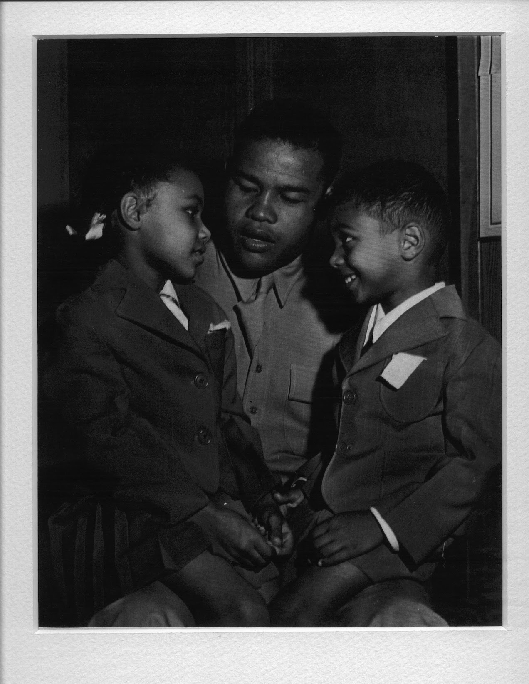

**Aunt Phyllis, Joe Louis, and William Burton Golden (My Birthfather)   
c. 1943**

The journey to find my birth father had taken me from microfilm readers to court documents, from disappointment to discovery, from isolation to connection. What began as a search for medical information had evolved into something far more profound, a quest to understand the complex tapestry of heritage and circumstance that had shaped my existence.

What I found was both less and more than I had imagined, not a living man but a legacy, not answers to all my questions but a family connection I hadn't known I was missing.

As Maya called me for dinner, I placed Burton's photo back on the shelf, beside the snapshots of Maya and Jamil, as if he'd always belonged there. I joined my family, the one I had created, the one that mattered most in my daily life. The past had given me new understanding, but my future continued to unfold in the present moments with the people who knew me not by blood or birth, but by choice and love.

Uncovering Marcia, my birth father's legacy, and Aunt Phyllis's acceptance connected me deeply to a past I'd sought for decades. It wasn't simple or singular, but it was mine, complete, complex, and finally known.

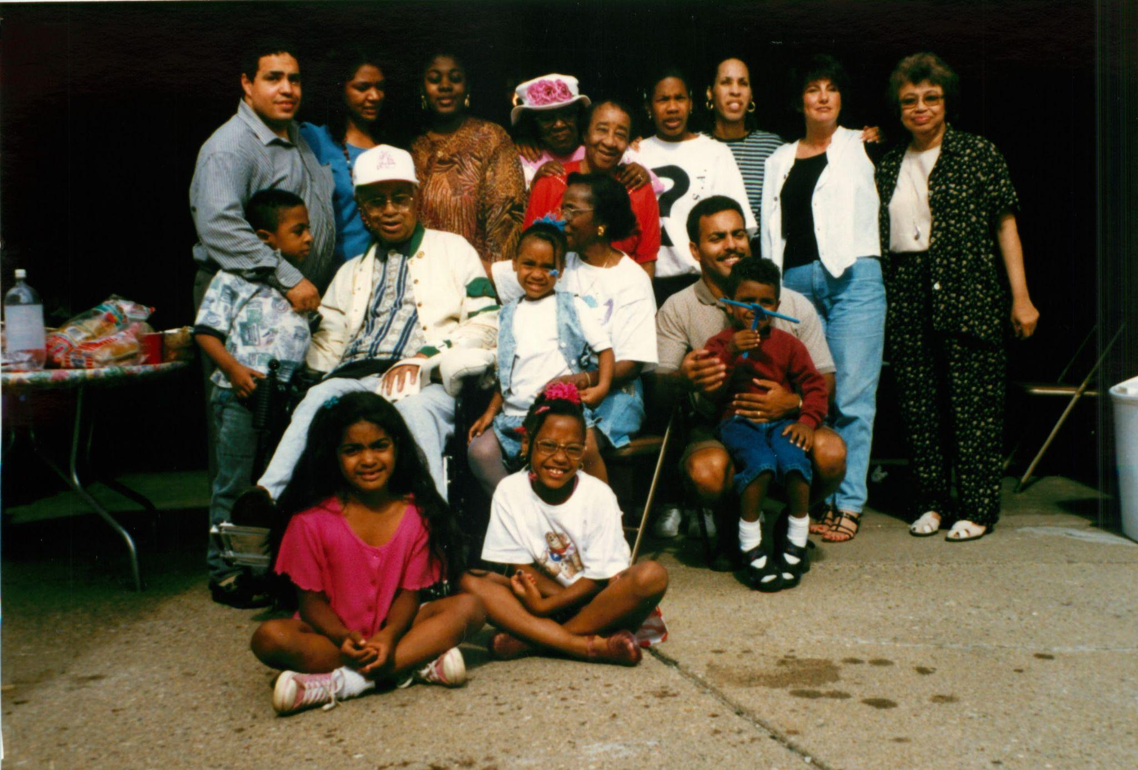

**My village:** Jala, Gina, Renee, Aunt Mildred, Aunt Vivian, Erika, Mary, Marcia, Phyllis (back row)  
Josh, Dad, Jessica, Mom, Derrick, Jamil  
Maya, Mary’s middle child  
**July 4, 1997**

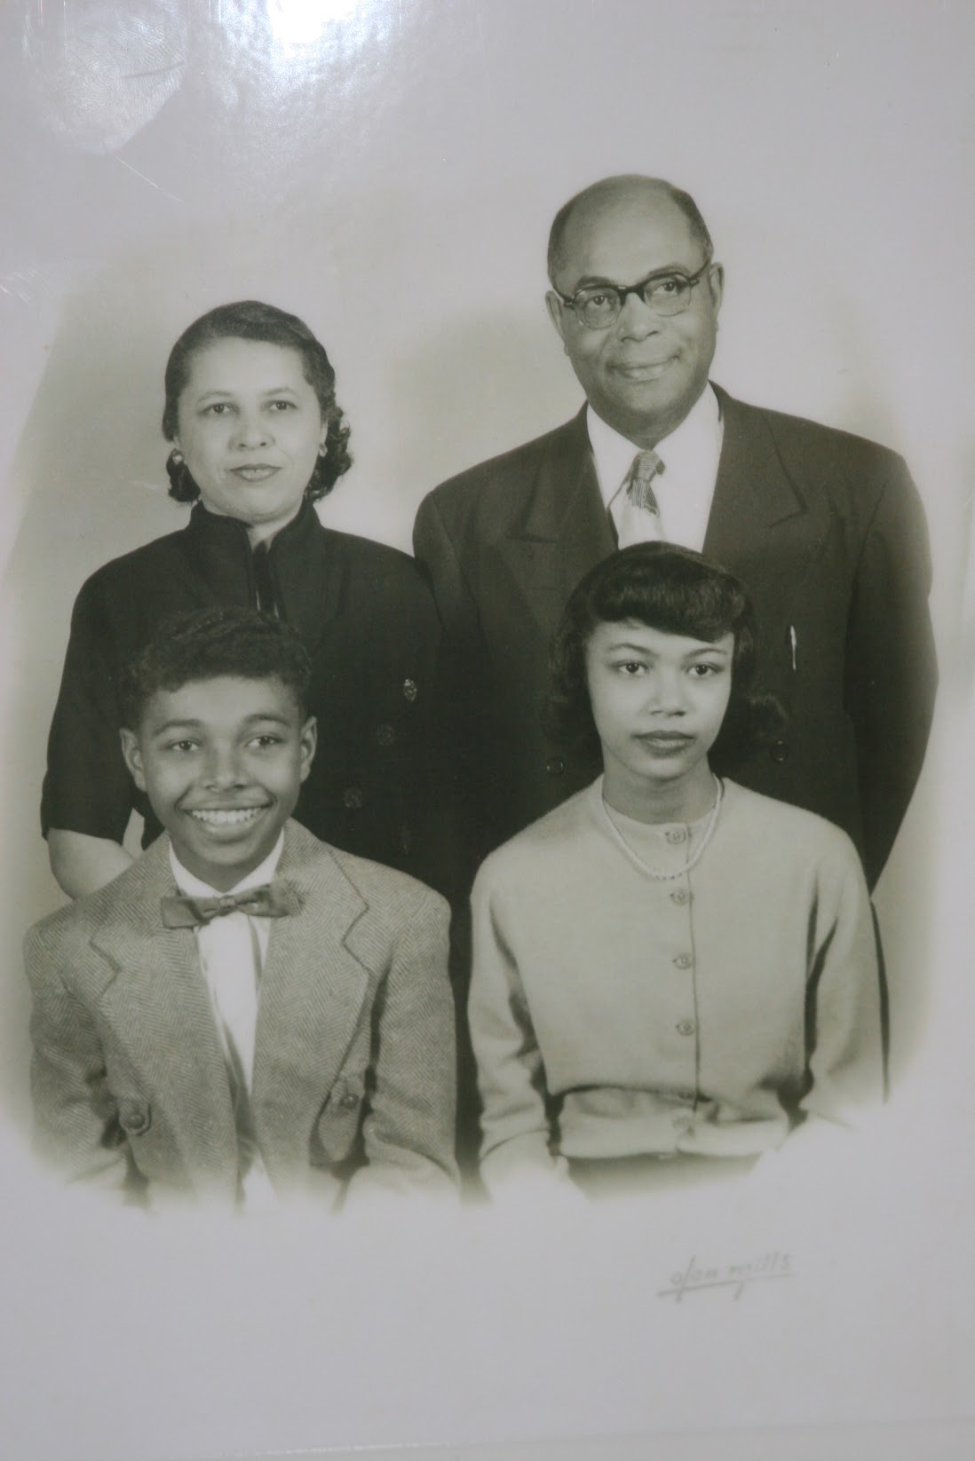

**Evelyn Maxine Golden (nee Burton), James Richard Golden  
Willam Burton Golden, Phyllis Ann Golden  
c. 1951**

## Chapter 20: What Love Complicates

### First Meeting - July 1997

Very few of us can recall meeting our mother for the first time. The concept seems odd. She is the woman who's there from the literal start of life. So when I say, "I can recall meeting my birth mother for the first time," it feels as strange to me as it might to you.

After receiving her letter in June, I began calling her "Marcia," as we had agreed. We arranged to meet in early July at her apartment in Birmingham, Michigan. As I hung up the phone after our brief conversation, a wave of nerves hit me. What would she think of me? How would I feel when I finally saw her face? A part of me longed to close the gap between us, but another part of me was terrified of what I might find when I did.

The days leading up to our meeting were filled with conflicting emotions. I found myself wondering which traits I had inherited from her, beyond the physical resemblance I'd seen in her yearbook photo. Did she share my analytical mind? My occasional bouts of melancholy? My love of puzzles and problem-solving? Or would we be strangers in every way except biology?

I also thought about what this meeting might mean for my relationship with Mom and Dad, who had raised me. They had been supportive of my search, but I wondered if they felt any sense of loss or worry. Mom had initiated my search seven(?)years earlier, a gesture of profound generosity that showed she understood my love for her wouldn't diminish.

Approaching Marcia's Woodward Avenue apartment, I felt a mix of excitement and trepidation. Though she knew I existed, I still expected her to be in shock. Our reunion was decades in the making, seven years of my searching, 33 years of her fearing discovery.

I rang the bell, my heart pounding. Moments later, the door swung open, and there she was, Marcia, the woman whose face I had studied in the Mumford High School yearbook, the same striking figure from the photos she'd sent me. Those images captured her in happier times, moments filled with joy, fun, and the kind of normalcy that seemed distant now. But this moment was anything but normal. Awkwardness lingered in the air, a tension shaped by decades of separation and unspoken questions.

"Hello, I'm Derrick," I offered, trying to steady my voice.

She stood silently in the entryway of her apartment, unable to speak. With a nod, she stepped aside. Inside, everything was white, the couches draped with oversized fluffy pillows, brass and glass end tables holding large lamps. Artwork lined the walls, but what caught my eye was a single photo: her daughter, my half-sister, Cara.

When she finally spoke a minute or two later, her words came slowly, as if her mouth was full of cotton.

"Let me get some water. Would you like a glass?" Her voice was soft, tentative.

"Yes, please," I said, remembering the manners Mom had taught me.

As she moved toward the kitchen, I took in her apartment. The decor reflected a refined aesthetic, abstract paintings, art books on the coffee table, soft white modern furniture. It signaled a world I understood: educated, cultured, intellectual. It was no different from the world my mother had crafted for me, no different from the one I had entered at Princeton. But in Detroit, I had never occupied these spaces when they were inhabited by white or Jewish families, familiar cultural worlds I had long observed, but never entered.

She returned with water and showed me old photos of herself, confirming what the social worker had described: stunningly beautiful, with long auburn hair and hazel eyes. In those photos, I saw the features I had inherited, the shape of her eyes, the high cheekbones, the curve of her smile.

She explained that she had lived in the apartment for a few years after returning from Connecticut following her divorce from her third husband, Lawrence. She initially went back to their home in Michigan, but on a school psychologist's income, she couldn't afford the mortgage or upkeep. I learned she taught English literature at a private school, a career she had pursued after her second divorce.

She spoke with measured calm, not guarded, but deliberate, like someone medicated just enough to stay afloat. Anxiety seemed to shadow her.

She pointed to a picture of her daughter with Lawrence, Cara, who was ten years younger than me.

"That's one of the few pictures I have of Cara wearing makeup," she said, her tone slightly judgmental.

"She is lovely," I said, looking at the photo for traces of myself.

I wondered what Cara knew of me, if she might someday want to know her half-brother.

As I absorbed the moment, I was struck by how utterly strange it all felt. It reminded me of stepping out of the car when I arrived at Princeton, not knowing which direction to walk in, but knowing I was where I was meant to be. I knew I was about to embark on a journey without a clear destination. Though I spoke, I kept my feelings to myself. I felt oddly hollow, present, but not fully there.

Our first meeting lasted about three hours. As I left, she hugged me, brief, tentative, and heavy with decades of silence. We agreed to stay in touch, though neither of us seemed ready to define what that would mean.

### The Honeymoon Phase

Over the next few months, our relationship blossomed with an intensity that surprised us both. We were hungry for knowledge of each other, eager to compress decades of absence into days and weeks of connection.

Marcia wanted to know everything about my childhood, about Gina, about my life in Detroit and at Princeton. I'd share stories for what felt like hours, and she would listen with rapt attention, perhaps trying to piece together the chapters of my life she had missed.

Soon, we were talking for hours each day as I drove to and from work. These conversations became a central part of my routine, a new relationship that consumed much of my emotional energy. The questions became more personal, her feedback more direct. I welcomed her curiosity, her fresh perspective.

I also found myself grappling with the new dimensions of my identity. Learning about my Jewish heritage opened up questions I had never considered. What did it mean to be both Black and Jewish? What does it mean to be Jewish?

I purchased books: "How To Be a Jew" by Sherwin Cohen, "The Vanishing American Jew" by Alan M. Dershowitz, "A History of the Jews in America" by Howard M. Sachar, "Telling and Remembering: A Century of Jewish Poetry" edited by Steven J. Rubin, "Jewish Renewal" by Michael Lerner, "What Do Jews Believe" by Davis S. Ariel, "What is a Jew" by Rabbi Morris N. Kertzer, and "World of Our Fathers" by Irving Howe.

I would delight in the purchase, read the first few pages, mentally catalog its value, and move on to the next shiny thing. My interest in Judaism was like my interest in climate change or the history of Cuba. I wanted the knowledge, but had no real use for it in my life. If it did not change my decisions, my actions, what good was the knowledge? Marcia was Jewish, her use of Yiddish words to me signaled her cultural affinity, but her experience was familial and cultural, not religious or historical. These treasures, my new books, offered no help with the real challenge that I faced: connecting with Marcia.

I did not integrate Judaism into my cultural practice during these years with Marcia, but I relished each new Yiddish word that she shared with me. I was a mensch one day and meshuggeneh the next. These linguistic gifts became small cultural touchpoints between us, fragments of her heritage that she passed on to me, even as we struggled to build a stable relationship. The Yiddish expressions, with their emotional richness and cultural resonance, offered a connection that went beyond our complicated personal dynamics, linking me to a heritage that was part of my biological story even if it wasn't part of my daily practice.

During this time, I found myself navigating multiple identities and loyalties. I called Mom every Sunday as I always had, but now I spoke to Marcia almost daily. I didn't tell Mom about the frequency of my calls with Marcia, feeling somehow that it might hurt her. This created a strange compartmentalization in my life, one that I wasn't entirely comfortable with but didn't know how to resolve.

Marcia told me that her uncle Sid was a Zionist who led fundraising efforts in the Detroit Area. My opinions were incompletely formed, but Zionism felt like colonialism to me, so I maintained my silence.

These moments revealed fault lines in our worldviews that no amount of shared biology could bridge, differences shaped by our distinct lived experiences and perspectives.

When Marcia called, I would go to another room, seeking privacy and intimacy. I felt like I was cheating, but how can one cheat with one's own mother? The intensity of our connection defied easy categorization - it had the secrecy of an affair, the desperation of lost love, and the complications of trying to compress thirty-three years of absence into daily phone calls.

During our "honeymoon phase" with Marcia, Gina and Marcia talked most mornings, developing their own relationship independent of me. Their connection seemed to complement the one I was building with Marcia, creating a web of relationships that felt, for a time, like they might integrate seamlessly into our family life.

### Growing Tensions

Gina stood by silently as I spoke on the phone to Marcia. While she did not voice her thoughts, her body language spoke volumes. I was pouring myself into my interests yet again, just like coding and searching for Burton, leaving her to take care of the kids.

Gina tired of my lack of attention to the family. She was overwhelmed by the changes that she could neither control nor predict. As a spouse, she supported me, but it was clearly difficult. Love, hate, swings. Exhausting. The unknown of life was playing out for us all.

My obsession with Marcia was creating distance in my primary relationship, though I was too consumed to fully recognize it at the time.

The reunion rippled through the entire family, affecting my children in ways I hadn't fully anticipated. When my four-year-old son Jamil asked Marcia, "How do I know that you won't leave me too?", the innocence and depth of his question struck us all. It revealed how even the youngest members of our family were processing this complicated new relationship, grappling with concepts of permanence and abandonment.

Gina assumed the role of protector of our children's emotions. We all struggled with being Black in a city that was only 3% Black, but now came the additional question: what did it mean for our kids to suddenly have a Jewish grandmother? Gina became the translator, helping our children navigate these complex waters of identity and belonging that had suddenly become even more intricate.

As Marcia's behavior became more unpredictable, Gina spent hours on the phone with her, trying to guide her toward healthier communication patterns. When there were blowups, misperceptions, fears of not being included, lack of respect, Gina would mediate, asking Marcia to pause before exploding. She explained to our children why their Jewish grandmother sometimes disappeared for months. This placed additional emotional labor on Gina's shoulders, managing relationships that were not her own while still dealing with how this new dynamic was affecting our home life.

But Marcia could flip in an instant.

### The Breaking Points

Ironically, one such flip was over genealogy.

Years later, I eagerly entered my family history into an online genealogy site and invited relatives to contribute. In my enthusiasm, I included not just my own details, but hers as well, including her past marriages. That was a mistake.

"You are a horrible man!" she shouted, her voice trembling with fury, and something deeper, something older than just this moment.

"Don't call me!" she commanded.

Her email to me afterward revealed the depth of her feelings:

*It was thoughtless of you to provide my personal background information, w/o my input and/or permission, to genealogy websites. Especially because (1) I am your birth Mother; (2) You knew AND/or should have known how disturbing an effect making public that info would have on me…*

*My marital/partnership history is no one's business. Please remove them. Please.*

The email meandered through past grievances before concluding,

*It's time for us to go our separate ways... Just please leave me and my name and marital history alone and off websites.*

Yet even in this message of severance, she signed off, "Love, Marcia."

I was stunned by the intensity of her reaction. What I had seen as a way to connect our family histories, she experienced as a profound violation of her privacy. Her three marriages and divorces were painful chapters in her life, not data points to be cataloged online. In my enthusiasm to document our newly discovered connection, I had inadvertently exposed wounds that were still raw for her

No apology would satisfy her. And so began a six-month time out.

Other conflicts followed the same pattern - a Christmas card featuring my adoptive mother triggered another explosive email, as did any perceived slight or exclusion. Each message contained the same whiplash between attack and affection: "You are a MEAN person" followed by "I truly love you."

The breaking point came when Marcia sent a particularly harsh email about Maya.

"I've been patient," Gina said, her voice steady but final. "I've tried to understand her pain, I've mediated her conflicts with you, I've explained to our children why their Jewish grandmother sometimes disappears for months. But I will not let her attack our daughter. I'm done. I don't say that lightly. I rarely cut people off, but I am DONE."

During one of our estrangements from Marcia, my phone rang.

"It's for you," Gina said, holding out the receiver. "It's Mom."

"I thought she was calling you these days."

"She was. But I told her she needed to work things out with you directly. I'm not going to be the communication hub for your family anymore. That's not my job, and it's not healthy for any of us."

It wasn't until much later, when my half-sister Cara confided in me, that I fully grasped the depth of Marcia's pain. Cara had distanced herself from me during those rifts, trying to avoid the pressure of justifying our relationship to Marcia.

As all this unfolded, Cara maintained a safe distance. While she did not avoid my overtures to connect, she did not initiate any of her own volition. She later told me, "I would not know when it was safe to mention your name to Marcia. I didn't want to lie, so I simply avoided interacting with you. It had nothing to do with you and me."

This revelation illuminated yet another ripple effect of my complicated relationship with Marcia, how it forced Cara to navigate treacherous emotional waters. Marcia's deep emotional insecurity and constant fear of betrayal isolated her from the people she loved, including Cara, who was caught in the middle of our rocky relationship.

### Learning and Growing

Over the years, my heart ached for Marcia. She was tragically insecure, always on guard for the next imagined betrayal. My son Jamil once remarked, "How could she be any different?" That question unlocked a new understanding for me, one that led me straight to empathy.

I saw parts of myself in Marcia. I, too, am sensitive to feeling excluded or ignored. I remember times when I would be talking to someone, only for another person to walk up, ignore me, and take over the conversation. I often blamed those moments on racism, which only fueled my anger. This interpretation wasn't necessarily wrong, racism certainly played a role in some of these interactions, but focusing solely on external factors sometimes prevented me from examining my own sensitivities and reactions.

Marcia took it even further, transforming her anger into verbal attacks. Where I might withdraw or seethe silently, she would lash out, burning bridges with those closest to her. Recognizing this pattern in her helped me see echoes of my own tendencies toward oversensitivity and withdrawal, prompting me to work on healthier responses to feeling excluded or overlooked.

In the aftermath of our turbulent relationship, I made a promise to myself: I would confront my own relationship issues directly. I refused to repeat the cycles of enrapture and estrangement that had defined Marcia's life.

The strain with Marcia had lasting effects on my marriage that Gina and I never addressed directly. As I emotionally neglected the kids during my obsession with Marcia, Gina's role as protector broadened. She filled the void I created, becoming their primary emotional anchor. Worse, when I later attempted to engage in disciplining, I perceived her as an impediment. Reaching agreement on how to parent became harder and harder. The ripple effects of my relationship with Marcia had created fault lines in our family structure that would take years to fully understand.

Time softened the sharpest edges, and in their place, understanding took root.

Meeting Marcia didn't just answer questions about my origins; it revealed patterns I'd inherited or adopted. Her intense need for belonging mirrored my own. Her explosive responses to exclusion echoed my own tendencies to withdraw or classify people as enemies. Most revealing was recognizing my pattern of pouring myself into obsessions - coding, searching for Burton, now Marcia - as a way to avoid family responsibilities and emotional complexity.

It was the same disconnection I felt during our first meeting, present physically while emotionally hovering at a distance. I'd developed this skill long before meeting Marcia: retreating to abstract, emotion-free worlds like writing software, where logic prevailed and messy feelings couldn't intrude. In these spaces, I knew exactly what would happen when I typed a command. People, relationships, emotions - these were unpredictable, uncontrollable. So I spent as much time as possible in environments I could manage, where the stakes felt high but the emotional demands remained low.

The way I managed my relationships with Mom and Marcia, calling Mom weekly while speaking with Marcia daily without telling Mom, reflected perhaps my most refined skill: compartmentalization. Throughout my life, I've separated different aspects of my identity and experiences into distinct mental containers that rarely interact. This ability served as both strength and weakness, allowing me to function in multiple worlds but preventing the integration necessary for wholeness.

Marcia and I never had the effortless comfort that exists between my Mom and me, that relationship built on decades of daily care and unconditional love. But we have forged something meaningful in its own right, a connection that honors both our biological bond and the complex history that separated and eventually reunited us.

Understanding Marcia helped me understand myself: where I'd come from, where I was stuck, and where I still had room to grow. That awareness didn't erase the past, but it offered something harder to come by: the clarity to parent differently, to love more bravely, to remain present even when emotions ran high.

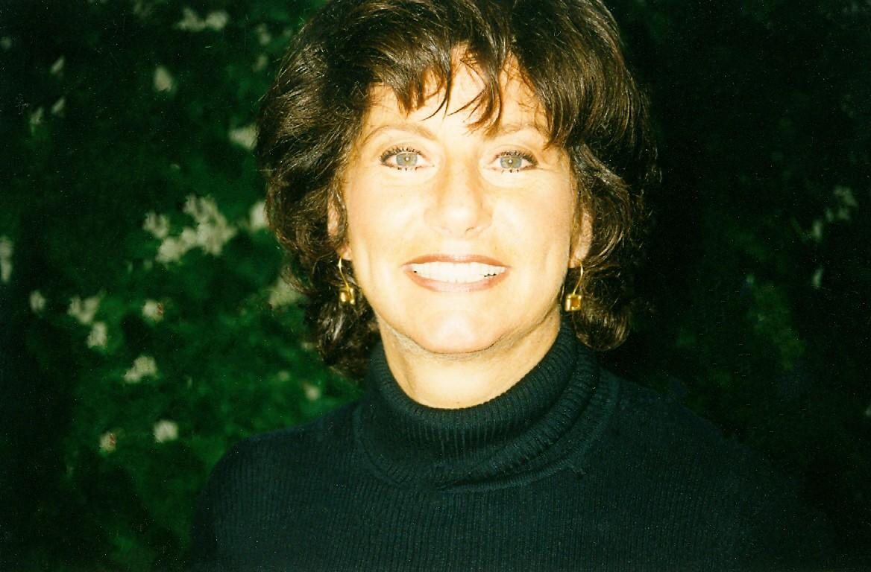

**Birthmother Marcia Rosenberg  
c. 1980**

## Chapter 21: Beyond the Algorithm: How Technical Excellence Wasn't Enough

### 1993

"No one has ever done this before."

Marc's whispered words, half in French, half in awe, filled the cramped demo room as The Terminator's face froze mid-sentence on our monitor. With a click, I rewound the scene. Another click—fast forward. Pause. Play.

We had built Netflix in 1993, a decade before it would exist. We weren't even sure we could make it work, but Frank and I had made it work.

"Frank!!! You are the man!" I shouted, unable to contain my excitement.

"Naw, you are DB," Frank responded with his slight New York/West Indian accent.

### Learning the Rules (1990–1992)

By 1990, I had established myself as a respected software engineer at Silicon Graphics. The proof sat right there on my desk: a stack of SIGGRAPH conference paper submissions waiting for my review. SIGGRAPH was the Olympics of computer graphics—and they were asking me to judge the competition. The irony wasn't lost on me.

Between compile runs, I'd pull another paper from the stack, scribbling notes in the margins. Some were brilliant, others barely coherent. This was the life I had dreamed of: being at the cutting edge of technology, my opinions valued, my expertise recognized.

That recognition, however, proved more complicated than I expected. Months after completing the paper reviews, Dan stuck his head in my office.

"Alan submitted a paper to SIGGRAPH. Did you know about that?"

"What? No I didn't!"

I walked to Alan's office. "Did you really submit a paper without my knowledge?"

He wasn't there, but I got my answer when I received a preprint. There it was—our algorithm, the one I'd spent months implementing, debugging, perfecting. Alan had contributed some basic theory, sure, but theory alone doesn't make software run. Every technical detail matched what we'd built together. But under the title, only Alan's name appeared.

I kept my mouth shut, not quite sure where I stood, but knowing any drama from me would only damage my reputation. A colleague, seeing my distress, offered advice I never forgot: "Don't wrestle with a pig; the pig will like it, and you'll only get dirty." So I swallowed my rage and buried the disappointment. Each time I saw Alan on campus, that familiar anger surged. Even success in Silicon Valley, I realized, came with a bitter aftertaste. Alan left SGI a year later, and gradually, I learned to let the burden go.

Still, I was beginning to see that SGI wasn't as straightforward as I'd believed. I had arrived thinking that good work spoke for itself, but now I was watching office politics unfold in real time. I kept quiet about Alan's theft to avoid being labeled difficult, but the experience shook my belief that technical excellence was all that mattered. There seemed to be an unwritten rulebook everyone else had read.

### The Vision (Early 1993)

Television in 1993 was completely passive—you watched whatever was on, when it was on. No pausing, no skipping, no control. The idea that you could browse movies like a menu, hit pause, rewind, or fast-forward sounded like science fiction.

Then Time Warner called. They had a vision, and they wanted SGI to help build it.

Their project was called the Full Service Network, and it aimed to be the first true interactive television platform. It would launch in Orlando, Florida, and beam digital content—movies, games, shopping, educational programming—into thousands of homes over a fiber-optic network.

We were building tomorrow with technology that barely existed, turning $5,000 SGI workstations into set-top boxes when standard cable boxes cost under $250. But we weren't building for cost—we were building to prove it was possible.

I was the third engineer on the team and there from the beginning. As the project grew, so did my role as the team leader building the software that would make it all work. I interviewed hundreds of candidates, often serving as the closer because I was best at selling SGI's culture. And I meant every word—I loved working there.

Kirk introduced me to his friend Frank, someone he knew from his East Coast days. Frank and his wife Celeste were ready for a change, and he was a perfect fit: always smiling, endlessly positive, and adaptable, the kind of person who thrived in SGI's unstructured chaos.

I also tapped the most talented engineer I knew at SGI: Kevin P. Smith.   
  
“Seem ambitious,” Kevin said, echoing the sentiment he expressed toward another previous project that I had undertaken.  
  
“Yep,” I chuckled, “this one is too, but I need your help to build it.”

Kevin, Steve, Sunita, Frank, and I became a team. We thrived on the challenge of building software for what we hoped would become the set-top box that changed everything.

### Breaking Through the Impossible

"Derrick man, I can't get this driver to work," Frank said one afternoon, frustration evident as he struggled with the video hardware.

He was tenacious, spending hours trying everything he could think of. I looked at the code—it was clear Frank was exhausting every possibility, but he had no idea how to make it work. Neither did I! I was awestruck by his persistence, but after a while I grew frustrated watching him hit the same walls.

Frank just smiled, saying "This is all messed up, man. Lol."

"Let's contact the manufacturer to see if we can get better documentation," I suggested.

Two weeks later, Marc, the designer of the chip we needed, flew in from France! We were his first customer, and he needed proof his creation could work in the real world. His thick accent and nervous energy filled our cramped lab as we walked him through our setup.

Within days, we had it running. Frank demoed The Terminator playing through Marc's chip. Marc was stunned.

"No one has ever done this before," he said, watching us control the video like it was a local file. "Streaming video in real time with full playback control—pause, rewind, fast-forward, all on demand."

Real-time digital video with full user control, running live on hardware. It was 2007, achieved in 1994.

But the timing was wrong. Set top boxes would get cheaper, but cable companies are slow-moving Mom and Pop operations. It would take decades to run new fiber optic cables. The world just wasn't ready yet.

"What you've built here," our Time Warner liaison said during the final demo, "is twenty years ahead of the infrastructure that could support it."

He meant it as praise, but I heard it as prophecy. Somewhere, someone would build that infrastructure. Someone would make billions bringing our vision to the masses.

Why shouldn't that someone be me?

### Learning to Lead (1994)

The Time Warner Full Service Network in Orlando was a rollercoaster—an ambitious, high-stakes experiment to reinvent television. We were a band of dreamers pushing the limits of what was technically possible. The energy was electric. The pace, unforgiving. After leading the team to deliver production-ready software and helping to recruit some of the best talent I'd ever worked with, I was offered a supervisory role.

I should have felt triumphant. Instead, I felt the weight of what we had built, and the world's inability to see it yet.

As the Time Warner project drew to a close and we delivered on our commitments, I grew bored. The project turned from innovation and discovery to execution and incremental improvement. I wanted another mountain to climb, not another railroad track to lay. Wei Yen provided me a path forward and a promotion. I jumped on it, while Frank stayed and delivered interactive TV to media companies from Japan to Europe, attempting to turn our breakthrough software into an installable package that any existing cable company could buy.

My former manager Reuel, 6'5", from Waco, Texas, with a full beard and a full head of long, straight hair combed to the side, was my model of a good team leader. He was caring but direct, focused on results yet never forgetful that we were all human and flawed. He operated with the highest integrity—he never exaggerated, never manipulated. You always knew where you stood with Reuel. I wanted to lead like that, but I didn't yet have his maturity or emotional steadiness.

In this new and challenging role, I found an unexpected haven in Ken Coleman's HR department. Ken, one of the few Black executives in Silicon Valley at the time, had risen through the ranks at Hewlett-Packard before joining SGI. Among his team was Colette McPherson, a perceptive Oakland native who quickly became my coach and confidant.

I stopped by her cubicle regularly. I wasn't wracked with anxiety, but I was facing situations that genuinely befuddled me. My instincts, so reliable in engineering, now felt out of tune in leadership. What used to work no longer did.

I was reminded of my time at Princeton, when I became president of the NSBE chapter. Back then, I had also stepped into leadership expecting competence and drive to be enough. But managing people, especially peers, proved far more complex. That same feeling had returned, only now the stakes were higher, the audience larger, and the margin for error thinner.

One morning, after a particularly tense meeting, I walked into Colette's cubicle, unsure what I even wanted to say. A team member, once collegial, had grown distant and resentful since my promotion.

"He won't even look me in the eye," I told her. "Leans back, folds his arms, looks down his nose like I'm the one who doesn't belong."

Colette didn't flinch.

"Invite him to lunch. One-on-one," she said. "Tell him you value his experience. Be honest about your challenges. Humility can be disarming."

So I did. And it didn't work, at least not at first. The first few lunches were stiff, awkward. He stayed guarded, and I kept second-guessing myself. But I persisted. I named the tension, owned my discomfort, and gradually, he softened. We didn't become friends, but we became functional. That was a start.

When I told Colette, she smiled. "See? People want to feel valued. The leader doesn't stop being human."

She kept nudging me toward something I didn't understand. I was frustrated. I wanted this guy to recognize my competence, to get over whatever insecurity or resentment he carried. Why couldn't he just fall in line like everyone else?

"How did that lunch go?" Colette asked after my third attempt.

"Better. But I still feel like I'm walking on eggshells."

"Did you tell him you were nervous about managing people?"

I stared at her. "What? No. Why would I—"

"Try it next time."

"Huh? Why would I do that?"

"It's not weakness. It's human."

The next lunch, I broke. Halfway through discussing how we needed to document our APIs, I stopped.

"Look Steve. I really want to make this work. I have not been a manager before, and I am clearly screwing up. You are amazing! You come from Apple, a real software company. I believe that if we work together, we can both be successful. How does that sound?"

He leaned back in his chair, studied me for a long moment. Then something shifted in his expression.

Steve looked at me, studying my face. His hands were still clasped. His lips still pursed. But then he unclasped his hands and rested them on his legs and spoke a single word: "Ok."

For the first time in weeks, he smiled.

Behind the scenes, Ken Coleman continued to shape my development. Perhaps having heard how much I struggled with conflict resolution, he sponsored me for Harvard's *Course on Negotiation*, where Professor Margaret Neale taught us about BATNA—the Best Alternative to a Negotiated Agreement. It shifted how I thought about leverage and power. Ken also secured me a spot in the Stanford Graduate School of Business / American Electronics Association Executive Institute, where I began to learn how to manage across functions and build relationships with people who didn't think like engineers.

### The Opportunity That Would Define Everything

By 1994, the Orlando project had peaked, and so had I. While others still chased the promise of interactive TV, my friend Maynard Holliday introduced me to something far more transformative: the Mosaic web browser.

In an instant, I saw tomorrow.

This wasn't just software—it was a portal. The internet would change everything.

Jim Clark, SGI's visionary and adventuresome founder, saw it too. He left the company to launch Mosaic Communications Corporation, later renamed Netscape, with Marc Andreessen, Mosaic's young co-creator. A few weeks later, over coffee in Palo Alto, Jim invited me to join them.

"Have you heard of Mosaic?"

"Yes, a friend of mine from Lawrence Livermore Labs told me about it."

"The inventor is Marc Andreessen. I am forming a company with him and his team from Illinois. They are moving out here. We are going to change the world. I want you to join us."

That night, while Gina fed the kids, I recounted the conversation.

"What did he say exactly?" she asked.

And I explained. I told her how Maynard had told me about Mosaic. It was so different, so new. I had come to California to build something great. I wanted to show what I could do, and Jim had confidence in me. He had also reached out to Kipp Hickman, Michael Toy, and other amazing programmers from SGI. They were all in!

But I hesitated. I knew nothing about networking or client-server computing, or user interface design. Could I really add value, or would I be exposed as a fraud? What if I stumbled? I had heard Jim criticize others. Bitter about making "only $40M," Jim was determined to keep a big stake in the new company.

"I am not giving this company away to the VCs. The founders will get rich," he promised.

I admired Jim's courage, but how courageous do you need to be if you're already worth millions? I didn't have a financial safety net. Outside of SGI I had no professional network. My Princeton friends were early in their careers too. My Detroit upbringing had taught me to be steady and self-reliant, but steady wasn't going to cut it here.

I was married with kids. I needed to build the net, not just for myself, but for Gina and the children. Every professional decision carried weight. Gina's job at Kaiser gave us reliable income, but I needed to provide just as much. In Silicon Valley, calculated risk was the currency of advancement. For me, risk wasn't theoretical—it was personal. And I wasn't playing with house money.

So I hesitated. Could I afford to fail with two children? I wanted to join so badly, but fear won out. I declined Jim's offer.

The decision haunted me in ways I hadn't expected. Three months after Netscape's IPO, I was at a Blockbuster Video, looking for movies to watch on our VCR. Then it hit me. I had not told Gina everything Jim had said. I was too embarrassed to. But he had told me in no uncertain terms that interactive TV was unimportant, a waste of time, a distraction from what really mattered. Mosaic would change the face of computing much faster and much sooner. I was already using their new browser at home. ITV may be running in Orlando FL in the Time Warner project, but not in the Bay Area where I lived.

But Netscape was building the infrastructure that would make it all possible.

I drove home gripping the steering wheel so tight my knuckles went white, Gina's words echoing: "What's really holding you back?" Not my technical skills. Not the opportunity. Fear. Plain and simple.

On April 9, 1996, Marc Andreessen appeared on the cover of Time magazine. Twenty-four years old. Worth millions. I folded the magazine and put it in my desk drawer, but I pulled it out every few weeks like picking at a scab.

"You see that story about Netscape hitting $3 billion?" Vince mentioned casually one day.

I had. The number felt like a physical weight in my chest. Each dollar of their success felt personal.

Years later I walked out of Kepler's Bookstore, next door to Cafe Borrone where Jim had approached me. I walked up to him, fighting back the deep well of embarrassment and regret I had suppressed for years. He saw me and smirked.

"Hi Jim!"

"Hi Derrick. You should have joined me." He didn't wait for a response. He just walked away, leaving me standing there with the weight of what I'd lost.

And he was right—it had sailed. But I wasn't ready to jump.

Not yet.

### The Decline Begins (1995–1998)

Soon after Jim left, so did the magic. SGI's market cap peaked just above $7 billion in 1995. My own tenure crested around the same time, when I was promoted to second-level leadership.

From there, the decline began; more political, more personal, and far less about technical merit than I had imagined.

At SGI, we built Ferraris—beautiful, powerful, expensive. The world wanted reliable Toyotas. Competition came from below—cheaper products—as it almost always does in technology, and SGI was like a deer in the headlights, frozen, as new entrants innovated much faster! I felt like a boat without a rudder, drifting between organizations with no real direction, no clear purpose.

At its peak, SGI wasn't just a hardware company; it was Silicon Valley royalty. Our machines powered the first blockbuster visual effects, drove NASA simulations, and enabled cutting-edge scientific breakthroughs. To work there felt like shaping tomorrow in real time.

A fundamental shift was underway. For years, cutting-edge graphics and simulation work required high-end workstations and supercomputers; custom-built machines that cost tens or even hundreds of thousands of dollars. But by the mid-'90s, that power was migrating to personal computers, which were rapidly becoming cheaper, faster, and "good enough." Instead of buying a specialized SGI machine, customers could now build powerful systems from off-the-shelf parts, and get most of the performance at a fraction of the cost.

Yet many of our customers were locked into SGI hardware, stuck until their systems fully depreciated. Ken Coleman believed a resourceful manager could manage anything, and brought in Willie C. Hooks, who had led professional services for DEC across the entire U.S. West Coast. He knew how to design, package, and deliver services to enterprise customers just like ours; complex environments, high expectations, and no room for failure.

Ken carved out a new role for me; not managing engineers, but serving as a General Manager with full profit-and-loss responsibility. It was a world I knew nothing about.

Seeing that, Willie paired me with Malcolm Jones, a seasoned professional services expert and former colleague; another Black man who had walked this road before me. Willie encouraged me to hire him as my personal tutor. I was stunned by this level of investment, and grateful.

"Repeatable offerings," Malcolm said, sketching on the whiteboard. "Plus high utilization. That's the formula."

I nodded, taking notes. It sounded simple.

"So, what do we do with our current offerings. From what you are telling me, they are not repeatable, so we have no way to project how much they will cost us to deliver. We need to get rid of them?"

"Right, now you get it."

"But what do we offer instead?"

"That is exactly the challenge! I can't tell you that."

Malcolm stopped writing. "Derrick, what happens when the next customer wants it to work with their different network setup?"

"We... modify it?"

"And the one after that wants a different user interface?"

"We modify that too?"

"And pretty soon you're back to building custom solutions for everyone. No repeatability. No scalability." He turned to face me. "What's your utilization rate when every project is unique?"

I stared at the whiteboard, the math becoming clear. "It's terrible. We're constantly reinventing everything."

"Now you're getting it."

I understood the theory, but I had no idea how to put it into practice. My problem: I had spent no time with real customers. Blake had. And listening to him wax poetically about the Hollywood meetings that he had, exposed wounds I didn't know I had. When Blake walked into a room, he owned it. A survivor of a transplant, Blake had an insight that I could not begin to grasp. He needed no one else's affirmation, and this confidence gave Blake the ability to paint visions of tomorrow. As an engineer, I found his visions fantastic, but not in a good way. Rather, I judged them as flights of fancy, and whispered as much in private.

Ken noticed.

One day, waiting for the elevator, he called me out.

"Derrick," he said, voice low and firm, "we need to talk about your behavior."

"What do you mean?" I asked, already bracing.

"Your anger. Your mistrust of colleagues. These men are your allies."

"But Ken—"

He cut me off, pressing a finger into my chest. "You don't lash out just because you feel anger. Know yourself. Control yourself."

The elevator opened, and Ken stepped inside, leaving me shaken but newly clear-eyed.

His words cut deep. Something was building in my chest—familiar heat, the same anger I'd felt watching Alan walk away with my work. But this time it had nowhere to go. Ken was right, and I knew it.

Later that day, I saw Ken by the elevators again. He must have seen something in my expression because he spoke quietly.

"Derrick. What are you really angry about?"

I struggled to find words. "I don't know how to do this."

"Blake gets the Hollywood meetings because he knows how to talk to those people. Malcolm understands P&L because he's done it for twenty years. These aren't your enemies. They're showing you what you need to learn." I stood there alone, watching my distorted reflection in the polished wall, feeling smaller than I had since my first day as an intern. In engineering, I'd always known exactly where I stood; my code worked or it didn't. But here, I was flailing, and instead of asking for help, I was lashing out at people who had what I wanted.

That night, I wanted to call Blake. I knew I owed him an apology. But I was too ashamed to pick up the phone. When I saw him at work, I made it a point to be kind and deferential. Blake deserved my respect, but I was too fragile to be vulnerable.

In 1996, my former engineering sponsor Wei Yen left SGI to start his own company. But Wei was more than a sponsor; he had championed my work, opened doors, and helped me earn credibility in rooms where I might not have been invited otherwise. I reached out to explore potential opportunities, assuming our shared history would at least merit a conversation. His dismissive response caught me completely off guard.

"Why are you calling me?" he scoffed.

His tone made it clear: I wasn't on his level. I recoiled, hurt and surprised. *Did you answer or just hang upt?*

The sting lingered. I had believed our professional relationship meant something, that the code I'd written, the problems I'd solved, had earned a baseline of respect. His rejection forced me to confront an uncomfortable truth: my perception of workplace relationships often diverged from reality.

My mind flashed back to our first meeting, years earlier, long before LinkedIn or social media made people visible on demand.

"Are you Derrick?" he asked, clearly surprised.

"Yes," I replied, already aware of his reputation.

"I expected an old white man," he admitted.

"I hope you're not disappointed," I joked.

"No," he chuckled. "Just surprised."

Now, after that abrupt phone call, I found myself questioning the sincerity of that first encounter. Had Wei been genuine? Or just strategic? The lessons of Detroit echoed clearly: stay vigilant, trust carefully.

As SGI's stock slid, Hollywood stopped calling. No more magazine covers. No more being the coolest tech company in town. We were yesterday's news.

### The End of an Era

Weeks later, Vince walked into my office and dropped into a chair.

"I'm leaving too," he said.

"When?" I asked, stomach already tightening.

Each departure now felt like a betrayal, even if I knew better. My chest tightened every time someone knocked on my door. Vince wasn't just a colleague; he was part of my foundation at SGI.

"End of the month," he said. "Did you see the stock?"

I checked. $15.75. Just three years earlier, it had been $45. Each dollar lost felt personal.

It felt like watching a slow-motion collapse. First Howard, then Jim, then Marc. A steady drip had become a flood. Each goodbye carved away another piece of what I thought I was building. And with each departure, the truth got clearer: my time was ending too.

SGI had become more than a job; it was a mirror, a proving ground, a second home. Leaving felt like an identity fracture.

After two failed attempts at internal transfers, I found myself seated across from Ken's HR rep, negotiating my severance. Twelve years after arriving as a summer intern, I was leaving as a General Manager..

I paused at the doorway to my office one last time. My books, technical journals, the entire "Derrick Burns branch" of the SGI library, were packed into boxes. I carefully placed my O2 project plaque—commemorating our groundbreaking sub-$20,000 workstation—on top, next to family photos.

As I rolled the boxes toward my car, wheels squeaking across once-lively floors, I passed conference rooms that used to ring with debate and laughter. The halls were quiet now.

Fired. Shaken. I took stock.

I needed redemption. A second wind. Silicon Valley still held possibilities, if I could learn what it had tried to teach me.

SGI had been my rollercoaster—thrilling, terrifying, transformative. I arrived believing talent would carry me. I left knowing it never would.

At my car, I loaded the final box. On top sat a photo of Marc Hannah and me—two engineers who helped shape the foundation of modern computer graphics.

As I pulled away, I felt the weight of a chapter ending.

A chapter I hadn't expected to close.

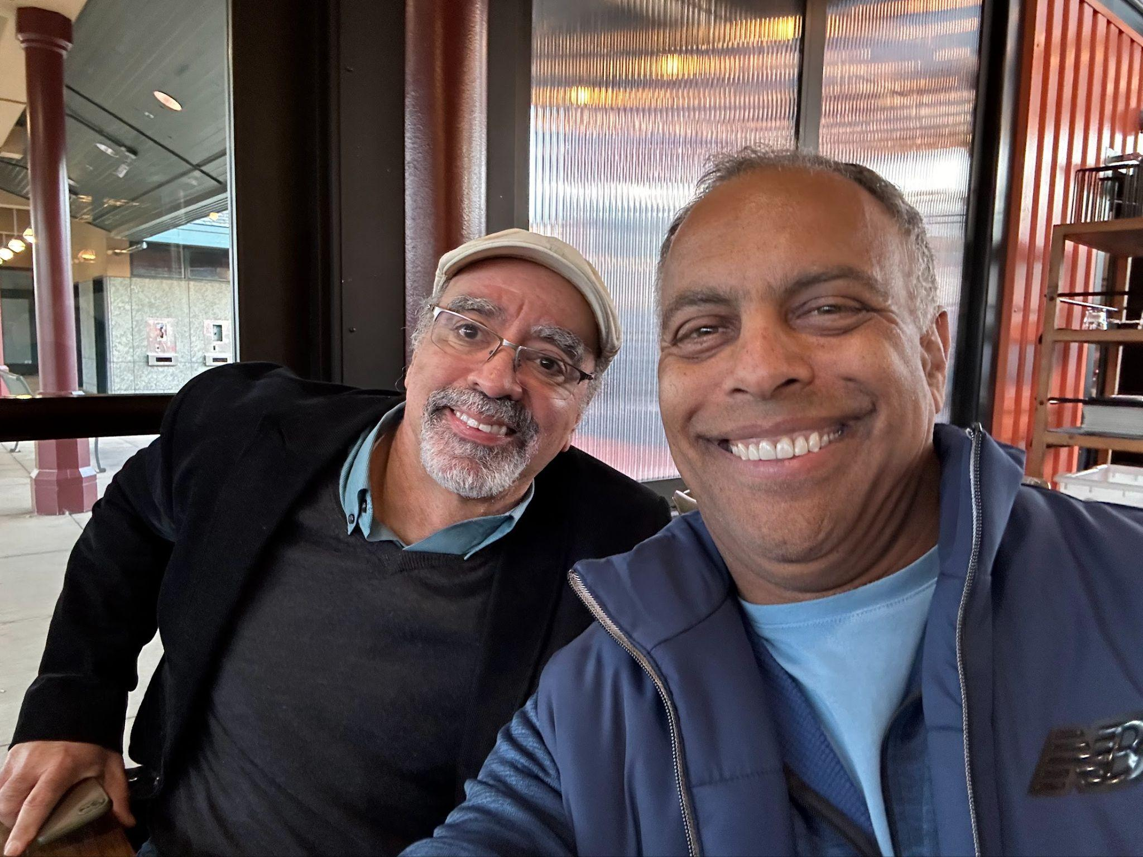

**Doctor Marc Hannah and Derrick Burns  
c. 2023**

## 

## Chapter 22: Swimming with Sharks: Lessons from the Valley

### After SGI: Searching for Air (1998-1999)

Silicon Valley measures success in stock options and titles. I measured mine in basketball games. After SGI imploded, I lived at the YMCA, first to arrive, last to leave. My jump shot was terrible, but I could play defense until my legs gave out.

While the others eventually headed back to their offices, I lingered. Without SGI, I had nowhere else to be. No title or corner office could replace being with my boys, Vince, Kirk, and James. As I sought out games at every gym in the Bay Area, I was really searching for what I'd lost: purpose, belonging, identity.

This personal drift mirrored the Valley's own precarious moment. The NASDAQ soared to unprecedented heights, but I could feel the instability underneath. Companies without viable business models received unprecedented funding based on little more than ".com" in their names. When the bubble burst in March 2000, I lost my kids' college tuition along with everyone else's dreams.

The boom had become a bust just as I was recalibrating life after SGI. In that chaos, Vince called.

"Derrick! NetApp needs a VP. I've already put your name in, and you know the founder."

"Dave Hitz? We sat side-by-side in Tarjan's grad class at Princeton," I said.

"Exactly. Send Dave an email."

### Network Appliance: The Costume I Wore (1999-2001)

The security guard cocked an eyebrow as he snapped my badge photo on Day 1 at Network Appliance. Sport coat, silk tie, shoes polished the way Dad taught me: I'd dressed to announce myself. At SGI everyone wore jeans; here, I was so excited to be an executive of a public company!

But the suit wasn't about blending in—it was armor. I'd spent years at SGI watching other people get promoted while I waited for recognition. Now I had the title I'd craved, and I was going to wear it like a uniform. The problem was, I was dressing for the wrong war.

NetApp wasn't another loose-burning dot-com. It ran on efficiency, teamwork, and a flat culture that prized substance over show. My urge to be visibly "in charge" was about to collide with a team that measured authority by results, not by the cut of my jacket.

Later that first day, Chris, the Senior Vice President of Human Resources, called me into her office.

"Most management hires from SGI do not perform well here," she said, studying my face.

"Why is that?" I asked.

"I don't know, Derrick." She shrugged, but her eyes held mine a beat too long.

What the hell? I had just accepted the job, and here was the head of HR telling me people like me don't fit in—and she couldn't even tell me why? I don't know if I was more afraid of failing than I was angry that she offered me no real help!

My new staff gathered in the conference room that afternoon. Six middle managers, all eyeing me with varying degrees of skepticism. One cleared his throat, his Michigan accent sharp as he announced:

"I interviewed for this position twenty-seven times."

The words hung in the air. Surely he was exaggerating, right? But exaggeration or no, I knew I had a problem on my hands. Here was a white guy from the Detroit area working for a Black man, probably for the first time in his life, and one who had taken the job he knew should be his. This was going to be fun. Not!

I flashed back to high school, to the day I got into Princeton while our valedictorian didn't. Same energy, different conference room. I was the outsider again, the one who didn't earn his place through the proper channels.

"Derrick, please get together with some folk here and put together a proposal for a summer internship plan," Dave directed me at his staff meeting.

My heart lifted—finally, something I was confident I could nail. I'd been recruiting top talent for years. The following week, I strode into the staff meeting with confidence.

"Derrick, you're up. What do you all propose?"

"Here's what I propose," I started, pride evident in my voice.

"Derrick, who was on the team with you for this proposal?" Dave interrupted.

"Uhh, no one. I did this last night. I didn't..."

"Stop. You missed the most important part. I don't want to hear what you propose!"

Silence swallowed the room. Heat rushed to my cheeks as the truth cut deep: I had procrastinated. A recruitment plan for summer interns? I had done that several times at SGI. I only needed an hour to draft the slides. I grabbed that hour just in time before the staff meeting.

Each morning after that, my stomach tightened as I walked into the building. I was drowning in plain sight, and my lifeline was Connie, my new executive assistant. She was like a cultural translator, helping me navigate currents I kept missing. *Can you give an example?*

You don't select a child like a pair of shoes. Dad's words echoed in my mind, but at NetApp, that's exactly how it felt—like I'd been chosen for the wrong reasons, a poor fit trying to force my way into a culture that valued collaboration over individual performance.

When I made decisions without consulting my team, when another direct report resigned in protest, I realized I was replicating the exact patterns that had always left me alone.

Then came the meeting. Dave and I had our regular one-on-one scheduled, but when I opened his office door, Chris from HR sat waiting. I'd orchestrated dozens of these final meetings from the other side, but this was my first time being fired.

"Derrick, your position has been eliminated," Dave began, then paused, his expression softening. "Derrick, I don't know what it is," he continued. "I really thought you'd be a good fit here."

In his awkward attempt at kindness, I glimpsed genuine regret—but neither of us knew how to bridge our different worlds. The cruel irony wasn't lost on me: at SGI, my technical expertise had been the foundation of my advancement, but at NetApp, I had abandoned that strength in pursuit of executive identity. Somehow, in moving up the ladder, I'd forgotten what had helped me climb it in the first place.

### Trovix: When Trust Breaks (2001-2003)

"Jeff! What are you doing here?!" I shouted at the Stanford Alumni job fair, spotting a familiar face that transported me back to freshman year. Jeff's voice and competitive edge hadn't changed since our Princeton debates.

"Derrick, my new company is named Trovix."

He had me at "new company." Jeff was also housed in Dodge Osborn Hall during my freshman year. He was a year older. I trusted Jeff and wanted in.

This time, I approached the challenge differently. No executive posturing, just hands-on technical problem solving. I developed breakthrough technology that could read between the lines of resumes, recognizing meaningful patterns and connections that traditional systems missed.

But we needed funding, and without a customer, no investor would bite. When our pitch to Yahoo failed, Jeff and Earl had been bootstrapping for three years, and the strain was showing.

"Jeff, you don't have funding, but I've contributed something fundamental. I'd like to be treated as a founder. All I want is 15%."

Jeff looked away and inhaled. The body language told the story. His voice cracked: "Derrick, we value you, but we've been at this for three years. We can't offer 15%."

I was extremely disappointed. I knew that my contribution was significant, and was just the tip of the iceberg. That day would never come.

*How many??*Years later, in 2008, my phone buzzed while I sat in traffic on 101. The headline read: "Monster Acquires Trovix for $75M."

My hands tightened on the steering wheel. The technology I'd created was now worth millions to someone else. After paying off investors, my theoretical share amounted to about $4 million that I'd never see.

I didn't see it as betrayal. I saw it as Silicon Valley greed, placing money over relationships, and I resented it. Just like I'd been doing with Gina and the kids—prioritizing achievement over connection, letting walls protect my interests while relationships crumbled around me.

I thought about Marcia's explosive emails, her fear that everyone would eventually leave her. Maybe she wasn't paranoid after all. Maybe she'd just learned, like I was learning, that trust is a luxury you can't always afford.

### Google: Recognizing My Own Reflection (2004)

I swung into the Googleplex, the same buildings I'd known at SGI, only the signs had changed. The interview process began immediately.

"So, what ideas do you have to expand our business?" one interviewer asked.

"It would be cool to be able to search video as easily as text."

"Well, that is obvious!" he said derisively.

Another room, another interviewer: "That's an interesting approach," he smirked at my system design. "But clearly not as elegant as..."

By the seventh interview, my jaw ached from forcing smiles. These weren't conversations; they were performances. Each interviewer seemed more interested in showing their brilliance than understanding mine.

After the interviews concluded, I had to wait a couple of weeks for Google's "interview committee" to meet. Then I got a call from the office of Alan Eustace asking for a meeting to present me an offer! Alan Eustace sat behind a desk piled with hardware prototypes.

"Derrick, we'd like you to join as a director of engineering."

Director? I'd just been a VP at NetApp. The demotion stung, but the compensation package was very attractive. What could go wrong?

And then it hit me: I was looking in a mirror.

This was me in Detroit, dismissing people with poor grammar. This was me at Princeton, driving my teammates well past the finish line. This was me ignoring Mike K on our projects because I wanted everyone to see that our project, my project, was so vastly superior to theirs. This was me at my worst.

The arrogance that had cost me at NetApp—the suit, the solo proposals, the assumption that intelligence equaled authority—I was seeing it reflected back at me. These Googlers were performing the same superiority I'd worn like armor for years.

"Tell me, are the seven persons who I met during the interview process typical of those within Google engineering?" I asked the recruiter.

"Yes, definitely."

My heart raced. The smart people at SGI had been humble. These people? Not even close. But hadn't I been just like them?

"Then I must decline the offer."

A year later, Google acquired YouTube for $1.65 billion—the same idea I'd suggested and they'd dismissed as "obvious."

"You could have been part of that," Gina noted when the news broke.

"Yes," I replied, "but I've learned something more valuable than money."

The potential wealth weighed on me for weeks. But for the first time in my career, I'd chosen environment over opportunity, substance over status. It felt like the first authentic decision I'd made in years.

### 

### Orbital Data: Finding Balance (2004-2006)

Eight AM. Steam rose from my coffee at my regular spot, one short mile from the Orbital Data office. Close enough for lunchtime basketball, close enough to be home for dinner.

"Sesame bagel with butter, Derrick?" Brad the barista asked.

"Yes please! Thank you, Brad."

Sometimes the best moves aren't the biggest ones.

With only 40 employees, most in engineering reporting to me, managing felt effortless. The technical stuff was new, but this time I dove deep, asking question after question instead of pretending to know.

"So the window size affects..." the technical co-founder started.

"I got that," I interrupted, drawing my own diagram. "But what about the control algorithm?"

He grinned, grabbing his whiteboard marker. He loved teaching, and I loved learning. This was nothing like the Google interviews where everyone had to prove how smart they were.

For the first time in years, I felt the satisfaction of authentic connection. The team didn't care about my title, but they respected my curiosity. When I suggested improvements, engineers would nod and take notes rather than posture.

But in summer 2004, the calm waters grew choppy. Two VPs had been pushed out, and I was next.

"Derrick, things are not working out," the CEO told me during our one-on-one. "It's time for you to go."

An odd calm settled over me. This wasn't like NetApp—no panic, no resentment. I felt control.

"Have you discussed this with the board?" I asked calmly.

"No," he said, clearing his throat.

One word. That's all I needed. The CEO gave me leverage. A month later, I had my job back and an ironclad severance agreement with financial kickers.

### 

### 

### 

### Citrix: Building My Own Table (2006)

"Citrix has signed a Memorandum of Understanding stating their intent to acquire Orbital Data," the internal email announced. As a VP with 1% equity, I'd ensured my severance agreement included immediate vesting upon change of control.

"Derrick, can you please sign your Citrix job offer so we can close the acquisition?"

"No."

"What do you mean 'no'?"

"The offer is insufficient. It's only marginally better than what I'd receive if I declined it."

"You don't understand how this works, Derrick." The CEO's voice cracked.

I thought about Trovix, about technology in my name worth millions to someone else. About NetApp's cultural drowning. About Google's arrogant certainty.

"No," I said, allowing myself a small smile. "You don't understand. My options accelerate on change of control with no other requirements."

The CEO turned red as he rushed out to review the document he'd recently signed.

This time, I knew exactly how deep the water was, and I was wearing a life jacket I'd designed myself. No drowning this time.

The pattern was finally clear. For years, I'd been chasing belonging through performance—the perfect grades for Mom's approval, the VP title for professional validation, the technical brilliance to prove my worth. Each time, I'd built walls to protect myself, then wondered why I felt so isolated.

But here at Orbital, something had shifted. Instead of demanding recognition, I'd earned respect through curiosity. Instead of protecting my turf, I'd shared knowledge. Instead of chasing status, I'd chosen environment.

I was back to being the technical leader I was at Princeton, but now with political knowledge.

The acquisition closed, my equity vested, and I walked away with both financial security and something more valuable: the knowledge that authentic connection mattered more than any title or stock option. It had taken years of failures to learn what Gina had been trying to teach me all along—that the walls I built to protect myself were the same walls that kept me from the love and belonging I was seeking.

The lesson wasn't just about business. It was about life.

## Chapter 23: Searching for Black Excellence: A Parallel Journey

### Finding Community While Rebuilding Career (2000-2004)

As my professional journey rose and fell through NetApp, Trovix, Google, and Orbital Data, another story was quietly unfolding, a quest for community among fellow Black professionals in Silicon Valley. While the previous chapter mapped my path through corporate waters, this one traces my parallel search for belonging in the Bay Area’s small but distinguished Black professional community.

In the fall of 2000, still nursing wounds from my departure from NetApp, Kirk called with an unexpected suggestion.

"Have you ever considered joining The Boule?" he asked casually over lunch.

"The what?"

"Sigma Pi Phi. The Boule. It's a fraternity for accomplished Black professionals."

I nearly laughed out loud. Me, joining a fraternity? The timing felt absurd. Kirk inviting me, a recently unemployed professional, to join a prestigious fraternity would have been unimaginable in thriving Black communities like those in Atlanta, Chicago, or Washington D.C. But in Silicon Valley, where our numbers were so few, perhaps the rules were different.

Initially, the idea of a fraternity conjured images of hazing rituals and blind loyalty, concepts I had always resisted. Kirk quickly reassured me: this was a graduate fraternity, free of hazing, comprising accomplished Black men who deeply understood the experience of being "the only one."

When Kirk introduced Gina and me at their annual Valentine's Day Formal, we were warmly welcomed with genuine offers of friendship. These men appreciated that merely reaching Silicon Valley as a Black professional was itself an achievement. They cared less about my current job status and more about whether I would positively contribute to their community.

“Roy, this is Derrick. I’m trying to get him to join,” Kirk introduced.

“Hi, Derrick! Welcome. It’s a pleasure to meet you. You should join!”

And so it went, as Kirk introduced me to Frank Greene, Samuel Johnson, Frederick Chancellor, and others. Ken Coleman, a long-time member, was also present. Was I truly being invited to join a fraternity alongside Ken Coleman?

“Kirk, what’s Roy’s last name?” I asked.

“Clay,” Kirk answered.

Then it clicked, I recognized some of these names. Roy Clay and Frank Greene were featured alongside Marc Hannah in a pivotal 1984 Ebony article celebrating pioneering Black technologists in Silicon Valley, a time when Detroit was still synonymous with automobiles. As a young man, reading about these trailblazers had revealed a world where Black excellence extended beyond traditional industries and into the burgeoning tech sector. Roy Clay, famously dubbed the “Godfather of Silicon Valley,” had led Hewlett-Packard's pioneering computer division in the 1960s and later advised venture capital firms investing in companies like Intel and Compaq. Frank Greene had developed revolutionary semiconductor memory systems at Fairchild Semiconductor, founded multiple successful tech companies, and became one of the first Black venture capitalists committed to funding women and minority entrepreneurs.

Roy and Frank weren't merely technical pioneers, they had actively paved pathways for other Black professionals in a predominantly white industry. Meeting them face-to-face now, especially after witnessing the impact of accomplished Black colleagues at SGI, underscored a powerful realization: Black professionals were indeed shaping Silicon Valley, and I was thrilled at the prospect of joining this esteemed community.

### First Impressions (December 2000)

Still doubtful, I agreed to attend their Christmas celebration at Carmel Valley Ranch with Gina. Walking into that gathering felt strangely familiar, yet distinctly different from any professional setting I'd experienced in Silicon Valley.

I found myself among distinguished Black men in suits and their equally accomplished wives. Most were old enough to be my father, yet they carried themselves with a quiet dignity that commanded respect without demanding it.

Just like the men at Metropolitan Baptist Church who had shaped my youth, these brothers displayed a particular bearing, that blend of confidence and humility unique to Black professionals who had succeeded despite systemic barriers. But instead of Detroit's automotive industry executives and small business owners, here were Silicon Valley pioneers and academic leaders.

As Gina and I circulated through the room, each introduction brought a new revelation of excellence.

Mr. John Arnold, the chapter president, commanded respect with his powerful presence. At over 50 years old, it was his physique that caught my attention, huge biceps that reminded me of my Uncle Tom. John modestly said he was in finance, omitting that he was a senior corporate finance executive at Levi Strauss, where he had worked for two decades. His voice carried both authority and compassion. After his corporate career, he had dedicated himself to community service, coordinating programs that provided healthy aging support.

Professor Lucius Barker, the elder statesman of the chapter, reminded me of the way Dad's generation had quietly integrated Detroit's workplaces. As Stanford's William Bennett Munro Professor of Political Science and the second Black president of the American Political Science Association, he had opened doors that would never close again. When he greeted me with special warmth because of our Stanford connection and upon learning my father's family had roots in Louisiana like his own, I felt that same embrace of mentorship I’d felt from Doctor Morton. His gentle manner blended with scholarly authority, making him both approachable and deeply respected among his peers.

Doctor Robert Floyd, with his gentle manner and careful speech, brought back memories of Dad. Having risen from humble beginnings in rural Mississippi under Jim Crow segregation to become our country's second African-American Naval Flight Surgeon and a distinguished OB/GYN, he embodied quiet triumph over systemic barriers. Though soft-spoken, his accomplishments spoke volumes, Chief of Staff at Alexian Brothers Hospital, Clinical Professor at Stanford, and president of our Boule chapter following John Arnold. His meticulous attention to detail and unwavering integrity, even in casual conversation, reflected the discipline that had carried him through decades of pioneering work in medicine.

"What do you think?" Gina whispered as we drove home that evening.

"They remind me of home," I said, surprised by the realization. "Of Detroit. Of the men at Metropolitan."

"But?"

"But this is Silicon Valley. The context is so different."

These California men, like their Detroit counterparts, had achieved excellence not by shouting about it, but by quietly proving their worth day after day. They had faced different challenges than the Detroit generation, integrating Silicon Valley boardrooms instead of auto plants, breaking barriers in West Coast universities rather than Detroit factories, but they carried themselves with that same combination of strength and humility I'd grown up admiring.

And boy could they party! We all danced until the last song by the live band. After the formal dinner dance, Gina and I were exhausted. The next morning, we dragged our tired bodies out of bed and walked across the street to the recommended Sunday brunch spot. As we arrived, Linda and Hugh Burroughs walked out.

“Good morning, sleepy heads!” Linda blurted out.

“When did you all get here for breakfast?” Gina asked.  
  
“Almost 2 hours ago!” Linda announced.  
  
“What?! You all party hard!” I said  
  
“Oh yes. We may be old, but we are fun!” Linda said.

And with that, I decided to apply for membership!

### Joining the Brotherhood (2001)

By spring 2001, I had completed Boule's initiation process, a dignified series of interviews and social gatherings that bore no resemblance to the fraternity hazings I'd feared. The induction ceremony itself was formal and solemn, emphasizing the organization's founding principles of excellence, service, and brotherhood.

The San Jose chapter was a gathering of accomplished Black men who understood what it meant to be the only one in the room throughout their careers. Like veterans swapping war stories, they found solace in each other's company, a shared understanding that they weren't alone in their experiences.

The chapter's humility struck me. These men, doctors, lawyers, executives, rarely spoke of their achievements. Instead, they sought genuine connection, a space where they could let down the professional masks they wore daily. When they invited me to take on the role of treasurer, I was touched by how these accomplished men made room for a younger member without pretense.

Each month, we gathered in a small banquet room at the Biltmore Hotel and Suites in Santa Clara, just off Highway 101. The setting was comparable to the Fellowship Hall of Metropolitan Baptist Church. Like those Sunday afternoons in Doctor Morton's office, these meetings were about building connections, sharing wisdom, and supporting each other's journeys.

The conversations reminded me of listening to Uncle Bubba, Mr. Russell Rickey, and my Dad in the Metropolitan Baptist Church Trustee Room, but instead of joking while talking about church finances, these men joked while talking about the changing American political environment! Yet beneath the different vocabulary, the fundamental challenges remained the same, being us in a world that would prefer that we disappear.

One evening stands out particularly in my memory, when Tyrone Willingham, Stanford's head football coach, came to speak in the fall of 2001. His presence commanded attention much like Reverend Charles Morton had at Metropolitan, but instead of preaching from a pulpit, he spoke about excellence on the football field and in the classroom. His perfectly pressed clothing and military bearing reminded me of how Dad always insisted on presenting himself impeccably to the world.

"At Stanford," Willingham explained, "our recruiting standards are not a limitation to our football team, they are a competitive advantage."

His words echoed the lessons I'd learned in Detroit, that excellence wasn't just about individual achievement, but about lifting up the entire community. Looking around that room, I saw the same pride in these men's eyes that I'd seen in Detroit when someone in our community achieved something significant. Whether in Detroit's automotive industry or Silicon Valley's tech sector, these were men who understood that their success wasn't just personal, it was paving the way for others to follow.

### Two Models of Black Excellence (2002)

By 2002, as my confidence rebounded from my experience at NetApp, I began to seriously consider my long-term aspirations in Silicon Valley. The dot-com bubble had burst, significantly reshaping the industry landscape, and the timing felt right to explore new opportunities.

Venture capital had always intrigued me, the capacity to fund innovation, shape technology trends, and determine which ideas and entrepreneurs would thrive. Given the notable lack of venture capital funding directed toward Black founders, I saw an opportunity to effect meaningful change.

My Boule brothers Roy Clay and Frank Greene, pioneers in both technology and investment, reignited my early excitement when I first read about them. Inspired, I decided to approach them for guidance.

Months later, summoning the courage honed through countless basketball challenges, I visited Frank Greene in his downtown Palo Alto office, situated just above Il Fornaio, one of my favorite spots. The elegant, quiet professionalism of his workspace sharply contrasted with the gritty basketball courts I knew so well. I shared my ambitions in venture capital, hoping for the supportive guidance I had found among my San Jose Boule brothers.

The gap between expectation and reality hit me hard. Frank's office felt starkly solitary, no junior partners, no assistants, just Frank himself. When I asked about apprenticing under him, his response was swift, direct, and crushing:

"Derrick, you'd be better off leveraging your connections in the venture capital world. I have nothing to offer you."

His words struck me deeply. It wasn't merely disappointment; it was devastation. Frank wasn't rejecting me personally; rather, he revealed a grim truth: his path was isolated, solitary, without followers. Leaving his office felt like receiving a terminal diagnosis. Was my journey toward greatness blocked by an insurmountable barrier? I had expected Frank, as a pioneering Black investor, to embrace my interest and show me the way forward. Instead, his advice directed me back toward the predominantly white networks controlling access to capital.

Walking back to my car, I contemplated the stark differences between Detroit and Silicon Valley. In Detroit, leaders like Doctor Morton provided clear paths and mentorship, backed by robust Black institutions. In contrast, even successful Silicon Valley pioneers like Frank remained isolated, lacking the kind of enduring networks that foster future generations.

Detroit's Black community had deliberately constructed parallel institutions, churches, businesses, social organizations, that emphasized collective progress and mutual support. Frank’s reality highlighted something profoundly different: Silicon Valley’s landscape required integration into existing, predominantly white networks. Brown v. Board of Education had declared separate inherently unequal, but here, perhaps, separate had offered something better.

### Finding My Way (2003-2004)

Over the following months, I reflected deeply on Frank's painful but illuminating advice and the stark contrasts between Detroit and Silicon Valley models of Black advancement. Gradually, clarity replaced the initial hurt. Frank wasn’t dismissing my ambitions; he was providing a brutally honest map of the landscape he knew too well.

The San Jose Boule offered another form of invaluable strength, not institutional power, but authentic community. Our monthly meetings reminded me of the comforting fellowship of Sunday afternoons at Metropolitan Baptist Church. Doctors, lawyers, and executives could remove their professional armor and authentically connect with brothers who understood their shared experiences.

By early 2004, as I began my role at Orbital Data, these seemingly contradictory lessons converged. Detroit had instilled in me the power of community and collective support. Silicon Valley figures like Frank taught me to navigate predominantly white spaces without sacrificing my authenticity.

Yet, the lessons were sobering. SGI and Frank had proven to be exceptions rather than standard-bearers, unable to establish lasting legacies or pathways for others. SGI was fading, and Frank remained largely isolated in venture capital.

Frank’s blunt message reflected Silicon Valley’s harsh reality: there were no clear roads, no enduring mentorship structures or parallel institutions to replicate Detroit’s strength. Models of Black excellence here were predominantly individual rather than institutional.

Recognizing this reality reshaped my purpose. Perhaps it was now my task to build those pathways that did not yet exist.

# 

## Chapter 24: Courts of Transformation

My journey to the San Mateo YMCA began years earlier with a simple invitation from James: "Derrick, flag football is cool, but there is not enough action. I prefer basketball. Want to play at lunchtime at Cubberly?"

Cubberly had been James's high school before becoming part of California's community college system. For me, it represented more than just a place to play, it was a chance at redemption. The shame of being cut from middle school baseball and basketball teams during first elimination rounds still burned. The memory of being hit in the face in the outfield at Kranz Park still stung. But James stood with me, offering through his friendship and leadership an opportunity to rid myself of that shame.

James introduced me to a crew that would become my first basketball family. Ed, a 5'11", 220-pound engineer with square glasses and the body of a tight end, played with an intensity that matched his principles, hard but fair. He was the court's conscience, demanding clean play and respect for the game.

Doyle, standing 6'0" and lean at 180 pounds, moved like silk on hardwood. A self-styled ladies' man off the court, he was all business on it, a fierce competitor who loved talking trash but backed it up with laser focus and unwavering courage.

Jerry, the elder statesman at 50, moved deliberately at 5' 10". He showed up consistently, letting the young bulls' comments roll off his back like morning dew. His presence taught me my first lesson about longevity in the game, ego was the enemy of endurance.

And then there was Cleve. At 5'10" and nearly 300 pounds, he was a study in contradiction. A former high school track standout who'd put on 100 pounds since his glory days, Cleve refused to acknowledge that Father Time and weight had slowed him down. He still carried himself with the swagger of that fast sprinter, daring anyone to suggest otherwise. As a probation officer, he was used to dominating grown men, and he brought that same intimidating presence to the court. Cleve was a bully who weaponized fear, challenging everyone, probing for weakness like a predator. When he found it, he pounced without mercy.

The danger Cleve posed wasn't theoretical. When I was assigned to defend him, I learned quickly that his 300-pound frame was a weapon he wielded without mercy. He'd swing elbows and stare me down. I refused to back down, showing fear would only invite more aggression, but I was no fool. An elbow to the teeth meant an expensive trip to the dentist. I learned to defend like a boxer, arms up, never leading with my face.

One day, I heard something different in Cleve's voice when he growled, "Stay out of my face!" The tenor told me this day was special, dangerous. I complied, trusting my instinct. Minutes later, Cleve picked up a 6' 4" player, turned upside down and planted his head on the gym floor. The man started choking, having swallowed his tongue. In a bizarre twist, Cleve then saved the man's life by extracting his tongue from his throat. I retreated to the locker room, grateful that my read of the imminent danger had protected me.

But James, at 6' 4" and north of 240 pounds of solid muscle, was the one everyone watched. He combined physical dominance with a deep understanding of the game. In a gym full of alpha males, he was the quiet force, the uber alpha who let his game do all the talking. Everyone wanted him on their team, and those who played against him relished the challenge while dreading the outcome.

And then there was me. I sucked. There was no gentler way to put it. The muscles I'd built the previous summer were already atrophying. My shot was non-existent. I had no court sense, couldn't dribble with my left hand, and barely managed with my right. I spent more time looking down at the ball than at the game unfolding around me. And I knew it, I really sucked.

Still, I showed up. I wanted to learn. That counted for something.

Cubberly had given me toughness. The YMCA would teach me grace.

When I first stepped onto the court at San Mateo YMCA in 1989, I carried these lessons with me, though I was still struggling to apply them. James had moved on, and now I had to stand on my own. Without his presence, every missed shot and fumbled pass reopened old wounds. The squeak of shoes against polished hardwood and the rhythmic bounce of balls echoing off cinder block walls felt foreign and intimidating. The incident with Cleve had taught me to read danger, but now I needed to learn how to read community.

When the YMCA opened its new Peninsula facility near Highway 92 and US 101, I made a strategic decision: if I couldn't master offense, I'd focus on defense. Defense didn't require natural talent, just determination and grit. Those I had in abundance, forged through years of facing down failure and fear on Cubberly's court.

Eventually, I became a regular. And then, a fixture.

Over three decades at the YMCA, I watched generations of players come and go, their stories unfolding like chapters in an endless book. None hit me harder than Dave's journey. When I first met him, he embodied everything I'd once envied, natural athletic grace and that easy social connection I'd struggled so hard to find. Surrounded by friends and admirers, Dave had what my younger self had dreamed of: acceptance, belonging, status.

Then he vanished. Five years passed before I saw him again, and the Dave who returned was a different man. The cocky swagger was gone, replaced by a quiet focus. Prison had aged him, not just physically but in his eyes, which now carried the weight of hard-earned wisdom. His kindness had a deliberate quality, as if he'd learned its value the hard way. Those friendships I'd once envied had led him down a path that broke my heart.

When Dave returned, I engaged him, welcoming him back. Words caught in my throat, I wanted so desperately to tell him that I see him, that I am here for him. But it felt like too little, too late. Years later, I saw him again, married and happy. The exhale that followed was deep and long, carrying years of worry. He had found peace, and somehow that gave me peace too.

After Dave, I saw the court differently, but it was Denly who showed me how to channel that awareness into action. At 6' 5" and 210 pounds, he carried himself with the same quiet authority as James, but with the added wisdom of age. Fourteen years my senior, Denly had emerged from the San Francisco projects to become a dental professor, retiring after 30 years of teaching. He was living proof that fierce competition and fairness weren't mutually exclusive.

Our connection deepened both on and off the court. Through his family, I learned about his journey from the projects to academia. Our wives, both physicians, strong black women who had carved out success in environments traditionally hostile to their presence, formed their own bond, further enriching our friendship.

From Denly, I learned a graduated approach to maintaining court culture. Where Cleve had taught me to read danger through fear, Denly showed me how to read it through understanding. I developed a three-tiered approach to maintaining order: First, a quiet, private conversation with troublemakers, "That behavior is not tolerated here." If that failed, I'd move to public correction: "That is not our culture here." The word 'culture' was deliberate, it reminded everyone that we were a community with standards, not just random players sharing a court. Finally, for those who only understood force, I'd resort to verbal dominance: "Shut the f*ck up!" It wasn't my preferred approach, but I'd learned from Cleve that some men only respect power. The difference was in the purpose, not to bully, but to protect.

When Denly left for back surgery, the loss hit me with unexpected force, as if I'd lost a father or brother. With James, I had needed protection from Cleve and other alpha males who sought to dominate me. But with Denly, the relationship was different, I no longer needed shelter, only refinement. He had been guiding me toward a version of myself I could barely imagine.

That's when young men began approaching me not just for basketball advice, but for life guidance. Like that twenty-year-old who lingered after a particularly intense game, wiping sweat from his face with his jersey, worry evident in his stance.

"My parents want me to move out," he finally said. The words came out flat, but I could hear the fear beneath them.

I used the patience Denly had modeled, asking questions rather than rushing to solutions. "How do you all get along? Any fighting?"

"No," he replied.

"You like living at home?"

"Yeah."

"What's your work situation?"

"Part-time bartending, when I can get shifts." He shrugged, bouncing a basketball absently.

I saw myself in his uncertainty, and remembered my own struggles for independence. But I also saw the opportunity to guide him the way Denly would have, with wisdom wrapped in practical advice.

"May I make a suggestion?"

He nodded, catching the ball.

"How much could you afford in rent each month? Something you know you could pay, no matter what?"

"Maybe $200, $300," he said after a moment's calculation.

"Here's what I'd do. Ask for a family meeting. Offer them that amount in rent. But only if you're sure you can pay it consistently."

Six months later, he caught me before a game, grinning.

"How did you know that would work?"

"Your parents weren't trying to get rid of you," I explained, thinking of how Denly would have handled this moment.

"They just needed to know you were on the path to standing on your own."

The circle was complete. From the scared outsider at Cubberly, protected by James, challenged by Cleve, refined by Denly, I had become someone who could now guide others. The court had transformed me, and through me, would help transform others. This was Denly's true legacy, not just the lessons he taught, but the leaders he lifted.

## Chapter 25: A Father's Love

"Your serve, Dad."

And in an instant, Dad flicked his left hand to send the ping pong ball screaming across the net, slight smirk on his face. I lunged for it, barely returning the shot, only for him to place the ball perfectly in the corner beyond my reach. That left hand of his, quick, precise, deadly on the ping pong table. He never showed mercy in our games, believing that earning victory was the only way to truly appreciate it. Years later, I would understand the gift in this approach, but then, I just wanted to finally beat him, to see pride replace that smirk. That competitive fire, that insistence on earning everything, it defined how Dad approached not just games, but life itself.

### Their Rhythm

As I settled into my life in California, my parents found a new rhythm together on Shields Street in Detroit. I like to think that I called frequently, checking in on their health and happiness, but I had no regular pattern.

During the winters, they visited Uncle Bubba and Aunt Mildred in Florida, like many Michigan snowbirds seeking refuge from the cold.

Mom poured her heart into the Stork's Nest project, a noble cause spearheaded by Zeta Phi Beta Sorority, Inc. and the March of Dimes Foundation. Her dedication aimed to ensure that more women received essential prenatal care, striving to prevent the heartbreak of low birthweight, premature births, and infant deaths.

Even long after I left for college, Dad maintained his unwavering routine. Every weekday at 7 AM, he made the familiar 5.6-mile drive down Mound Road to the military base in Warren, where his job at TACOM involved managing payroll for both military personnel and civilian employees. The work demanded meticulous attention to detail and a strong grasp of financial systems, qualities Dad possessed in abundance.

He remained dedicated to this role until his retirement in 1986, completing 35 years of federal service. But Dad's timing wasn't coincidental, he deliberately waited until I graduated from college before retiring, ensuring I had the resources I needed to finish my education.

Dad came alive at the bowling alley. The strikes and spares mattered, but what truly drew him in was the brotherhood, a place where he belonged completely. He threw himself into leadership roles with The National Bowling Association, an organization founded in 1939 Detroit as black bowlers sought to build their own community around the sport they loved.

Bowling was beautifully democratic, inexpensive enough that class barriers fell away on the lanes. By 1944, when the group became the National Bowling Association, Inc., Dad was part of something powerful. These men and women were creating their own space, their own traditions, launching the "Equality in Bowling" campaign that opened doors across the sport in 1950.

For Dad, those long evenings at the lanes meant finding his tribe, men who understood both the weight of responsibility and the sweet satisfaction of knocking down pins that had no choice but to fall.

During tax season, Dad's love of numbers became an act of service. He prepared tax returns for friends and neighbors, charging exactly $2, not because the work wasn't worth more, but because that small fee transformed help into a transaction, preserving everyone's dignity. Numbers were Dad's language of care.

To prepare, he brought home thick IRS guidebooks printed on cheap newsprint, studying every rule and regulation with the same precision he brought to TACOM payrolls. I devoured those guidebooks alongside him, absorbing my first lessons in accounting while watching Dad decode how the world worked. His excitement for the logic of numbers was infectious, each form was a puzzle to solve, each calculation a way to help someone keep more of what they'd earned.

When my own tax time came, I followed his example, working through every line with pencil and paper, letting the arithmetic tell its story by [hand.](http://hand.so)*[so](http://hand.so) did you do your neighbor’s taxes for $2 too?*

Both Mom and Dad remained dedicated members of Metropolitan Baptist Church. Under the steadfast leadership of Doctor Charles E. Morton, who had been shepherding the congregation since August 1963, the church maintained its commitment to worship quality and community service. But the congregation faced an inexorable challenge, its membership was diminishing as the children of longtime members, like me, moved away from Detroit in search of opportunities that the shrinking city could no longer provide.

The once-thriving congregation began to dwindle, its remaining members aging and growing frail. Among them, most painfully for our family, was Dad.

### The Fall

Shortly after Dad's retirement in 1986, our world was shaken when he was diagnosed with prostate cancer. The treatment, a radioactive implant and Lupron hormone therapy, was successful, and the cancer went into remission. For a time, we allowed ourselves to believe it was over. Dad returned to his routines, the bowling alley, tax season, Sunday church. Nine years of borrowed normalcy.

Then, one cold December day in 1995, Dad's life changed forever. On a simple trip to the local K-Mart on Sherwood Street, just 2.2 miles from home, he suffered a massive stroke in the parking lot. Shoppers watched in horror as he collapsed, and someone quickly called 911.

I flew to Detroit Metropolitan Airport as soon as I could, rented a car, and drove to the hospital. The antiseptic smell hit me as I walked through the automatic doors, but I pushed it aside along with everything else I didn't want to feel. Dad was being taken for tests. My palms were sweaty, mind racing. As I waited, I attempted to quiet my mind, to dissociate into the world of business by reading the one book I brought with me, Stephen Covey's popular "The 7 Habits of Highly Effective People."

I fought to keep my attention on the book. The world of the book was safe, calm, hopeful.

"Seek first to understand, then to be understood."

Well, I did not understand why my Dad was fighting for his life. My hero didn't deserve this. I found myself bargaining with a God I did not really believe in.

Each page, just two more minutes lost. I retained nothing. I could not focus.

Dad survived the night and the following weeks in a coma. When he finally woke, he was paralyzed on his dominant left side and spent most of his days in a deep, unyielding sleep. Mom stayed by his side day and night at the hospital, her heart breaking a little more with each passing day.

### Exile

But hospital care couldn't last forever. Dad needed round-the-clock attention, and with immense reluctance, Mom moved him to Bortz Health Care of Warren, a facility 6.2 miles from home. The closer options were far worse, but even Bortz was dreadful.

When Dad awakened from his coma several weeks later, he began to understand his situation, helpless in the care of strangers, paralyzed on his left side. With slurred speech, he eventually communicated.

"Willa, don't make a fuss. When you leave, I need these people," Dad cautioned, his once commanding voice now soft and raspy, yet still carrying the quiet dignity that had always defined him.

Mom understood his counsel, but she bristled under the conditions.

Visiting nursing homes had become a grim routine for our family. Every Sunday, Dad had visited Uncle Bill when Aunt Net could no longer care for him due to his Parkinson's disease. Now, it was Dad's turn to be confined to one of these places.

I smelled the stench of urine, saw the understaffed facility, realized the indignity of it all. But I processed it like data, like a problem to be analyzed rather than a tragedy to be felt. Men and women alone in their rooms, lying in their own waste. Mom demanded better care, but the overworked staff were slow to respond. She did her best to clean him before I arrived, trying desperately to preserve his dignity.

Seeing my father like this, I felt powerless. I offered money to help, but Mom refused. She insisted they could manage and reminded me I had my own family to care for. I was left feeling ashamed of my impotence.

Over time, Dad started to stay awake more, settling into a somewhat normal sleep schedule. This brought its own agony; as his awareness grew, so did his realization of his predicament. Yet, he never succumbed to self-pity.

Ultimately, her demands for better care fell on indifferent ears.

### Coming Home

Mom's heart was splintered. Her partner of 36 years was now trapped in a broken body in a place that seemed devoid of compassion. But she had a plan.

Determined to bring Dad home, she hired a construction company to transform the den into a wheelchair-accessible bedroom with a private attached bathroom, providing him with the privacy and dignity he needed. The adjacent back bedroom, where Mom had sometimes escaped Dad's snoring or welcomed house guests, now became her listening post, close enough to hear every sound he made, every shift in his breathing.

Ten months after Dad's stroke, the construction was complete. Mom equipped the room with an adjustable hospital bed, a wheelchair, and an ADA-compliant ramp to a new back door. With everything in place, she brought Dad home, her heart swelling with relief and determination.

Several of Mom's friends chose to warehouse their disabled husbands in distant nursing homes. Mom did not. She modeled for me true commitment and love. As I watched Mom's selfless dedication to Dad, I reflected on my own selfishness, my own self-absorption. I embraced the realization, even as I fought to avoid the depths of shame.

Mom showed me how to love.

During my visits home, the ping pong table stood silently in the northwest corner of the basement, a reminder of times past when Dad's quick left hand had sent balls screaming across the net. But their quiet partnership seemed unshakeable even in these new circumstances.

### Grace Under Pressure

Mom had earned a pension from the State of Michigan, and Dad had one from the U.S. federal government. Together, they had excellent health care coverage. However, home care was exorbitantly expensive, and their combined pensions weren't enough to cover all the new expenses without significant adjustments.

"We can make it," Mom would insist whenever I offered money, her chin set in that familiar stubborn angle.

She started clipping every coupon, driving across town for sales on adult diapers, and making regular trips to agencies that supplied free medical equipment and supplies to the elderly and sick. The same woman who had faithfully tithed to the church throughout her working years and into retirement now found herself navigating the world of social services, friends dropping off casseroles, neighbors offering to sit with Dad for an hour.

I started tracking their finances, entering each transaction into Quicken as I did my own, making sure that Mom and Dad had what they needed. It gave me a safe routine to follow when I visited, something concrete and manageable in a situation that felt overwhelming. "Derrick is here," Mom would announce to her friends that called. "He is taking care of my money." The pride in her voice gave me a role I could fulfill, a way to help that didn't require me to navigate the emotional depths I wasn't ready to face.

Dave and I started traveling to Detroit more often. I remember one time helping Dad with a urinal, both of us avoiding eye contact, the silence heavy with unspoken embarrassment. Later, I found myself grateful for even that small moment of usefulness in an ocean of needs I couldn't fill.

When I asked Mom how she got Dad to his appointments, she'd wave off my concern.

"We manage," she'd say.

Most of the time she scheduled home health aides to assist, but on more than one occasion she had no one to help. Yet somehow, this 4'11" woman would wrestle Dad's 160-pound frame from wheelchair to car seat, her body straining against his dead weight, sweat beading on her forehead as she adjusted his legs and buckled him in. "I've got this," she'd tell herself, even as her hands shook from the effort.

When the hospital offered a week of respite care, Mom's relief was visible, her shoulders dropping, her smile genuine for the first time in months. "Just one week," she'd tell Dad, kissing his forehead. "I'll be right here when you get back."

Through the hardship, Mom created a sense of normalcy, culminating perhaps in a 40th Wedding Anniversary party that she hosted, complete with a sit-down formal dinner.

And she always was. Through every small crisis, every medication change, every sleepless night when Dad's breathing grew labored, Mom remained constant. For five years, they built a new life within the confines of disability, Mom's commands, Dad's compliance, small victories measured in successful transfers from bed to wheelchair. They had found their rhythm again.

Until the cancer returned.

### The Last Call

Mom and Dad found a new delicate rhythm.

"Howard, stand up."

"Howard, turn this way."

"Howard, …"

If walking were a matter of will power, Dad would walk under Mom's demand. He never walked again on his own power, but he did stand on his one good leg and hold himself up. Mom insisted! But in 2000, five years after his debilitating stroke, his prostate cancer returned with a vengeance, spreading to his lymph nodes. Mom and Dad carried the truth like a private ache, shielding Dave and me from the weight of it.

On May 5, 2000, the façade of normalcy shattered. Mom called me with a tremor in her voice, telling me that Dad was in hospice care and that I needed to come home. I booked the earliest flight, my heart pounding with each passing second. The flight was delayed, prolonging the agony of anticipation. I finally landed at 11 PM, rented a car, and sped home, arriving just after midnight.

When I placed my key in the side door, the door I always entered by, I felt a stillness inside. Mom did not hear me come in. I walked to her bedroom, afraid like I had been as a child in the dark basement. But this wasn't the boogeyman. It was something colder, emptier. In my heart, I knew.

I stepped inside, and silence met me like a wall. I called out, "I'm home!" hoping to pierce the stillness. As I walked to her bedroom, quiet, afraid, unsure if I'd woken her, the phone rang. The sound was jarring, cutting through the stillness like a knife. I picked it up, my hand trembling.

A nurse from St. John's Hospital was on the other end. Her voice was gentle yet firm as she delivered the blow: Dad had just died.

The words stopped me cold. Time stilled around me. I stood there, in the home that held so many memories. My rock, my hero. The left hand that once guided a tax pencil and a ping pong paddle was gone.

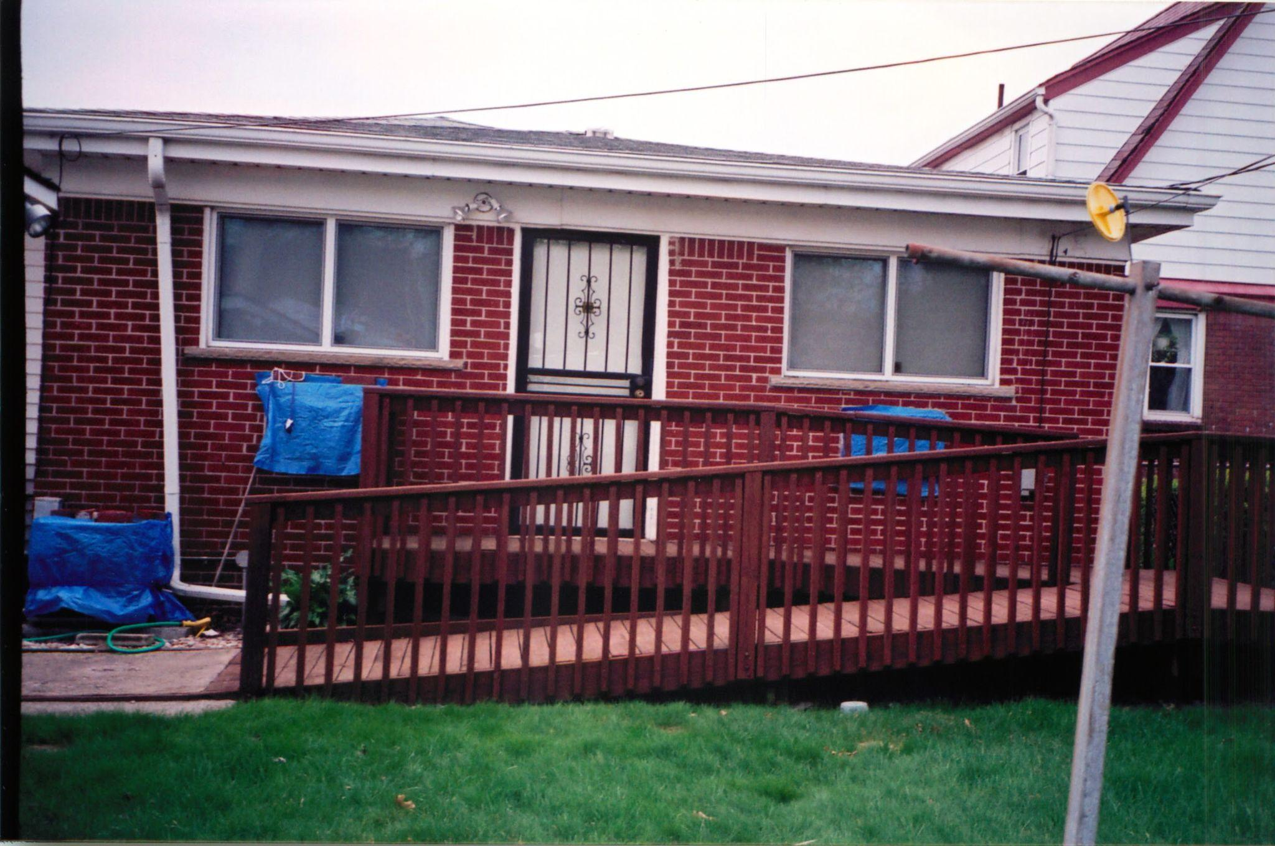

**Dad’s new entrance to his home, 2001**

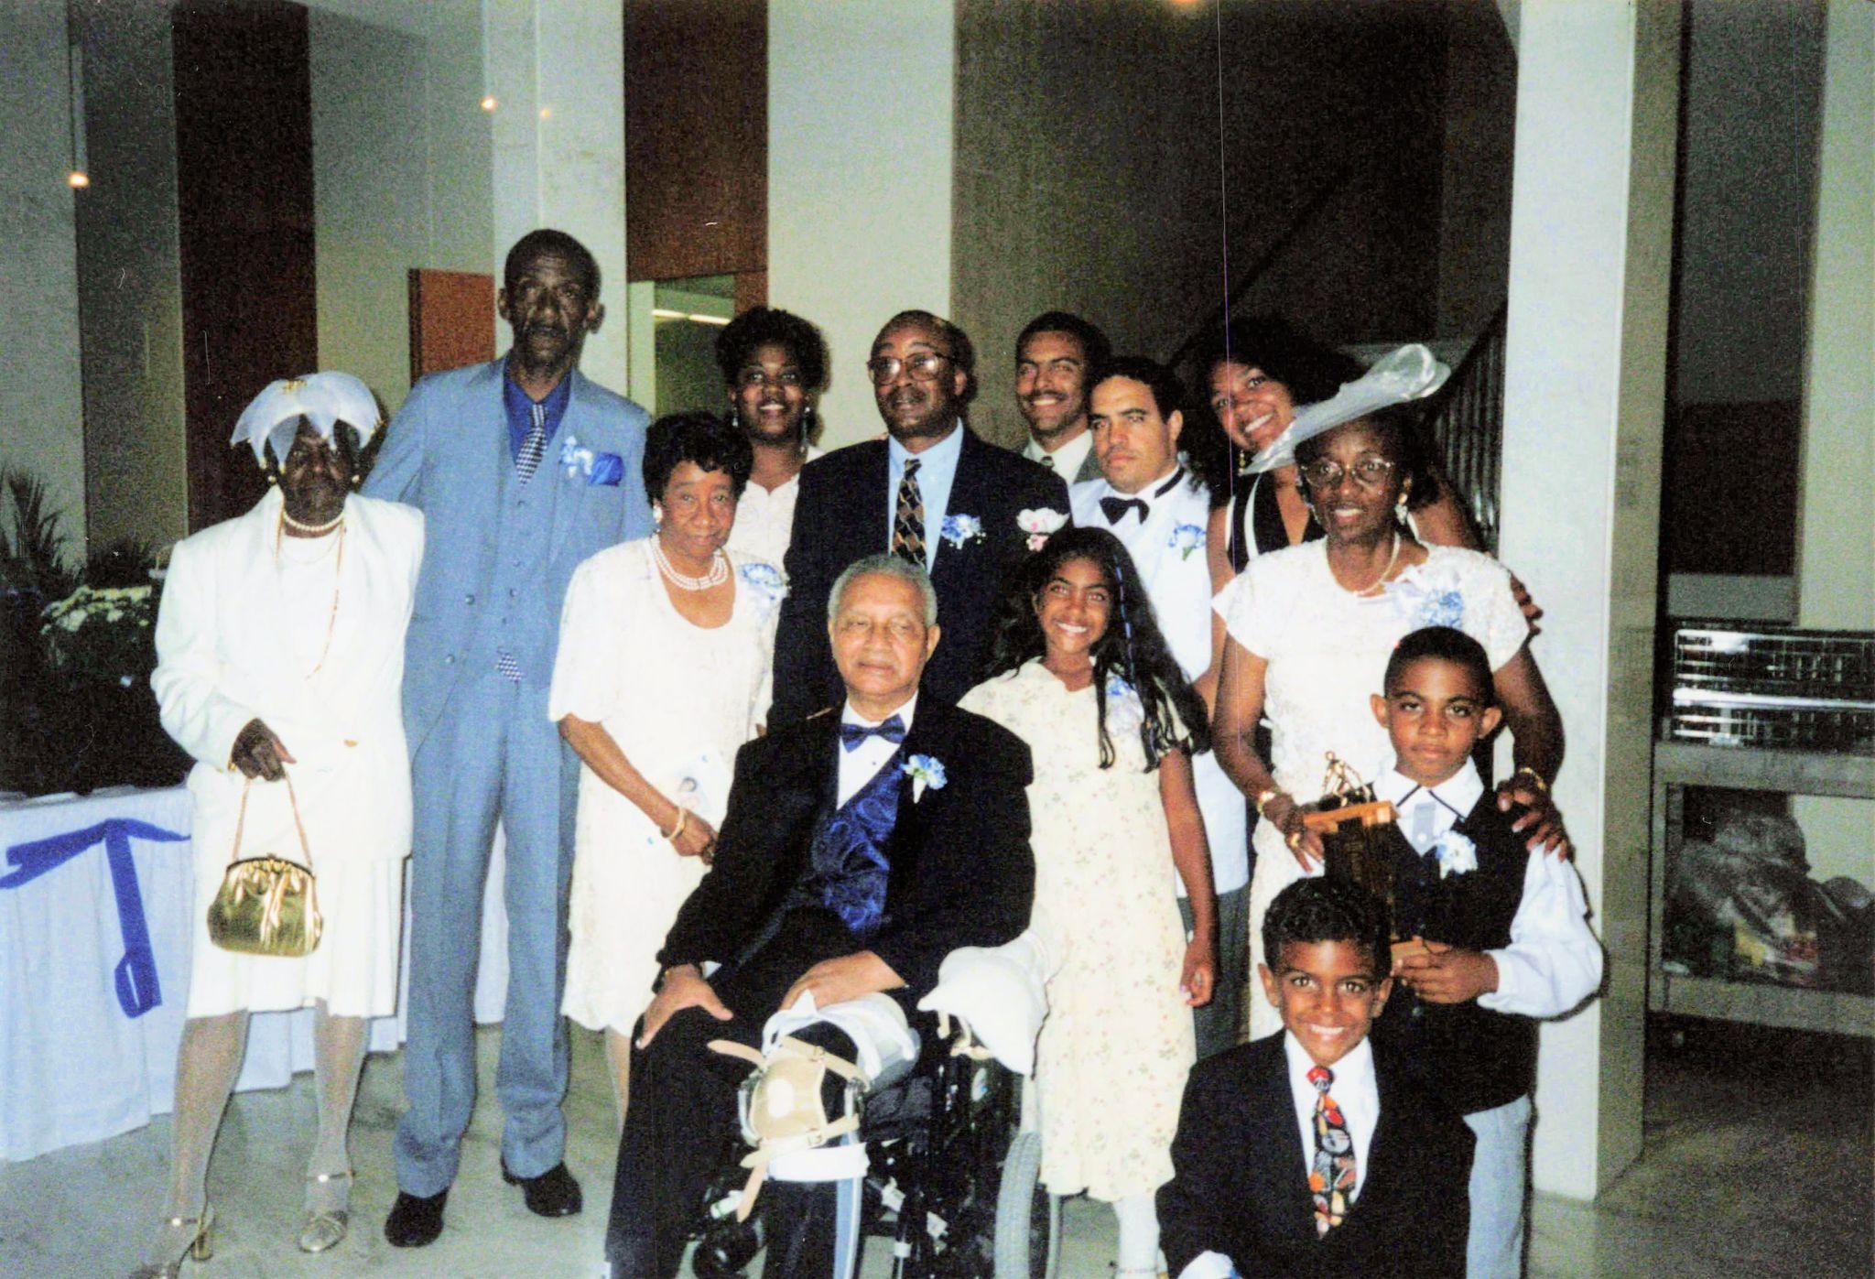

**40th Wedding Anniversary Party August 1999**

Aunt Agnes Bailey, Cousin Bradford Bailey, Aunt Vivian Austin, Renee Burns, Cousin Ronald Austin, Derrick Burns, Maya Burns, Dave Burns, Doctor Gina Gregory-Burns, Willa Burns, Joshua Burns, Jamil Burns, and Howard Burns.

.

## Chapter 26: A Mother's Farewell

In the days following Dad's funeral, I focused my mind on tasks. I "took care of Mom's money," as she described my bookkeeping efforts to her friends. I helped Mom clean out her bedroom, identifying which of Dad's clothes to give to charity, and which to discard. As I went through his papers, I found out about Dad's prior marriage and his son. I did not ask Mom then. Not ever. But when I read the words I suddenly realized why Dad was so quiet about his history. He did not want to lie, so it was better to stay silent. Mom had been grieving the slow loss of her husband for five years. If her history of grieving Aunt Mae's death was any guide, she would grieve for another five years... and she did.

### A Life in Full

At 82, she joined a Wayne State alumni group for a trip to Egypt, standing at the foot of the Great Pyramids with the same wonder I'd seen in her eyes as a child when she'd point out constellations in our backyard. The photograph she sent me showed her dwarfed by ancient stones, her smile radiant beneath a wide-brimmed hat, arms spread wide as if trying to embrace the world itself.

"Derrick, you should have seen the sunrise over the Nile," she told me during our weekly phone call, her voice animated in a way I hadn't heard since before Dad's stroke.

She described the colors, "purple and gold like nothing I've ever seen", with the enthusiasm of someone discovering beauty for the first time.

At 85, Mom had carved out a new rhythm for herself. Mornings began with coffee and the Detroit News, though she preferred waiting for Wednesdays when the Michigan Chronicle arrived, savoring the community news and perspectives that connected her to the world she'd always known. When she backed her blue Cadillac DeVille out of the driveway, she might scrape the chain link fence occasionally, but that never stopped her resolve to go where she needed to go.

"Good morning Mr. Allen!" she would yell across the street when she saw her dear neighbor of fifty years tending to his yard, her voice carrying the warmth of decades of shared “hello”s.

Afternoons were for volunteer work at the Stork's Nest project, evenings for long phone conversations with Mrs. Elma Peddy and Mrs. Virginia Donaldson, friendships that had weathered decades, voices that still made her laugh.

When friends suggested she might be "too old" for international travel, she'd wave them off with characteristic determination.

"I've got places to see and things to do," she'd say, already planning her next adventure.

### The Call That Changed Everything

I was at my desk in San Mateo when the phone rang that January morning in 2009. Four airline tickets to Virginia sat beside my computer, Toni Townes-Whitley, my Princeton classmate, was hosting a party at her compound for Obama's inauguration. I was hoping to see Michelle and Barack there, to celebrate this historic moment with friends who had become part of history themselves.

"Derrick?"

Mom's voice sounded different. Careful. Measured in a way that made my stomach tighten.

"Hi Mom, how are you?"

"Well, the lymph nodes in my armpit are swollen and I have been having trouble sleeping. I am getting a biopsy this week."

My hand tightened on the phone. Lymph nodes. Biopsy. These weren't words that belonged in conversations with my 85-year-old mother who still drove her blue Cadillac and yelled greetings to neighbors.

And as we held our collective breath, the news came back.

"I have non-Hodgkin's lymphoma. The doctors recommend chemotherapy."

The words stopped time. Non-Hodgkin's lymphoma. Cancer. Mom. The airline tickets on my desk suddenly looked like artifacts from someone else's life, promises of celebration that belonged to a world where my mother wasn't sick.

"What does that mean?" I managed to ask.

"We'll figure it out," she said, her voice steadying into the tone she'd used when I was sick as a child, as if she could will this away through sheer maternal determination.

History could wait. Detroit was calling me home again.

### The First Battle

The doctors explained the treatment plan with the practiced efficiency of people who delivered this news regularly. CHOP chemotherapy, they called it, cyclophosphamide, doxorubicin, vincristine, and prednisone. The names sounded like weapons because that's exactly what they were, chemical warfare against the cancer that had invaded my mother's body.

I flew to Detroit for her first treatment, determined to be there as she had been there for me through every childhood illness, every scraped knee, every fever that sent her to my bedside with cool washcloths and worried eyes.

She was admitted to the hospital for treatment. At her age, the doctor warned, the treatment could be difficult to tolerate. Nausea, fatigue, even loss of balance. Mom nodded as if she were receiving a weather report, her purse clutched in her lap as if it might anchor her to the world she knew.

"This will help you feel better," the nurse said as she inserted the IV, but I could see the doubt in Mom's eyes.

She had already survived breast cancer years before, fought that battle with characteristic privacy and determination. But she was 85 now, and her body felt different, more fragile.

The chemicals dripped into her veins with mechanical precision. Within days, the woman who had stood at the pyramids was reduced to someone I barely recognized. Her tiny frame was wracked with pain that seemed to emanate from her very bones. Lethargy pinned her to the bed like invisible weights. Her mouth became a battlefield of its own, the treatment attacking the cells that lined her throat, making it nearly impossible to eat or drink.

"Derrick, bring me the magic mouthwash," she whispered, her voice barely audible.

The thick, medicinal liquid was supposed to soothe the burning, but nothing seemed to touch the deeper agony.

When I offered her the water glass, she pushed it away with a trembling hand.

"I'm not doing that again."

### Difficult Choices

In the weeks that followed, Mom slowly emerged from the worst of the treatment's effects. Her appetite returned in small increments, first sips of broth, then crackers, finally real meals that she could taste again. But something fundamental had shifted. The woman who had backed her blue Cadillac out of the driveway with such determination now moved more carefully, as if her body had become unfamiliar territory.

When she felt strong enough to travel, I brought her to California for a visit. Watching her in our San Mateo home, surrounded by the life Gina and I had built, I saw how small she looked in our guest room, how she seemed to be measuring herself against the distance from everything familiar.

"Mom," I said one afternoon as we sat in the garden.

"I've been thinking. What if you moved out here? I could take care of you properly, make sure you get the best treatment."

She was quiet for a long time, her hands folded in her lap, eyes fixed on something beyond our fence. When she finally spoke, her voice carried the weight of a decision already made.

"Detroit is my home, Derrick. That house on Shields Street, that's where your father and I built our life together. That's where you grew up. That's where I belong."

I wanted to argue, to list all the practical reasons why California made sense, better doctors, my proximity, the mild weather that might be easier on her aging body. But looking at her face, I understood. The house wasn't just where she lived; it was the repository of fifty years of memories, the place where she had been a wife, mother, neighbor. If she couldn't have her health, at least she could have the comfort of familiar surroundings.

"I understand," I said, though part of me wanted to keep pushing.

"But you'll need help."

She nodded, that stubborn set to her jaw softening slightly.

"We'll figure it out."

### The Search for Help

Back in Detroit, the reality of Mom's situation became starkly clear. I placed an ad in the paper and simultaneously asked Mom to ask her friends for referrals. One referral seemed perfect, but she wasn't available to start for a couple of months. When I got a response from a home health aide who could start immediately for just over half the cost of the first one, I jumped at it.

Sheila was tall and strong at 5'10", with steady brown eyes and a capable frame that suggested she could handle the physical demands of caregiving. Her resume listed years of experience with elderly clients, and when she spoke about her teenage son, I heard something I recognized, the weight of responsibility, the drive to provide.

"I understand what Mrs. Burns needs," Sheila said during our interview, her voice calm and assured.

"Dignity. Respect. Someone who sees her as a person, not just a patient."

But convincing Mom to accept help was another challenge entirely.

"I don't need help yet, Derrick," Mom said, that familiar edge of stubbornness in her voice.

"I can cook and clean for myself," she added.

"I know you can, Mom. I just want to make sure that if you do need help, someone is there for you. Do this for me," I implored.

Mom grudgingly accepted the help. Just a couple of hours a day. But those hours gave me comfort. I had a person I could call who was placing eyes on my mom, who could tell me how she was really doing. It wasn't the work that I valued, it was the presence.

But as Mom's condition worsened, the complexity of her care increased. Three months after her initial diagnosis, we sought a second opinion from an oncologist recommended by one of Mom's friends. His clinic was modest, just an outer office with a receptionist and an inner office lined with white cabinets that perhaps contained the drugs that might save her.

### Harsh Realities

We sat in the oncologist's inner office, Mom in the patient chair, me beside her taking notes I hoped I'd never need to reference. The doctor reviewed her chart with the methodical attention of someone who had delivered this kind of news many times before.

"Tell me about the first treatment," he said, looking up from the papers.

I found myself speaking for Mom, describing the reaction she'd had to the chemotherapy, the dizziness that left her unsteady on her feet, the lethargy that kept her in bed for days, the way her mouth felt like it was on fire, making it impossible to eat or drink anything without pain.

"She couldn't keep anything down," I explained, watching Mom nod in agreement. "The nausea was constant."

The doctor listened, occasionally making notes. When I finished, he set down his pen and looked directly at Mom.

"Mrs. Burns," he said, his voice matter-of-fact in a way that somehow made his words more ominous, "I can cure any cancer. The question is, can you survive the treatment?"

The words hung in the air between us like a diagnosis of their own. I felt something cold settle in my chest as I watched Mom absorb what he'd just said. This wasn't about hope versus despair, this was about mathematics. Her body versus the poison that might save it.

"What are you saying?" I asked, though I was afraid I already knew.

He explained that removing her cold turkey from steroids had been a mistake in the first treatment. He could modify the approach, he assured us, monitor her more closely, reduce the dosages of the harsh chemicals. But the fundamental equation remained unchanged: the cure might kill her faster than the disease.

Mom was quiet for a long moment, her hands folded in her lap. When she finally spoke, her voice was steady.

"I'll try it one more time."

### The Final Treatment

The modified treatment plan was administered in the sparse clinic this time. Mom received the second chemotherapy session in that simple office with its white cabinets and minimal equipment. When she left, I felt a surge of hope, she was walking on her own accord, her gait steady, looking more like the woman who had yelled greetings to Mr. Allen.

But days later, the symptoms returned. Not as severe as before, but present nevertheless. The nausea crept back, the fatigue settled into her bones, and the mouth sores made eating a careful negotiation between hunger and pain.

After a few sessions, Mom made a decision that shouldn't have surprised me but somehow did.

"I'm stopping," she told me during one of our phone calls.

Her voice was tired but resolute, carrying the tone she'd used when I was a child and she'd made up her mind about something, final, non-negotiable.

I didn't ask if she was sure. She had already tried twice, had already given the treatment every chance she could. This wasn't my decision to question or make more difficult.

"I understand, Mom," I said.

"I'd rather have fewer good days than more bad ones," she explained, her voice carrying the same practical wisdom she'd applied to every major decision in her life.

In that moment, I heard an echo of the woman who had refused to let Dad languish in a nursing home, who had transformed their den into a place of dignity and care. She knew what she wanted, and what she wanted was to live, really live, for whatever time remained.

### Fading Memories

During my increasingly frequent visits to Detroit, I began to notice changes in Mom that were harder to dismiss than physical frailty. She would ask me the same question three times in an hour, each time with the genuine curiosity of someone hearing my answer for the first time.

It was simple conversation on the phone that revealed the changes most clearly. She would talk about her day, what she'd had for breakfast, a conversation with Mrs. Peddy, something she'd seen on the news, then twenty minutes later, repeat it all again, word for word, as if sharing it for the first time.

She began complaining about misplacing things. Keys that she was certain she'd left on the kitchen counter. Her reading glasses had somehow moved from the coffee table. Most troubling, she started hiding her precious jewelry and what little cash she kept in the house, then forgetting where she'd put them.

"Derrick, I can't find the Tiffany necklace you got me," she'd tell me, worry evident in her voice. "I know I put it somewhere safe."

The woman who had managed Dad's complex medical needs with military precision, who kept copious notes on everything from doctor appointments to household expenses, was becoming untethered from the moorings of memory that had always anchored her.

I took her to Henry Ford Hospital for an evaluation, sitting beside her as doctors administered tests with names I'd never heard before. The analysis confirmed what I had feared but couldn't bring myself to name, significant memory loss and cognitive decline.

"It could be 'chemo-brain,'" the doctor explained, using a term that sounded almost casual for something so devastating.

"Memory failure induced by the chemotherapy treatments."

Whatever the cause, the implications were clear: Mom's judgment was becoming less reliable. The independence she had fought so hard to maintain was slipping away, piece by piece, memory by memory.

### Escalating Needs

Faced with Mom's declining memory and judgment, I increased Sheila's hours, ensuring Mom had supervision throughout the day. The woman who had once managed every detail of our household now needed someone to remind her to take her medications, to help her find things she'd hidden and forgotten.

At the airport, preparing for yet another delayed return to California, I found myself making two phone calls that had become routine, once to check on Mom, once to apologize to Gina for another postponed homecoming. The balance between caring for my mother from across the country and maintaining my own family felt increasingly impossible to sustain.

By spring, our fragile equilibrium was shattered again. During a routine examination, Mom's doctor found something that made my blood run cold, a recurrence of breast cancer. The cancer hadn't metastasized, but it was there nonetheless, and she elected to have a mastectomy.

The surgery itself was successful. I remember visiting her in the hospital afterward, watching her walk down the hallway with the temporary buoyancy that steroids can provide. She was smiling, chatting with nurses as if nothing fundamental had changed, her spirit temporarily lifted above the reality of what her body was enduring.

But as the steroids were gradually reduced, so was Mom's energy. The brief spark I'd seen in the hospital corridor dimmed, and her recovery stalled in ways that had nothing to do with surgical healing. Her body seemed to be reaching its limit for fighting battles, and we faced another agonizing decision.

The doctors recommended transferring her to a rehabilitation facility to help her regain strength. I spoke with friends of Mom's, seeking their advice. They recommended a particular rehab facility, assuring me that it was much better than Bortz, that Mom would be well cared for. The doctors said it was only for a couple of weeks. Mom could return home.

But even with these reassurances, the reality proved different from the promise.

### The Call Home

Two weeks into her stay, Sheila called me with alarm in her voice that I'd never heard before.

"Your mother looks terrible," she said, her words tight with concern.

"This place is killing her."

My stomach dropped. I had trusted the recommendations, believed the assurances that this facility would be different from Bortz. But Sheila's voice carried the urgency of someone who had seen Mom at her best and was now witnessing something frightening.

"What do you mean?" I asked, though I was already reaching for my laptop to book a flight.

"She's not eating. She barely responds when I talk to her. The staff..." Sheila paused, choosing her words carefully.

"They're not taking care of her the way she needs."

I could hear the weight of what she wasn't saying, that despite all my research and the promises from Mom's friends, this place was failing her just as surely as Bortz had failed Dad.

"Get her home immediately," I said, my fingers already pulling up airline websites. "I'm coming."

When I arrived in Detroit and saw Mom, Sheila's alarm made perfect sense. The woman who had walked hospital corridors with steroid-induced energy just weeks before looked diminished in ways that went beyond physical healing. There was something in her eyes, a dimming that spoke of neglect, of being forgotten in a place where care was supposed to happen.

That night, sitting beside her bed in the house on Shields Street, I made a promise that felt as sacred as any vow I'd ever spoken:

"I will never send you to a place like that again. You are home now, and home is where you'll stay."

### The Final Months

I extended my visits from one week to three, spending precious time with Mom in what we both understood were her final months. The house on Shields Street became the place where we could simply be together, away from the clinical efficiency of hospitals and the institutional neglect of care facilities.

Sheila and I established a routine that gave each other breaks from the constant vigilance that caregiving required. During my shifts, I would keep simple meals for Mom whenever I could get her to eat. Her appetite was barely enough to feed her tiny body that competed with the cancer cells for nourishment.

"Mom, I am making you some oatmeal with some bananas," I'd announce.

Then I would bring it to her bedroom on a wooden tray with legs for her to place over her lap.

We revisited her wonderful life through stories and old photo albums. Her fingers would trace the faces of people long gone, her parents, Dad in his younger days, me as a gap-toothed child grinning in our backyard. Sometimes the memories came easily; other times I would gently fill in the gaps, helping her navigate the spaces where her mind could no longer reach.

"How is Mrs. Donaldson? Mrs. Peddy?" I'd ask, hoping to spark joy at the mention of her dear friends.

Other times we simply sat in comfortable silence, the weight of our shared history filling the space between us. The afternoon light would filter through the curtains she had hung decades ago, casting familiar patterns on furniture that had witnessed our entire family's story.

But each day, her hands grew thinner. The lymphoma had metastasized, spreading through her body with the same relentless determination she had once brought to caring for Dad. Sheila and I began speaking in hushed tones when Mom napped, our conversations full of careful euphemisms that couldn't quite mask the reality we were all facing.

One night, as I lay next to Mom in her bed, the room filled with the familiar scents of home, lavender lotion and the faint mustiness of old wood, she turned to me with an urgent need. Too weak to make it to the bathroom, she needed to defecate.

I helped her to the portable folding commode we had placed next to her bed, supporting her frail frame as she lowered herself onto the seat. Her body felt impossibly light, as if the cancer had hollowed her out from within. When she was finished, I wiped her clean with the same gentle care she had once shown me as a child.

She accepted the indignity with quiet resignation, her eyes avoiding mine not from embarrassment but from the exhaustion that came with needing help for the most basic human functions. There was no shame in this moment, only love expressed through the most fundamental act of caregiving.

This was the circle of life made manifest. She had done the same for me when I was small and helpless. I had done the same for my own children during their countless diaper changes and potty training accidents. Now I was doing it for my mother, the woman who had taught me that love sometimes meant doing the things that were difficult, unglamorous, necessary.

As I cleaned the commode and helped her back to bed, I felt the weight of what we were sharing, not just this moment of physical care, but the profound trust she was placing in me. In her vulnerability, she was teaching me one final lesson about what it meant to love someone completely.

### The Last Goodbye

I returned to California to attend to my family, carrying with me the certainty that our time together was almost over. The flight home felt different this time, not the usual relief of returning to my own life, but the heavy knowledge that I was leaving Mom to face her final battle without me physically present.

When I called her now, the transformation in her voice was unmistakable. The energy and strength that had always characterized her, what I had come to think of as "the general" in her, was gone, replaced by an acquiescence, an acceptance that her time was ending.

"Hi Derrick," she would answer the phone, her voice barely above a whisper.

"Hi Mom, how are you feeling today?" I would ask, injecting as much cheerfulness as I could muster.

"Ok," she would say, the single word trailing off into silence that spoke volumes about her diminishing strength.

These conversations became a ritual of careful optimism on my part and gentle resignation on hers. I would tell her about Maya and Jamil, about work, about the weather in California, anything to keep her tethered to the world of the living. She would listen, sometimes responding with a soft "mm-hmm" or "that's nice, honey," but I could feel her drifting further away with each call.

The woman who had once commanded household schedules and family dynamics with military precision now struggled to hold onto the thread of our conversations. Yet in her weakness, there was a kind of grace, an acceptance of what was coming that I wasn't sure I possessed.

A week later, Sheila called.

"Mrs. Burns is gone," she said simply.

The words hit me like cold water, though I had been preparing myself for them for weeks. Gone. The finality of that simple word seemed to echo in the silence that followed Sheila's announcement.

I stood in my California kitchen, the phone pressed to my ear, trying to process what she had just told me. Mom, who had yelled greetings to Mr. Allen across the street, who had stood at the pyramids with arms spread wide, who had fought so hard to bring Dad home and care for him with dignity, was no longer in the world.

"When?" I managed to ask.

"About an hour ago," Sheila said softly.

"She went peacefully. In her sleep."

After I hung up, I sat down at my kitchen table and let the reality wash over me. The woman whose strength and love had shaped everything I had become, her voice, her laugh, her fierce determination to live life on her own terms, existed now only in memory.

But more than personal loss, I felt something else: a profound gratitude for those final months we had shared. For the wooden tray meals and the gentle conversations about Mrs. Peddy and Mrs. Donaldson. For the trust she had placed in me when she needed help with the most intimate aspects of care. For the way she had taught me, even in her dying, what it meant to love someone completely.

Losing Mom was like losing a piece of myself, but it was also the completion of a circle that had begun when she first held me as an infant, teaching me that love sometimes meant doing the difficult, unglamorous, necessary things. Now I carried that lesson forward, along with all the others she had given me.

### The Empty House

When it came time to bid her farewell in the hallowed halls of Metropolitan Baptist Church, the contrast with Dad's funeral eight years earlier was stark. About sixty people attended, a modest gathering that would have filled perhaps a quarter of the sanctuary. The church that had once been the vibrant center of our community now felt cavernous, its empty pews a testament to Detroit's continuing decline and the diaspora of its children.

Doctor Morton, who had presided over Dad's funeral with such dignity and grace, had himself passed away a year earlier, in November 2009. The congregation that had once numbered in the hundreds during my childhood had dwindled to fewer than a hundred faithful members, most of them aging alongside the city itself.

A younger minister led the service, reading from notes about a woman he had never really known. He spoke of Mom's dedication to the Stork's Nest project, her love for her family, her strength in caring for Dad during his final years. The words were kind and appropriate, but they felt like echoes in a space that had once resonated with the full-throated celebrations of a thriving community.

Mrs. Peddy and Mrs. Donaldson were there, both using walkers now, their faces etched with the grief of losing another member of their shrinking circle. A handful of Mom's former colleagues from the school system came to pay their respects. Sheila sat in the back, her presence a reminder of the final chapter of Mom's life.

As we gathered around the graveside, I thought of Aunt Mae and Uncle John, buried next to Mom and Dad, as Mom had planned. The four plots now filled with the bodies of those who loved me the most and who I loved with all my heart.

After the funeral, I returned to the house on Shields Street one last time before flying back to California. Walking through those familiar rooms, everything looked the same, the furniture in its appointed places, Mom's coffee cup still sitting by the sink, the Michigan Chronicle from the previous Wednesday folded neatly on the kitchen table. But nothing felt the same.

This house had been the center of my universe for the first eighteen years of my life. Every room held memories: learning to tie my shoes in the kitchen, doing homework at the dining room table, the countless conversations with Mom and Dad about everything from school to dreams to disappointments. Now it felt like a museum of a life that had ended.

With my own life firmly established in California and Detroit continuing its economic decline, the family home became a burden I couldn't manage from across the country. The house itself was in excellent condition, structurally sound, though perhaps showing its age in ways that reminded me of Mom herself in her final months. But maintaining it from 2,000 miles away felt impossible.

I considered whether my sister Jala might need a place to stay, but her life was in North Carolina now. I reached out to local family members for help. My cousin Nicole lived alone in her apartment, and I thought perhaps she might want to move into the house. She deliberated for a week before declining, she preferred the comfort and convenience of her apartment, which was better located for her needs.

The house remained empty, and I felt the weight of a decision I wasn't ready to make. This wasn't just a piece of real estate; it was the physical embodiment of everything my parents had built together, everything they had given me. How do you sell the place where your family's story began?

Desperate to keep the house from deteriorating while I wrestled with what to do, I offered to rent it to Sheila. The woman who had been Mom's caregiver, who had called me with alarm when the rehab facility was failing her, who had been present for Mom's final moments, surely she would treat the house and its contents with the respect they deserved. I thought she might appreciate having a stable place to live in exchange for modest rent and maintaining the property.

For a time, it seemed like the perfect solution. Sheila moved in, paid her rent, and kept me updated on the house's condition. I felt relief knowing that someone who had cared for Mom was now caring for the home where that care had taken place.

The following winter brought a betrayal that cut deeper than I could have imagined. Sheila stopped paying rent and began ignoring my calls. When she finally moved out several months later, I discovered she had taken Mom's belongings with her, not just small items, but furniture, jewelry, pieces of our family's history that could never be replaced.

I discovered the theft in the most jarring way possible: scrolling mindlessly through Facebook one evening, I stopped breathing. There were Mom's tables, the glass insets catching afternoon light, those carved white and gold legs I'd helped Dad move so many times during my childhood. They sat casually in someone else's living room now, background props in Sheila's apartment photos, as if they had always belonged to her.

Staring at that photo, rage settled like sediment in my chest. The Tiffany necklace I had bought for Mom years earlier, the one she couldn't find during her memory lapses, had likely been stolen by Sheila as well. Even more heartbreaking was the disappearance of my mother's sapphire ring, which she had promised to my daughter Maya. The woman I had trusted with my mother's final months had been systematically stealing not just possessions but family legacies intended for the next generation.

The betrayal by Sheila was just the beginning of the house's decline. I changed the locks and tried to secure the property from across the country, but Detroit's accelerating decay made vacant houses vulnerable targets. Despite my efforts to maintain it, squatters eventually broke in, turning the once-peaceful home into something I barely recognized.

They bypassed the DTE meter, stealing electricity while I continued to receive bills for a house I could no longer control. The small kitchen where Mom had prepared countless meals, where she had taught me life lessons over morning coffee and evening snacks, was damaged in a subsequent fire. The scent of smoke and neglect replaced the familiar aromas of home cooking and Pine-Sol that had defined that space for decades.

The house was uninsured, not by choice, but because Allstate had dropped coverage years earlier, even before Mom got sick, despite our family's faithful and timely insurance payments for over forty years. They had deemed Detroit properties too risky to insure, leaving us vulnerable at the very moment we needed protection most.

Faced with mounting costs for a property I couldn't secure, couldn't insure, and couldn't maintain from California, I made the wrenching decision to relinquish the house to the state for unpaid property taxes. It was the final severing of my ties to Michigan, the place where I had been born and raised, where my parents had lived and died.

When the notice arrived from the state acknowledging repossession of the home, I thought about Mom's hands on that front door key, fifty-one years of turning that same lock, of coming home to the place where she and Dad had built their life together. The house was gone, but I could still feel her teaching me to tie my shoes in that kitchen, still hear Dad's voice calling us to dinner from the living room.

Some things burn down. Others you carry with you forever.

Where Dad's death had driven me toward tasks and discovery, Mom's passing left me with only emptiness. The house on Shields Street became a wound I couldn't touch, while Marcia's death three years later would teach me something different about loss—that some grief carries relief alongside sorrow.

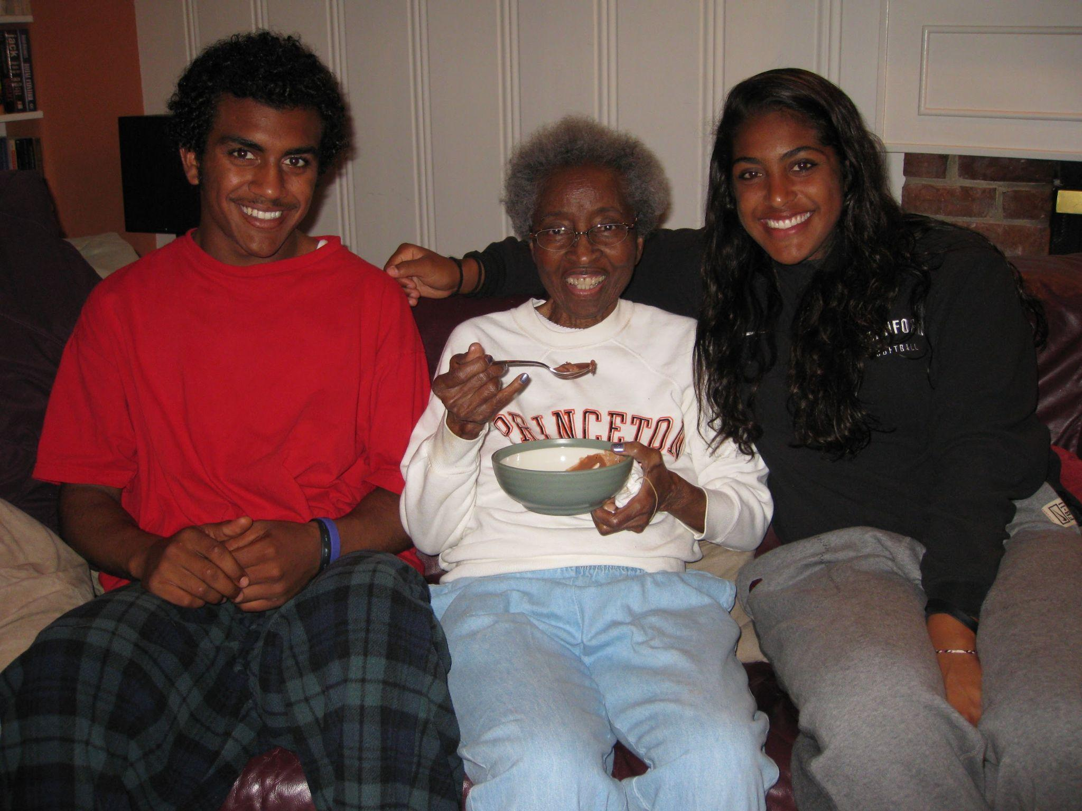

**Mom Visits Our San Mateo Home, March 2010**  
Jamil, Mom, Maya

## Chapter 27: Colliding Worlds

### The Invitation

When his imposing 6'2", 300-pound frame filled the doorway of the funeral home, the chatter in my mind about the people I recognized and those I did not came to a sudden halt. My focus narrowed completely to my uncle. I had only seen him in person a few times before, always on his turf, restaurants in Michigan, his haunts, not mine, where he moved with the easy confidence of someone who belonged. But now he was here, on mine?

"I came to show my respects," he'd said simply, pulling me into an embrace that felt both foreign and familiar. "On behalf of the family."

*The family.* Marcia's family. The other family. The family I'd discovered at thirty-three but never quite figured out how to integrate into the life I'd already built. David's presence was his way of saying *I see you. You belong to us too.* But as he held me, I felt a door open, though it would be three years before I walked through it.

Now, twenty-four hours later, as we prepared for Mom's funeral at Metropolitan Baptist Church, I found myself bracing for another collision. Marcia had called to say she was coming.

### Before the Service

The morning of the funeral, I stood in my childhood bedroom, the same room where Mom and I knelt down to pray, where Dave and I snuggled together, where I'd hidden in the closet. I stood in front of the mirror attached to the back of the dresser, confirming my appearance as I had every Sunday before going to Church. I adjusted my tie, the tie Dad had taught me how to don in front of this very mirror.

Gina was busy getting herself ready after getting up early to make a full breakfast for us. Maya at age 20 and Jamil at 18, were dressed, quietly bracing themselves for the event that they knew was coming, but at their age they could never be ready for: seeing their grandmother in a casket, never to hear her call their names again.

“My-er!"

"Ja-meeel!"

"Coming grandma" they'd respond.

When I walked out of the bedroom, I barely noticed the kids. Maya's eyes were puffy and red. Jamil walked gingerly.

"Mom, when do we need to leave the house?" Maya asked.

"In about 15 minutes. We will go directly to the cemetery from the church, so bring your gloves. I don't know how long we will be outside." Gina instructed, always thinking ahead to the needs of the family.

Not me. I was locked in my own head, barely functioning as an adult, let alone as a parent. I just needed to drive us to the church. Back out of the driveway, turn west onto Stockton a few blocks, make a left onto Ryan Road, drive past the warehouse where Dave could have lost his freedom when his friends killed a cop.

Driving down Ryan Road between McNichols and Davison in the 1970s, you'd see tall, narrow two-story homes packed tightly together, each with a deep front porch where families sat, kids played nearby, and the scent of cut grass or barbecue drifted through the air. The houses, mostly wood-framed with worn siding and high gabled roofs lined up like sentinels just feet from the sidewalk.

Today, that same stretch of Ryan Road is a ghost of its former self, most of the houses are gone, replaced by vacant lots overrun with grass, weeds, and silence. Where once there were porches full of life, now there's mostly open space, the occasional lone house clinging to its foundation, surrounded by emptiness and memories.

The life of that street is gone.

As we pulled into the church parking lot, I found myself remembering the only time both my mothers had been in the same space in Detroit, that July 4th celebration in our backyard thirteen years earlier. Mom had insisted on showing Marcia my baby pictures, a gesture layered with meaning. *Look what I raised,* it seemed to say. *Look at the boy who became a man in my house.* But there had been something else in Mom's eyes that day, maybe recognition, maybe pity for the woman who had given birth but couldn't mother. They had barely spoken, but something had passed between them. An acknowledgment of the impossible situation we'd all inherited.

Now Mom was gone, and Marcia was coming to claim her place in my grief. But which place? What right?

### The Collision

We climbed the steps to the main church entrance, an entrance that we had rarely used before. Like the front door entrance to my home, this entrance was sacred, official. Raising my leg to climb each step was an ordeal, as if I were carrying an eighty pound backpack. I looked down, planted one foot at a time and pushed. I might as well have been alone, for I was detached from all other humanity.

Metropolitan Baptist Church looked exactly as it had throughout my childhood, the warm wood tones, the familiar scent of furniture polish and aged hymnals. Mom's casket sat at the front, surrounded by arrangements of pink and white flowers mixed with Zeta Phi Beta blue. The sanctuary was maybe a quarter full, a painful reminder of Detroit's decline and the diaspora of families like ours.

We made our way down the center aisle, one I’d only rarely walked as a child while collecting offerings as an usher. Mom never sat in the center; she always chose the far-right side. Jala led Joshua and Maya into the first pew, then Jamil, Gina. I took the end seat, closest to the casket and nearly centermost in the room.

My eyes locked on the casket, *Mother’s casket*, the one I’d ordered online like I was shopping for a television. She would’ve approved: modest, decorative, dignified. From where I sat, I couldn’t see her face, though I had when we walked in. It was wrong. Her eyes closed, makeup off, something missing. This wasn’t my mother. My mother was gone.

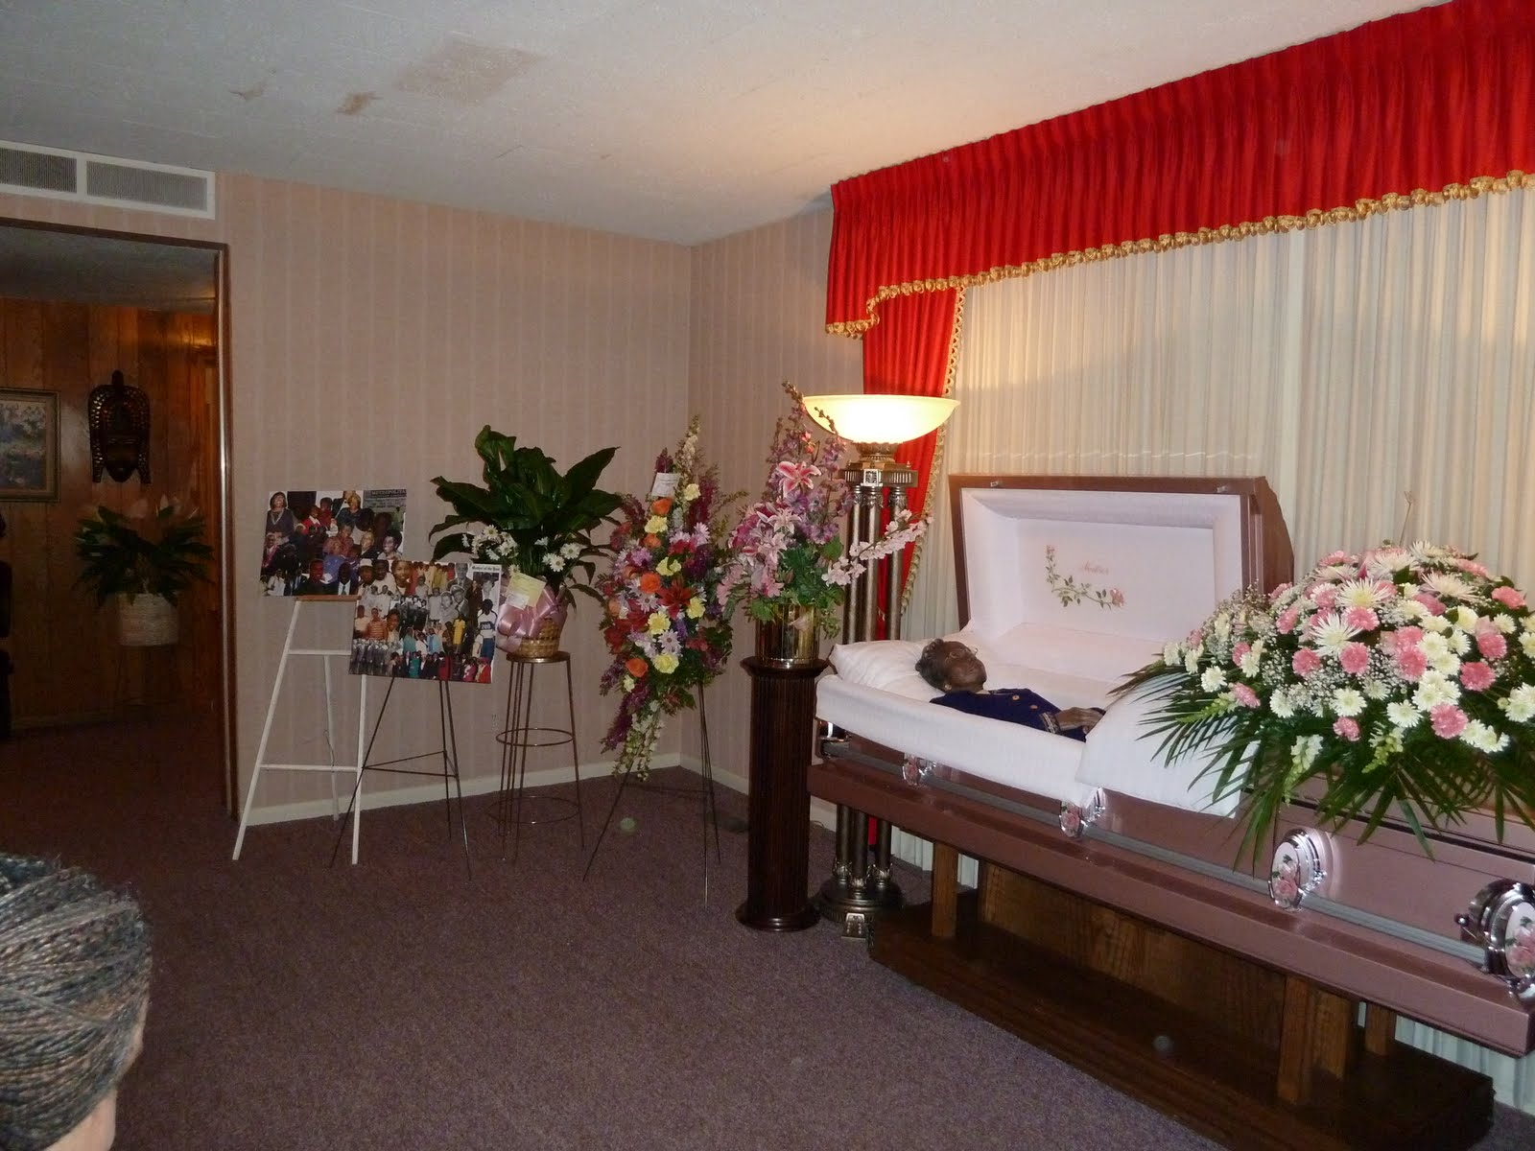

**The Wake at Funeral Home, December 2010**Mom

The minister began the service, and I tried to focus on his words about Mom's life of service, her dedication to family, her strength. But the minister did not know Mom, and his words felt flat to me. As a recent addition to Metropolitan which had struggled to find a new spiritual leader since Doctor Morton passed, he did now know my mother. He did now know her fifty years of service. My attention kept drifting back to that casket, to the wrongness of everything about this moment.

People filtered in behind us. I could hear the soft shuffling of feet, whispered condolences, the rustle of programs.

Then I heard shuffling in our row coming from the right. It was Marcia. Her expression was flat. No. Not flat. I could see her stealing herself. Holding it together, not unlike her visit to Mom's house. This was Mom's house too, after all, not hers. But like that first meeting, this one was not optional, and she summoned the strength to walk into this church, this black church, where she was the only white face.

*What am I supposed to feel right now?* The question crashed through my mind as I watched her settle into the pew. *Relief that she came? Resentment that she's here? Gratitude that she cares enough to honor Mom's memory?*

The gesture was bold, presumptuous, and heartbreaking all at once. Here was a woman claiming her place in a family constellation that had never quite had room for her. At that moment, I saw not the complicated woman who had cycled in and out of my life for thirteen years, but someone who had lost the right to publicly mourn her own child. Someone who had to assert her claim to grief.

*She gave birth to me,* I thought, *but in this room, surrounded by people who knew me as Willa Burns's son, what does that mean?*

Marcia sat down next to Maya, as Maya, perhaps unconsciously, recoiled. The tears started streaming down Maya's face again, as Jamil joined in. Both tried to face forward, tried to brave the torrential flood that rushed at them. Gina stiffened as well, perhaps only noticeable to me. Or was I projecting? I don't know, can't know. The sanctuary was empty, just the five of us and ... Mom. At least Mom was at peace, beyond the reach of the flood of emotions that sought to knock us all down.

The minister continued his words about Mom's life of service, her dedication to family, her strength. But part of my attention remained fixed on the impossible geometry of that front pew. Maya trying to control her tears while unconsciously pulling away from the stranger beside her. Jamil's shoulders shaking with fresh sobs. Gina's tension radiating through the space between us. And Marcia, rigid and present, claiming space in grief she had no roadmap to navigate.

*Am I Willa's son or Marcia's son?* The question felt urgent, blasphemous. *Can I be both in this sacred space? Do I owe Marcia recognition of her loss, or do I owe Mom protection of her memory?*

But mostly, I just stared at that casket and tried to make sense of a world where my mother was gone.

### The Breaking Point

When the minister invited people to come forward for the final viewing, we rose as a family. I walked to Mom's casket first, my legs still heavy as if carrying that eighty-pound weight. As I walked up to the casket, I was performing the role of strong, honorable, dedicated son. I escorted my family up. I showed my wife and kids who had not grown up in the church how to pay final respects. I did not cry. It was like when Mom told me to go get a switch. I turned off emotionally, and simply performed the task at hand.

I looked down at her peaceful face one more time, trying to memorize every detail beyond the wrong makeup, beyond the stillness that wasn't her. The hands that had bandaged my scraped knees. The voice that had called "Derrick!" when dinner was ready. The woman who had claimed me completely when another woman couldn't.

As I returned to my seat, a strange numbness settled over me. It felt like watching myself from outside my body, performing the rituals of grief while my mind tried to process the collision happening around me. When other mourners filed past, Mrs. Donaldson leaning heavily on Kenny, church members offering whispered condolences, I responded appropriately, but felt disconnected from it all.

Then I saw Marcia approaching the casket. She stood there longer than most, and I found myself wondering what she was thinking. *Was she thanking Mom for raising the child she couldn't? Apologizing for the intrusion? Saying goodbye to the only other woman who truly understood the impossible situation we'd all inherited?*

When Marcia returned to the pew, I watched as she approached my children. Maya sat with tears still streaming down her cheeks, trying to be strong. Jamil had his head in his hands, lost in the kind of pure grief that eighteen-year-olds feel, devastating and complete.

"Jamil, I'm so sorry about your grandmother," Marcia whispered, reaching toward him.

But Jamil didn't look up. Lost in his own world of grief, he gave no sign he'd heard her. He was drowning in the loss of the woman who had made him feel special, chosen, loved unconditionally.

As Marcia reached for Maya, she stiffened, her instinctive recoil pronounced. To her, this was still a stranger offering comfort in a moment when all she wanted was the grandmother who would never call her name again.

And that's when I saw it, the moment when careful family choreography collapsed into raw human confusion. Maya's obvious discomfort. Jamil's complete withdrawal. My children had no roadmap for this relationship, no script for how to receive comfort from someone they barely knew who claimed a place in their grief.

*I never taught them how to be Marcia's grandchildren,* I realized, *because I never learned how to be Marcia's son.*

The recoil lasted only seconds, but it felt like hours. I watched Marcia's face flush with embarrassment and hurt. I watched my careful compartmentalization, keeping my birth family and chosen family in separate spaces, collapse in real time.

Marcia straightened, her lips tightening, and returned to her seat without another word. The rest of the service passed in a blur of hymns and prayers, but I could feel the tension radiating from that front pew like heat from a furnace. The emotional numbness that had carried me through the viewing deepened, wrapping around me like armor.

*This is what happens,* I thought, *when you try to belong to two families that were never meant to meet.*

### After the Storm

The ride to the cemetery was silent except for the soft sounds of ongoing grief. Maya stared out the window, her confusion written across her face. Jamil remained lost in his sorrow. Gina held my hand, her touch the only thing that felt real. I found myself thinking about protection, how Mom had protected me from questions I wasn't ready to answer, how Gina had tried to protect my children from relationships too complicated to navigate, how Marcia had tried to protect herself from another rejection.

*But you can't protect people from the truth,* I realized. *You can only delay the collision.*

At the graveside, I thought about the four plots Mom had purchased years earlier. Uncle John and Aunt Mae already rested there, the aunt and uncle who had loved me unconditionally, who had never questioned my place in their family. Soon Mom would join Dad beside them. Four people who had claimed me completely when claiming was what I needed most.

*This is my family,* I thought, looking at those headstones. *This is where I come from, regardless of who gave birth to me.*

But even as I thought it, I felt the weight of Marcia's presence behind me. She belonged here too, in some way I couldn't quite define. She had given me life, and that life was now being buried alongside the woman who had shaped it.

The minister said the final words. We threw dirt on the casket. And then it was over.

Marcia approached me one last time as people dispersed.

"I'm sorry for your loss," she said formally, as if we were strangers.

"Thank you for coming," I replied, equally formal.

We stood there for a moment, two people who shared blood but not understanding, connected by grief but separated by everything else. Then she walked away, and I didn't know it would be three years before I saw her again.

### Recognition

In the days that followed, as the sharp edges of grief began to dull into a persistent ache, I found myself thinking about that moment in the pew differently. Maya's recoil hadn't been cruelty, it had been honesty. She had responded to a stranger in a moment when she needed the familiar comfort of family. Jamil's withdrawal hadn't been rejection, it had been the self-protection of a teenager overwhelmed by loss.

But I also began to understand something else. Watching Marcia that day, seeing her face flush with hurt, I recognized something I'd felt countless times myself, the sharp sting of rejection, real or imagined, and the defensive lashing out that followed. The same hypersensitivity to perceived slights that had marked my own relationships. The same desperate need for belonging coupled with the defensive expectation of abandonment.

*We both carry wounds that never properly healed,* I realized. *We both struggle with feeling secure in relationships.*

The irony wasn't lost on me that the very traits that might have helped us understand each other were the same ones that kept driving us apart. Two people damaged by the same trauma, circling each other warily, each waiting for the other to provide what we'd never learned to give ourselves.

When Marcia's letter to Maya arrived a week later , harsh words about Maya's behavior and our failings as parents, I read it with a familiar hollowness in my chest. The pattern was so predictable it felt scripted. I couldn't even muster anger. I just felt tired. Tired of the endless cycle of tentative connection followed by explosive rejection. Tired of watching my children become collateral damage in a drama that had begun before they were born.

Standing in Mom's church that day, watching my children respond with honest emotion while the adults around them performed their careful emotional dance, something had shifted inside me. I realized I could no longer sustain the hope and disappointment that had defined my relationship with Marcia. My children deserved better. I deserved better.

The door between us didn't slam shut; it closed quietly, with a resignation born of exhaustion rather than anger. Sometimes love, no matter how earnestly desired, simply isn't enough to bridge certain divides. And sometimes, the kindest thing we can do for ourselves and others is to acknowledge that painful truth and learn when to walk away.

## Chapter 28: Final Gestures

### The Call

Three years had passed since Marcia and I had parted ways, our estrangement still an open wound. It was early morning when the phone rang, and my Uncle David's somber voice pierced the silence. Marcia had suffered a catastrophic brain aneurysm. Though she was stable, she lay in a coma.

I was numb. I always thought that we would have time to reconcile. I was so accustomed to Marcia coming into and out of my life. But there would be no reconciliation this time. That opportunity had passed, and I would have to live with that.

The news hit me in waves, first shock, then a peculiar emptiness, followed by regret. Not regret for things done, but for things left undone, words left unsaid. Though our relationship had been fraught with complications, Marcia was still the woman who had given me life. My existence began with her. And now, suddenly, unexpectedly, that connection was about to be severed permanently.

David extended an invitation for me to join him and Cara in Florida, where Marcia was hospitalized, to say our final goodbyes.

### The Last Goodbye

I traveled to Florida and joined the somber gathering at the hospital: Cara, her partner Dave, Uncle David, and his wife Debbie. Entering the room, my breath caught in my throat. Marcia lay motionless in the hospital bed, a breathing tube down her throat and another tube draining blood from her skull. A patch of her beautiful hair had been shaved, an indignity that my vain Marcia would have loathed. Yet there she was, seemingly at peace, moving only with the mechanical rhythm of the breathing machine.

Time seemed to slow as we absorbed the gravity of the situation. Eventually, Marcia's doctor entered the room. His words were gentle but firm: though her condition was stable, she was almost certainly brain dead, her brain irreparably damaged by the swelling. After he left, we convened as a family to make an agonizing decision.

When the doctor returned, we conveyed our choice to withdraw life support. He nodded understandingly and asked us to step out while the nurses removed the tubes from her body.

Returning to the room, I saw Marcia lying there, appearing more at rest than before. I took my place at her right side, Cara at her left. I reached out, holding her hand as it lay still.

Then, unexpectedly, Marcia's hand moved, pulling mine to her heart. The motion, whether voluntary or not, was unmistakable. A surge of emotion coursed through me. Was this a final, silent message?

Within half an hour, Marcia's breathing ceased. The declaration of her death echoed through the room, final and irreversible. We lingered beside her lifeless body, grappling with the swift reality of her passing. There were no regrets, only a profound need to process the rapid sequence of events.

### A Question of Love

A couple of hours later, we gathered at a local restaurant for brunch. We took our seats at the table, the elder men at each end, Cara to my right, David opposite me. The waitress introduced herself and distributed menus, the kind you might find at a Denny’s, hard, plastic, and somewhat greasy.   
  
“Can I get anyone coffee or juice?”   
  
“Yes, I will have coffee.”   
  
“Me too.”  
  
Just another day, right?

We selected our meals, and as we waited for the waitress to return, I broke the silence. "Was Marcia's pulling her hand up a final signal of her rejection of me?" I asked, my voice barely a whisper.

Cara shook her head strongly.

"No," she said softly, "she was pulling your hand to her heart to tell you she loves you." Debbie quickly voiced her agreement with Cara. I looked up at David, wondering if he shared my dark sense of humor or Debbie’s sensitivity.   
  
“Well, …” his voice trailed off.

The little boy in me clung to Cara's comforting words, yet the rational engineer within knew that neither interpretation could be true if she was indeed brain dead. The truth remained elusive, but in that moment, I chose to believe in love.

That choice wasn't just about Marcia, it was about me. About deciding what story I would carry forward. The facts were unclear, ambiguous, like so much of my relationship with Marcia had been. But in this final chapter, I had the power to choose the meaning I would assign to her last gesture. And I chose love, not because it was certain, but because it was healing.

### The Broken Bond

Marcia and I both wanted very desperately to belong. As hard as we both tried, we could not give that to each other. Our bond had been irrevocably broken and replaced with the adoption myth, a story that we both know glossed over a pain so deep that it could never be spoken. The drunk stork did deliver the baby to wonderful loving parents, but she took the baby from an emotionally devastated mother.

As I flew home from Florida, I reflected on the strange symmetry of my life, how I had now been present for the deaths of both my mothers, the one who gave me life and the one who raised me. Each had given me something essential, something irreplaceable. Each had shaped me in ways both visible and invisible.

With Marcia's passing, a chapter of my life closed definitively. There would be no more cycles of tentative connection and painful withdrawal, no more attempts to forge a relationship that could never quite bridge the fundamental rupture at its core. That particular pain was over.

What remained was the task of integration, of finding a way to hold these complex, sometimes contradictory pieces of my history in a coherent whole, of acknowledging both the losses and the gifts that came from being a child of two mothers, of multiple worlds.

The plane climbed through clouds toward California, carrying me back to the family I had created, the life I had built. Below me, Florida receded, taking with it the woman who had first carried me beneath her heart. I closed my eyes, feeling the gentle pressure of Marcia's final gesture, real or imagined, pulling my hand toward her heart. Whatever it meant, I would carry it with me, one last connection to bridge the divide that had defined us both.

With Marcia's death, a complicated chapter finally closed, bringing strange peace rather than fresh anguish. But losing Jala would be different—not the complex grief of difficult relationships, but the pure devastation of losing someone whose love had been uncomplicated and true.

## Chapter 29: Dave Becomes Jala

In stark contrast to my turbulent relationship with Marcia, my bond with Dave was rock solid. He was my constant. What I didn't yet understand was that Dave's steadiness in our relationship masked profound internal turbulence in his own life.

After I left for college, Dave stayed behind in Detroit to finish his degree at Eastern Michigan University in Ypsilanti. We didn't talk as much during that time, and when we did, our conversations were light—updates on our old neighborhood friend Glenn Burch, small things that had a grounding quality, like holding onto pieces of home that hadn't changed.

Glenn was like an older brother to both of us. He went on to play football at the University of Toledo and even had a shot at going pro. After college, he bought a home back in Detroit but commuted to Toledo for work—a 60-mile drive each way—until he retired in 2018. Glenn was steady, dependable, always there. But eventually, things started to shift.

### Dave's Inner Turmoil

Dave met his best friend and future wife, Renee, at Eastern. Together, they had a son and eventually moved to North Carolina, where they spent the next ten years building a life. But beneath that surface stability, Dave was wrestling with something profound and deeply personal.

I always sensed that something wasn't quite right. Dad's pictures rarely showed Dave smiling. I, on the other hand, always smiled—just as Mom had taught me. But Dave? I could never tell if he was unwilling or simply unable.

I got my answer a decade later.

The truth was, Dave didn't feel like Dave. Inside, he didn't feel like a man at all. Eventually, Dave came out as transgender and embraced her true self, legally changing her name to Jala Alyshia McKenzie-Burns.

### The Revelation

Dave and I had not talked in several weeks and I was ashamed that I had not called. So I picked up the phone.

"Hey Dave, how are you doing?" I said, trying to sound casual despite the guilt gnawing at me.

"Hi Derrick. I'm good. Actually, I'm really good." Something in his voice was different - lighter somehow, but also nervous. "Derrick, there is something I need to tell you. This is not about you. You have always been my hero, my big brother. I love you."

The careful way he said it made my stomach tighten. When someone starts with "this is not about you," it usually means it's going to feel like it's about you.

"Okay..." I said, settling back in my chair, phone pressed closer to my ear.

"Derrick, I have always known that I don't feel right in this body. I remember when I was with Mrs. Williams. They made me dress up in girls' clothes and dance."

"What?" I asked, my voice sharper than I intended. Mrs. Williams - that name from Dave's early childhood that he rarely mentioned.

"Yes, but the thing is Derrick. I am a girl inside. I started to dress like a woman in my apartment. When Paris and I go out to the mall, I dress as a woman. I am not doing it at work yet, but I will soon."

"Do you feel better?"

"Oh yes. I picked a new name too. Jala. Jala Mackenzie Burns. I did not want to change my last name. That would disrespect Dad."

"Wow. I don't know what to say."

My mind scrambled to make sense of what I'd just heard. Dave... Jala? I thought about all those years of shared bedrooms, of calling him "man" and "dude." Had I been hurting him this whole time without knowing? The protectiveness I'd always felt surged, but now I didn't know what I was protecting him from - or how.

"Well Jala, I love you, unconditionally. I did not know about your feelings. I... I don't really know what to say other than that. I am here for you, but it may take me a while to get used to this man." As I made my first mis-gendering mistake.

There was a pause on the other end of the line. Not angry, just... waiting.

"Sorry," I said quickly. "I mean... I need time to get used to this. But I love you." The word "unconditionally" felt important to repeat, like an anchor in suddenly shifting waters.

"I know, Derrick. Thank you for saying that. It means everything." Her voice was softer now, relieved. "I know it's a lot."

"Yeah, it is," I admitted. "But we're family. We figure it out together, right?"

"Right."

After we hung up, I sat staring at the phone for I don't know how long. Twenty-five years of calling someone "Dave," "man," "dude" - all those casual greetings that now felt wrong. I thought about all the times I might have missed signals, moments when Dave had seemed distant or sad that I'd attributed to other things.

I picked up the phone twice to call back with questions, then set it down. What would I even ask? This wasn't about my understanding. This was about her courage to finally tell me who she'd always been.

But one thought kept circling: If Dave had known since childhood, how had I missed it? What kind of brother was I?

### Learning the New Language

"Derrick, call me Jala. I am not Dave," Jala said during one of our early conversations after her revelation.

I did not know what that meant. My brother was... what? In front of me? Dead? Gone?

When I mistakenly used the wrong pronouns, Jala immediately and forcefully corrected me. I often slipped, calling her "man" or saying things like, "yes sir" and "Dude, really," out of old habit. These unintentional slips hurt her feelings in the early years, but I asked for and received her forgiveness. It took time to unlearn twenty-five years of ingrained greetings, but I was determined to honor who she truly was.

Beyond pronouns, I had to examine my own assumptions about gender and identity. Watching Jala live her truth taught me that authenticity isn't just brave—it's essential. She wasn't becoming someone different; she was finally becoming herself.

### The First California Visit

When Jala stepped off the plane at SFO in 2011, there was no mistaking her intent. Hot pink slippers caught the terminal's fluorescent light, and her frilly top announced to anyone within fifty yards: I am a woman, and I will not be invisible.

"Derrick!" she called, her voice carrying that familiar warmth but with a new confidence I'd never heard before.

As we embraced in the bustling terminal, I felt the curious stares of other travelers, but Jala seemed oblivious to them. Here in California, three thousand miles from Detroit's watchful eyes, she wasn't performing femininity—she was celebrating it.

During the drive home, she chattered excitedly about the flight, the view from the plane, how different everything looked. But as we pulled into my driveway, I noticed her fidgeting with her top, smoothing it down.

"They know, right?" she asked suddenly. "Maya and Jamil? You told them?"

"They know," I assured her. "And they're excited to see you."

When we walked through the front door, the welcomes came immediately.

"Aunt Jala!" Maya rushed forward, seventeen and unafraid, wrapping her newly-out aunt in a hug that lasted long enough to matter.

"Oh sweetie," Jala responded, the endearment flowing naturally, "look how beautiful you are!"

Jamil, nineteen and typically reserved, stepped forward without hesitation. "Hey Aunt Jala."

"Hello, dear," she said, her eyes misting slightly.

Gina approached last, her smile genuine and warm—not the careful, supportive smile she'd worn during difficult family moments, but real delight. "Welcome to California," she said, embracing Jala. "We're so glad you're here."

The casual acceptance from my family—no awkwardness, no questions, just family being family—seemed to overwhelm her. I watched her shoulders relax, saw her settle into herself in a way I'd never witnessed before.

That week, I became Jala's personal tour guide, driven by a desperate need to compress years of missed connection into seven days. We climbed the three hundred steps to Coit Tower, her pink slippers somehow managing the concrete stairs while she paused every fifty steps to catch her breath, not from exertion but from the view.

"Honey, this is gorgeous," she said, looking out over the San Francisco Bay. "I can see why you love it here."

In Napa, at Silverado Winery, we walked around the enormous estate, two stories over the sprawling hills of grape vines. Watching her take in the vast landscape—confident, engaging, authentically herself—I realized something profound: Jala hadn't just changed her appearance. She'd found her voice.

On the coast near Half Moon Bay, we walked along the beach in comfortable silence, her frilly top catching the ocean breeze. The Pacific stretched endless before us, and I found myself thinking about all the Sunday phone calls I'd cut short, all the visits I'd postponed, all the time I'd let slip away while she struggled alone with the biggest transformation of her life.

"I'm sorry," I said suddenly.

She turned, confused. "For what, Derrick?"

"For not being there. For not visiting more. For letting work and distance become excuses."

Jala stopped walking and faced me fully, her expression soft but firm. "Derrick, you have always been there for me," she said, embracing a lie that was the foundation of her sense of security. I was her rock, no matter what I did.

The words hit me like a wave. Here I was, drowning in guilt over my absence, and she was rewriting history to protect both of us. In that moment, I understood something profound about love—sometimes it requires us to hold space for the stories people need to tell themselves to survive.

I could have corrected her, listed all the ways I'd fallen short, all the calls I'd missed, all the times I'd chosen my own comfort over her needs. But looking at her face, radiant with the simple joy of having her big brother acknowledge her as she truly was, I realized that argument wasn't about facts—it was about faith.

Jala needed me to be her constant, her north star. And maybe, in the ways that mattered most, I had been. Not perfect, not always present, but ultimately, inevitably there when she needed me to see her.

"I love you, Jala," I said simply.

"I love you too, dear," she replied, and we stood there together on that California beach, brother and sister, holding onto the story that let us both forgive the imperfections of love.

The hot pink slippers were getting sandy, but neither of us moved to head back to the car. Sometimes the most important conversations happen in the spaces between what we say and what we choose not to correct.

### Finding Her Voice

Over the months that followed, as I learned to see Jala for who she truly was, I also began to understand the remarkable person she'd always been beneath the surface.

Jala was a natural salesperson—the region's best closer month after month. Her gift wasn't technique; it was her deep caring heart. She genuinely cared about people, and the way she looked into customers' eyes conveyed it immediately.

At the time, I didn't fully grasp the importance of her work; I naively saw retail sales as a job for the uneducated. But what I failed to understand then was how meaningful Jala's connection with people really was.

Her true calling was community organizing. Through the Poor People's Campaign led by Rev. Doctor William J. Barber, she found a platform for her instinct to protect and uplift others. Her ability to speak truth to power, combined with her courage to live authentically, defined Jala far more than any sales numbers ever could.

Adopted by the Burns family at the age of four, Jala told me that she realized her true gender was female when she was just six years old. From a young age, Jala demonstrated a remarkable empathy for others. Perhaps this was why she had such an instinctive drive to protect those around her. In her memoir, she recounts a moment that I later verified: Jala jumped into a five-on-one fight to defend a friend. Her intervention worked, and the attackers fled. She seemed compelled to stand up for others, no matter the personal risk.

### Family Acceptance

While I quickly embraced Jala's new gender identity, our mother struggled. Raised in a conservative environment, Mom had difficulty understanding and accepting the transition. Her Christian upbringing taught her that there were only two sexes and three types of sexual behavior: heterosexual, homosexual, and asexual. How could she possibly grasp the idea of her son becoming her daughter? What would her friends think? Was she somehow to blame for this "confusion"?

Mom couldn't bring herself to mention Jala at all. When I would ask Mom if she had talked to Jala, she'd simply say "No."

"She is doing well," I'd add. "I talked to her last week. She asked about you."

Mom would nod but look away, as if the words themselves were too heavy to carry. It was easier for her to pretend the topic didn't exist than to navigate the complexity of what she couldn't understand.

As I watched Jala endure the pain of this silence, I found it hard to accept my mother's inability to embrace the child she had adopted and raised as her own. It was one of the few times I felt ashamed of my mother.

But over time, I realized I needed to extend her some grace. She was fallible, just like the rest of us. The problem wasn't that she didn't love Jala—she did. The real issue was that she felt she had failed her child.

### Early Struggles

But Jala struggled to hold onto her own sanity. The childhood trauma and the constant worrying about not being worthy of love tormented her. But changing her name and gender was just the tip of the iceberg of grief and shame. During her first hospitalization she suffered a major depression.

"Hi Derrick" she listlessly answered when I called.

"Hi Jala" I said, struggling for the words to lift her spirits.

During her next hospitalization she claimed to be six years old, then regressed even further to claiming she was a baby, needing to wear a diaper. This time I could not even call. I had no words. I wanted to say "what the hell are you doing? You are not a baby!"

What I was afraid to say, Jala's best friend Paris actually said. "You need to stop with that bullshit and woman up!" But the journey was not that simple.

Jala later shared much of her journey in her memoir, Climbing Life's Mountains. But what I want to focus on is the part of her story that lives outside the pages of her book. Jala's path was anything but linear.

### The Cost of Authenticity

One painful casualty of Jala's transition was her relationship with Glenn. Our old neighborhood friend, who had been like an older brother to both of us, cut off contact after learning about the transition. The silence stretched for years, adding another layer of loss to Jala's already complex journey.

If our own mother struggled to accept Jala's truth, perhaps Glenn's silence shouldn't have surprised me as much as it did. The rejection hurt deeply. Glenn had been family in all the ways that mattered—someone who knew us as children, who had watched us grow, who had been steady and dependable through all our changes. But this change, apparently, was too much.

As Jala settled into her authentic life in North Carolina, building community through her organizing work and finding her voice as an advocate for the poor and marginalized, she carried this loss with her. The price of living truthfully, it seemed, sometimes included saying goodbye to people you thought would love you no matter what.

But authenticity, as Jala was teaching me, wasn't about guaranteeing that everyone would understand or accept you. It was about choosing to be real, even when that choice came with a cost.

### Our Love

In her memoir, Jala may have unduly lionized me, but one thing is certain: our love for each other was steadfast throughout our lives. From the start, Dave was there for me, the sibling I had asked for. It was a privilege to fulfill my role in Dave's life, and in doing so, I had the opportunity to learn and express unconditional love.

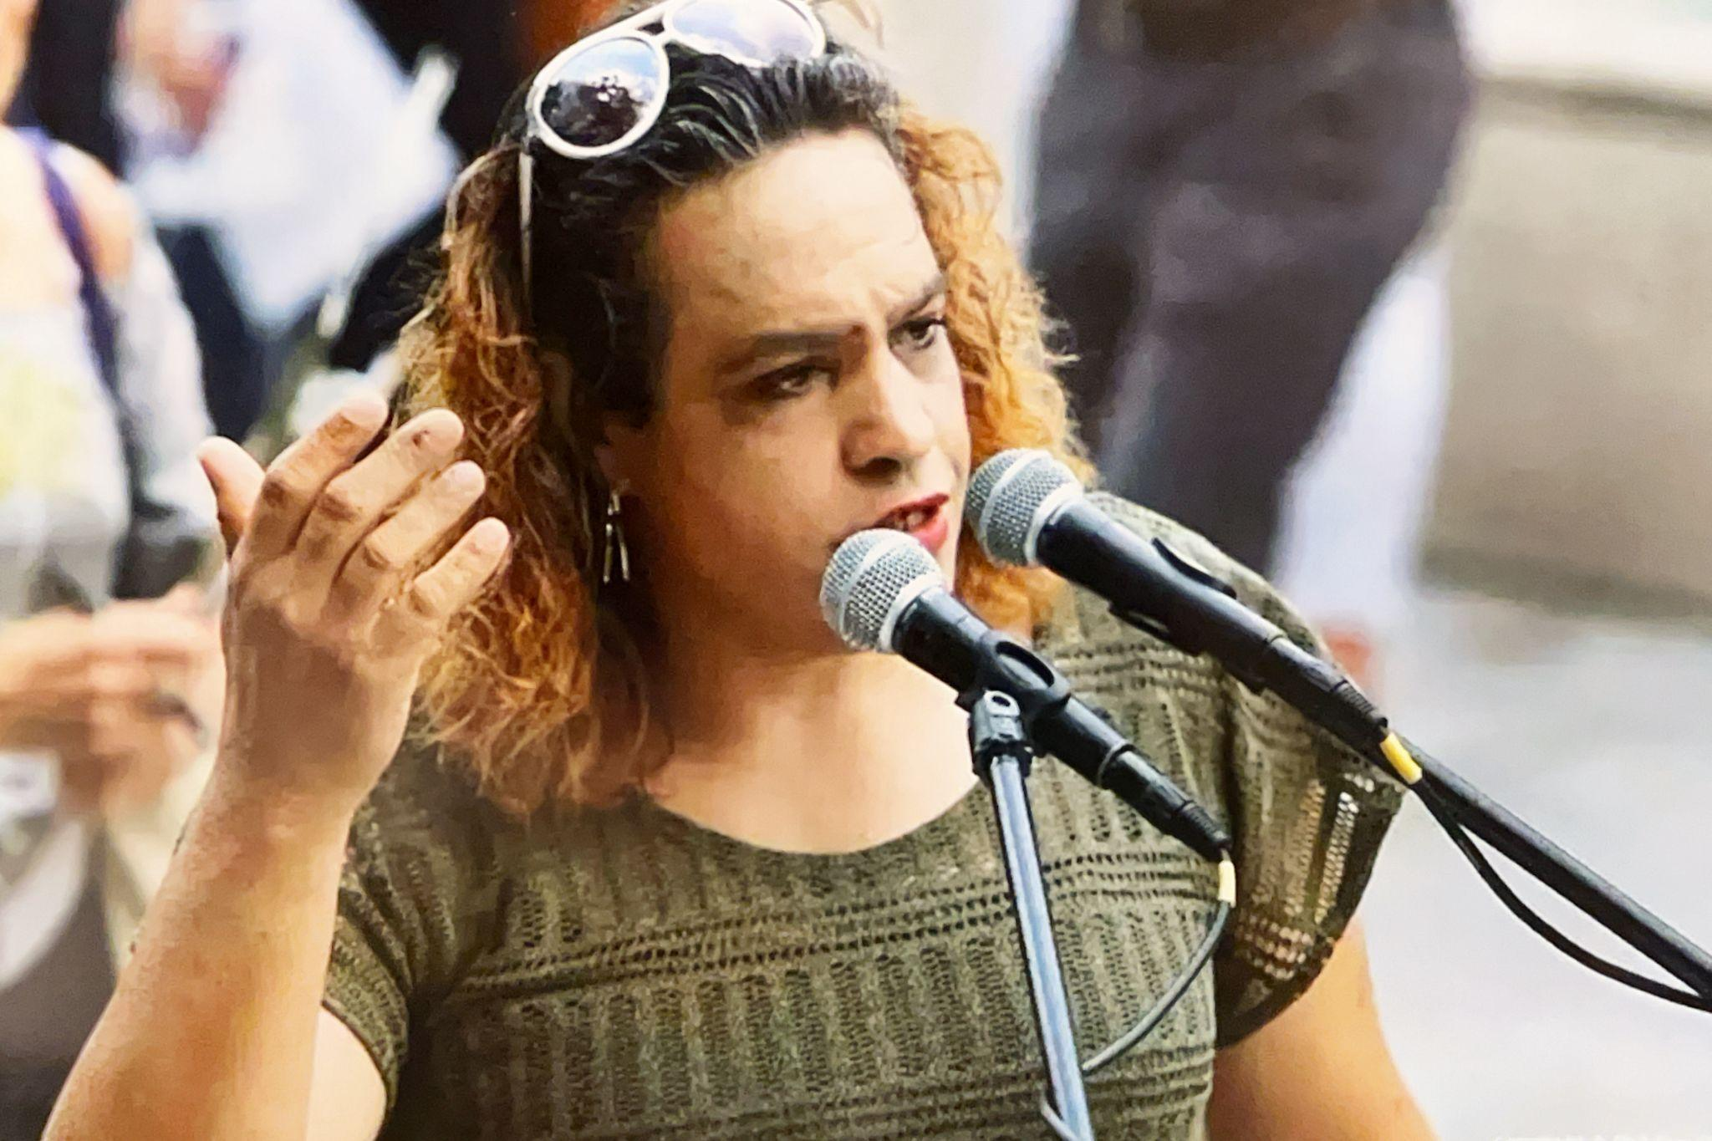

**Jala Speaking for Poor People’s Campaign, c. 2010**

# 

# 

# Act III: Integration

## Chapter 30: Holding On

With Marcia's death, my last parental tether to humanity, with all its messy, corporeal connections, was permanently severed. The number of people with firsthand knowledge of my claim to belonging in human society was dwindling. I had braced myself for the loss of parents, but no amount of preparation softened the impending loss of Jala.

### The Pattern of Crisis and Recovery

After watching her survive multiple heart attacks, battle pneumonia, and live with chronic, unmanaged diabetes, I knew her time was limited. Jala had had stents placed before. She had advanced cardiovascular disease. Each crisis followed the same pattern: the urgent phone call, the flight to Charlotte, the hospital room where I'd find her connected to machines but still fighting.

I'd been here before—twice. Years ago when she was in the ICU, unable to breathe without a ventilator. Another time, when she faced major surgery.

Both times, she had looked me in the eye and said, "Derrick, I'll be okay."

And I'd answer, "Yes, Jala. You will. I got you."

But I never knew if it would be true. She was a cat with nine lives—and I had no idea how many were left.

### The Quintuple Bypass Surgery

"Hi Derrick, I got the results of my angiogram," Jala announced. "I need bypass surgery for my blocked arteries."

"How blocked are they and how many?"

"Five are blocked. A few are 95% occluded, so I need the surgery now. I am scheduled for next week. Can you come?"

"Of course I can."

I arrived before the surgery. I could not tell that Jala was so compromised, but she said that she could not walk 50 feet without gasping for air.

Gina was with me. When we arrived at Novant Presbyterian Hospital, Jala already had a room. This wasn't her first time here. She'd had stents placed before - her advanced cardiovascular disease had been a shadow over our family for years. But five blocked arteries, some 95% occluded, meant we'd moved beyond the minimally invasive procedures into major surgery territory.

"Hi Jala!" I said as we entered her room.

"Hey Derrick, I am so glad to see you man," she said, choking back tears. "I missed you."

How long had it been since I had seen her? I can't remember. Years of phone calls about doctor visits, medication adjustments, insurance battles - but when was the last time I'd actually been present? And this may be the last time. My heart raced.

"I am here Jala," I said, when I really meant "I am so sorry that I have been such a bad brother."

When I looked at her more closely, I noticed something that broke my heart - Jala had cut her hair to appear to be a man. She was concerned that if she died, that she would not be accepted by God as a woman. Seeing her beautiful hair shorn away, watching her trying to present as Dave again after years of living authentically as Jala, felt like witnessing someone preparing to deny herself even in death.

Josh, Gina, Jala, and I discussed her wishes: how she wanted her funeral to go, who to contact, what name to use on any paperwork. The conversation felt surreal - here was this vibrant person I loved, planning her own memorial service while wearing a hospital gown with cartoon bears on it.

It went in one ear and out the other. Jala would be ok. Uncle Bubba had had quadruple bypass surgery and lived another 30 years. Technology was better now. Surely Jala would be ok.

But even as I dismissed her fears, something about the hair haunted me. How much internal torment had led to that decision? How much fear about divine acceptance had she carried alone? While I'd been living my comfortable life in California, she'd been wrestling not just with physical illness but spiritual terror about her very identity.

The surgery would take hours. While we waited, we left to eat with Josh and help him navigate what would become his new routine.

At twenty-five, Josh was old enough to manage on his own, but living in their shared apartment, he'd relied on Jala for transportation and emotional support. Now, with her facing weeks of recovery, he'd need to handle everything alone - work, hospital visits, and caring for the parent who had always been his anchor.

We drove him to the grocery store first. Watching him carefully count bills and select the cheapest options reminded me of Jala's financial struggles. While I lived comfortably in California, they scraped by on her disability payments and whatever Josh could earn at his job.

"How much does the bus cost?" Josh asked as we mapped out the route from their apartment to the hospital.

"Two dollars each way," I said, realizing that four dollars a day for hospital visits could strain their already tight budget. I pressed a twenty into his hand. "For bus fare."

The route we traced on paper - three transfers, an hour each way - would become Josh's lifeline to his only parent for the next month. As we drove the route once to show him the stops, I felt the weight of how precarious their life was. One surgery had turned a twenty-five-year-old into the primary caregiver, managing medical visits, work schedules, and survival on limited resources.

When we returned to the hospital, Jala was still in surgery.

### The Years Between

The years that followed brought a predictable cycle of crisis and recovery, each one leaving Jala a little weaker, me a little more aware of how precious our time together was. She survived the quintuple bypass, but it marked the beginning of a steeper decline.

I had tried everything to help with what became her most dangerous enemy: diabetes. I'd worked for a nonprofit that helped people manage diabetes, learned of the techniques and technologies, and been coached on how to battle diabetes successfully by my friend Steve Van.

I begged her to eat better. I suggested a continuous glucose monitor so she could see, in real time, what certain foods were doing to her body. But Jala lived on permanent disability and rent assistance I provided. She could not afford the glucose monitor. And the cheapest food is always the worst—high in salt and sugar, low in everything else.

She'd been living with uncontrolled diabetes for years. Her vision was failing, her feet had gone numb, and she'd once crashed her car into her apartment's wooden stairwell because she couldn't feel the pedals. Her kidneys were failing. Dialysis every two or three days was the only thing keeping toxins from building up and killing her.

### Joshua's Bond

To Joshua, Jala wasn't just a parent—she was his protector, his motivator, the one who had shared an apartment with him for much of the past three years. Their bond was fierce and complicated in the way that only parent-child relationships can be. Jala pushed Joshua to complete his education, and failing that, to get a job.

Her son had recently moved to Richmond, Virginia. Her only consistent companion now was Sasha, her dog.

### Maya's Wedding: A Rally

Yet, six years later in 2022, Jala surprised us all.

She rallied to attend my daughter Maya's wedding in Jamaica. Her flight was delayed, which nearly pushed her anxiety to a breaking point. She even considered turning back. But the thought of missing her niece's wedding and the chance to see family kept her moving forward. When the shuttle finally dropped her off at our villa, she looked completely worn, makeup smudged, sweat pouring down her brow in the humid Jamaican sun, wearing shoes that were barely fit for donation. But she had made it, with just a few hours to spare.

Gina helped Jala prepare for the wedding. An hour later, showered, shaved, and dressed in a knee-length hot pink dress with flat shoes because heels would be impossible with her neuropathy, Jala emerged to join us for the ride to the wedding hall. Her presence was all the more remarkable given the twenty guests who couldn't attend, including my two half-sisters from New York, due to an unanticipated Jamaican air traffic controllers' strike. Those who did make it shared in a truly magical celebration.

After the wedding, Jala joined us for a night at a traditional British-style inn. Our rooms were on the second floor, with no elevator. I took her bag and started up the stairs, but when I turned back, it was clear she was struggling to breathe. Gina and I exchanged a look that said everything—Jala couldn't make it up the stairs.

We quickly arranged a pair of ground-floor rooms, and Gina and I shared a tearful acknowledgment of the seriousness of Jala's condition. When she returned to the United States the next day, we insisted she see her cardiologist. It turned out that Jala had suffered another heart attack while trying to climb those stairs.

### A Difficult Thanksgiving

Six months later, on Thanksgiving Day 2022, a phone call shattered whatever peace the holiday promised. Jala had been hospitalized, immobilized by excruciating back pain. Tests revealed sepsis. The infection from her dialysis port that she had battled for weeks had spread to her spine.

I booked the next flight.

At Novant Presbyterian Hospital in Charlotte, I found her awake but heavily medicated. Stubble shadowed her jaw and upper lip. Her once-vibrant curls were matted and dull. Sweat beaded on her brow.

This time felt different.

When I walked into the room, her face lit up through the haze of pain.

"Derrick! I'm so glad you're here," she said, tears welling in her eyes.

"I can't walk," she confessed. Her voice was heavy with fear and exhaustion.

The infection had invaded her spine and spinal cord, causing weakness in her legs. The doctors recommended surgery to clear the infection. There were no guarantees. The alternative? Certain paralysis. Loss of bowel and bladder control. Dependence.

"I want to come stay with you in California," she said. "I can't live in a nursing home. Not alone."

"I understand, Jala. I got you. Don't worry about that," I said.

But I didn't say yes. I couldn't—not yet. The responsibility scared me. But this wasn't the time for hesitation, and she knew it.

"Okay, Derrick," she said quietly.

"Let's focus on getting you healthy," I offered.

She nodded, then paused.

"Can you help me shave? I don't like looking like this. I already had to correct a nurse who called me 'sir.'"

"Of course."

I got a razor and shaving cream from the nurse's station and gently shaved her, one careful stroke at a time—helping her reclaim a piece of dignity, a piece of herself, in a place that had taken so much.

### The Surgery

The next day, Jala chose to have the surgery.

When I saw her stable afterward, I returned home, clinging to hope.

But hope didn't hold. The surgery failed.

When I flew back to Charlotte days later, her eyes told me everything before she spoke.

"Derrick," she said, her voice hollow, "I can't feel my legs. I can't live like this."

"I know, Jala. I understand."

I had tried for years to get her to stop driving after multiple accidents—neuropathy and near-blindness had made it reckless—but she'd refused. She wasn't one to give up.

Until now.

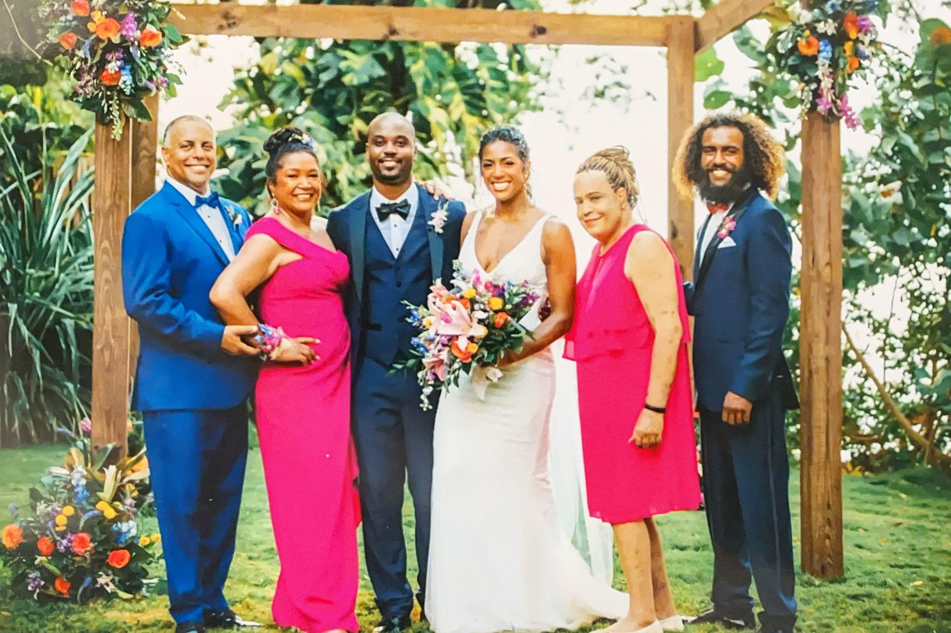

**Maya and Harold’s Wedding, Jamaica, May, 2022**Derrick, Gina, Harold, Maya, Jala, Jamil

# 

## Chapter 31: Letting Go

"I think I'm going to stop dialysis," she said.

We both knew what that meant. Stopping meant death. No ambiguity.

"But I need to know something first," she said, her voice trembling. "Will God still accept me in heaven?"

Her eyes—usually clear, confident, full of fire—were now clouded with fear. Life had often been cruel, but eternity? That was something else. That was permanent.

"Why wouldn't He, Jala? You're one of the kindest, most godly people I know," I said, trying to pull her back from that edge—trying to convince her, and maybe myself, that she was worthy.

"I need to know it's not suicide. And I need to know if my gender… if that's a problem."

And there it was.

She wasn't just preparing to die. She was seeking divine permission to let go.

We'd both been raised in church, but we didn't know the scriptures like that. Still, we clung to the God we believed in—the one who loved boundlessly.

"No God we were taught to believe in would reject you, Jala."

She looked away.

"Yeah…" she said, softly. Not quite believing.

### Facing Mortality and Faith

As Jala's condition declined, she turned to me one afternoon and said, "I need your help planning my funeral."

She was still Jala—organized, clear-headed, a planner to the end. She already had everything mapped out in her mind. I took notes as she spoke: donate her body to science, invite the labor leaders and local politicians she had championed, and ask Reverend Doctor William J. Barber II to preside.

I hadn't realized how deep her connection to Doctor Barber ran—until she handed me his private number and said, "Call him."

When he answered, she didn't hesitate.

"Bishop Barber," she asked, "will I go to hell for being transgender?"

There was a pause. Then his voice came through—measured, grounded in scripture.

He quoted Matthew 19:12:

"For there are eunuchs who were born that way, and there are eunuchs who have been made eunuchs by others, and there are those who choose to live like eunuchs for the sake of the kingdom of heaven. The one who can accept this should accept it."

He went on to reference the Ethiopian eunuch in Acts 8:26–40—a figure welcomed into the faith, baptized without hesitation. Jala listened intently, her eyes wet but steady.

Reassured, she asked her next question.

"Bishop Barber, will I go to hell for stopping dialysis?"

His response was gentle but firm.

"No, Jade," he said, using her chosen name for her public advocacy persona, Jade X Jackson.

"You have served the Lord your God with all your heart and soul. Your body is tired. God is ready for you."

A long silence followed. Not uncomfortable—just full.

Then Jala made her final request.

"Doctor Barber, will you preside over my funeral?"

He didn't hesitate.

"Yes," he said.

As Jala thanked Doctor Barber and hung up the phone, I sat back and marvelled at the beautiful person that I had the honor of calling my sister.

### One More Thing

With her funeral program set and having received permission to "let go and let God" as my mother would say, Jala seemed nearly content.

"One more thing, Derrick. Glenn has refused to speak with me since I transitioned." Jala said, tears welling up in her eyes, as my heart sank with hers.

I stepped out of the room and got Glenn's phone number from Jamie, another high school friend of Jala's.

"Glenn, this is Derrick." I announced.

"Hey Derrick, how are you doing?" he said, as if we had just spoken last week.

"Not so good man, Dave is dying" using the name that Glenn would immediately recognize.

"He – well she now – feels so bad that she hasn't spoken to you since transitioning to Jala. Will you speak with her?" I pleaded.

"Sure Derrick. I don't have any bad feelings for Jala."

I walked back into the hospital room and passed the phone to Jala. Listening to half the conversation, I witnessed years of estrangement melt away, as tears of joy streamed down both of our faces.

For the first time in days, she looked at peace.

### The Final Moments

Days later, Jala was drowning. Not in water—in her own body. Her lungs heavy, her limbs bloated, skin stretched and tight from fluid. Her choice to stop dialysis was killing her. Slowly. Brutally.

Death by kidney failure isn't peaceful. It's gasping, choking, swelling, suffocating. But the hospital did what it could—morphine, silence, dim lights.

It wasn't enough.

Her eyes locked on mine—pleading, terrified. Her chest heaved like it was lifting a mountain with every breath. Each time she inhaled, it shattered me.

I leaned in close, cradling her head like something sacred, my lips at her ear.

"I got you. I'm here. I'll take care of Josh. Your job is done. You're safe now. You can rest now. I'm here."

Her breathing turned frantic. Wild. She thrashed, eyes wide.

"Help me… I can't… breathe—"

The nurse rushed in, injected the last dose of morphine. Then she turned to me, quiet and tense.

"I can't give her anything more," she said. "But… if she enters hospice care, the nurses there can do more."

More.

What the hell was more?

I looked down at Jala, at the woman who'd survived so much already. Who kept going when her body screamed no.

"Jala," I said. "It's time. Hospice. Are you ready?"

Her eyes softened. "Yes, Derrick. I'm ready."

The nurse left to enter the orders. Minutes later, she returned.

"Hospice is on this floor," she said. "We'll wheel her down the hall."

We moved as one—me, Gina, Maya, Jamil, Joshua—hands on the bed, hearts in our throats. As we walked, I looked into the rooms we passed. Patients alone in their beds, rooms quiet, just… waiting to die.

That would not be Jala.

Not like my father.

Not like my mother.

Not without us.

In the hospice room, a new nurse came in. She carried a syringe and a calm voice.

"This will help ease her suffering."

I glanced at the monitor. She was confirming the med—Dilaudid.

I knew that drug.

I'd had it once for kidney stones. Killed the pain, instantly. But the dose had been too strong. I hadn't passed out—but I stopped breathing.

I turned to Jala just as the nurse pushed the plunger.

Then I looked at the screen.

Dilaudid dispensed.

When I turned back, everything had changed.

The fight was gone.

No more gasping. No more panic.

She breathed in—slow, full.

Then out.

And that was it.

Her last breath.

Gina had seen it coming. She knew. After thirty years of marriage and countless conversations about medical situations, I could practically be a triage nurse—but I was still one step behind.

I had told our kids the night before. I had prepared them. We were here to say goodbye.

But Joshua? I couldn't bring myself to say the words. How do you tell a child his father is dying?

Because that's what Jala had been to him—father, protector, anchor.

He had seen her suffer before. Struggle and survive. Jala had always survived. Every time.

"Wake up! Wake up!" Joshua screamed.

"You can't leave me! I need you! Wake up!"

And for the next hour, we held him—while he screamed the things the rest of us were too shattered to say. Later, when his voice gave out and exhaustion took over, we sat together in that sacred silence, learning that sometimes love means simply bearing witness to unbearable loss.

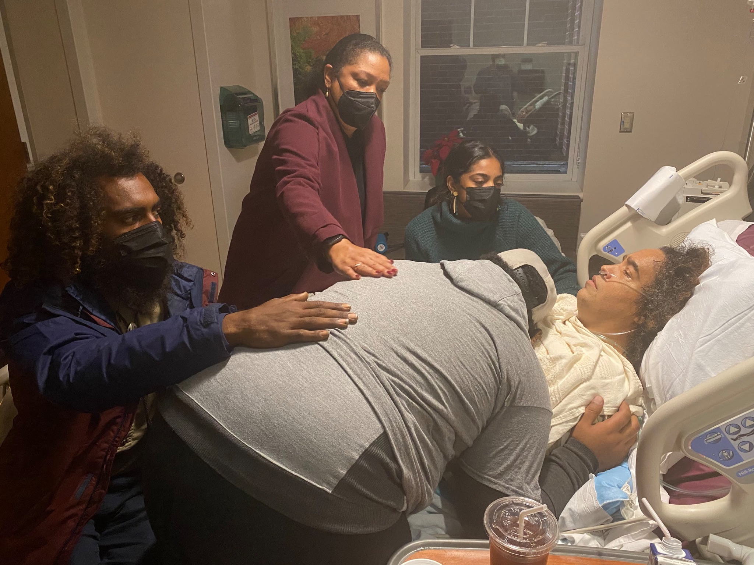

**Jala’s Last Breath, December 2023**  
Jamil, Joshua, Jala, Gina, and Maya

# 

## Chapter 32: The Diagnosis

### September - First Symptoms

I had emailed Daniel, Doctor Greenwood, on September 30, 2023, Gina's birthday.

*Hi doc! I know that you are very busy, so I apologize in advance if this is nothing…. For the last month or so I've had discomfort as I swallow on my left side near the base of my tongue. I assumed it was from when I had Covid Aug 22-28, 2023 but it has not gone away. Thoughts?*

"Have you spoken with Daniel?" Gina asked a couple of weeks later.

"I missed his call. I will email him again today," I promised.

Nearly a month had passed since I reached out to Daniel. I procrastinated. Scratchy throat. "No big deal," I thought. I am constantly bothering him. I need to stop being such a wuss.

Finally, I responded to Daniel's email, suggesting anytime today or tomorrow.

*Hi Derrick, I will call you at 10:15 AM tomorrow morning. Cordially, Daniel Greenwood*

The next morning at 10:00 AM, Caller ID showed that it was Kaiser Permanente. The call was early.

"Hi Derrick, what's going on?"

His voice carried that gentle tone he always used, the one that usually put patients at ease. Today it made my stomach tighten.

I described the swallowing issues, trying to sound casual. "It's probably just lingering Covid stuff, right?"

A pause. In fifteen years as my doctor, Daniel had never paused like that.

"Hmmm. Let me ask you a few questions." The shift in his tone was subtle but clear. This wasn't our usual friendly chat.

"Do you smoke?"

"No, never." I knew he knew this.

"How about alcohol? How many drinks? How often?"

My mouth went dry. These weren't casual questions. After all those years asking Gina about how she diagnoses patients, I recognized what these questions meant. These were cancer screening questions.

"Derrick, I'd like you to see a colleague of mine, Doctor Tang, in head and neck surgery. He'll take a look at your throat. Is that okay with you?"

"Yes," I managed, aiming for bravery but landing somewhere near terrified.

"He has an opening on Thursday at 8:30 AM. Will that work for you?"

"Yes." I submitted, surprised that my appointment would be so soon.

After we hung up, I stood there, phone still pressed to my ear. The wall felt cool against my palm. Three days felt like three weeks as I waited for the appointment.

### November - The Appointment

The November fog hung low over San Francisco as I pulled into the French Campus parking lot on November 2nd. My tires crunched over scattered eucalyptus leaves, still wet from the morning mist. I'd driven past this building before—the old French Hospital, now a Kaiser facility. The medical staff called it what it was: the oldest and darkest Kaiser campus in San Francisco, a place purely functional. But today was different. Today I was a patient.

I sat in my car, hands still on the steering wheel, watching the few patients shuffle through the entrance. One moved slowly, shoulders hunched. Another strode purposefully, as if walking quickly might get him out faster.

The dashboard clock clicked to 8:22 AM. I couldn't stall any longer.

Inside immediately to my right sat the guard.

"Mornin’!" I said.

"Mornin’." he responded, with the dip of the chin that black men give to each other that says "I see you."

I had already forgotten what floor to go to, so I scanned the directory on the wall to the left.

"Head and Neck Surgery ... 2". Second floor. I pushed the button for the elevator. Fifteen seconds felt like minutes. The door opened.

When the elevator door opened, I turned to the left and saw the receptionist at her desk. Long nails! Really long nails! Eyelashes too.

As I exited the elevator, I could not help but notice how dark and dreary it looked. Primer covered some of the walls, ready for paint. But paint would not remake this building into a place that felt welcoming or safe.

"Pretty nails" I said, always looking for ways to make strangers smile.

"Thank you!" she smiled. "How can I help you?"

"I am here to see Doctor Tang." I pulled out my iPhone, looking for my Kaiser card in my Apple Wallet.

"That's ok, just tell me your name and birthdate," she suggested.

And I complied.

"Ok, have a seat and someone will be out to get you shortly."

I sat down, scanned the hall again. Desolate. Depressing. I pulled out my phone to transport my mind away.

A medical assistant walked toward me.

"Mr. Burns?"

"Yes."

"Please follow me to the exam room."

It was a young brother.

"Whatcha think of the Warriors?" I asked.

"We will see, man. Steph and Dray need some help. But I live in Oakland. I’m pissed that though."

"I hear you!"

The walk to the exam room was short, just ten or twenty steps. I tried to ward off the feeling that I was walking to the gallows.

A couple of minutes later,

"Mr. Burns, I am Doctor Tang."

"Hello Doctor Tang."

"I understand from Doctor Greenwood that you have some discomfort swallowing?" he asked.

I explained my symptoms.

"Okay, well it could be one of three things," he said confidently. "Since you have a history of GERD, you could have irritation from reflux. You could have an infection. And you could have cancer."

His voice didn't change. Monotone, like reading a cake recipe.

"Let's take a look. I'm going to spray your nose to numb it a bit while I retrieve the scope."

When Doctor Tang returned carrying a sealed tray, I couldn't feel my nostrils when I tensed them.

"First I'll take a look in your ears. I am going to place this into your ear canal," he said.

I looked up on the screen and saw giant hairs but thankfully very little ear wax.

"All good."

"Now let's take a look at your throat. I'm going to put this through your nose. It should not hurt."

As he moved the scope from my ear to my nose, the monitor flashed images of the floor. As he guided the scope up my nose, he had a difficult time maneuvering.

"Hmm," he pulled back. "Your nasal passages are quite small. Let me get a pediatric scope instead," Doctor Tang said as he withdrew the scope and left the room.

Minutes later he returned. This time, the scope slid past my nasal hairs, creating an odd tickling sensation. Not painful, just... wrong. On the monitor, pink tissue filled the screen. I tried to decode the images, searching for what looked normal. I saw pink and yellow skin. Normal, even healthy-looking.

Doctor Tang manipulated the scope with practiced precision. His confidence was reassuring, like a bomb disposal expert—skilled, focused, waiting to find something dangerous. I could not break my attention from the screen. I thought about the tiny camera lens and his ability to control the scope as it snaked through me.

"Looks good," he reported.

I was encouraged, but the scope continued to move. We weren't finished yet.

It stopped. Doctor Tang manipulated the tip, scanning the area more carefully.

The room went quiet. Even the equipment seemed to hum more softly. Doctor Tang raised his arm, forefinger extended, pointing at a mass.

Where there had been pink tissue, there was now something else. Something yellowish-white. Something that didn't belong.

"Mr. Burns," he said, his tone shifting. "This is cancer, almost certainly squamous cell cancer."

The word hung in the air between us. Cancer. My father's voice, garbled from his stroke, echoed in my memory. My mother's eyes, tired and imploring, reflecting the unrelenting oral pain from chemotherapy.

"Would you like to call your wife?"

I nodded, my voice trapped somewhere in my throat. As Doctor Tang dialed, I stared at the monitor, at the mass that had been hiding inside me. The image blurred as my eyes welled up.

"Hi Doctor Gregory-Burns," Doctor Tang's clinical voice cut through my fog. "I'm here with your husband. I've just scoped his throat and found what appears to be a large tumor."

"Cancer?" The word escaped me like a plea.

"Yes, this is squamous cell cancer. The tumor is large," he said, pointing to the screen. "You will need chemo-radiation. After that, you will see me regularly for the next five years."

My mind raced. Mom had died of cancer after suffering horrible mouth sores from chemotherapy. Dad had died of cancer too, unable to speak and swallow easily after his stroke. Would I be like them, in pain and nearly mute?

I told Gina I would call her later.

"Do you need me to come there?" she asked.

"No, thanks. I will call you later," I responded, summoning the strongest voice I could muster.

Doctor Tang explained the next steps: biopsy to confirm diagnosis, CT scan to measure size, PET scan to check for metastasis.

"If it has spread to your brain or liver, then there is nothing we can do."

When he offered to do the biopsy immediately, my body made its decision before my mind could catch up. Sweat beaded my forehead, my throat closed tight.

"I can't do this now. I'm sorry to cause you all this trouble."

Doctor Tang's expression softened slightly. "Don't worry about that, Mr. Burns. I understand completely." He reached for his phone. "This is Doctor Tang. I have a patient who needs an immediate throat biopsy. Yes, today. It *can't wait*."

*Can't wait.* The words echoed in my head. Doctors don't rush unless... I pushed the thought away.

"They can take you at 3 PM. Will that work?"

Six hours. From diagnosis to surgery in six hours. "Yes," I heard myself say.

## Chapter 33: A Problem to Overcome

### The Drive Home

I drove home in a daze. The Tesla's navigation system guided me—"In 500 feet, turn left"—but I existed in a tunnel between my steering wheel and the car ahead of me. Buildings, sidewalks, people dissolved into peripheral static. When I found myself in our driveway, I couldn't remember a single turn.

Inside, I called Steve Van. Beyond his diabetes, Steve has wrestled with health crises for decades. If anyone could guide me through this territory, it was him.

"I'm scared," I admitted, the words feeling foreign in my mouth.

"D, you need to treat this like a problem to overcome," he said, his voice steady with hard-won wisdom.

A problem to overcome.

### The CT Scan and Biopsy

The same day, the CT scan came first, delivering its clinical verdict: "Enhancing soft tissue mass at the left base of tongue measuring approximately 3.6 x 2.4 cm x 3.6 cm, suspicious for neoplasm, likely squamous cell carcinoma. Multiple bilateral nonspecific small nonpathologically enlarged lymph nodes. However, one 9 mm left cervical lymph node is necrotic suggesting a site of nodal metastatic disease."

Numbers. Clinical measurements of something growing inside me that I couldn't feel or see, like discovering a stranger had been living in my house all along.

That afternoon, Gina drove us to the main hospital for the biopsy. The fog had lifted, but everything felt wrapped in gauze—too bright, too sharp, too real.

In the surgical prep area, a nurse with gentle hands started my IV. "This is Gabapentin," she explained. "It'll help you relax."

The medication hit my system like a warm wave, and suddenly I was talking too much, cracking jokes that probably weren't funny. Anything to fill the silence that kept trying to swallow us.

An hour later, I was rolled into the operating room.

"Count backward from ten," she said, adjusting my oxygen mask.

"Ten, nine, eight..."

No.

"Dreamland."

Later, Gina told me the surgeon had explained everything right after the procedure. But those moments disappeared into the fog of anesthesia. That's why I needed Gina there—not just as my wife of thirty-four years, but as the person who could hold onto the pieces of me I was losing track of.

The first biopsy came back the next day.

Inconclusive.

Doctor Tang remained unwavering in his diagnosis.

"Mr. Burns, I am convinced you have squamous cell cancer, but we need a positive pathology report before I can present your case to the tumor board and start your treatment."

Tumor board. Is this the medical panel that denies medical care that Republicans talked about when trying to block Obamacare?

"Are you available Friday, November 10?"

"Yes" I said immediately. What could be more important on my calendar?

"Ok, good. I'll cut until we have proof," Doctor Tang announced.

How do I respond to that? "Great, doc, cut all you need!"

### Telling the Children

That evening, still drowsy from the biopsy drugs, Gina and I had agreed to tell the kids. We called a family meeting for 8 PM—not unusual in our house, but we'd never gathered to discuss a parent's mortality.

I walked around the neighborhood first, barely able to put one foot in front of the other as the anesthesia wore off. When I returned, I sat in the living room staring at my iPhone calendar. Christmas plans suddenly felt like wishes written in disappearing ink.

Jamil and Alexa came into the living room. Maya and Harold joined us on Zoom from Los Angeles, their faces compressed into pixels on our laptop screen, trying to bridge three hundred miles of worry.

"I have squamous cell carcinoma at the base of my tongue," I began. The medical words were familiar after thirty-three years of marriage to an internist, but using "I" in front of them felt like speaking a foreign language. "I'll have radiation and chemotherapy. Steve told me to treat this like a problem to overcome, and that's what I'm going to do."

The questions came rapid-fire. Maya: "How long have you had it?" Jamil: "How big is the tumor?" Both: "What's the prognosis? When do you start treatment?"

I answered what I could, but mostly I wanted to own this moment. To establish early that this was my battle to fight.

Maya made her decision immediately. "We're coming up. Harold can work remotely, and I can take time off."

"You don't need to—" I started.

"Yes, we do," she said with that familiar Burns family determination that both infuriated and comforted me.

"How are you doing?" Gina asked, her physician's voice mixing with her wife's worry.

I wanted to say I was fine, that I'd handle it like every other challenge. Instead, I heard myself saying, "I'm scared."

"Of dying?"

"Of not being able to speak. Of not being able to eat with you. Of becoming someone you have to take care of instead of someone you choose to be with."

We sat in the blinking light, holding hands like teenagers, neither of us having answers but both of us finally naming what felt true.

### Happy Birthday

Two days later, November 4th, we celebrated Jamil's birthday at home. Gina cooked a wonderful meal. Jamil donned our traditional family velvet birthday hat from a long-ago trip to Disneyland, a silly striped thing we'd been using for birthdays for years. He sat at our kitchen table, leaning forward to blow out the colorful "HAPPY BIRTHDAY" candles on the chocolate cake that she made. Gina sat across from him in her coral sweatshirt, her hand near her face, fighting back emotions—the bittersweetness of trying to maintain birthday joy while processing my diagnosis just forty-eight hours old.

Without telling anyone, Jamil and I had some recreational drugs. He played some Cumbia music. No, he played one song, *Como Te Voy A Olvidar* by the Los Angeles Azules,

over and over. The heavy brass section drilled into my psyche, straight to my emotional core. Jamil went upstairs, music blaring on all the Sonos speakers in our house. I danced around the oval dining room table, spinning in circles like the earth around the sun, leaning off center. Jamil came back downstairs thirty minutes later, sobbing uncontrollably. I hugged him. "What happened?" I asked.

"I want Mom," he said, like a five-year-old boy reeling in pain after having broken his favorite toy. And the three of us embraced, Jamil hunched over grabbing Gina's waist. And then I realized, what happened is... cancer.

### The Cuts

"Hello Derrick. Hello Gina," Doctor Tang greeted me as I lay in bed with an IV in the preoperative holding area.

During the second procedure, the pathologist was present in the lab next to the surgical suite, examining samples under the microscope as Doctor Tang cut. The first four samples came back benign—A, B, C, D. All superficial. All normal squamous tissue. No dysplasia seen.

Then came the deeper cuts. E, F, G, H, I. Each one positive for P16-positive squamous cell carcinoma. The deeper Doctor Tang went, the more cancer he found.

"Mr. Burns, I had to cut deep to get to the cancer. There was a great deal of inflammation and necrotic tissue."

Necrotic. Dead. No, don't think about "dead."

The pathology report would later spell it out in clinical language: "Strong p16 positivity is a reliable surrogate for high risk HPV." My ghost from college, buried forty years deep, had been quietly building this tumor at the base of my tongue.

HPV is nearly universal, with tens of millions of men infected, but fewer than 1%—about 1 in 3,000 per year—will ever develop oropharyngeal cancer from it. In my case, the virus was latent for years—dormant and not contagious—before reactivating and leading to cancer, an uncommon outcome of a common infection. Yeah, lucky me.

### The Wait

Five days to go before the PET scan felt like an eternity. Each morning, consciousness arrived with the same brutal reminder. I have *cancer*, and it could kill me soon.

I went through the motions—meetings, phone calls, emails—but everything felt provisional, written in pencil. I caught myself ending sentences with "if" and "maybe." Even my calendar seemed to mock me, its dates stretching beyond what might be possible.

On November 15, 2023, the PET scan results brought our first real breath: "No suspicious right neck nodes. No findings to suggest distant metastatic disease." Clear. No metastasis to my brain or liver—the death sentence scenarios Doctor Tang had warned about. The cancer was contained to my throat and one lymph node.

The tumor board confirmed the recommendation: synchronized chemotherapy and radiation.

"I plan to go away for Thanksgiving."

But how would I be around my daughter's in-laws? They are so loving, so joyful. Would I be able to engage, to be present, to show them the love that they had shown us?

"Mr. Burns, I recommend you start as soon as possible."

"How about the week after Thanksgiving?"

"December second."

### Meeting Doctor Katzel

Pathology confirmed the diagnosis—squamous cell cancer—and I was assigned to Doctor Jed Katzel, head of head and neck cancer treatment across Kaiser nationwide.

"Hi Mr. Burns, Jed Katzel," he said, extending a firm handshake.

"Hello Doctor Katzel. You know my wife Gina."

"Yes, hello Gina." His smile reached his eyes. "I've reviewed your case. You have P-16 positive squamous cell cancer—HPV-related, which means a better prognosis than tobacco-related cancers. It's highly treatable and often curable with radiation and chemotherapy. But I need to be honest—the treatment is among the most difficult in oncology."

A small blessing wrapped in a terrible diagnosis.

The clinical language couldn't mask what we both understood—this was a battle I could win, but the war would exact its price.

For the first time since meeting Doctor Tang, I broke down.

"Doctor Katzel," I said, my voice cracking, "my mother couldn't handle the chemotherapy. The mouth sores were unbearable. And my father, after his stroke, could barely speak. This sounds like both of their worst symptoms combined."

Tears streamed down my eyes, clouding my vision as I looked Doctor Katzel in the face. I had spent my childhood learning to suppress tears, summoning anger or even dissociating. This time, there was no running away, nothing to vent anger at. God? Even if I professed a belief in God, every God I had studied was merciful.

He set down his pen and met my gaze directly. "It will be difficult," he said, his tone gentle but firm. "But I don't think you'll suffer like your parents did. We have better supportive care now. And I promise you this—we will get you through this."

I looked at him, really looked at him, and saw something I desperately needed: certainty. Not about the outcome, but about the fight. The tears stopped, not because I forced them away, but because I recognized the promise in his words. This time, I wouldn't face it alone.

### The Consent Form

Doctor Katzel pulled out the consent form—several pages thick. His pen hovered over each item as he read aloud, his voice steady and clinical. With each new side effect, my stomach knotted tighter.

"The radiation will likely cause burns, similar to a severe sunburn, both inside and outside your throat."

No.

I was not afraid now. I listened, but I believed. Doctor Katzel is the national leader. Gina believes in him, and she and Kaiser have never steered me wrong.

"The common effects you can expect: dry mouth, loss of taste, swallowing difficulties, radiation burns on your neck, crushing fatigue. From the chemotherapy—nausea, hearing changes like tinnitus, low white blood cells."

He continued methodically. "Less common but possible: severe mouth and throat ulcers called mucositis, neck muscle tightening, long-term swallowing problems, dental decay requiring extractions, voice changes, peripheral neuropathy in your hands and feet, moderate hearing loss, kidney strain that we'll monitor closely."

Each possibility echoed with memories of my parents' suffering. Mom, unable to eat, her mouth too raw from chemotherapy. Dad, struggling to form words after his stroke, frustration clouding his eyes.

"The rare but serious effects: permanent feeding tube dependence, jawbone damage, severe hearing loss, chronic pain, even secondary cancers decades later..."

The words hung between us like a sword.

I decided then to expect the common side effects and to assume the best. I could do this. I can do hard things.

I took the release form. Hadn't I already agreed to the treatment? Oh, right. Liability. I need to sign.

### December 2nd - First Treatment

The morning of my first treatment, I woke at 5:30 without an alarm. Gina was already awake beside me, staring at the ceiling.

"Can't sleep either?" I asked.

"I was thinking about breakfast. What sounds good?"

Such a normal question. Such a married-couple-of-thirty-years question.

Gina had planned to retire early next year, after finding a suitable doctor for each of her 1,000 patients. But with my diagnosis, she moved her date sooner.

"Kaiser will assign them someone," she said, trying to sound matter-of-fact, when in reality she felt like she was letting them down. After over 30 years with some of the patients, she would very likely never see them again.

Her sacrifice humbled me. While I focused on my own fears, she was quietly dismantling the career she'd built patient by patient, relationship by relationship.

"Oatmeal with bananas," I said, though I usually grabbed a croissant and coffee at my local shop. This morning, I wanted to be home. I wanted Gina to take care of me.

While she showered, I walked through our house, really seeing it. The vinyl flooring we'd replaced in the master bathroom, cutting and shaving each square to fit perfectly around the door jamb. The carpet we'd changed throughout the upstairs. The kids' bedrooms we'd gutted together. I had rewired the lights and outlets personally, painted every wall and ceiling.

Had I caused this? All those years of sugar addiction—that time I'd consumed an entire sixteen ounce bag of chocolate peanut butter cups and ended up with a kidney stone. Did the cancer feed off the excess sugar in my bloodstream? On my tongue itself?

This time, I put my bowl and spoon directly in the dishwasher instead of leaving them in the sink—a habit that had always annoyed Gina, a relic from my childhood when Mom didn't own a dishwasher. Small gestures suddenly felt enormous.

As we drove north on Highway 101, I thought about my mother's experience. Would I end up in a hospital bed, helpless and diminished? No. Doctor Katzel had been clear—this was outpatient treatment. I would sit in a chair for six hours with an IV. The radiation would be even quicker but more frequent: five days a week for seven weeks instead of once every three weeks.

The revelation felt almost as significant as the diagnosis itself: I could fight this from home.

Despite having "good veins," it took the nurse three attempts to place the IV in my hand.

"The hand is better," she explained. "It gives you more freedom to move."

"We'll start with basic fluids. When you need the bathroom, just disconnect the power from the wall socket. The drip continues on battery. Bathrooms are down the hall."

As the first treatment began, I felt something unexpected: not fear, but a strange kind of relief. The waiting was over. The fight had begun.

After three visits, I became a pro, dragging my IV pole like a reluctant dance partner to the nearby bathroom.

And I was still myself—scared, determined, and ready to treat this like a problem to overcome.

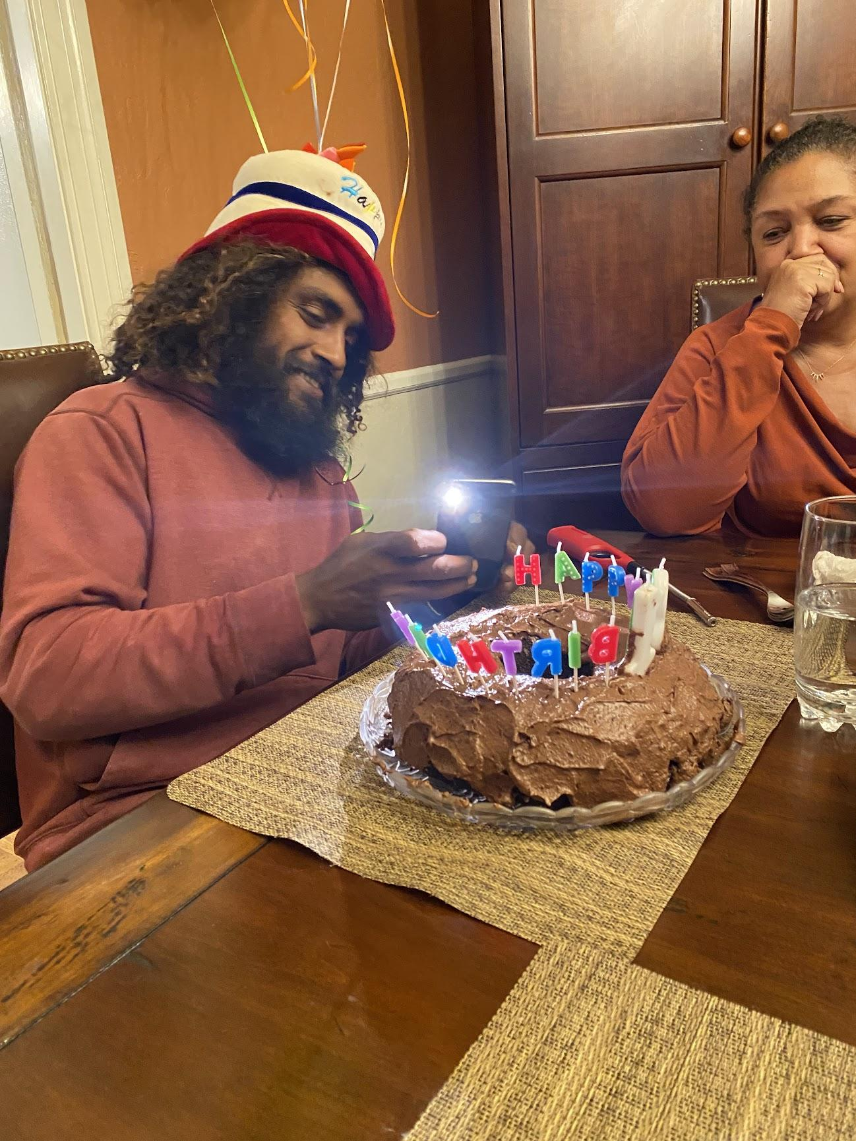

## Chapter 34: The Battle

### A Terrifying Outcome

I reached out to Steve. We were estranged, but I had heard through the grapevine that he had coded in the hospital, but was finally back home.

“Hey Steve! How are you doing? I heard through your daughter on Facebook that you have been sick.”

“Hi Derrick! It is good to hear from you. Yes, it has been pretty rough…”

And so restarted our relationship. But the conversation took a dark turn.

“I heard that you nearly died. What happened?” I inquired.

“Well, I had been treated for throat cancer. Four weeks after my treatment ended, my throat started bleeding badly. Ultimately, I needed surgery and the surgeons rebuilt my throat and removed my larynx. I cannot speak.”

I gasped. I reread the text.

“Oh my God. I, too, have been diagnosed with throat cancer. P-16 positive. I just started treatment.” I declared, my heart racing, chest tightening, as I gasped for air.

“Wait, what do you mean Derrick?” he asked incredulously

I repeated myself.

“I too have throat cancer.” I repeated as the gravity of the situation sunk it to both of us.

“Can we meet?” I asked.

“Yes,” he offered.

When I met with Steve I saw a shadow of his former self. He had lost over 20 pounds after a long stint in a hospital and months long recovery in a rehab center. The booming baritone voice that so identified him was gone, replaced by total silence. His home that he had so meticulously constructed with his architect’s eye was sold to pay for health care expenses, replaced with a small garden style apartment, so common for such an uncommon man.

We talked for hours. Or should I say I talked and he typed on his iPad. We knew each other well enough that I could guess what he was trying to say and I’d help the conversation along by saying it aloud to save him the work of one finger pecking one slow letter at a time. He would shake his head up and down and point to me if I got it right, and left and right if I got it wrong. The method was tedious, but effective.

The caring man who had adopted a young girl and raised her as his own had resurfaced to replace the stubborn, scared, and overbearing man that I had run away from.

Steve detailed his trials. He too had P-16 positive cancer. It was supposed to be curable if caught early as his cancer was. But something went terribly wrong. When the bleeding began in his throat the doctors prescribed Hyperbaric treatment. It failed.. Everything failed. When he lost consciousness his family had to make a difficult decision. Remove his larynx and replace a section of his throat or … death.

Steve was quick to reassure me that my fate would be different. It **had** to be different, we both needed to believe.

Steve needed to regain his strength, so we started a regular regimen of walking. Our first walk along the lovely Sawyer Creek Trail was a favorite of mine. The 6.5 mile trail curves around the Crystal Springs Reservoir. We walked two miles and then back, noting each half mile marker as a major accomplishment. We interrupted our journey first by voluntary stops to take in the beautiful scenery but later by Steve’s need for oxygen and rest. Steve would control his breathing during these breaks, driven less by his lung capacity and more by his weak racing heart’s need for rest. The more rest Steve needed, the more I tried to interpret his thoughts, suggesting completions to the messages he typed on his iPhone messages. The gentle rolling hills curved around the source of our drinking water on this cool windless day. After 4.5 hours, we completed the 4 mile walk.

Steve thanked me profusely, later telling me that he vomited that night from over-exertion.

After several weeks of attending to his needs, I gradually pulled back. The shock of Steve’s outcome was ultimately too much to bear. Steve was right. He and I were two different people. I would have a different outcome, and now was not the time for excessive empathy. With some guilt, I slowly pulled away, justifying it by reminding myself that we were estranged for a reason. I just could not handle the weight.

### Friends and Family

I told my closest friends and family. Vince and Ellis introduced me to friends who had survived the same cancer. Vince’s friend Stephanie had survived surgery and chemotherapy treatment five years ago. She warned me that my friends and family may not be truly able to empathize with me. Some would be so distraught that they could only focus on their feelings. Others would be so afraid that they would put up an emotional wall. Few would truly listen and hear my needs. Her words were prophetic.

Ellis’s friend had chemo-radiation twelve years ago. His pain was so bad that he was on heavy narcotics for nearly two months. He could remember very little of his ordeal, but incredulously said that it was the *best* e*xperience of his life*.

At 3 Bees Coffee in San Mateo, I met Wade and his wife Lorraine. Wade has survived chemo-radiation for the same cancer two years ago. He also had very challenging side effects, but had learned to ameliorate them over time.

But it was my family’s response to my cancer that hit the hardest. Jamil was crushed with anguish. The night after I told him, he sobbed uncontrollably.

Gina had been planning to retire in January 2024, but wanted to provide a smooth transition for her patients by providing each of the 2000+ patients with an introduction to a new doctor who would attend to their primary care needs. Instead, she immediately took several weeks off work to shuttle me to my appointments and attend to my needs.

Maya and husband Harold flew up from Los Angeles and stayed at our home for seven weeks as I went through the roughest period of the treatment.

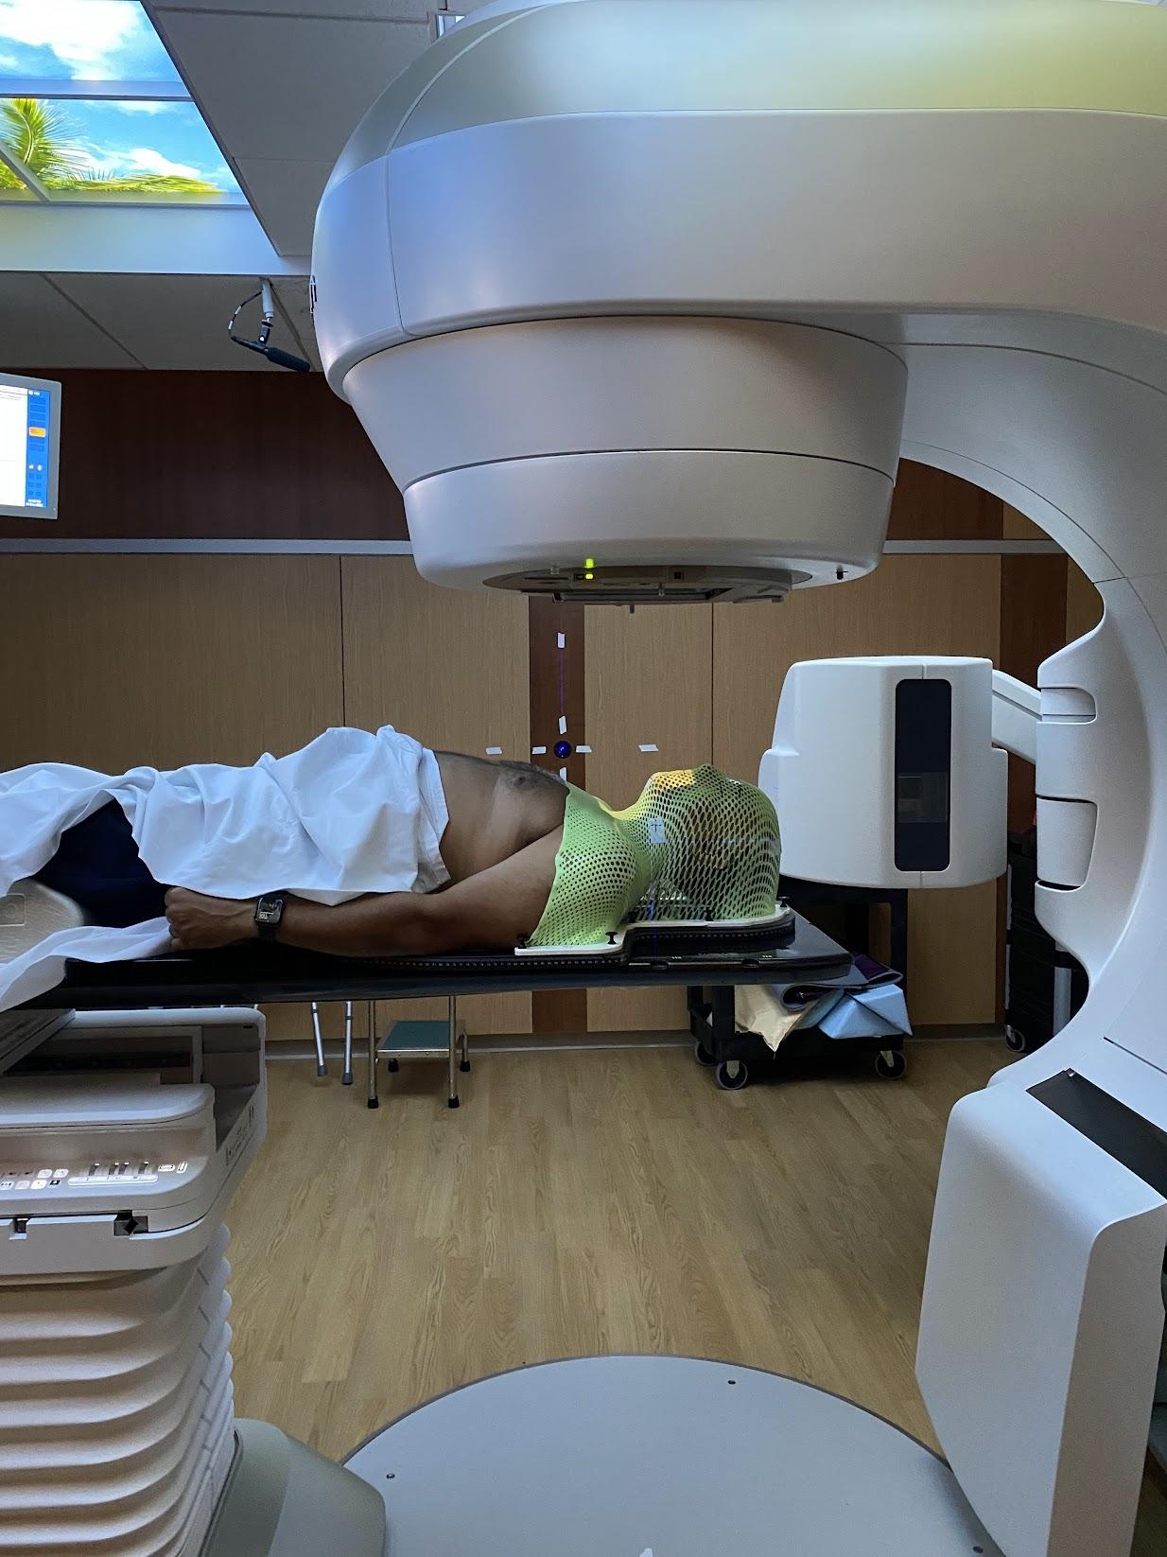  
**Derrick gets radiation at Kaiser Cancer Treatment Center, South San Francisco**  
**December 3, 2023**

At the start of each radiation session, the technician immobilized my head by screwing a custom molded green mesh mask that I wore like armour into the table on which I lay, pressing tightly against my face and leaving no room for any head motion.

“Don’t swallow. Don’t swallow” came the commands over the speaker from the control room on the other side of the wall.

“Ok, you may swallow now.”

I heard between the initial CT scan and the administration of therapeutic radiation to my neck and chin, finally making its way to my tumor and back out the back of my body.

“Don’t swallow Mr. Burns. Don’t swallow,” came the final command before the radiation.

The mask had been molded for my head and shoulders. Though I could see through, I simply closed my eyes and meditated. Instead of anxiety that gripped so many other such patients and required Xanax, I entered a Zen state that left me nearly asleep at the end of the 10 minute session. I trusted the process.

Chemotherapy proved even more challenging. The room had the capacity to treat three patients simultaneously. But my six-and-a-half-hour marathon was longer than most, so a friend I would make at the beginning of my session would leave before I was done, so I listened to audiobooks and slept.

Debates raged among doctors about which therapy was harsher. For me, the answer lay in the gradual unveiling of side effects. Chemotherapy brought immediate nausea, countered by lethargy-inducing antiemetics. Radiation's effects were cumulative. Initially harmless, it eventually burned my neck, obliterated my sense of taste, leaving a persistent salt water flavor, destroyed my salivary glands, and caused throat pain requiring Gabapentin.

My appetite vanished, along with my sugar addiction. My once-beloved treats became a distant memory. I lost 42 pounds, a dramatic change that alarmed my medical team.

And the kicker, when the treatment ended, my side effects actually got worse.

## Chapter 35: The Triumph

The squeak of my sneakers against the court felt foreign after months away. My first step back onto the YMCA basketball court in March 2024 carried more weight than just physical movement - it was a declaration of life. The familiar smell of rubber and sweat mixed with the sound of bouncing balls, a symphony I'd missed during my months of treatment.

"Man, you're moving better than you have in years!" Denis called out, his voice carrying across the court.

"You move like you are twenty years younger!"

The words hit differently than the usual trash talk. He was right - my lateral movement felt explosive, my defensive slides smoother. The chemotherapy weight loss had stripped away years of accumulated bulk, leaving me lighter, quicker.

But recovery came with its own rhythm, two steps forward, one step back. My beloved three-point shot abandoned me - the muscle memory was there but the strength wasn't. My triceps had withered along with other muscles I'd taken for granted. Each attempt fell short, a humbling reminder of the work ahead.

"It'll come back," Armando assured me, his voice carrying the weight of thirty years watching players recover from injuries.

"Just keep shooting."

The physical transformation was stark - forty-two pounds lighter, I caught glimpses of my reflection in the gym mirrors and barely recognized myself. My new Zara wardrobe replaced the baggy Costco clothes that hung like tents on my transformed frame. "Zara Distinguished," I dubbed my new style, taking pride in wearing clothes targeted for young, fashion-conscious customers. I even befriended the Costco return agents as I unloaded 10 years of clothing that no longer fit, using their "unlimited" returns policy for clothing (though the real limit is 10 years!).

But beneath the visible changes, invisible battles continued. As my oncologist had warned, "radiation is the gift that keeps on giving." The muscles on the left side of my neck had become like leather, requiring daily stretching exercises. A constant dry mouth demanded a water bottle companion. When I walked, it felt like I had a wad of tissue under my left foot - neuropathy, they called it. Tingling sensations shot down my back when I bent forward. Carpal tunnel syndrome plagued my left wrist. My quadriceps were so weak that I tore my right calf playing basketball, twice.

The changes went deeper still. My gums no longer bled - not from improved dental hygiene but from decreased blood flow, another subtle reminder of the treatment's lasting impact. The skin on my neck bore a slightly darker shade on the left side, a permanent badge of survival. Ringing in my ears signaled mild hearing loss.

Yet these were small prices to pay. I still had my larynx, unlike my friend Steve. The bigger threats - thyroid problems, secondary cancers, kidney damage - remained at bay. My immune system had recovered, the lethargy and nausea were gone, and my voice had returned to normal.

In June, Doctor Tang's office felt different. The same dark corridors that had once filled me with dread now felt almost welcoming. As he manipulated the scope through my nasal passage, I watched the monitor with new understanding. "Complete response to treatment," he announced, showing me two images side by side - my throat from diagnosis and now.

Then he shared something that stopped my breath. He pulled up the image from my second biopsy, taken just eight days after the first. The tumor's growth was shocking - aggressive, invasive, pressing against my epiglottis. "It took three anesthesiologists to place your breathing tube," he said quietly. "We were very worried." The urgency hadn't been about my wife's status as a colleague. It had been about saving my life from a particularly aggressive cancer that had been winning the race against time.

This brush with mortality changed everything. I thought about Ellis's friend's words: "Looking back, it was the best experience of my life." At the time, they'd seemed impossible, perhaps influenced by heavy narcotics. I understood. Cancer had given me something precious - a second chance to connect with what mattered most.

The gift of time made me reach deeper into my past, seeking connections I'd let fade after leaving Detroit. After Aunt Mae's death, I'd built walls around my heart, letting childhood friendships dwindle to annual phone calls and holiday greetings. Now, those walls felt as unnecessary as my old, oversized clothes.

I started first by researching friends and teachers online.

Doctor James Allen Jones, who opened my eyes to me living in a bigger world, had died. His obituary said that he had earned a *Fulbright Scholarship* in 1957, over a decade before I had the good fortune of being his world geography and drama student!

All but one of my high school teachers had died, as had Mrs. Voss who was killed in a car accident by a man fleeing the police. I needed a connection to someone living!

"JIMMY!" I called one afternoon, my voice carrying the same excitement it had in high school.

"D. BURNS!" he responded instantly, decades melting away in those two words.

Jimmy knew me before the masks, before the performances. He knew my parents when they were healthy, knew Dave before the transition to Jala, knew me when tears flowed freely down my cheeks. Our conversations, once confined to birthdays and holidays, now spilled into marathon phone calls two or three times a week. The timing was perfect - his kids were out of college, his wife back at work, and both of us ready to reclaim the brotherhood we'd let slip away.

Between basketball games at the Y, I'd sit in my car, phone pressed to my ear, sharing my cancer journey with Jimmy. His responses carried the weight of shared history - he understood not just what I was saying, but what it meant in the context of who I'd always been. The boy who'd hidden his feelings behind achievement was finally learning to be vulnerable.

The reconnection spread like ripples in a pond. Jim, my sister-cousins, Ron, and Bill - each relationship rekindled with new depth. They were the family I'd chosen, and though distance had created gaps, the foundation had never truly crumbled.

But time doesn't pause for healing. One morning, as I was planning my next round of calls, my phone rang.

"Derrick, this is Dennis, Glenn's brother."

My heart tightened before he even said the words.

"I have some bad news. Glenn died a few days ago. We found him in his home."

"Had he been sick?" I managed to ask.

"No!" Dennis's shock matched my own.

The memories flooded back - Big Glenn, our neighborhood leader, packing us into his Deuce and a Quarter on Friday nights, my mom's Bonneville following close behind as we roamed from party to party. His voice, soft and slow, making the hard decisions we needed to hear:

"Yo Fellas. We can't hang out anymore," he'd pronounced after bullets flew too close one night.

We'd felt invincible together, but Glenn's wisdom had probably saved our lives.

The timing felt cruel. Just months earlier, I'd helped bridge one final gap for Glenn. He and Jala had grown apart - Glenn wanting Dave, not accepting Jala. The day before Jala died, I'd made the call.

"Glenn, this is Derrick."

"Hey Derrick, it is good to hear from you," that familiar drawl warming the line.

"Yeah man, it has been far too long." My voice cracked.

"I have some bad news buddy. Dave is dying. She goes as Jala now, as I think you know. One of the heaviest weights on her heart is the loss of friendship with you. Could you talk to her for a few minutes to give her some comfort?"

"Sure Derrick. I don't have any hard feelings for Dave... err Jala."

When I told Jala that Glenn was on the phone, her eyes lit up through tears. The call was brief, but I watched years of pain flow down her cheeks - grief for lost time, joy for this moment of reconnection.

Now, just months after losing Jala, Glenn was gone too. When Dennis tried to comfort me, saying Glenn had lived a good life, I understood something deeper about time and connection. The physical scars from cancer would fade, but its greatest gift was this urgency to reconnect, to heal old wounds, to say the words that matter while there's still time.

Back on the basketball court, I catch glimpses of who we all used to be - young, strong, believing we had all the time in the world. My three-point shot is slowly returning, but the real victory isn't in the baskets made. It's in understanding that every squeak of these sneakers, every conversation with old friends, every moment of connection is precious. Cancer didn't just change my body - it changed how I move through time itself, teaching me to value not just the big moments, but all the small ones that make a life complete.

## Chapter 36: Full Circle

The Zoom meeting window reflected back a version of myself I barely recognized - thinner, grayer, but somehow more present. My heart raced as I waited for my new boss’s boss to join, not from the cancer treatments this time, but from a different kind of survival instinct. After decades in Silicon Valley, I knew what reorganizations meant. The familiar signs were all there: my boss's boss departing, a new aggressive leader taking charge, an increase in tension and anxiety.

"Why haven't you solved the problems?" The words cut through the digital space, carrying the sharp edge of Silicon Valley's relentless drive.

I felt the familiar tightness in my chest, but this time it sparked something new - clarity rather than anxiety. After facing mortality, corporate politics felt surprisingly small. The collaborative, respectful environment I'd helped build was already shifting, and I recognized the aggressive style I'd encountered years ago at Google. The water wasn't just rising; it was changing temperature.

My oncologist's words echoed:

"Most people take six months off after a diagnosis like yours."

But I had pushed to return sooner, still caught in the old patterns of proving myself. Thirty minutes into that first meeting left me exhausted in a way no amount of corporate determination could overcome.

"Doc, I'm not ready," I admitted during my next checkup.

"I have no stamina."

He nodded, unsurprised.

"Aim for May 2nd. Give your body time to heal completely."

Over lunch with Willie Hooks, my longtime mentor, I found myself questioning everything I thought I knew about success. Willie had walked this path before me, stepping away from the corporate ladder in his fifties to pursue a different kind of impact.

"What do you really want now?" Willie asked, his question cutting through my rehearsed answers about career advancement.

"Quality of life," I answered, surprising myself with the immediacy of the response.

"Flexibility. Trust. The chance to mentor others. Time to travel. Space to keep learning."

The promotion to chief architect that once seemed so natural, now felt like a relic from another life. Under the previous SVP, someone I'd built trust with, it might have made sense. But now? The respect of my immediate colleagues, the daily joy of solving problems, the freedom to learn and grow - these were the real measures of success.

I decided to stay a bit longer, knowing it was temporary. My relationships with my boss, peers, and team remained strong and fulfilling. But the writing was on the wall with the new leadership. I still struggled with accepting the ending: being sent out to pasture without so much as a simple “thank you”. However, I felt no panic about the future. Cancer had taught me something about time - it couldn't be saved or stored, only spent. The question was no longer about survival, but about choice.

Looking at my reflection in the Zoom window, I saw someone who had finally learned to read not just the water level, but the currents beneath. The corporate world hadn't changed - I had. The masks I'd worn for decades, the performances I'd perfected, the constant adaptation to others' expectations - all of it felt heavier now, less necessary. I had faced death and emerged with a different understanding of what it meant to live.

My calendar still filled with meetings, my Slack channels still beckoned with new unread messages, but I approached it all with a new perspective. Each day was a choice now - to stay or go, to engage or step back, to perform or simply be. The tick-tock of corporate time no longer drove my decisions. I had found a different rhythm, one that matched the beating of my healing heart.

# 

## Chapter 37: Fearless Love

The kitchen in our Queens Airbnb was small—barely big enough for two people to pass without bumping elbows. But that morning, Jamil commanded it like he was back in that Italian cooking class ten years ago, when a local grandmother had taught our family to make fresh pasta from scratch.

He moved with the same focused intensity now, every gesture deliberate. The way he chose each avocado, pressing gently to test its ripeness. How he diced shallots with precise, even cuts, the knife work rhythmic and sure. The careful attention he paid to the heat under his pan, adjusting the flame with the confidence of someone who understood that cooking was an act of devotion.

This was Jamil's love language—and he was fluent.

The scent of caramelizing shallots filled the small space as he folded them into scrambled eggs that he'd been whisking to perfect peaks. French toast soaked in vanilla-scented custard waited its turn on the griddle. Fresh fruit arranged in careful patterns. Coffee brewing strong and dark.

"Everybody sit," he called, his voice carrying the authority of a chef who'd just orchestrated something beautiful. "It's ready."

We gathered around the small table—me, Gina, Maya, Jamil—four adults crowded into a space meant for a quick breakfast, but somehow it felt exactly right. The morning light streamed through windows overlooking Queens rooftops, and the aroma of Jamil's feast made the cramped space feel like the most important place in the world.

We were here in New York City to celebrate cousin Jasmine Gregory's solo exhibition, "Who Wants to Die for Glamour" at the Museum of Modern Art PS1. Despite having a full time job, separated by three time zones from the east coast relatives, and nine from Jasmine, Maya had crafted a multi-day itinerary for family to gather. She'd taken it upon herself to organize this reunion and to pay homage to Jasmine, now a major artist in Geneva, Switzerland. I never understood artists. How do they make a living? Somehow Jasmine had figured it out!

The day before, at the exhibition, I had walked with pride. My niece, though not my blood, had put herself via her art on full display. What courage that took! I studied the paintings. One featured a boy piloting a boat as his father hovered over him, guiding him to accept his place among the owners of the finest things and his inheritance of membership in the top caste. I chuckled. The meaning was so clear to me. I asked other family members how they interpreted the pieces. Most were silent, summarizing the art eventually as "abstract."

"Artists see things differently than us," one offered.

Perhaps, but we are the audience, and I felt this one deeply.

I approached Jasmine and suggested my interpretation.

"Exactly," she said, in a way that suggested that the interpretation should be obvious!

Maya was glowing. At thirty-four, having orchestrated this family gathering around Jasmine's triumph, she had that particular happiness that comes from being exactly where you want to be, with exactly the people you want to be with.

"Oh, Dad," she said, cutting into Jamil's French toast, "I meant to tell you earlier. Remember that article I sent you? The one co-authored by your birth father?"

I nodded, fork paused halfway to my mouth. The 1962 research paper on communicator credibility—dry academic work that I'd filed away without much thought.

"Well, I reached out to the other author. Elliot Aronson. He's ninety-two now, lives in Santa Cruz." She said it casually, like she was mentioning the weather.

The fork completed its journey to my mouth, but I barely tasted Jamil's perfect creation. "You... reached out to him?"

"Through his website. I found out we have a connection—his great-nephew Brendan was in my business school class." Maya's voice carried that same fearless confidence I'd watched her display her entire life. The same tone she'd used at eight years old when she announced she was going to dive off the ten-meter platform, despite never having done anything higher than the three-meter board.

"He wrote back," she continued, pulling out her phone. "Want to hear what he said?"

Before I could answer, she was reading:

"'Dear Maya, Wow! How exciting. I was very fond of Burton, a smart, courageous young man. We worked together in 1960-61 when I was a new assistant professor at Harvard. Your grandfather was taking my class on social influence, and our publication marked my first collaboration with an undergraduate...'"

Maya's voice faded into background as the words settled into me. *Smart, courageous young man.* Burton—the abstract figure I'd carried as a question mark my entire life—suddenly had dimension. Had presence.

"'He was one of the few black students at Harvard at that time,'" Maya continued reading, "'even conducting a study on prejudice. Burton had approached me to collaborate, and together they ran an experiment... His resilience, using Jackie Robinson as a model, left a lasting impression...'"

The kitchen went quiet except for the gentle sizzle still coming from Jamil's pan. I could feel my family's eyes on me, but I was somewhere else entirely. Seeing Burton as a young man not much older than Maya was now, walking across Harvard Yard in 1960, carrying himself with the kind of courage that left impressions on professors decades later.

"This brings tears to my eyes," I heard myself say, my voice thick. "Burton was such a bright light, full of passion for learning and life. I was the same at that age, yearning to contribute to humanity. I feel a deep sadness that he felt he had to extinguish that light."

The tears came then, not the controlled kind I'd learned to manage, but the real ones that surprise you with their intensity. Jamil reached across the table, his hand finding my shoulder. Gina's fingers intertwined with mine.

But it was Maya I couldn't stop looking at. Maya, who had fearlessly reached across sixty years to connect me with something I didn't even know I needed. Just like she'd fearlessly launched herself off that diving platform, trusting that the water would catch her. Just like she'd fearlessly charged toward fly balls in right field, diving at full speed without hesitation, or thrown out runners from her knees with perfect accuracy and total confidence.

While I had spent decades learning to drop my performance and connect authentically, Maya had been living that way all along. And now she was using that fearless love to heal parts of me I hadn't even known were broken.

I looked around that cramped Queens kitchen—at Jamil, who had poured his soul into feeding us; at Maya, who had poured her courage into connecting me with my history; at Gina, who had poured three decades into helping me become someone worthy of this moment.

For the first time, I truly understood what it meant to be surrounded by fearless love. And I realized that my children hadn't learned authenticity despite my years of performance—they had learned it from watching me finally become myself.

The tears kept coming, but they felt like gratitude now. Gratitude for a daughter brave enough to dive deep, and a son who knew that love tastes like perfectly caramelized shallots and vanilla-scented French toast, served with absolute devotion on a Sunday morning in Queens.

# 

# Acknowledgments

Writing this memoir has been a journey of discovery, made possible by the love, support, and wisdom of many people who helped transform my walls into bridges.

To my wife **Gina Gregory-Burns**, for reading countless drafts and forgiving countless of my failings.

To my editor, **June Cross**, whose early encouragement and detailed comments on early drafts inspired me to have the audacity to publish.

To my children, **Maya Burns Benard and Jamil Burns**, thank you for your patience as I wrestled with these stories, for your honest feedback, and for showing me daily what fearless love looks like in action. You are my greatest teachers and my proudest achievements.

To my sister **Jala McKenzie-Burns** whose boundless love and authenticity taught me that the strongest family bonds are often the ones we choose. Your courage in living your truth continues to inspire me.

To my friend **Paige Wolfson** for reminding me that what we feel is much more important to know than we accomplish.

To my Wednesday warriors, **Steve Van, Jean-Claude Brunache, Tony Lindsay, and Rick Navarro**, thank you for thirty-plus years of friendship that has sustained me through corporate battles, health crises, and life's inevitable challenges. Your loyalty proves that chosen family can be as enduring as any other.

To **Vince Nakayama** and **James Raby**, my brothers in spirit for over thirty-five years, through martial arts, corporate wars, and philosophical debates late into the night. You've shown me that true brotherhood transcends blood and geography.

To my mentor, **Willie Hooks**, whose mentorship in business and in life has guided me like the North Star.

To the **basketball community at the YMCA**, for three decades of games that taught me more about leadership, community, and authentic connection than any boardroom ever could.

To my medical team, **Doctor Daniel Greenwood, Doctor Christopher Tang, and Doctor Jed Katzel**, whose expertise and compassion guided me through the darkest chapter of this story and into the light of recovery. Your skill gave me years; your humanity gave me hope.

To my high school buddies **James Latham and James Wardell** who showed me vulnerability and strength can coexist.

To my college roommate **Jamal Mazrui** who showed me the courage that fortified me through Princeton and cancer.

**And finally, to The Sign**, that faithful witness in our basement whose simple question—"Are you grateful for such wonderful, loving parents?"—took sixty years to fully answer. Thank you for teaching me that congratulations aren't just for receiving love, but for learning to give it fearlessly in return.

To each person who helped me understand that our deepest wounds can become our greatest sources of strength, and that the spaces between worlds are where the most beautiful bridges are built—my heart overflows with gratitude.

Derrick R. Burns  
July 9, 2025

# 

# Back Cover

*What does it mean to build a life from the spaces between worlds?*

*Born to a Jewish mother and Black father in 1964 Detroit, adopted into a loving Black family, Derrick R. Burns discovered that the answer lay not in choosing sides, but in building bridges.*

*From the basement sign that asked "Are you grateful for such wonderful, loving parents?" to a cancer diagnosis that stripped away all pretense, this memoir traces a sixty-year journey from survival through performance to authentic presence. Through Princeton's halls, Silicon Valley's innovation labs, family loss, and life-threatening illness, Derrick learns that our deepest wounds can become our greatest sources of strength.*

*More than an adoption story, From Walls to Bridges is a masterwork of contemporary memoir—a sophisticated three-act journey that transforms individual struggle into universal wisdom about identity, belonging, and the radical power of chosen family. It demonstrates how the spaces "between worlds" that initially isolate us can become the foundation for healing divisions across all manner of differences.*

*This is the story of how walls built for protection become bridges toward connection—and how the greatest achievements emerge not through performance, but through fearless love.*

*Derrick R. Burns is a Princeton graduate and Silicon Valley veteran whose memoir represents a sophisticated achievement in contemporary life writing. He lives in San Mateo with his wife Gina.*